Roberto Vasquez
1/18/2020
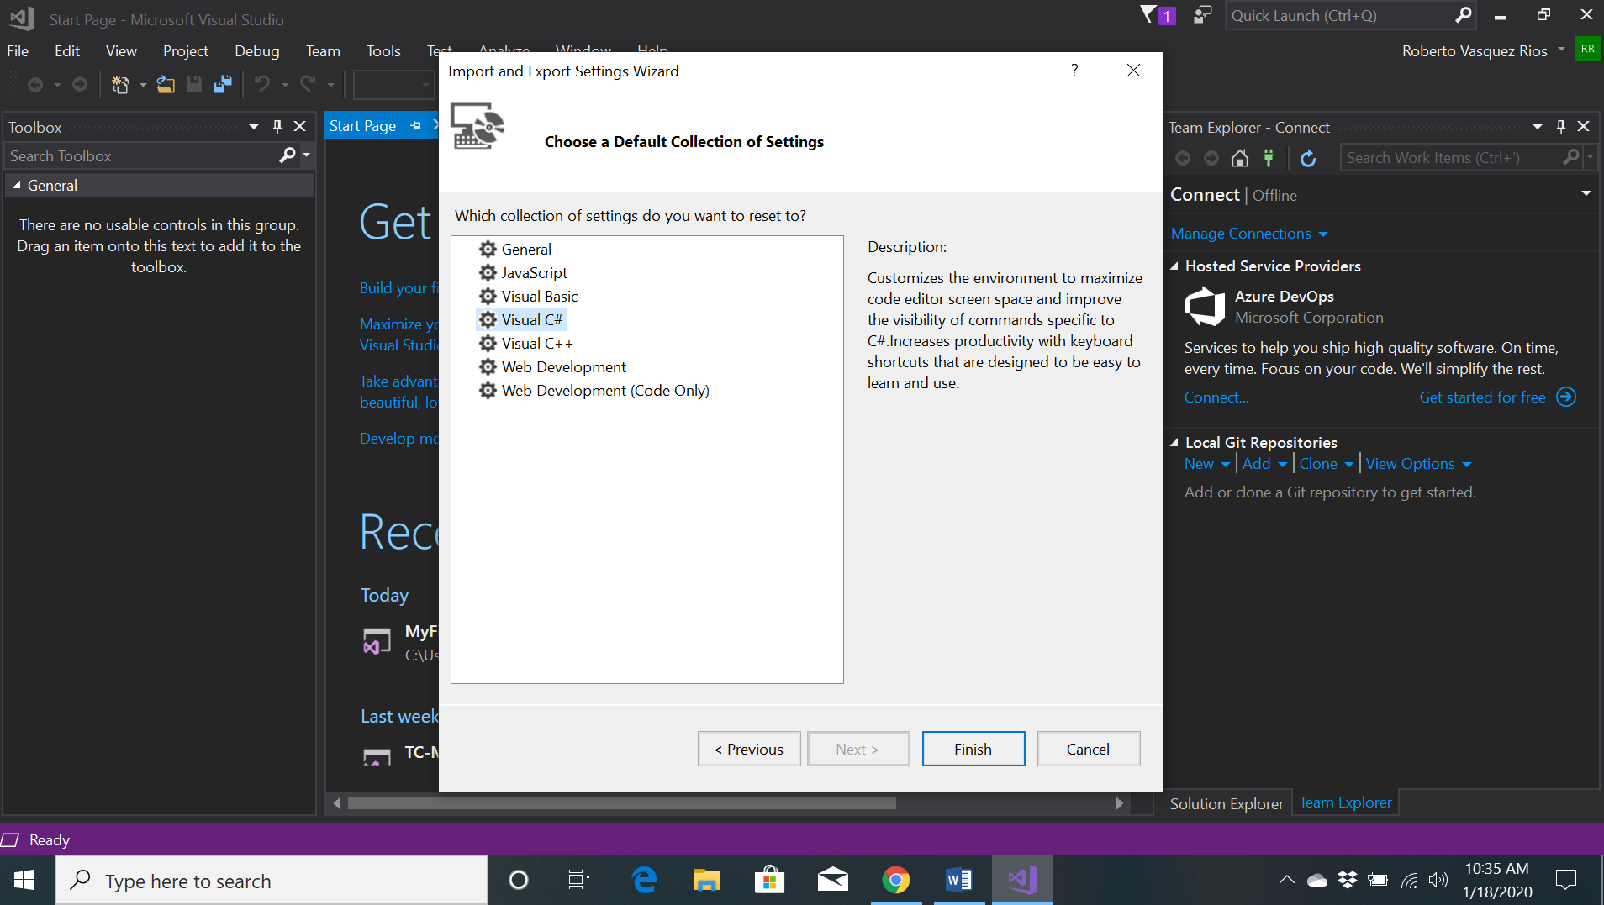
Figure 1: Tutorial 1-1

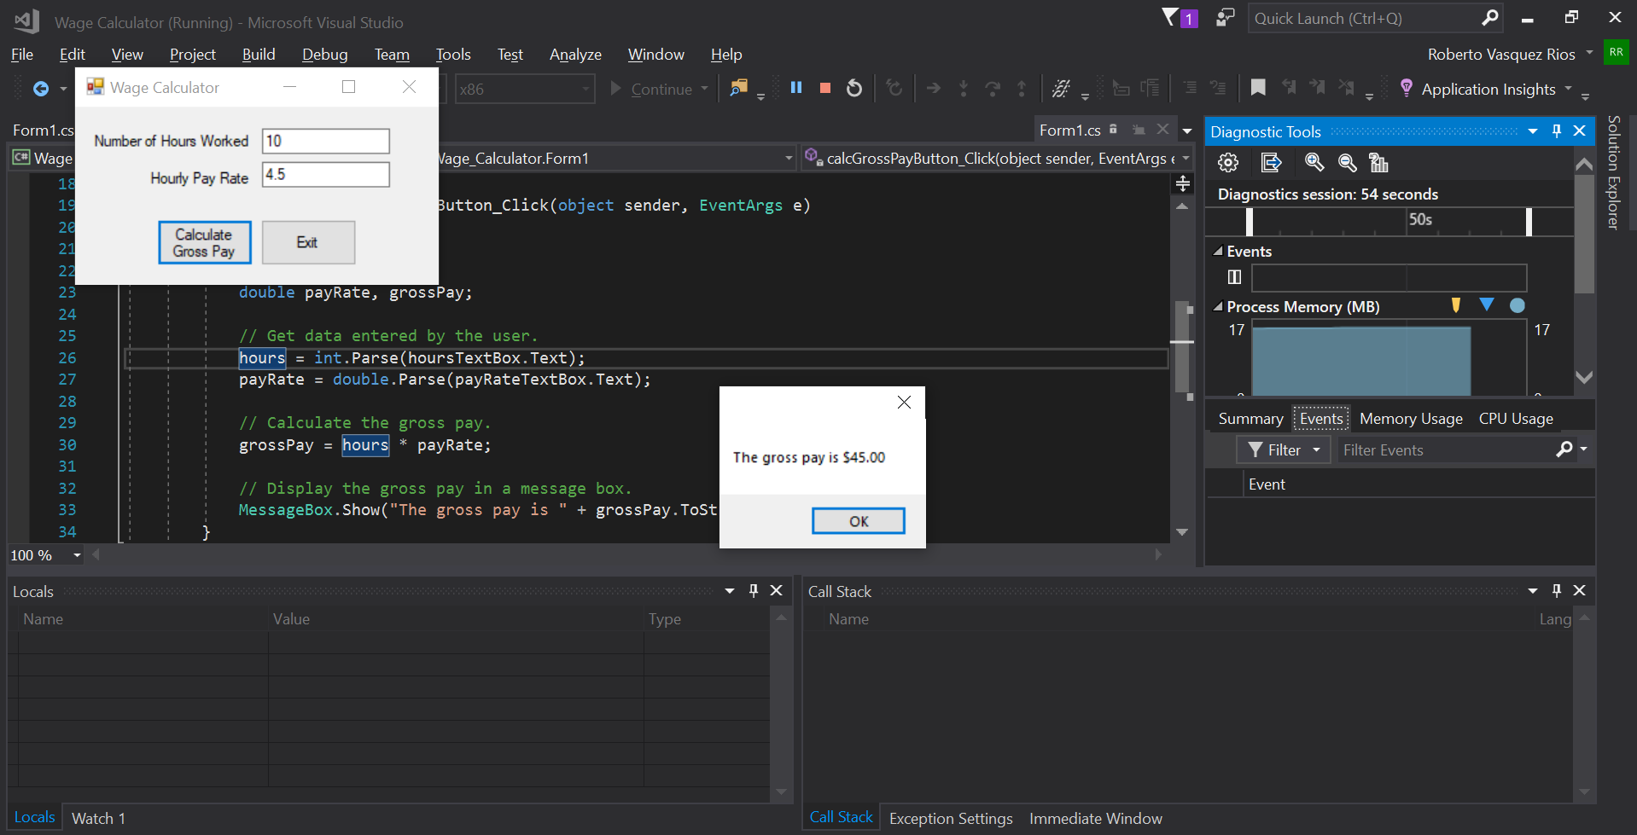
Figure 2: Tutorial 1-4
However, the program doesn’t valid float and string input for “Number of Hours Worked”
and string input for “Hourly Pay Rate.”

