Class: Authenticator

Purpose: Compares hash of password user inputs with hash in user database.

Methods: String hashPwd(String pwdIn) Boolean checkPwd(User user, String pwd)

Data: UserDatabase userDatabase

Class: Clerk

Purpose: Contains information on clerk and allows only access to read db.

Methods: [Inherited Methods]

ringOrder()

cancelOrder()

Data: [Inherited Data]

ProductDatabase db

Class: Manager

Purpose: Contains information about managers and allows to edit db.

Methods: Inherited methods

addItem(Product productIn)

Product lookupItem(String name)

editItem(Product productIn)

Data: Inherited data

ProductDatabase db

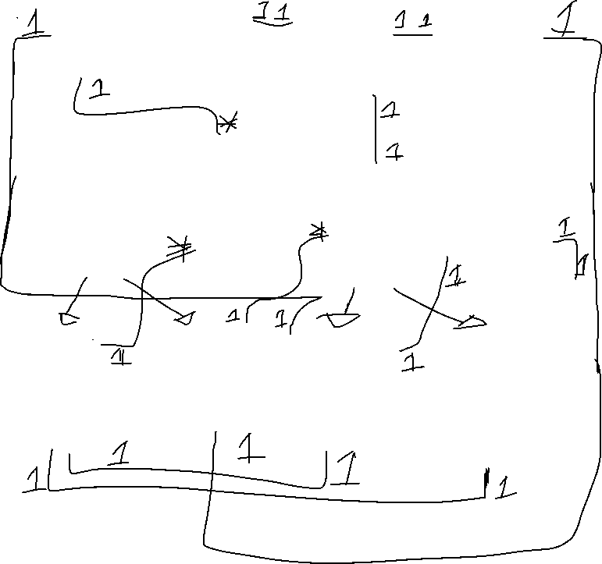

Class: UserDatabase

Purpose: Keep functions specific to accessing the User database. This is a subclass of Database.

Methods: User lookupUser(String name)

User lookupUser(int employeeID)

Data: [Inherited Data]

Class: ProductDatabase

Purpose: Keep functions specific to accessing the product database. This is a subclass of Database.

Methods: Product lookupItem(String name)

Product lookupItem(int productid)

Data: [Inherited Data]

Class: PaymentProcessor

Purpose: Handles transactions and processes Payments.

Methods: openNetwork()

boolean processPayment(int cardNumber, Image signature, float amount)

Data: NetworkManager networkManager

Class: NetworkManager

Purpose: Manage network

Methods: connect()

Data: int productId

Class: ReceiptPrinter

Purpose: Hold information as a buffer for a receipt, then print on-demand.

Methods: addItem(Product productIn) printReceipt() clearOrder()

Data: Product[] productsList

Class: SystemGUI

Purpose: Handle windows and gather general input and screen response.

Methods: int promptForInt() int promptWithMessage(String message) int readBarcode()

Data: [GUI elements]

User currentUser, BarcodeReader barcodeReader, Authenticator au

Class: Product

Purpose: Keep product information.

Methods: getters.. setters. mostly a data class.

Data: int productid

String name

all fields from use-case 2 and 3 for product

Class: User

Purpose: Contains information on the user of the system.

Methods: getters.. setters. mostly a data class.

Data: String username int userId String hashedPwd

Class: BarcodeReader

Purpose: Collect ProductID from barcode.

Methods: int read()

Data: int productId

Class: Database

Purpose: Includes all functionality with regards to general database functions.

Methods: Object query() Object getLastQuery()

Data: Object lastObject