The Complete Working Inventions of Robert Petrušić
Book II · PWS HexCell
Recycled-Polymer Block, Layered Mould and First 1 m² Wall Proof
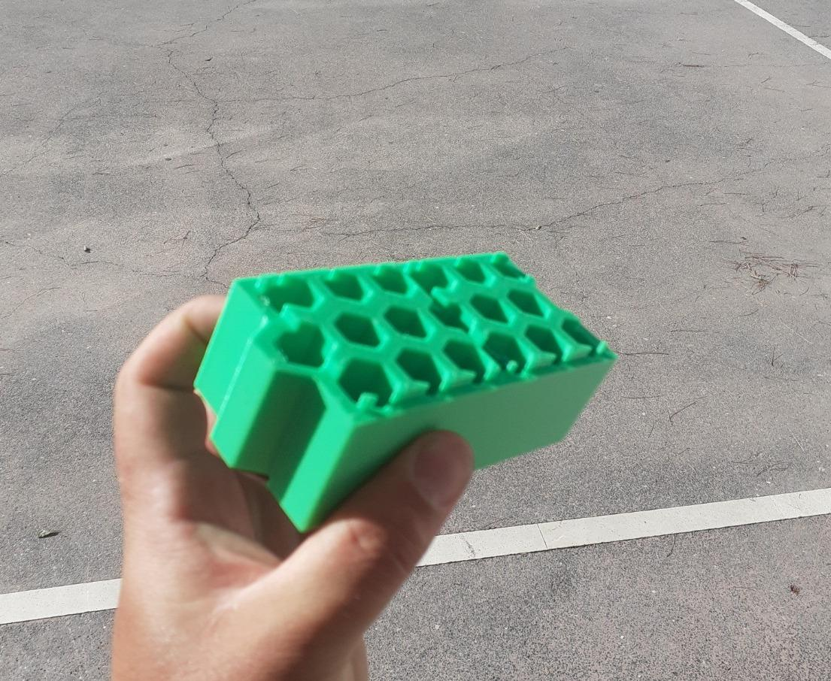
Author-work photograph of the physical green PWS HexCell print, recovered in the 2026 technical archive. It proves that this printed form exists at hand scale; it does not prove recycled-polymer composition, structural capacity or building suitability.
Inventor and originating author: Robert Petrušić · Ploče, Croatia
Definitive technical living edition · Working revision 0.1 · 4 August 2026
English technical reconstruction and document engineering: collaboration between the inventor and ChatGPT

Contents
Book division | Page
Purpose, dates and evidence standard | 3
Part I · Identity, evidence and development history | 4
Part II · Current block geometry and mechanical logic | 7
Part III · Layered mould and manufacturing cycle | 11
Part IV · Quality, traceability and local production | 21
Part V · First 1 m² wall proof | 26
Part VI · Physics, failure control, cost and boundaries | 32
Part VII · Development gates and current build package | 36
Appendices · dimensions, records, sources and inventor note | 41

PWS HexCell invention and subsystem register
Stable book ID | Invention or subsystem | Page
PWS-HC-V1 | Current simple full-sided HexCell block | 8
PWS-VOID-01 | Open vertical hexagonal void field | 9
PWS-LOC-01 | Two-cube course locator system | 10
PWS-COURSE-01 | Staggered dry-course assembly logic | 10
MOLD-REF-7 | Seven-core historical reference tool | 7
PWS-MOULD-01 | Layered laser-cut experimental mould | 11
PWS-CORE-01 | Individually removable hex core system | 18
PWS-WARM-01 | Warm breakaway and core-release process | 18
PWS-QC-10 | Ten-block repeatability proof | 23
PWS-TRACE-01 | Human-readable batch and revision record | 24
PWS-MICRO-01 | Local one-way microfactory cell | 25
PWS-WALL-1M | First non-occupied 1 m² wall proof | 26
PWS-SEAL-01 | Dry seal and limited pressure-zone test | 29
PWS-STEM-01 | Small educational construction branch | 40
PWS-FUTURE-01 | Later serviceable PWS envelope branch | 40

Purpose of this edition
This book reconstructs PWS HexCell as a physical object, a manufacturing experiment and a bounded wall test. It is not a catalog entry and not a promotional description of an unbuilt house. Every important mechanism is followed from feedstock identity through mould filling, warm core release, cooling, inspection, course assembly, wall testing and final disassembly. Unknown dimensions remain unknown; they are converted into explicit measurements or freeze decisions rather than filled with editorial precision.
The controlling design is intentionally plain: one rectangular block with full side faces, an open vertical field of hexagonal voids, two basic lower cubic locators with matching upper pockets, and staggered brick-like courses. Side hooks, decorative grooves, special corner blocks, vacuum electronics and several parallel block sizes are not part of V1. They may return only if a measured wall problem proves that the simple geometry cannot solve it.
Iteration record. Working revision 0.1 is the first English book consolidation, not the first attempt at the invention. PWS passed through many informal branches before the surviving technical record. The exact attempt count cannot be reconstructed honestly; the book therefore records the current correction and the surviving evidence instead of inventing a linear revision history.

Dates, authorship and source authority
Robert Petrušić is the originating inventor and the authority for geometry and purpose. The recovered dossier named ‘03 – PWS – Plastique Wall System’ was updated on 22 July 2026. The Croatian Atlas technical edition was assembled on 25 July 2026. Neither date is automatically the conception date. The original idea may predate the surviving file by months, as many of Robert's inventions did, but no exact earlier day is asserted without a dated drawing, photograph, file or publication.
Date or authority field | Meaning in this book
Approximate conception | Author recollection or honest range; never fabricated from a chat timestamp.
First surviving record | Earliest presently recoverable source that actually contains the idea; not necessarily the date of invention.
Latest controlling correction | Robert's newest explicit decision; it controls over older diagrams and editorial summaries.
Edition date | Date on which this English technical block was assembled; not a priority claim.
Editorial analysis | Organisation, calculations, risk analysis and English explanation; these do not transfer authorship of the invention.

Evidence language
The small green 3D print is built evidence of a form. The author photographs show its visible shape, hand scale, full side surfaces, vertical openings and locator features. They do not identify its polymer, measure its mass, prove a moulding process or establish building performance. The MOLD-REF-7 plate and layered-mould drawing are design evidence. The ten-block series, recycled-polymer block, metal mould and one-square-metre wall are proposed tests until physical records exist.
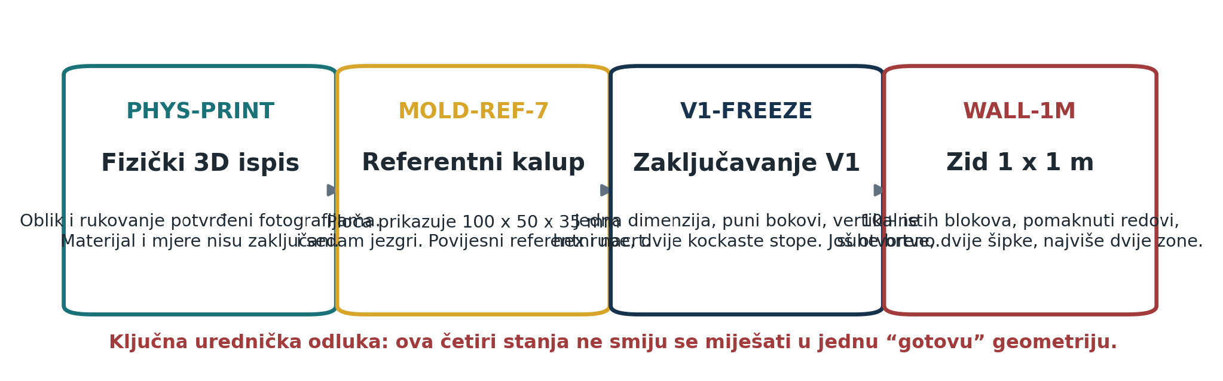
Approved four-state map separating PHYS-PRINT, the MOLD-REF-7 reference, the still-unfrozen V1 geometry and the first 1 m² wall proof. The Croatian labels are retained as part of the accepted source visual.

PART I · IDENTITY, EVIDENCE AND DEVELOPMENT HISTORY

1. Canonical identity and current definition
Field | Current record
Atlas ID | ATLAS-001
Canonical IDs | MAT-001 / BLD-04
Name | PWS HexCell
Inventor | Robert Petrušić
Field | Recycled materials, modular construction and educational construction systems
Current form | One rectangular full-sided block, open vertical hex voids, two basic lower locators, matching upper pockets and staggered courses
Highest physical evidence | Small green 3D print photographed in the inventor's hand
Next decisive evidence | Measured print, signed V1 freeze, three-core release coupon, then a small layered steel mould

PWS HexCell is the smallest honest production nucleus of the larger Plastique Wall System. Its full outer sides create a handleable block and protect the internal web field. The open vertical voids reduce material and provide visible internal paths. Two shallow lower forms locate the next course without pretending to be a structural snap-lock. Staggered rows provide the first lateral organisation. The V1 goal is not maximum insulation or maximum novelty; it is one repeatable block whose failures remain observable.

2. The problem the invention addresses
Conventional wall construction is often wet, permanent and destructive to service. Layers are bonded, rendered or closed so that a later cable, leak, damaged insulation layer or material-recovery operation requires breaking finished work. The wider PWS family asks whether a wall can behave more like a serviceable assembly: courses can be positioned dry, layers remain separately replaceable, internal routes stay inspectable and the material can return to a known stream after disassembly.
The second problem is material credibility. Local waste plastic may be abundant, but mixed waste is not automatically a building material. A useful system must turn one known, cleaned and documented polymer family into a traceable part, reveal contamination and incomplete fusion, preserve rejected samples and connect each block to its process history. HexCell deliberately makes these failures visible before an expensive monolithic tool or inhabited building hides them.

3. Present evidence and forbidden claims
Claim | Status | Evidence boundary
A small physical form exists | BUILT | Three author photographs of the green 3D print.
The print has full sides and open vertical voids | VISIBLE | Directly visible; dimensions and material are not established.
Lower positioning forms exist on the print | VISIBLE | Visible shape only; tolerance and cycling are unmeasured.
The layered steel mould exists | NOT BUILT | An approved technical plate and detailed proposal exist.
A declared recycled-polymer block exists | NOT PROVEN | No recovered full hot cycle using a known waste lot.
Ten same-revision blocks exist | NOT PROVEN | Defined development gate, not a result.
A 1 m² wall has been assembled | NOT PROVEN | Detailed test plan only.
The block is structural, fire safe or housing-ready | FORBIDDEN | No mechanical, fire, smoke, UV, creep, emission or regulatory evidence.

Current status. The physical print proves a form exists. Everything involving declared recycled feedstock, hot moulding, repeatable release, wall pressure, structural capacity, fire behaviour or construction compliance remains to be measured independently.

4. Development genealogy and controlling correction
PWS once carried multiple block sizes, side slots and hook-locks, special corners, vacuum cells, electronics, active façades and service equipment inside one expanding architecture. These branches remain valuable as future systems, but they made it difficult to identify the first physical proof. Robert's controlling correction was subtraction: one block, one principal dimension, one mould and one wall experiment. A feature returns only when a measured deficiency gives it a job.
Earlier branch | Why it appeared | Current V1 decision
Side slots and hook-locks | Additional lateral locking | Removed: they add undercuts, weak edges and tool variants before the wall proves a need.
Special corner blocks | Finish every corner with a product | Deferred: first test staggered courses and simple cut/end restraint.
Several sizes / Hex150 / Duo+ | Scaling and specialised uses | Archive branch: V1 freezes one main size.
Vacuum and electronics | Advanced insulation and diagnosis | Outside V1: only after a repeatable block and dry wall.
Full side faces | Handling, stiffness and a block-like surface | Retained.
Vertical hex voids | Lower mass, directional webs and visible paths | Retained.
Two locators and staggered rows | Course positioning with minimal parts | Retained as positioning logic, not certified structure.

5. What the physical print proves
The green print establishes the tactile proposition that a cellular part can still feel like a solid block. Its side faces are continuous rather than an exposed honeycomb mesh. The upper view shows a multi-row field of openings. The side and oblique photographs show a light hand-held object and small lower positioning forms. The print therefore justifies measurement and a moulding experiment; it does not justify copying dimensions from a separate seven-core diagram.
The first high-value action is measurement, not a new render. The existing object should be weighed and recorded in six orthogonal views with a scale. Length, width, height, void count and pattern, minimum web, side-wall thickness, locator position and upper-pocket geometry should be recovered. That single record would resolve more uncertainty than another unmeasured CAD branch.
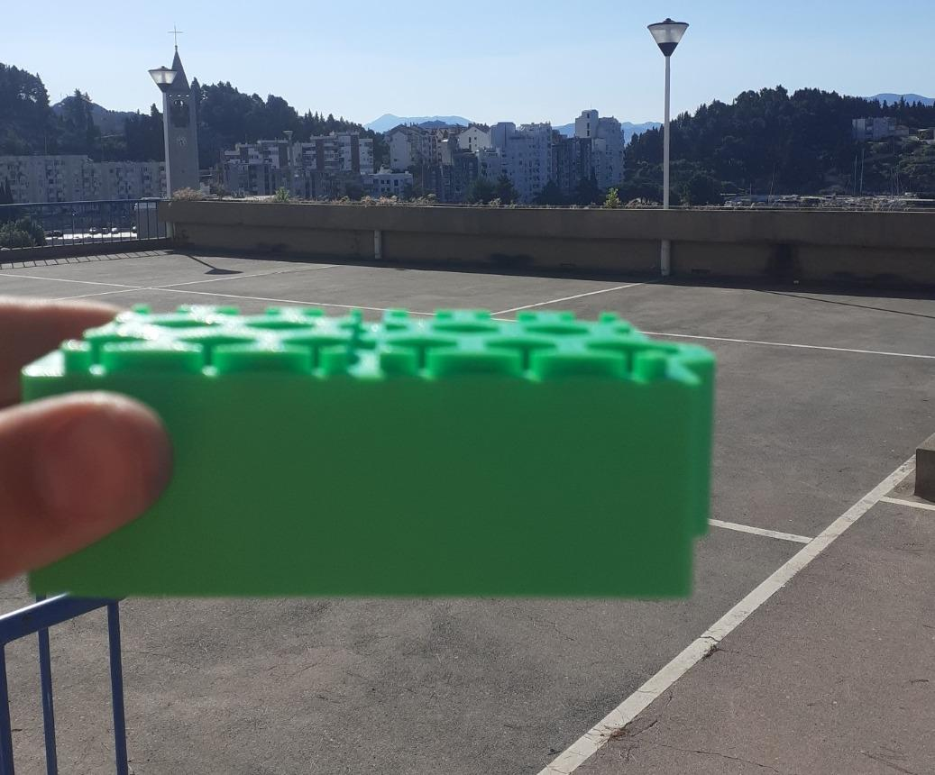
Author-work side photograph of the physical print. The full side face provides the intended block-like handling surface; the photograph is not a dimensional drawing or material certificate.

PART II · CURRENT BLOCK GEOMETRY AND MECHANICAL LOGIC

6. Three geometry states that must not be merged
The archive contains a physical multi-row print, a seven-core reference plate and an unfrozen future V1. Their similarities do not make them one geometry. PHYS-PRINT records what can be seen on the green object. MOLD-REF-7 records a compact 100 × 50 × 35 mm reference body with seven cores in one row and is useful for tool reasoning. V1-FREEZE is the geometry that will eventually control CAD, DXF, mould, inspection and the ten-block lot. Only a signed freeze sheet can turn the first two states into a production decision.
State | Purpose | Permitted claim
PHYS-PRINT | Existing green 3D print | A full-sided cellular form exists; exact dimensions, material and strength remain unknown.
MOLD-REF-7 | Historical reference coupon/tool plate | Reference body 100 × 50 × 35 mm, seven cores, about 13 mm across flats and two feet around 8–9 mm high.
V1-FREEZE | Still-to-be-signed production geometry | One selected size, void pattern, walls, locators, pockets, radii, tolerances, mark and revision.
WALL-1M | First system proof | A separate non-occupied wall test after repeatable blocks exist.

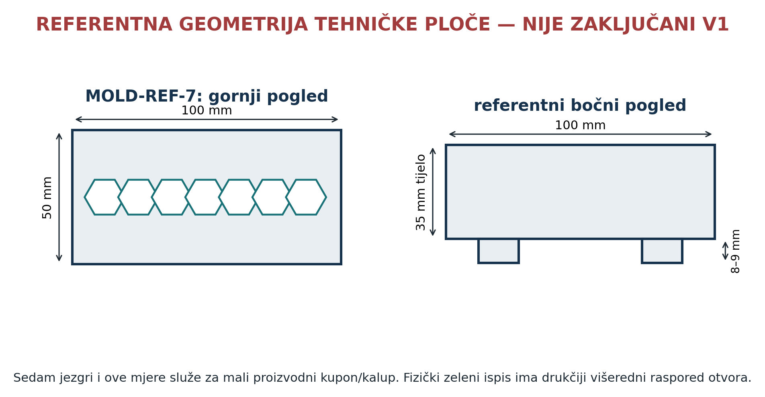
Approved MOLD-REF-7 geometry plate. Its red heading correctly warns that the 100 × 50 × 35 mm seven-core arrangement is a reference, not the locked V1.

7. Locked functional architecture of V1
Although numerical dimensions remain open, the functional architecture is sufficiently constrained. The body is rectangular so it can be held, gauged and supported on simple flat references. Side faces remain full and free of undercuts. The hex field stays open from top to bottom. Two lower cubic or simple rectangular forms locate the course below; matching pockets remain visible and cleanable. Rows overlap like masonry so one vertical joint does not continue through the wall. A durable revision and orientation mark connects the part to material and mould records.
Component | Function | V1 rule | First proof
Full-sided body | Handling surface and protection of the internal webs | No side hooks or decorative undercuts | Edge inspection, drop, side squeeze and fracture map
Vertical hex field | Reduce volume, form multi-directional webs and create inspection paths | Open both ends; one frozen pattern | Probe every void, measure webs and section a sacrificial part
Two lower locators | Repeat course position | Shallow lead-in; no snap lock | Seating force, rocking, dust and ten cycles
Matching upper pockets | Receive the locators | Visible, cleanable and not a water trap | Gauge and fit across temperature cycles
Staggered courses | Interrupt aligned joints and organise the wall | Brick-like overlap before special corners | Six-block corner and short dry wall
Revision mark | Trace geometry and material | Readable without a network | Abrasion, cleaning and blind trace

8. Full side faces and load distribution
A full side face gives the hand, seal, guide or removable panel a continuous contact surface. It also distributes a local touch across several internal webs instead of exposing every cellular edge. That does not make the block structural. A thin side face can oil-can, crack over a void or peel from poorly fused material. Side thickness must therefore be frozen together with web thickness, corner radius, feedstock and cooling support—not selected from appearance alone.
The side face also controls manufacturing. A very thick face raises mass, cooling time and differential shrinkage. A very thin face fills poorly and can burn or tear during core release. The first tool should keep the outer surface simple enough that flash, cold joints and warpage can be photographed and measured without cosmetic texture. Handles, façade anchors and service clips belong to later independent interfaces, not to the V1 mould.

9. The open vertical hexagonal void field
A regular hexagonal opening is not universally stronger than a circle or rectangle. Its value here is a repeatable tessellation that creates webs in several directions and leaves the interior visually inspectable. The field may reduce mass, provide drainage or future service paths and let the block be illuminated from one end during inspection. Performance still depends on minimum web, side-wall thickness, void-to-edge distance, material fusion, root radii and the direction of load.
Open channels have liabilities. Dirt may bridge a pocket, water may remain if the base detail blocks drainage, and a narrow web can appear complete while containing a cold joint. Every final opening must accept a simple straightness probe. The V1 layout should avoid blind cross passages, trapped inserts and undercuts so that a failed block can be sectioned and its formation understood.

10. Course locators and staggered rows
The two lower forms are locators, not load-bearing studs. They help a block find a repeated position while the base, overlapping courses and any controlled vertical compression perform the larger assembly work. A tight interference fit would be hazardous because recycled polymers shrink, expand with temperature and collect dust. An excessively loose fit creates apparent alignment while the course can still slide. The correct clearance must be derived from measured production spread and assembly tests.
Each locator needs a robust lead-in without a fragile thin lip. The receiving pocket must be inspectable and should provide a route for dust or cleaning. A damaged locator is recorded and quarantined rather than carved by eye in the wall. If production requires several locator sizes, heating or hand filing to assemble one revision, V1 has failed its simplicity criterion.

11. Reference geometry calculations for MOLD-REF-7
The following calculations describe only the historical 100 × 50 × 35 mm reference body with seven regular hexagonal openings measuring approximately 13 mm across flats. Feet, pockets, radii, process porosity and shrinkage are excluded. They are screening calculations that explain scale and core contact; they are not measured properties of the green print or frozen V1.
Quantity | Relation | Reference result
Gross body volume | 100 × 50 × 35 mm | 175.00 cm³
Regular-hex side | 13 / √3 | 7.51 mm
One void area | (√3 / 2) × 13² | 146.36 mm²
Seven voids through 35 mm | 7 × area × 35 | 35.86 cm³
Remaining body volume | gross − voids | 139.14 cm³
Geometric volume reduction | voids / gross | 20.5%
Mass scenario at 0.90 g/cm³ | remaining volume × density | 125 g
Mass scenario at 0.96 g/cm³ | remaining volume × density | 134 g
Polymer–core contact area | 7 × hex perimeter × 35 mm | 0.0110 m²

Calculation limit. The mass values exclude the lower locators and upper pockets. Actual density depends on the selected polymer, fillers, contamination, porosity and thermal history. The estimated 0.011 m² of polymer–core contact explains why cooling shrinkage can lock several cores even in a small tool; extraction force still requires measurement.

12. Decisions deliberately left unfrozen
Final length, width, height, void pattern, across-flat dimension, minimum web, side thickness, edge distance, locator size, pocket clearance, radii, mark location and dimensional datums remain open. The material for the first hot test is also open. These are not signs that the invention lacks definition. They are the exact variables that connect geometry to a mould and a repeatable test, and they should be frozen only after the physical print is measured and the three-core coupon exposes release behaviour.
Decision | Why it remains open | Evidence that closes it
PHYS-PRINT as dimensional basis or only tactile proof | No recovered measurements | Six-view measurement record and author sign-off
Seven cores, multi-row field or two-stage route | Reference plate and physical print disagree | Three-core coupon plus selected V1 layout
Exact locator form | Visible print lacks controlled tolerance data | Measured pair, dust cycles and thermal fit
First polymer family | Archive does not freeze PP, PE or another stream | Known local lot, identification and safe processing assessment
Wall end and corner detail | Premature special parts would branch the mould | Short staggered wall and bounded edge restraint

PART III · LAYERED MOULD AND MANUFACTURING CYCLE

13. The layered experimental mould
The first useful hot tool is deliberately modular. Its cavity is assembled from flat, laser-cut steel layers rather than machined as one irreversible block. The lower package establishes the base and the core positions. Two side packages close the rectangular body. The upper package guides the long hexagonal cores and spreads clamp load. Individual cores pass through the cavity and are withdrawn separately. Alignment keys define the geometry; bolts supply compression. This separation allows one damaged or poorly dimensioned plate to be replaced without discarding the complete tool.
A layered tool is not automatically cheap or accurate. Burrs, plate flatness, accumulated thickness error and thermal distortion can create a stepped cavity or a leak path at every interface. The concept becomes credible only when every layer has a stable ID, material, thickness, orientation, datum and inspection result. The DXF package must be treated as controlled manufacturing data, not as a collection of similar-looking silhouettes.
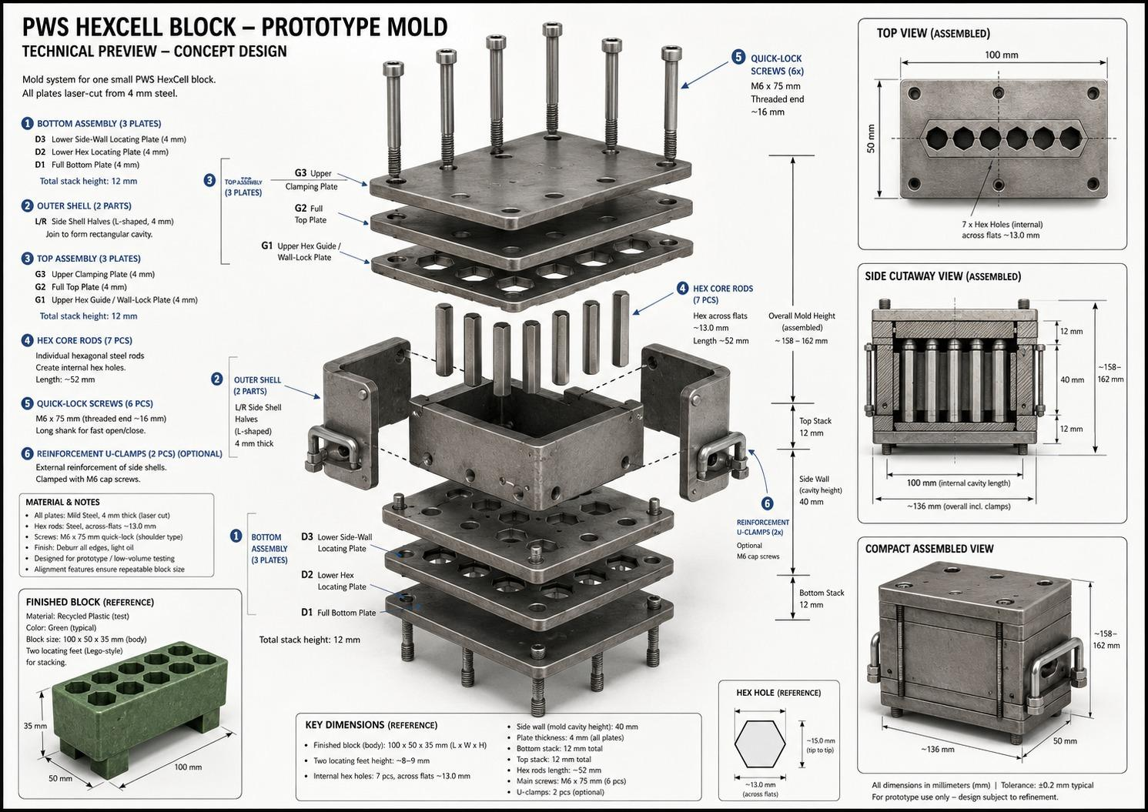
Approved exploded technical plate for the proposed layered PWS HexCell mould. It is design evidence, not a photograph of a completed steel tool.
Package | Primary elements | Mechanical duty | Inspection before assembly
Bottom | D1 full base; D2 core locator; D3 side registration | Support fill, locate core tails and register side halves | Flatness, hole pattern, burr direction and locator fit
Left / right | Stacked side profiles L and R | Create full side faces and resist cavity pressure | Matched height, clean edges and no inward steps
Top | G1 core guide; G2 full top; G3 clamp plate | Guide cores, close the fill and spread clamp load | Core clearance, vent route and plate bow
Cores | Separate polished hexagonal bars or fabricated inserts | Create open vertical voids and transmit shrink contact | Across-flats size, straightness, end finish and surface condition
Alignment | Dedicated dowels or keys | Return layers to one repeatable geometry | Slip fit without bolt force and no visible rocking
Clamping | Six reference M6 × 75 bolts in MOLD-REF-7 | Hold closed layers together | Thread condition, washer bearing and even engagement

14. Tool elements, datums and load paths
The mould needs one declared primary datum system. A practical experimental choice is the upper face of the full base plate as datum A, one long external edge or precision key line as datum B and one end face as datum C. Every cavity layer, core guide and inspection drawing then refers back to A–B–C. Without that convention, each plate can be individually within tolerance while the stack produces a curved cavity or misaligned cores.
Clamp load should travel through broad steel contact, not through a thin cavity web or a protruding core. Washers and a stiff upper plate distribute bolt force. Alignment keys take in-plane shear during assembly but should not be asked to resist all thermal pressure. The cores require positive axial control so they cannot float upward during filling, yet the retention method must release without bending the hot part. A separate mechanical stop or guide plate is preferable to improvised hammering against core ends.
Load or motion | Intended path | Failure if path is wrong
Bolt preload | Bolt → washer → clamp plate → full plate stack → base | Local bow, open seams and variable block height
Cavity pressure | Polymer → side layers → keyed plate stack → bolts/base | Flash, layer separation or permanent side distortion
Core shrink contact | Polymer → polished core → guide/retainer | Bent core, torn web or uncontrolled hot part motion
Demould pull | Individual core pull along its own axis | Compound extraction load and fracture if all cores are tied together
Handling | Lift points on cold tool frame or full plates | Burn, pinch or misalignment when lifted by a core or bolt

15. Alignment is not clamping
A bolt through an oversized clearance hole can pull two plates together but cannot repeat their lateral position accurately. If the bolts are also used as locating pins, tightening order changes the cavity, the cores bind and the measured block width becomes an assembly artifact. Dedicated dowels, keys or two deliberately close-fitting reference holes should establish position before any clamp force is applied. The remaining bolt holes should retain enough clearance for thermal movement and straightforward assembly.
The cold proof is successful when a technician can assemble the complete dry stack by hand, insert every core without driving it, tighten the bolts in a written sequence, reopen the tool and reassemble it to the same gauge readings. Witness marks must show the orientation of every asymmetric layer. A layer that can be installed upside down and still appear plausible is a design error; it needs an unmistakable key, mark or geometry change.
Acceptance boundary. No polymer enters the mould until the cold stack closes without force, all cores pass through their guides, the cavity can be probed end to end, and three complete assembly–disassembly cycles return the same reference dimensions.

16. Tool progression: mock-up, three-core coupon, full small mould
The tool programme is split into three steps because the main unknown is release, not the artistic completeness of a full block. Stage A is a cold plate-stack mock-up made from inexpensive sheet or the intended steel without heating. It verifies filenames, layer order, keys, bolt access, cavity continuity and core straightness. Stage B is a narrow three-core coupon. It exposes fill, venting, shrink lock and warm extraction with a much smaller material charge and lower stored heat. Stage C is the complete small block tool only after Stage B has produced repeatable records.
Stage | Built object | Question answered | Exit criterion
A · cold geometry | Complete dry stack, no hot polymer | Can the tool assemble, align and reopen repeatably? | Three clean cycles; gauge readings within the provisional stack tolerance
B · three-core coupon | Short cavity with three representative cores | Can the selected material fill, vent and release without tearing? | At least five logged coupons with bounded extraction behaviour and interpretable defects
C · full small tool | One complete same-revision block cavity | Does the method scale to all cores and full side faces? | Ten-block lot with traceable process and dimensional results

A failed coupon is useful if its failure is preserved. The part, material label, core order, temperature readings, elapsed times and photographs remain together. The next run changes one principal variable. Changing feedstock, fill mass, heat history, lubricant, core finish and release timing simultaneously would produce another object but not knowledge.

17. Feedstock identity and the first material boundary
The first hot trials must use one known polymer family from one documented lot. ‘Recycled plastic’ is not a material specification. Polymer identity, source, colour, previous use, visible contamination, washing method, drying method, particle-size range and retained sample belong to the batch record. Where identification is uncertain, the material is quarantined or tested before heating. Unknown mixtures and possible PVC contamination are stop conditions because incompatible polymers can separate, degrade or release hazardous products.
The archive does not freeze polypropylene, polyethylene or another polymer for V1, so this book does not invent a processing temperature. A competent material-specific assessment must establish the safe temperature window, ventilation, residence time and degradation indicators for the selected lot. The equipment setting is not the part temperature. At least two independent measurements—such as controlled hot-plate temperature and a protected tool or material probe—are required before temperature is used as a comparison variable.
Batch field | Required entry | Reason
Batch ID | Unique human-readable code | Connects every specimen and reject to one lot
Declared polymer | Known family and identification method | Prevents a mixed-waste assumption
Source | Supplier, collection stream or previous product | Provides contamination context
Preparation | Sort, wash, rinse, dry and shred record | Explains moisture and debris
Particle range | Screen or measured minimum/maximum | Controls packing and heating repeatability
Retained sample | Sealed labelled reference portion | Permits later comparison or analysis
Disposition | Released, research only or quarantined | Stops accidental reuse of uncertain material

18. Sorting, washing, drying and size preparation
Sorting starts before washing. Foreign metal, glass, wood, paper, elastomer, multilayer film, batteries, electronic parts and any container with an unknown hazardous history are removed. The purpose is not cosmetic purity but a controlled feed stream. Washing removes surface dirt and soluble residues using a documented method appropriate to the known polymer and previous service. Rinsing continues until the chosen cleanliness check is met; visual clarity alone is not sufficient where the source carried oils or chemicals.
Drying is verified by a repeatable method suitable for the polymer rather than by touch. Moisture can create steam, bubbles, incomplete fusion and dangerous ejection from a hot open tool. Prepared material is stored closed and labelled so it cannot reabsorb water or be confused with an untreated lot. Shredded particles are screened into a declared range. Very large pieces bridge narrow webs; excessive fines heat differently, escape through seams and increase contamination exposure.
Preparation checkpoint | Record | Stop condition
Incoming inspection | Source, appearance, odour and prohibited objects | Unknown chemical container, battery, PVC suspicion or uncontrolled mix
After washing | Method, detergent if any, rinse result and dry mass | Persistent residue, unknown odour or unremovable contamination
After drying | Time, controlled environment and verification method | Condensation, inconsistent mass or wet storage
After shredding | Screen range, fines fraction and equipment clean-down | Metal fragments, mixed colour from prior batch or uncontrolled dust
Before release | Label, retained sample and operator sign-off | Missing identity or preparation record

19. Hot-work cell and operator protection
Hot polymer work requires a bounded, ventilated area with a stable non-combustible bench, temperature-controlled equipment, guarded hot surfaces, suitable gloves, eye and face protection, clothing that does not melt against the skin, and a clear path away from the tool. Local fire controls and emergency arrangements must be selected for the actual equipment and material by a competent person. The operator never leans over a filled cavity, tests softness with bare skin or uses water on an unknown hot system.
The mould contains pinch points and stores heat after the visible polymer surface has cooled. A simple status marker—COLD, HEATING, HOT / DO NOT TOUCH, WARM RELEASE and SAFE TO HANDLE—prevents a second person from treating the tool as cold scrap. One person directs the cycle. A second trained person may observe and record, but nobody reaches into the closure zone while a bolt, clamp or press can move.
No recipe without a material. This edition intentionally omits a universal melt temperature and heating time. Publishing one number for an unidentified waste stream would create false precision and unsafe practice. The controlled material lot and its verified processing window must come first.

20. One complete manufacturing cycle
The cycle begins with records, not heat. The operator opens a numbered run sheet, confirms the current drawing revision, identifies the tool and core set, records the batch ID and verifies that measuring instruments are in service. The clean cold mould is inspected for damage, residue, burrs, blocked vents and loose keys. Each core is checked for straightness and surface damage. Any approved release treatment is identified and applied by a repeatable minimal method; an unnamed workshop oil is not acceptable process data.
The lower package, side halves and cores are assembled against the declared datums. Bolts are brought to contact and tightened in the same crossed sequence. Empty cavity access and vent routes are verified. A weighed charge is prepared, with unused material kept separate. Heating and filling follow the material-specific trial plan. The operator records time, set temperature, measured tool/material temperatures, visible fusion, vent behaviour, additions, compaction actions and any smoke, odour or colour change.
At the planned warm-release condition the clamp is reduced in a controlled order, side breakaway is initiated and cores are extracted individually while their order, force proxy, elapsed time and damage are recorded. The part remains supported flat during cooling. Only at the defined handling condition is it moved to the inspection station. Tool residue and every reject are labelled before the next batch enters the cell.
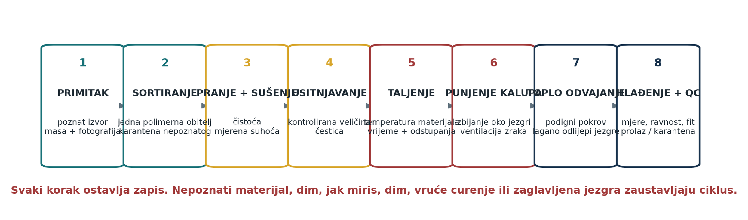
Approved process map for one traceable PWS HexCell manufacturing cycle. Each arrow represents a recorded state change rather than an assumed continuous craft operation.
Cycle phase | Recorded state | Primary decision
Release | Revision, tool/core IDs, material lot and instrument check | Is this run authorised to begin?
Cold assembly | Layer order, keys, core fit, closure gap | Can the tool close without force or ambiguity?
Charge | Target and actual mass; particle range | Is the cavity charge comparable with prior runs?
Heat / fill | Time, measured temperatures, additions, venting and visible condition | Continue, hold or stop for degradation / unsafe behaviour
Warm release | Release state, core sequence, force proxy and defects | Has shrink lock been interrupted without tearing the part?
Cooling | Support, time and handling condition | Can the part be moved without distortion?
Inspection | Dimensions, mass, voids, locators, defects and disposition | Pass, research-only, regrind or quarantine

21. Filling, venting and compaction
A full-sided block with narrow internal webs can trap air even when the top appears full. The fill method must therefore make flow paths and vents observable. The first coupon should use a simple, repeatable charge distribution rather than random handfuls. Material is weighed, divided into planned additions and placed so that one region does not complete long before another. If external pressure or tamping is used, the tool, operator barrier and load path must be designed for it; improvised impact on a hot open cavity is excluded.
Vent routes belong at the last-to-fill regions identified by the coupon, but a vent must not become an uncontrolled flash knife or spray path. The operator records the first appearance of material, gas or moisture at each vent. A blocked vent, unexpected vapour pulse, sharp degradation odour, darkening material or visible separation ends the run. More heat is not the default repair for incomplete fusion; charge distribution, moisture, particle range, venting, surface temperature and pressure are considered separately.
Observed defect | Possible mechanism | Next controlled check
Unfilled web or corner | Bridging, cold region, trapped gas or insufficient charge | Map location; verify charge distribution and temperature at that zone
Large bubbles | Moisture, entrained air or degradation gas | Stop; verify drying and safe processing window
Layer-line flash | Open seam, burr, plate bow or excessive pressure | Cold-check stack and clamp distribution
Dark / brittle patch | Overheating, long residence or contamination | Quarantine batch and inspect temperature history
Core-to-core variation | Uneven heat, finish, geometry or extraction timing | Record cores individually; do not average the result away

22. Warm breakaway and individual core release
Core release is the central mechanical experiment. As the polymer cools, it contracts against the long core surfaces. If the tool remains fully closed until the part is cold, shrink pressure and friction may lock several cores together. Pulling the complete core set at once adds the forces and can tear internal webs. The proposed process interrupts that lock while the material is strong enough to retain shape but still warm enough to relax locally.
The side packages are first unloaded according to a defined safe sequence so the body can relieve slightly. Cores are then extracted one at a time along their axes. The same core order is used until a deliberate order experiment is run. Each extraction is classified with a calibrated force gauge when available; until then a declared proxy such as pull-tool reading, standardized tap count or lever displacement is recorded. ‘Easy’ and ‘hard’ are insufficient unless the operator scale is defined before the run.
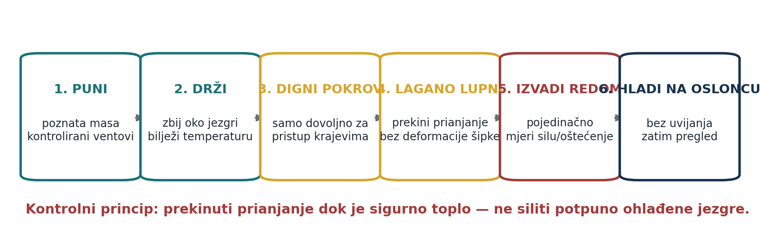
Approved warm-breakaway concept: release the side constraint and withdraw individual cores before cooling shrinkage creates a combined lock. The sequence remains a proposal until instrumented coupons are completed.
Release variable | Record per core | Why it matters
Core ID and position | A1, A2, A3… with diagram orientation | Separates geometry and temperature position effects
Release time | Elapsed time from heating stop / tool opening | Connects extraction to cooling state
Temperature | Defined surface/tool reading and instrument | Makes ‘warm’ reproducible
Force or proxy | Peak force, standardized tap count or other predeclared scale | Reveals shrink-lock growth and surface damage
Motion quality | Clean, stick–slip, rotation, bending or seizure | Distinguishes friction from alignment failure
Damage | Core scoring, web tear, whitening, deformation or residue | Shows whether apparent release consumed part life

23. The three-core extraction experiment
The coupon contains an edge core, a centre core and a second edge or otherwise thermally distinct core. Its outer wall and minimum web should represent the intended V1 difficulty rather than an unrealistically thick test bar. Thermocouples or protected contact measurements are placed so they do not create a new release mechanism. The coupon has enough length to show axial friction but remains small enough to stop safely and section after a failed run.
A baseline series holds geometry, material lot, charge, core finish and heating method constant while varying only release state. A second series may compare an approved surface finish or release treatment, but only after the untreated baseline is understood. At least five interpretable coupons at one condition are needed before a trend is called repeatable. All coupons, including visibly failed ones, receive IDs and dispositions.
Run family | Controlled variable | Minimum useful observation
C0 · cold assembly | No polymer | Core insertion/removal, alignment and gauge repeatability
C1 · early warm | Release earlier in cooling | Whether shape collapses or webs smear
C2 · mid warm | Intermediate state | Whether cores release with bounded force and intact webs
C3 · late warm | Later cooling | Onset and rate of shrink lock
C4 · surface comparison | One defined core finish or release system | Measured change without material or geometry change

24. Cooling, part support and demould handling
A newly released block can be geometrically complete and still be unstable. Unequal cooling between thick side faces, thin webs and locator forms can bow the body or twist the seating planes. The part is placed on a flat, clean support that does not block necessary cooling paths or imprint a soft surface. The support method, orientation, contact material, cooling time and room conditions are recorded. Fans, water, clamping weights or forced straightening are not added silently.
The earliest handling time is defined by a repeatable condition, not by impatience. If the block deforms under its own mass or a light prescribed gauge, it remains supported. A warped part is not reheated and pressed flat before inspection, because that would erase evidence about the tool and cycle. After as-moulded measurements and photographs, a separate labelled research experiment may examine correction or annealing.

25. Tool cleaning, service and lifecycle record
After every cycle the tool cools to the declared safe-cleaning state. Polymer residue is removed with methods that do not round core corners, scratch sealing faces or leave an unidentified coating. Every plate and core is inspected under consistent light. Damage is mapped by component ID. A core that was polished or reworked receives a new service entry because its friction condition may have changed even if its nominal across-flats measurement did not.
Service item | Routine check | Escalation threshold
Layer faces | Residue, burr, corrosion, bow and witness-mark clarity | Any step into cavity, open seam or lost orientation mark
Cores | Across flats, straightness, scoring, end damage and residue | Out-of-limit size, bending, seizure mark or chipped corner
Keys / dowels | Free insertion and visible wear | Rocking stack, forced fit or changed gauge result
Bolts / washers | Thread, bearing surface and equal engagement | Galling, stretched thread, cracked washer or uneven clamp
Vents | Clear passage and stable geometry | Blocked route or enlarged flash path
Tool record | Cycle count, event and disposition | Missing history or unapproved repair

PART IV · QUALITY, TRACEABILITY AND LOCAL PRODUCTION

26. Block inspection: identity before performance
Inspection begins before a dimension is taken. The part ID, geometry revision, mould/core set, material batch, run number, operator, date and disposition must agree with the cycle record. An attractive object without that chain is an anonymous sample, not evidence for repeatability. The as-moulded block is photographed from six orthogonal directions and at least one oblique direction beside a scale and identity card before trimming, sanding, reheating or fitting.
The first inspection is deliberately non-destructive. Mass is recorded on a verified balance. Overall length, width and height are measured at declared locations. Seating faces are checked on a reference plane for rock, bow and twist. Every void is illuminated and passed with a straightness probe. Minimum visible web, side faces, corners, locator forms, pockets, flash, cold joints, bubbles, inclusions, sink, scorch and release damage are mapped. A passing appearance cannot override a blocked void or missing identity.
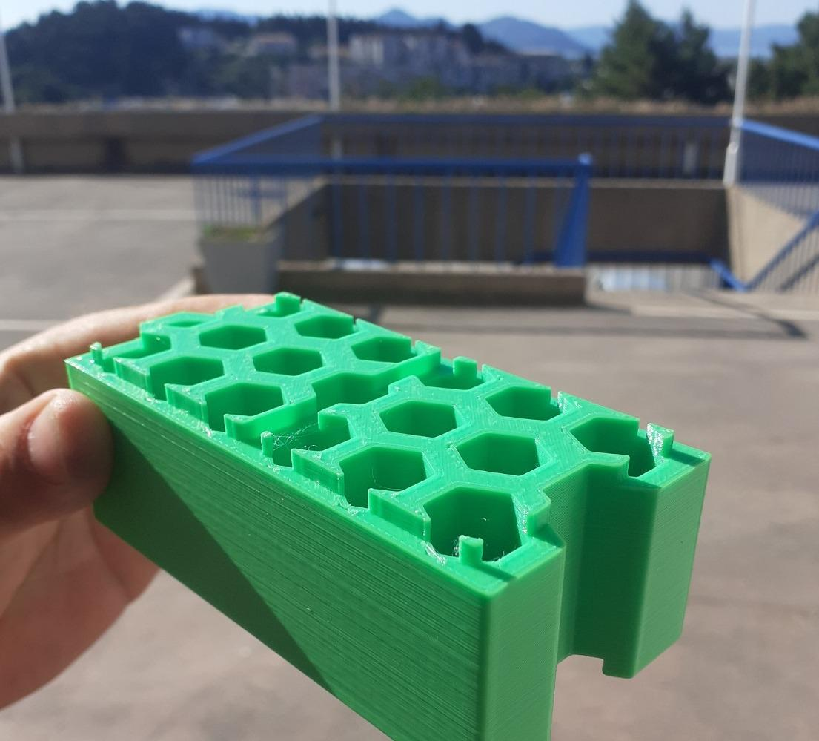
Close author-work photograph of the existing print. It illustrates the kind of visible geometry that must be measured and mapped; it is not a substitute for a controlled inspection record.
Inspection family | Method | Recorded result
Identity | Cross-check mark and run sheet | Block, revision, batch, tool/core set and run
Mass | Verified balance | As-moulded mass and trimmed mass, never conflated
Envelope | Caliper, height gauge or fixture at declared points | Length, width, height and range
Flatness / twist | Reference plane and feeler/gauge method | Maximum gap and corner-rock pattern
Void field | Light, probe and selected measurements | Open/blocked status, straightness, across flats and web observations
Locators / pockets | Gauge and known mating block | Position, lead-in, clearance, seat and damage
Surface defects | Consistent light and defect map | Flash, voids, scorch, contamination, cold joints and tears
Disposition | Predeclared criteria | Pass, research-only, regrind or quarantine

27. Ten-block same-revision repeatability proof
One good block shows possibility. Ten consecutive blocks from the same geometry revision and declared material lot begin to show process stability. The lot is not cherry-picked. Every started cycle receives a run number, including aborts and obvious failures. If the tool is repaired, a material lot is changed or a core finish is altered, the intervention is recorded and the sequence may become a new lot rather than silently continuing the old one.
The ten-block proof asks four questions. Can the tool cycle without accumulating damage? Can the block remain within provisional mass and dimensional bands? Can the locators assemble repeatedly without hand correction? Do defects and extraction forces stay bounded instead of drifting with tool temperature or residue? Statistical claims are premature with ten parts, but the raw sequence, range, median and run-order plot can reveal drift and special causes.
Proof item | Lot rule | Failure signal
Completeness | All ten starts and aborts are retained in the log | Missing or discarded run
Identity | One frozen CAD/DXF revision and one declared material lot | Unrecorded geometry, feedstock or tool change
Mass / envelope | Same methods and locations for every block | Trend, step change or unexplained outlier
Core release | Each core remains separately recorded | Rising force, repeated seizure or position-specific tearing
Assembly | At least two standard neighbours and ten seat/unseat cycles | Filing, heating, fracture, excessive rocking or retained deformation
Tool state | Cold inspection before and service record after each run | Progressive flash, bow, scoring or alignment loss

Minimum proof. The first credible process milestone is not ‘a block came out’. It is a complete ten-start sequence whose successful and failed parts, tool interventions and measurements can all be reconstructed.

28. Human-readable marking and traceability
The first trace system remains readable without a phone, cloud account or proprietary database. A moulded or permanently applied revision mark identifies the geometry. A compact batch/run code identifies the material and cycle. The external log expands that code into dates, source, tool components and measurements. A later QR or digital passport may duplicate the record, but it cannot be the only route to identity on an experimental part.
Marking must not create a thin crack starter, trap water or occupy a locator/gauge surface. The mark location and minimum legibility are frozen in the drawing. If hot marking, engraving, label adhesive or ink is used, its effect on the selected polymer and recycling route is evaluated separately. A part with an unreadable mark can remain a research specimen but cannot enter the wall proof as a traceable pass block.
Code element | Example structure | Meaning
System | PWS-HC | PWS HexCell family
Geometry revision | V1-R00 | Frozen block drawing revision
Material batch | B260804-A | Declared prepared feedstock lot
Run | R01…R10 | Individual started cycle
Block | PWS-HC-V1-R00-B260804-A-R03 | Complete human-readable specimen identity

29. Defect disposition, rework and regrind
Disposition preserves the meaning of evidence. PASS means the block meets the current experimental acceptance criteria and may enter the next declared test. RESEARCH ONLY means it remains useful for sectioning, handling or a bounded comparison but cannot be counted as a conforming wall component. REGRIND means the material may re-enter a controlled stream only after the effect of additional thermal history and contamination risk is addressed. QUARANTINE means identity or safety is uncertain and the material cannot return to production.
Rework is not invisible correction. Removing flash may be allowed if the drawing defines a non-functional trim line and both as-moulded and final masses are recorded. Filing a locator, drilling a blocked void, heating a warped face or gluing a crack changes the specimen and disqualifies it from the as-produced repeatability lot. Such operations may form a separate labelled repair study.
Observed condition | Default disposition | Allowed next use
Complete, traceable and within provisional criteria | PASS | Assembly cycling and wall proof after lot review
Traceable cosmetic defect outside gauge surfaces | RESEARCH ONLY unless criterion explicitly permits | Surface study or non-counted demonstration
Blocked void, torn web, major warp or modified locator | RESEARCH ONLY | Sectioning and root-cause investigation
Known compatible clean offcut / reject | REGRIND candidate | Controlled reprocessing study with thermal-history record
Unknown batch, suspect PVC, foreign object or degradation | QUARANTINE | Competent identification or safe disposal route

30. The local one-way microfactory cell
The first production cell is arranged so dirty incoming material cannot cross back into clean prepared feedstock or finished inspection. The sequence is receipt and quarantine, sorting, washing, drying, shredding/screening, closed prepared storage, weighed charge, hot tool, warm release, flat cooling, inspection, disposition and records. Regrind returns through a separately controlled route. Airflow, drainage, dust collection, noise and hot-work controls must fit the local equipment and regulations.
A small cell succeeds by discipline rather than throughput. Each location has a clear status, container ID and clean-down boundary. Tools that contact unknown incoming waste do not touch dried feedstock. The hot-work zone cannot be a general storage surface. Inspection remains physically downstream so a rejected block cannot be mistaken for a released block. A simple board showing the active geometry revision, batch and run prevents parallel undocumented experiments.
Zone | Permitted material state | Separation rule
Receipt / quarantine | Unknown or unverified incoming objects | No contact with clean tools or prepared storage
Wet preparation | Sorted wash stream | Drainage and residues remain outside the dry zone
Dry preparation | Verified dry material and controlled shred | Closed labelled containers; dust capture and equipment clean-down
Hot work | One released batch and weighed charge | Bounded access, ventilation and no unrelated storage
Cooling | Hot/warm identified parts | Flat supports and status labels; no early handling
Inspection / archive | Cooled traceable parts | PASS, research, regrind and quarantine physically separated

PART V · FIRST 1 m² WALL PROOF

31. HexCell inside the wider PWS architecture
HexCell is the repeating material element, not the complete building envelope. The wider PWS idea includes restraint, seals, drainage, removable faces, service access and later specialised layers. V1 keeps those interfaces external wherever possible so a weakness in one block is not confused with a façade attachment, vacuum system or electronic feature. The first wall is therefore a transparent test rig around one block type, not a miniature certified house.
The block carries three immediate duties: remain handleable, repeat course position and expose its internal condition. The rig carries global stability and prevents the experimental wall from falling. Threaded rods and a top beam apply bounded vertical compression. Dry seals and at most two pressure zones test contact behaviour. A removable face may be attached to the independent frame, not claimed as a proven load path through untested polymer.
Subsystem | First-wall duty | Explicitly not claimed
HexCell blocks | Repeatable dry courses and visible cellular bodies | Certified structural masonry, insulation or fire barrier
Independent frame | Prevent collapse and define test geometry | Evidence that the blocks alone are self-supporting
Threaded rods / top beam | Apply and retain measured preload | A final architectural connection detail
Dry seals | Bounded contact and leakage experiment | Permanent weatherproof envelope
Removable face | Explore serviceable attachment to the rig | Approved façade or cladding system
Drainage base | Collect and measure introduced water | Long-term moisture durability

32. Configuration of the first 1 m² rig
The target is approximately one square metre of exposed wall area using one frozen block revision. Exact course count follows the measured block and joint geometry. The rig stands on a level base with an independent frame on both ends, a lower drainage tray, two vertical threaded rods outside or in deliberately isolated routes, a load-spreading top beam, guarded restraint against overturning and a removable test face where required. The assembly remains accessible from both sides.
Blocks are placed in staggered courses with a documented start/end arrangement. Special corner mouldings are not introduced. Any cut block, spacer or end restraint is clearly nonstandard and excluded from the repeated-block statistics. The wall is not placed above people, used as a guard, loaded as a roof support or connected to an occupied building. Its exclusion zone remains in force during impact, pressure, heat and water tests.
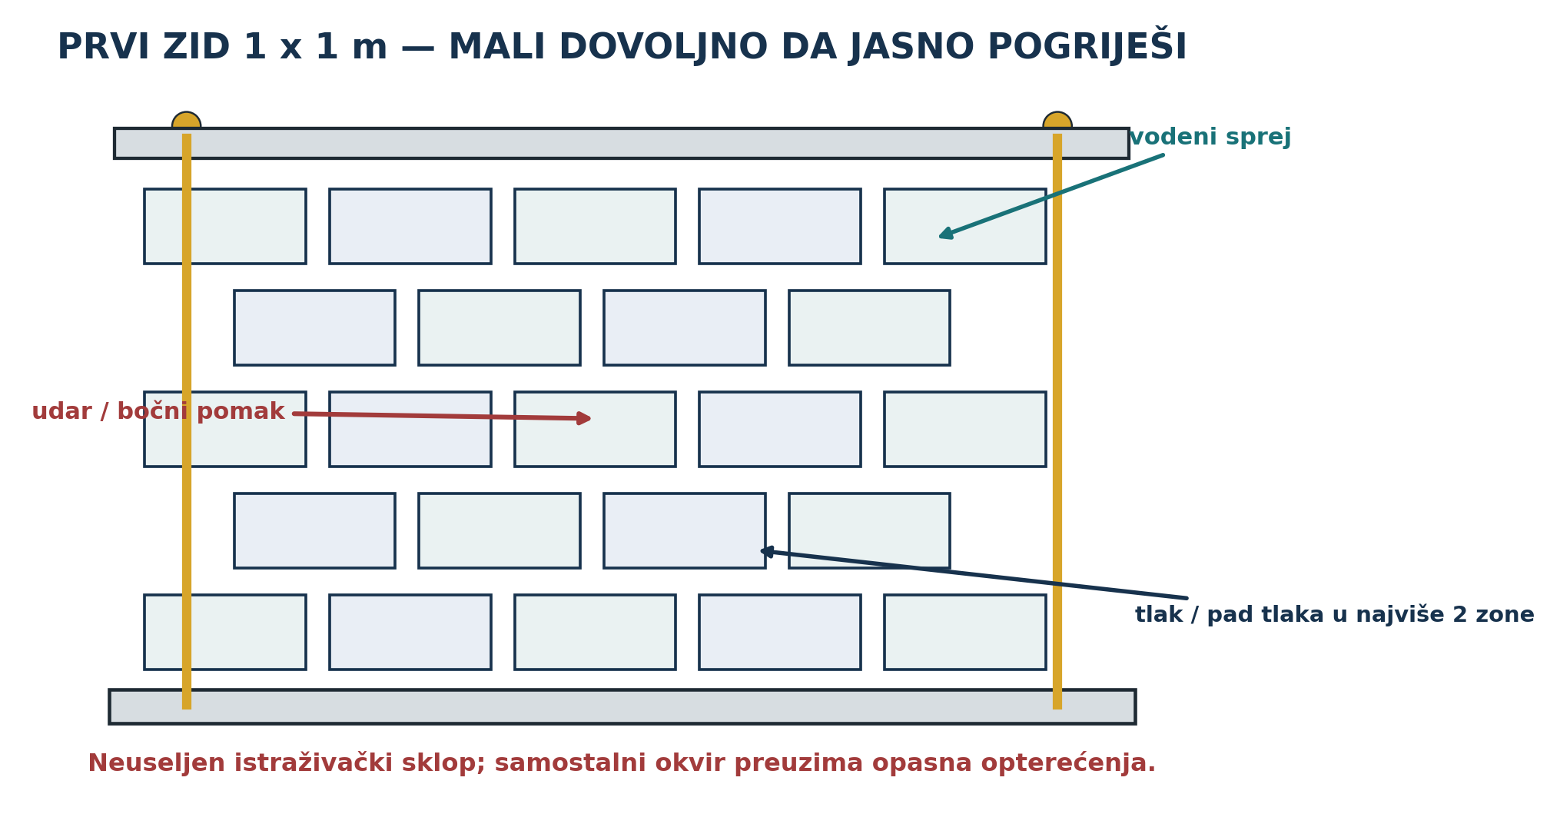
Approved first-wall concept: one block type in staggered courses, independent restraint, two controlled rods, a top beam, dry seals, drainage and access for complete disassembly.
Rig element | Measured / recorded item | Acceptance before blocks
Base | Level, flatness and drainage slope | Stable, clean and no uncontrolled ponding
Frame | Geometry, anchors, restraint and exclusion zone | Can carry all test reactions independently of blocks
Rods | Diameter, free length, position and calibration method | Straight, guarded and not rubbing the block field
Top beam | Stiffness, bearing path and movement reference | Load spreads without local crushing fixture
Water tray | Collection area, outlet and scale/container | No leakage outside the measured path
Instrumentation | Displacement points, force/torque method, temperature and pressure devices | IDs, ranges and zero checks complete

33. Dry assembly sequence

33.1 Base and first course
The empty rig is photographed and measured. The base datum and wall centreline are marked. Blocks are selected from the accepted ten-block lot without hiding the highest or lowest measured parts. The first course is placed dry against a known straight reference. No adhesive, foam, heating or hand carving is permitted. Each block ID, orientation and seat condition is entered on the wall map.

33.2 Staggered courses
The second course is offset by the frozen overlap and lowered so both locators enter visible receiving pockets without side impact. The operator records seating force or a predeclared hand scale, gap, rock and correction. Subsequent courses repeat the pattern while cumulative line, level, face offset and course height are measured. If error accumulates, the wall is stopped and mapped rather than forced straight by the top beam.

33.3 Seals, rods and top beam
Only after the uncompressed dry wall is recorded are the selected seals installed in their declared interfaces. Rods and the top beam are fitted without preload and checked for free alignment. Preload is applied in small equal increments while top-beam displacement, wall width, local gaps and block sounds or whitening are observed. Torque alone is a poor force measurement; if torque is used as a proxy, thread condition, lubrication, washer and calibration procedure remain fixed and are disclosed.

33.4 Baseline hold
The completed wall rests for a declared period before dynamic tests. Rod force or proxy, top-beam movement, course line, wall bow, temperature and photographs are repeated. A sudden loss of preload, growing bow, locator damage, creeping gap or audible cracking stops the programme and triggers safe unloading.

34. Vertical preload and restraint
Vertical compression can improve contact and prevent blocks from lifting, but too much preload can buckle thin faces, crush webs or hide poor locator fit. The test therefore begins near zero and increases by declared increments. The load path is top beam to broad bearing interface, through the stacked seating planes, to the level base. Rods react the load through the independent rig. No concentrated nut or washer bears directly on a thin polymer face.
Preload is bounded by observed deformation and the unknown capacity of the experimental blocks, not by an arbitrary construction value. Measurements include total force or calibrated proxy, loaded area, top-beam displacement, wall shortening, face bow and local damage. If the rods are tightened unequally, the wall can be forced into a misleading straightness or twist; left and right readings are therefore recorded separately at each increment.
Preload state | Required observations | Stop condition
P0 · contact | Beam seated; minimal force; baseline wall geometry | Any block already requires force to enter position
P1 · low | Left/right force proxy, shortening, gaps and sound | Local whitening, cracking or sudden movement
P2 · working trial | Repeated readings after hold | Progressive creep or unacceptable seal/face distortion
P3 · bounded exploration | Only after prior states are stable and risk review permits | Any fixture or block behaviour outside the predeclared envelope
Unload | Recovery, permanent set and damage map | Unsafe stored movement; use guarded release procedure

35. Dry seals and limited pressure zones
A seal experiment is useful only if the leakage path can be located. The first wall uses no more than two controlled pressure zones, each with a known boundary and accessible seal. This prevents a large network of cells from producing an attractive pressure reading that cannot be diagnosed. Seals remain removable and are identified by material, section, lot, compression target and placement. Adhesive caulk is excluded from the baseline because it would mask geometry and prevent clean disassembly.
The pressure test remains small and guarded. The enclosed volume, pressure instrument, connection, relief path and maximum differential pressure are documented. The operator approaches the pressure in increments and observes both pressure decay and physical movement. A successful decay curve is not an insulation or wind-load certificate. It is evidence about one rig, seal condition, temperature and time window.
Seal variable | Record | Interpretation limit
Material / profile | Supplier or source, dimensions, lot and condition | No generic claim about all elastomers or foams
Compression | Initial thickness, installed gap and calculated compression | Gap accuracy and material creep remain sources of error
Zone volume | Measured or bounded volume including tubing | Needed to compare decay between setups
Pressure | Initial differential, time series and temperature | Small rig result only; not a façade rating
Leak location | Smoke-free safe tracer, sound, local probe or section isolation | A global curve cannot locate a path by itself
Reuse | Seal condition after disassembly and second assembly | One seal cycle does not establish service life

36. Water entry, drainage and moisture observation
The water test introduces a measured spray from one controlled side while the opposite side, lower tray and internal openings remain observable. Water quantity, spray geometry, distance, duration, pressure, wall temperature and ambient conditions are recorded. The test starts at low severity. Wind-driven rain certification is outside scope; the purpose is to identify direct paths, pooling, capillary retention and whether the base can drain without hiding moisture.
Collected water is weighed or measured by zone. Tracer-safe colouring may be used only if compatible with materials and cleanup. After spray stops, the wall is inspected immediately and at declared intervals. Blocks and seals are weighed where useful. The wall is then disassembled so hidden contact faces can be mapped. A dry outer surface is not proof that no water remains inside a pocket or between courses.
Observation | Method | Decision supported
Applied water | Calibrated container or flow/time measurement | Normalises the trial
First visible entry | Time-stamped zone photograph | Identifies path onset
Collected drainage | Separate zone containers by time | Distinguishes drained from retained water
Retained moisture | Mass change and disassembly inspection | Reveals hidden storage or blocked route
Damage / swelling | Dimensions, fit and surface map after dry-down | Determines whether exposure changed assembly

37. Wall test sequence and measurement discipline
The wall programme proceeds from least damaging to more demanding so each stage retains an interpretable baseline. First comes dry assembly and ten-seat cycling of selected interfaces. Second is a preload hold and unload/reload cycle. Third is a bounded lateral push or pendulum/soft-body impact chosen by a competent test plan. Fourth is a heat–cool environmental exposure within the verified material boundary. Fifth is controlled water spray. Sixth is the small pressure-decay experiment. Final disassembly occurs even if earlier results appear successful.
Every stage has a pre-test state, applied input, time series, stop rule and post-test inspection. The rig is never left loaded without status and access control. Damage is not repaired between stages unless the programme deliberately restarts from a documented new baseline. When a result is surprising, the correct response is to preserve the configuration and inspect it, not immediately repeat at greater severity.
Order | Test | Primary measurement | Gate to continue
1 | Assembly / reassembly | Seating, gaps, line/level and damage after cycles | No forced fitting or progressive locator failure
2 | Preload hold | Force/proxy, shortening, bow, creep and recovery | Stable bounded response and safe unloading
3 | Lateral push / bounded impact | Input, displacement, residual set and damage map | Rig stable; no uncontrolled fragment or collapse risk
4 | Heat–cool | Temperatures, movement, fit and residual distortion | Material remains within verified safe range
5 | Water spray | Applied, drained and retained water plus paths | No unsafe interaction with equipment or hidden rig instability
6 | Small pressure decay | Pressure, volume, temperature and time | Zone boundaries remain secure
7 | Complete disassembly | Time, force/proxy, damage and recovered parts | All material accounted for and classified

38. Complete disassembly and reuse proof
Disassembly is a principal experiment, not cleanup. The preload is removed through a guarded, written sequence. The top beam, rods, seals, face and each block are removed and mapped. Time, tools, force proxies, seized interfaces, damage and contamination are recorded. Parts are cleaned only after the as-disassembled state is photographed. Every block returns to inspection and receives a post-wall disposition.
A reuse claim requires a second assembly with identified recovered blocks and seals, not merely a statement that the wall could be rebuilt. The same geometric and pressure checks are repeated at reduced or equal severity. Replaced items are counted and reasons are listed. The most informative output may be that one cheap external seal is consumable while the blocks remain reusable; the architecture should report that honestly rather than forcing every component into a ‘zero waste’ narrative.
Recovery class | Definition | Book language
Reassembled unchanged | Same identified component returns without repair | Direct reuse demonstrated for the tested cycle
Cleaned and reassembled | Defined cleaning only; no geometry change | Reuse after recorded maintenance
Repaired | Material added, removed, heated or reshaped | Repair experiment; not unchanged reuse
Reprocessed | Block converted to controlled feedstock | Material recovery experiment; not component reuse
Discarded / quarantined | Unsafe, unknown or uneconomic recovery | Loss is counted and reason preserved

PART VI · PHYSICS, FAILURE CONTROL, COST AND BOUNDARIES

39. Screening equations and what they can reveal
Simple equations are useful when they expose a controlling scale and remain attached to measured inputs. They are dangerous when an unknown coefficient is selected to make a finished-looking result. The relations below are therefore screening models. They help design coupons and instruments; they do not predict a certified block or wall. Every calculation sheet must list its source dimensions, units, measurement condition and uncertainty.

39.1 Geometric shrinkage
For a reference length L and measured free linear shrinkage strain ε, the dimensional change is ΔL = εL. A 100 mm trial bar that becomes 99.0 mm has a measured shrinkage of 1%, but the moulded HexCell will not necessarily shrink uniformly. Longitudinal, transverse and thickness directions can differ because of flow, cooling and constraint. The correct V1 correction is derived from same-material coupons and actual cavity measurements, not a generic internet shrinkage number.

39.2 Thermal movement
For a stable temperature range and a measured or reliable material coefficient α, free thermal movement is approximated by ΔL = αLΔT. The wall concern is not only one block changing length. Unequal sun exposure, dark surfaces, steel restraints, dry seals and polymer courses can move differently. A test rig should therefore measure temperature at more than one location and allow the distinction between free movement, restrained force and permanent creep.

39.3 Core extraction
A first friction model is F ≈ μpA, where μ is an effective friction coefficient, p is average shrink contact pressure and A is polymer–core contact area. For MOLD-REF-7, the seven reference cores present roughly 0.011 m² of contact. Neither μ nor p is known. The equation nevertheless explains why individual extraction, warm release, polished straight cores and shorter representative coupons are rational. The measured force-versus-time curve is more valuable than a guessed coefficient.

39.4 Pressure force and preload stress
A pressure difference Δp acting over zone area A produces a resultant F = ΔpA that must be reacted by the independent rig. Even a small pressure across a large panel can create a significant force, so the wall test remains low-pressure and guarded. Average compressive stress under vertical preload is σ = P/Ab, where P is measured preload and Ab is the effective bearing area. Local webs and imperfect contact may see much higher stress than this average; visual and displacement measurements remain essential.

39.5 Pressure decay
For a fixed test volume and approximately stable temperature, a falling differential pressure indicates leakage and/or volume relaxation. A simple comparison may use the time to fall between two declared pressure levels or a fitted decay constant. Temperature drift, seal creep, flexible walls, instrument resolution and connection leakage can dominate the result. The empty fixture and tubing must be checked before the wall is credited with a curve.
Model | Needed measured inputs | Useful decision | Not established
ΔL = εL | Coupon and block dimensions before/after controlled condition | CAD allowance and locator clearance | Universal polymer shrinkage
ΔL = αLΔT | Temperature field, length and material coefficient | Rig movement allowance and seal trial range | Long-term façade movement
F ≈ μpA | Core area plus measured extraction force/time/temperature | Coupon length, release window and surface comparison | Exact friction or contact pressure
F = ΔpA | Zone pressure and projected area | Frame and restraint sizing for the bounded test | Wind resistance or code compliance
σ = P/Ab | Preload and effective bearing geometry | Compare preload states and visible deformation | Local web stress or compressive strength
pressure decay | Volume, pressure, time and temperature | Compare two controlled seal assemblies | Airtightness certification

40. Principal failure modes and control logic
Failure analysis starts with the entire evidence chain. A dimensional block can fail because the material was mixed. A good material can fail because one vent closed. A complete part can fail during late core extraction. Ten blocks can pass individually yet accumulate course error. A wall can hold pressure because adhesive accidentally sealed the diagnostic joint. Controls are placed before, during and after each mechanism so the result does not depend on final appearance alone.
Failure mode | Effect | Early indicator | Primary prevention / response
Unknown or mixed feedstock | Incompatible fusion, degradation, emissions and untraceable results | Uncertain source, odour, separation or inconsistent melt behaviour | Quarantine; identify one polymer family; retain a sample
Residual moisture | Bubbles, steam event, weak webs | Mass instability, condensation or vent pulse | Verified drying and closed storage; stop hot run
Layer misalignment | Stepped cavity, core bind and flash | Cold gauge drift or forced core insertion | Dedicated keys, datums and three dry cycles
Blocked vent / bridging | Incomplete webs and trapped gas | Uneven fill, late gas release or void map | Three-core coupon, particle control and observable vents
Overheating / long residence | Brittleness, colour change and hazardous decomposition | Darkening, smoke or sharp odour | Material-specific boundary, multiple temperature measurements and immediate stop
Shrink lock | Seized cores and torn internal webs | Rising release proxy, stick–slip and scoring | Warm breakaway, individual cores and timed extraction study

40.1 Part, assembly and evidence failures
Failure mode | Effect | Early indicator | Primary prevention / response
Uneven cooling | Bow, twist and locator misfit | Growing plane gap during cooling | Defined flat support; record before any correction
Locator tolerance failure | Forced assembly or excessive rocking | High seat force, filing or persistent gap | Freeze measured clearance; ten-cycle mating test
Course accumulation | Wall lean, open joints and false preload | Line/level drift by course | Map every block and stop before force correction
Excess preload | Web crushing, face buckling and creep | Whitening, sound, rapid shortening or force loss | Incremental measured load and guarded unloading
Hidden water retention | Contamination, freeze/biological risk and misleading dry face | Mass gain or wet contact after disassembly | Drainage tray, zone collection and post-test opening
Record loss | No defensible result or reuse identity | Unreadable mark, missing run or changed revision | Human-readable IDs, protected records and physical separation

A formal FMEA score can be added after the team defines consistent severity, occurrence and detection scales. Multiplying arbitrary scores in the first meeting creates false rankings. Until then, any hazard involving unknown fumes, hot ejection, uncontrolled pressure, collapse, fire or uncertain material identity is treated as a stop condition regardless of a numerical priority score.

41. First-tool cost and resource envelope
The recovered archive carried a rough experimental-tool estimate of EUR 250–700, with a healthier working target of roughly EUR 350–500 for the small layered mould. These are historical planning numbers, not supplier quotations and not current market prices. They exclude development labour, failed cuts, heating equipment, ventilation, safety controls, measurement instruments, feedstock preparation, wall rig, certification and production scaling.
The cost structure matters more than the total. Laser-cut plate cost grows with material thickness, cut length, hole quality and post-processing. Cores may dominate if straight hex bar is unavailable and precision fabrication is required. Alignment components and a stiff clamp plate should not be removed to save money because they determine whether the cavity can be compared between runs. A staged purchase prevents the full tool from consuming the budget before the three-core release question is answered.
Cost group | Historical / planning basis | Decision rule
Cold mock-up | Low-cost sheet, sample steel or partial plate set | Buy only enough to validate stack, keys and file topology
Three-core coupon | Representative steel, three cores, basic clamp and instruments | Fund before full cavity; preserve reusable parts
Full small mould | Archive estimate EUR 250–700; target EUR 350–500 | Request current quotations against a frozen DXF pack
Hot-work cell | Not included in mould estimate | Do not start without material-specific ventilation and protection
Inspection | Not included | Prefer simple calibrated gauges and traceable records over cosmetic finishing
1 m² rig | Not included | Independent safety frame and instrumentation are separate work packages

42. Safety, regulatory and use boundaries
PWS HexCell revision 0.1 is an experimental invention record. It is not a construction product declaration, structural design, fire-rated assembly, pressure vessel, electrical enclosure, food-contact part or instruction to process unidentified waste. The green print is not evidence of recycled content. The reference calculations are not certification. The proposed wall must remain non-occupied and independently restrained.
Before any building application, competent laboratories and professionals would need to address material identity and consistency; mechanical strength and creep; connection and impact behaviour; fire reaction, flame spread, smoke and toxic products; thermal and acoustic performance; water, vapour, drainage and biological effects; UV and weathering; emissions and indoor-air suitability; dimensional stability; durability; repair, reuse and end-of-life; and the applicable Croatian, European and project-specific regulatory route. The relevant requirements may change, so they must be checked for the actual jurisdiction and date of application.
Use boundary. Do not use an untested PWS HexCell block in a load-bearing, overhead, occupied, guarding, fire-separating or weather-critical position. All hot-work, pressure, impact and wall experiments require competent local risk controls and an independent safety structure.

PART VII · DEVELOPMENT GATES AND CURRENT BUILD PACKAGE

43. Gates G0–G8
The gates keep later ambition from erasing earlier uncertainty. A gate is passed only by a named record, signed review and preserved evidence. Work may continue in parallel on harmless documentation, but a failed physical gate blocks the dependent hot tool or wall step. A new geometry revision reopens the affected gates; it does not inherit a pass from a visibly similar predecessor.
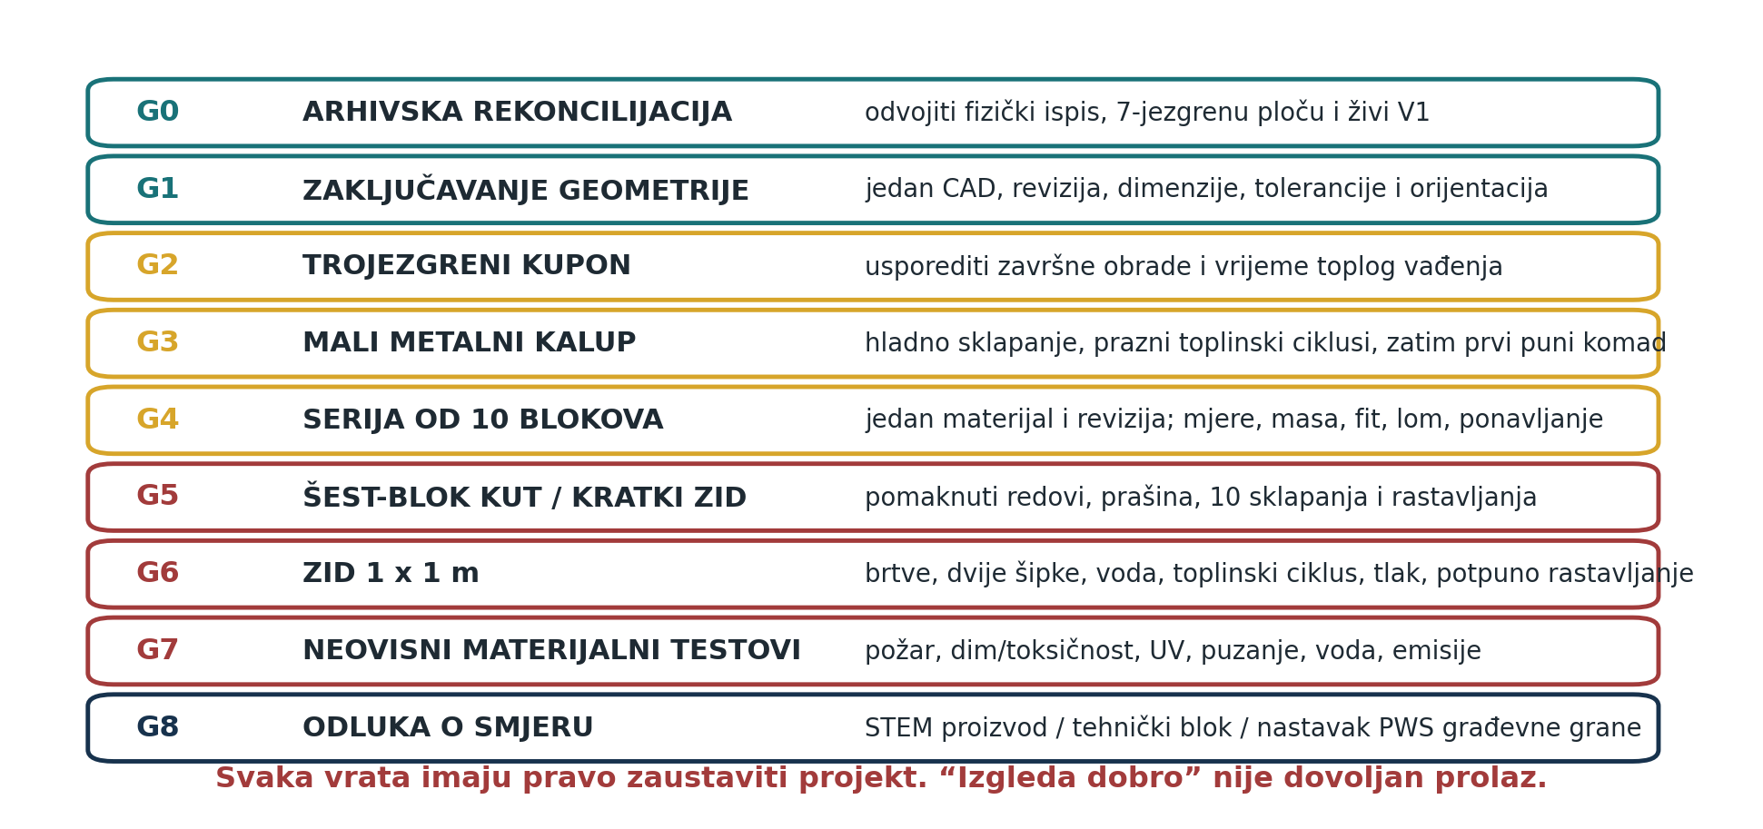
Approved development-gate map from identity and geometry freeze through the first repeatable block lot and one-square-metre wall proof.
Gate | Required evidence | Pass decision
G0 · source reconciliation | Controlling correction, source list and state separation | PHYS-PRINT, MOLD-REF-7 and V1 are no longer conflated
G1 · physical-print record | Mass; six-view photography; dimensions; void, wall and locator map | Existing object is a measured reference
G2 · V1 geometry freeze | Signed drawing, CAD, datums, tolerances, mark and configuration index | One manufacture-ready revision exists
G3 · cold tool proof | Layer register, gauges and three assembly cycles | Stack aligns, cores pass and tool reopens without heat
G4 · material release | One known prepared lot, retained sample and safe processing assessment | Feedstock identity and hot-work boundary are adequate
G5 · three-core release | At least five interpretable coupons and per-core extraction records | A bounded warm-release condition exists
G6 · full small mould | One complete tool, load-path review and safe dry/hot procedure | Full cavity can enter controlled cycles
G7 · ten-block lot | All starts, measurements, defects, tool service and assembly cycles | Same-revision process is sufficiently repeatable for a rig
G8 · 1 m² wall | Rig review, staged tests, disassembly and reuse disposition | System-level behaviour is recorded without building claims

44. Current build package
A fabricator should receive a controlled package, not this book alone. The package begins with one configuration index stating the active block, mould and test revisions. Every file carries the same revision, units and date. PDF drawings communicate intent; native CAD/DXF defines geometry. A checksum or protected archive copy guards against silent overwriting. Obsolete files remain readable but move to a superseded folder and cannot share the active manufacturing directory.
Package item | Minimum content | Release owner
V1 freeze sheet | Overall geometry, void field, walls, locators, pockets, radii, datums, tolerances and mark | Inventor plus technical reviewer
Block CAD | One authoritative solid and neutral exchange file | Geometry owner
Mould assembly | Exploded view, sections, layer IDs, core positions, alignment and clamp path | Tool designer / fabricator review
DXF plate set | Units, material, thickness, quantity, orientation and no duplicate contours | Geometry owner and fabricator
Core drawing | Across flats, length, straightness, finish, ends, ID and extraction feature | Tool designer
Cold assembly procedure | Order, datum contact, keys, bolt sequence, gauges and acceptance | Test lead
Material batch record | Identity, source, preparation, retained sample and disposition | Material lead
Hot cycle record | Charge, measured temperatures/times, vents, release, cooling and events | Operator / observer
Block QC record | Identity, mass, geometry, voids, defects, fit and disposition | Inspector
Wall test plan | Rig drawing, instrumentation, sequence, stop rules and disassembly | Independent test lead

45. Frozen decisions and open decisions
Frozen now | Open until measured
One rectangular full-sided block | Final external length, width and height
Open vertical hexagonal voids | Void count, pattern, across flats, minimum web and edge distance
Two basic lower locators and matching upper pockets | Locator/pocket dimensions, lead-in and clearance
Staggered dry courses | Exact overlap, end treatment and bounded corner restraint
No V1 side hooks, slots or decorative undercuts | Whether any later measured wall deficiency justifies an interface feature
Layered experimental tool with separate cores | Final layer thicknesses, steel grade, key details, vents and clamp values
Warm individual core release as the test hypothesis | Release temperature/time window, sequence and surface treatment
One known polymer family per first lot | Selected family, source and validated process window
Ten-block same-revision proof before the wall | Provisional numerical acceptance bands
Independent, non-occupied 1 m² rig | Block count, seal profile, preload and test severity

A freeze is not permanent dogma. It is a controlled baseline. If the three-core coupon proves that a chosen void length cannot release safely, the geometry may change by a new signed revision with the reason and affected records listed. What is prohibited is a silent edit that leaves photographs, DXFs and test sheets carrying one unchanged name.

46. The most valuable next measurements
The next programme is ordered by information gained per unit of cost and risk. It begins with the object already in hand and delays full metal work until release is understood. Each action produces an archive item that can be inserted into the next living edition without rewriting the evidence standard.
Priority | Action | Output | Decision unlocked
1 | Measure and weigh the green print | Signed six-view PHYS-PRINT record | Whether it guides V1 proportions or remains tactile evidence only
2 | Freeze one V1 geometry | Drawing, CAD, datums, tolerances and revision mark | One valid mould design and inspection plan
3 | Inspect a cold layered stack | Three-cycle alignment and gauge log | Whether DXF topology and keys are adequate
4 | Select one identified feedstock lot | Batch release and retained sample | Safe material-specific hot trial
5 | Run the three-core series | Force/proxy, time, temperature and defect curves | Core length, finish and warm-release window
6 | Build and cycle the full small tool | Complete cycle records and service history | Ten-block proof
7 | Produce ten starts without cherry-picking | Run-order mass/dimension/release/defect dataset | Wall-rig eligibility
8 | Assemble and fully disassemble 1 m² | System map, staged tests and recovered-part dispositions | Evidence for or against the next PWS envelope branch

Immediate practical move. Photograph and measure the existing green print before modifying or losing it. That record closes the oldest avoidable uncertainty and costs far less than cutting a mould around an assumed geometry.

47. Two materially different later branches
Two branches are preserved because they change the system's purpose, not merely its colour or scale. Neither branch modifies the V1 tool package. They begin from measured, traceable HexCell parts and receive independent IDs, drawings and test plans. If a branch needs side hooks, embedded parts or a different void pattern, it becomes a new block revision rather than an undocumented option in the V1 mould.

47.1 PWS-STEM-01: small educational construction set
The educational branch uses small, nonstructural blocks to make material identity, cellular geometry, staggered courses, dry assembly and disassembly directly visible. Parts may be 3D printed or produced by another safe, age-appropriate process; they are not represented as recycled-polymer construction blocks unless the material is actually documented. The set avoids heating, sharp tools, pressurised cells, fragile snap features and hidden magnets for young users. A flat base, a limited number of identical blocks, two end restraints and illustrated build cards are sufficient for the first exercises.
A useful lesson begins by weighing a solid reference prism and a HexCell form of the same outer envelope, then maps the missing volume without claiming strength. A second exercise compares aligned and staggered joints under a small safe lateral push. A third assembles, photographs, disassembles and sorts every component for reuse. The learning record distinguishes observation from conclusion: learners can report mass, count, fit and recoverability, but cannot infer fire safety, structural capacity or ecological benefit from appearance.
STEM component | First specification | Safety / evidence boundary
Blocks | One visible geometry, rounded handling edges and durable IDs | No building-use or recycled-content claim without evidence
Base / ends | Stable low-height tabletop restraint | Prevents collapse without implying block self-support
Build cards | Mass/void, course staggering and reuse exercises | No hot processing or hazardous feedstock handling
Record sheet | Count, mass, photographs, failed fits and recovered parts | Observation is kept separate from engineering certification
Acceptance | Ten assembly cycles without fragments, sharp damage or lost identity | Age suitability and local product-safety requirements still need review

47.2 PWS-FUTURE-01: serviceable wall-envelope branch
The later envelope branch returns to the larger PWS aim: wall layers that can be accessed, diagnosed, replaced and materially separated. A future assembly may combine a dry block field with independent internal and external faces, controlled seals, drainage, service channels, replaceable insulation cassettes and, only after simpler tests, small monitored or reduced-pressure cells. Each function remains separable so a failed seal does not require destroying the block and a new sensor does not force a new load-bearing geometry.
This branch is intentionally downstream of the one-square-metre wall. Pressure zones are limited and serviceable; they are not vacuum-insulated building panels by assumption. Sensors may record temperature, humidity, pressure and leak location, but the wall must remain inspectable when electronics fail. External cladding and internal finish attach to an independent rail or tested interface. Fire barriers, cavity stops, vapour control, drainage and structural restraint require competent project-specific design and cannot be inherited from the bare HexCell form.
Future layer or function | Reason to keep it separate | Evidence required before integration
Removable inner face | Provides service access without cutting blocks | Repeated removal, attachment load, fire and indoor-air review
Removable outer face | Allows weather layer replacement | Wind, impact, drainage, UV, fire and safe-failure testing
Service route | Keeps cables/pipes inspectable | Temperature, condensation, separation and code-compliant detailing
Insulation cassette | Changes thermal layer without changing block | Thermal, moisture, fire and dimensional compatibility
Limited pressure cell | Makes leakage observable and potentially reduces convection | Safe pressure boundary, decay repeatability and graceful loss of pressure
Sensors / diagnostics | Locate changes before destructive inspection | Calibration, power loss, privacy, replacement and offline operation

The gate into either later branch is the same: a measured V1, a repeatable material/tool cycle and a wall that has been completely taken apart. Until then, the branches remain preserved system definitions—not features to be added to the first block.

APPENDICES

Appendix A · MOLD-REF-7 reference dimensions
This appendix preserves the historical reference values without promoting them to V1. Dimensions marked approximate were read from the surviving technical plate and must be verified against native CAD before fabrication.
Reference item | Recorded value | Authority / limitation
Body envelope | 100 × 50 × 35 mm | MOLD-REF-7 only
Void arrangement | Seven hexagonal cores in one row | Differs from the visible multi-row physical print
Hex opening | Approximately 13 mm across flats; about 15 mm vertex to vertex | Reference geometry; core tolerance not frozen
Lower feet / locators | Approximately 8–9 mm high | Plate estimate; exact pocket relation unavailable
Core length | Approximately 52 mm | Tool reference, not finished block height
Side cavity package | Approximately 40 mm | Reference stack description
Plate thickness | 4 mm steel | Historical proposal
Clamping | Six M6 × 75 bolts | Historical proposal; no verified clamp force
Total mould height | Approximately 158–162 mm | Dependent on layer and hardware stack

Appendix B · Manufacturing cycle record
Record field | Entry
Run identity | Run ID; date/time; operator; observer; authorised geometry revision
Tool identity | Mould assembly; layer revisions; core-set IDs; cycles since service
Material | Batch ID; polymer identity method; retained sample; prepared particle range
Charge | Target mass; actual mass; additions; unused return mass
Temperature instruments | Instrument IDs; locations; zero/check status
Heat history | Start, set values, measured values, holds and end
Fill / vent | Placement sequence; compaction; vent observations; abnormal events
Warm release | Opening state; elapsed time; temperature; core order and per-core result
Cooling | Support, orientation, environment, movement and handling time
Disposition | Part ID; pass/research/regrind/quarantine; reason; tool service needed

Appendix C · Block quality record
Inspection block | Entry
Identity | Part ID; revision; material batch; run; untrimmed/trimmed state
Photographs | Six orthogonal views; oblique; scale and identity card
Mass | Balance ID; as-moulded and final values
Envelope | Defined length, width, height locations and values
Plane condition | Maximum gap; rocking corners; bow/twist map
Void field | Open/blocked map; probe result; selected across-flats and web values
Locators / pockets | Position; gauge result; seating; clearance; ten-cycle damage
Defects | Flash; cold joint; void; inclusion; scorch; sink; release tear; photograph refs
Disposition | Acceptance criteria revision; result; reviewer; date

Appendix D · Core-extraction record
Field | Entry
Coupon / block | Specimen ID, geometry and material batch
Release zero | Defined event from which elapsed time is measured
Core map | Position diagram and core IDs
Per core | Sequence; elapsed time; temperature; force/proxy; motion quality; damage
Tool state | Surface treatment; prior cycles; residue; measured size / straightness check
Part result | Web tear, distortion, residual material and final disposition
Change for next run | One principal variable and reason

Appendix E · First-wall test record
Record block | Entry
Configuration | Rig drawing; block map; seal/face/rod/top-beam IDs; test revision
Baseline | Line, level, bow, gaps, preload, temperature and photographs
Assembly | Order; seating observations; nonstandard spacers/cuts; time and tools
Preload | Left/right increments; force/proxy; shortening; hold; recovery
Lateral / impact | Input method, magnitude, position, displacement and damage
Heat–cool | Surface/air temperatures; movement; fit and recovery
Water | Applied, drained, retained, path map and dry-down
Pressure | Zone volume; instrument; temperature; pressure/time series; fixture baseline
Disassembly | Sequence; time; force/proxy; seized/damaged parts; recovered mass
Reuse | Second assembly result; replaced components and dispositions

Appendix F · Source and version note
The principal internal sources for this edition are the Croatian Atlas technical manuscript ‘Atlas Izuma Roberta Petrušića 001 — PWS HexCell’, working version 0.1 dated 25 July 2026; the updated system record ‘03 – PWS – Plastique Wall System’ dated 22 July 2026; Volume 8 of the Grand Canon covering construction, recycled materials and fabrication; the short illustrated PWS HexCell PDF; author photographs of the green physical print; and the approved technical plates reproduced in this book. Source dates describe surviving documents and edits, not necessarily conception.
Where sources disagree, Robert Petrušić's latest explicit correction controls: simple rectangular body, full side faces, open vertical hexagonal voids, two basic lower locators with matching upper pockets, staggered courses and no side-hook complexity in V1. The MOLD-REF-7 dimensions are retained only as a historical tool reference. Calculations, test matrices and technical explanations added in this English edition are editorial engineering work based on the invention record; they do not claim that unperformed tests have occurred.
Evidence label | Meaning
BUILT / PHYSICAL | A photographed or otherwise recovered physical object exists
MEASURED | A stated result comes from an identified method and specimen
DESIGN EVIDENCE | A drawing or approved technical plate defines a proposal
REFERENCE | A historical value or branch useful for reasoning but not controlling V1
PROPOSED TEST | A detailed procedure that has not yet produced a recovered result
FORBIDDEN CLAIM | A use or performance statement unsupported by current evidence

Appendix G · Inventor record
Robert Petrušić of Ploče, Croatia, is recorded as the originating inventor of PWS HexCell and the broader Plastique Wall System concept represented in the source archive. This living technical edition preserves his latest geometry correction and separates that authorship from editorial organisation, calculations, risk analysis and document production. If an earlier dated sketch, photograph, prototype or publication is recovered, its date and evidence class can be added without deleting the present edition history.
Working edition 0.1 was consolidated on 4 August 2026. It should be revised only through a new version record stating what changed, why it changed, which physical evidence now exists and which prior drawings or claims became superseded. The purpose of the record is continuity: a future reader should be able to rebuild the chain from the object in Robert's hand to the first moulded series and wall proof without guessing which version was meant.

Closing technical state
PWS HexCell currently has a clear nucleus, an existing tactile print, a bounded historical reference geometry, an experimental layered-tool architecture and a complete route to repeatable evidence. Its strongest design decision is subtraction. The next edition should not become longer because more imagined features are added; it should become stronger because the green print is measured, V1 is frozen, cores are pulled under recorded conditions, ten honest starts are completed and a one-square-metre wall is assembled and taken apart.
Until those records exist, this book preserves exactly where the invention stands: more than an idea, less than a construction product, and ready for the next controlled physical proof.

