# Catlog~log

February 5th - Decided on web browser application for project, attempted installation of gtk+

February 6th - teacher decided I can’t use gtk+ for unknown reasons, wxpython chosen.

- Later found that wxpython is unsupportive of web pages, even though told that it would be easy

February 8th - finally get idea for assignment so that I can use wxpython, is about an 8/10. Tl;dr it’s a cataloguing system similar to that in use of Woolworths

February 9th - catlog 0.1 Title and layout features such as dividers testes and working  
- catlog 0.2 Scrolling features tested and functioning, except with a grid, unwanted  
- catlog 0.2.2 Different (Simpler) approach taken to scrolling, decided on uses of this in continued builds.  
- catlog 0.3 Menu bar with submenu’s, status bar, and add item entry window added  
All help up to this stage taken from “thenewboston” YouTube Channel

February 12nd - catlog 0.4 Dictionary created with text entry to add items, with defaults set for values

February 15th - catlog 0.5 Items value changer with item selector implemented

February 17th - catlog 0.6.1 Items now draw onto screen, not in a nice fashion thought. Not aesthetic/10.  
0.6.1 chosen over 0.6 because of drawing method actually works.

February 18th - catlog 0.7 Complete re-layout for the textbook level aesthetics, and also for easier drawing of the items. List box now is used for items list.

March 28th - catlog 0.8.1 Initial list box now in place. Few glitches with it, but they’ll get ironed out hopefully next stage. Also, subheadings for information on a selected item are now on screen and functioning  
0.8 had a really bad approach to the subheadings, hence the remaking of it and using of 0.8.1

May 12th - catlog 0.9.1 Now moving in leaps!! Got the checkout system layout done and functioning, with string methods for displaying the quantities and prices for quantities in the checkout list box, and also the subtotal is adding up. Delete button not working yet, though I’ll get to that in due time.  
- 0.9 was just a work in progress, just in case I done goofed it up and needed to go back to a working version  
Thanks to [http://www.codecademy.com](http://www.codecademy.com/) for lessons on string methods and things. Really helped here, and onwards.

May 14th - catlog 1.0 Now with more menu buttons for those clicking addicts. Also item list window now functioning properly with clickable and resizable columns for sorting purposes.   
Used sortable columns methoding idea from <http://zetcode.com/wxpython/advanced/>. Solid site for the wxpython

May 27th - catlog 1.1.5 done. Save and load features now operating to an extent. The new function isn’t quite working at the moment, as the system checks are all over the place, which needs immediate fix, when I get around to it.  
all parts of 1.1.x are just attempts of getting the save/load to work, using pickle. Turns out the whole time I had “Paths” instead of “Path” because I’m a genius, and paths gives the directory’s contents, not the directory. Never mind that though, it’s working now, thanks to Mr. Rothe’s almost immediate pick up of that after finally asking for help off him about it.  
Thanks to the official wxpython help file. Took me this long to find it, damnit, but it helped here

May 28th - catlog 1.2.1 System checks all neat and such. Took a bit but there was a re-writing of all the checks in the main class. Brain will no longer function till tomorrow.  
1.2 was just a backup

May 30th - catlog 1.3.3 can print! Receipting is done using some epic string methods and rjusting. Pretty happy about it all.  
Printing thanks to ubbn on GitHub (<https://github.com/ubbn/wxPython/blob/master/Chapter-17/printing.py>) who was the only person in the entirety of the internet to explain the printing process in wxpython so I could actually use it. Thanks buddy.

June 4th - catlog 1.4.3 Orders function now in place. Now I can order in all my carrots and beans. But really, the orders function includes saving and loading of orders, multichoice dialogs and all that good stuff. Also, the program automatically calculates the amount to refill the product. Talk about ease of use!  
1.4.x version were all just attempts at getting this to work properly  
Thanks again to zetcode for the multichoice dialog, and again to code academy for the string methods. <3 you guys  
- catlog 1.5 Just added error messages for ease of use and for checking logic as I went

June 6th - catlog 1.6 put the help file in and tidied up. Not too much going on. Now to complete the rest of the documentation!

June 10th - I may be getting really really sick, or really really sick of this assessment task, but in the words of Textbook himself, “I’m done”. THANKyou

## Usability Report

Tests were conducted by people who had not seen the construction of this software, or likewise any planning. A survey was conducted after completing satisfactory use of the software by their own means, choosing to watch the video tutorial or not.

The full results can be found here <https://docs.google.com/spreadsheet/ccc?key=0AipagpohHOiCdFFRLTdobkxSOHRPVUlXM2xaZjhRa1E&usp=sharing>

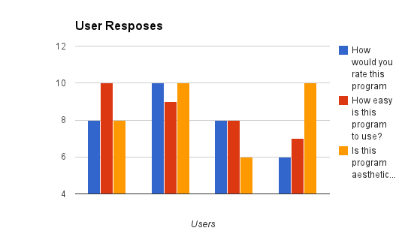

This chart represents the users ratings on the program. The rating varied between users, but the majority of sections were rated 7 or above.

Some of the suggestions given for improvements included a bug for the subtotal not fully resetting itself on upon a fresh reset of the inventory, and things like not having easier access to edit buttons for items and the checkout list not adding to items when the same thing is added twice.

# Verification Report

In the initial stages of the software development, functionality requirements were stated as an aiming point for this program. These were:

1. The program should be able to handle at least 150 store items at once

This will be tested by creating 150 items in the program and performing all the usual functions to see if the program will still run stably

1. The program should be able to save the inventory dictionary to a text document in under 10 seconds

This will be tested by creating a number of items, saving it to file and recording the time

1. The program should be able to read the inventory list from a file into the program in under 10 seconds

This will be tested by loading a saved inventory file into the program and recording the time taken

Testing was done at the conclusion of the software development, and testing was conducted to test the validity of these statements. The results were:

1. 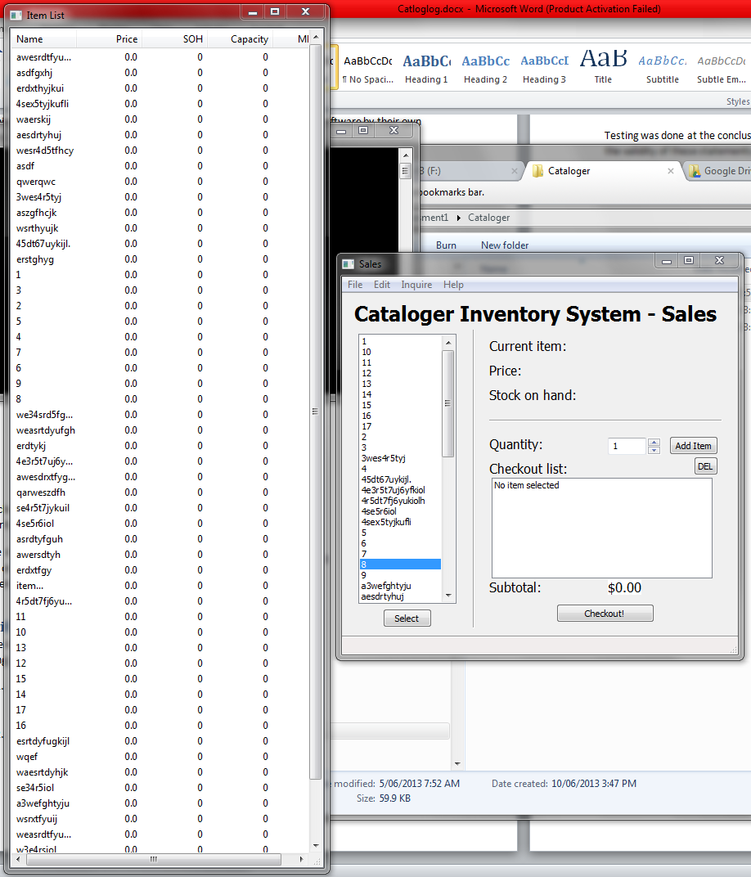A number of items were added to the inventory, and the program still seemed to operate, not only stably, but at the same speed when only a few items were in the inventory.
2. The program can save inventories in an unmeasurably short space of time. This was tested by saving the list in the previous test, only to find it saved instantly.
3. The program, once again, can open large inventories instantaneously. This was tested by clearing the inventory and re-opening the inventory from the last test.

# Test Data

The first thing I tested was the creation of names. Putting in blank names, numbers, symbols, and Boolean values all did not break the program.  
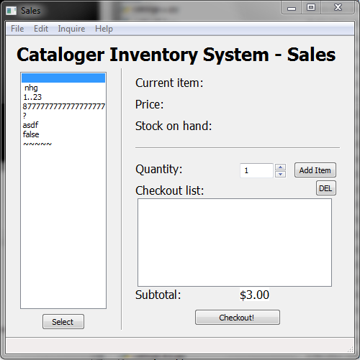

The next thing was to test the program with its checkout system. Using the names previously, but with edited values for the use in the inventory. Attempted input of negative values/words into the edit entry was not a problem as the program does not allow it.

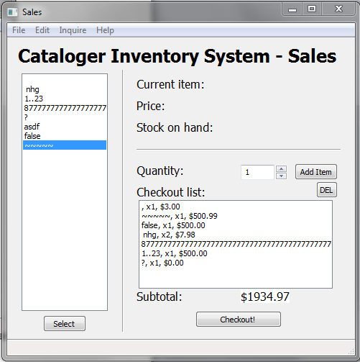

Then putting in bogus information into the customer information in the receipting did not throw it off

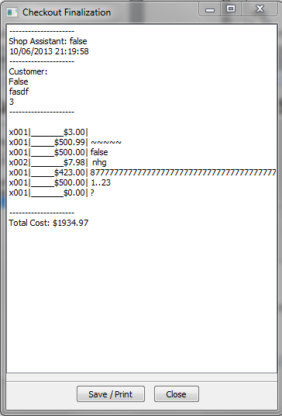

The save file worked fine with this information, and the print window came up  
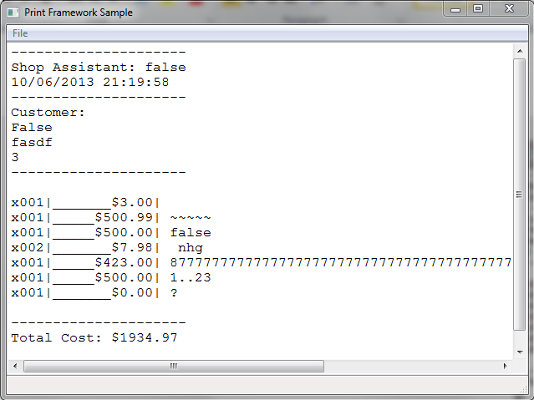

The item list window also worked no dramas

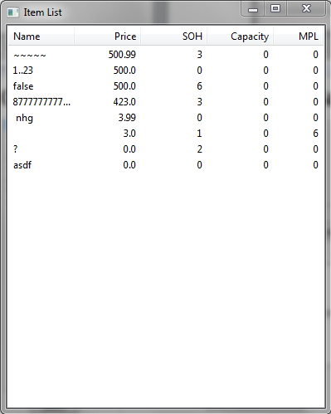

The program then saved the inventory and loaded it without errors.

The program also was able to calculate an order, save the order, and successfully receive it. (glitch with subtotal is just an issue with a system check, not to do with the current values

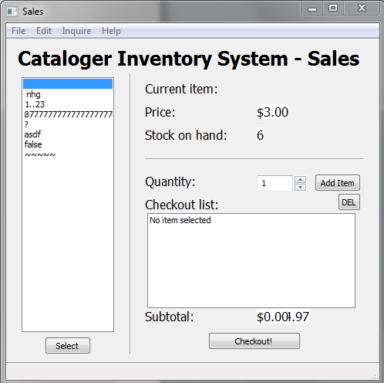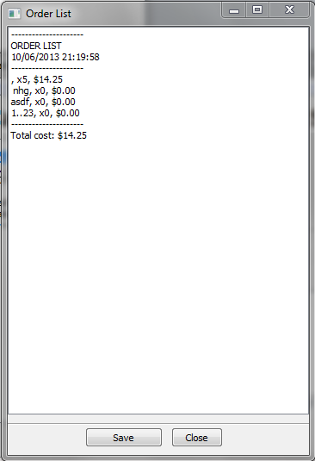

Most of the issues that could arise from data entry are caught before they can do any damage. When entering a name for a product, it is immediately stated as a string. The same for numbers, which are always entered in wx’s spinners, which let you set the max and min allowed to be entered, preventing letters and such, and negatives where it matters.