Physics 134 PET Experiment Student Manual
Table of Contents
1. Introduction 1
2. Radiation Safety 2
3. The Apparatus 3
4. Starting the System 4
5. Recovering from Mistakes 5
6. Configuration and Calibration Procedures 6
6.1. Internal Trigger Threshold and High Voltage 6
6.2. The Gamma-Ray Spectrum and Energy Calibration 11
6.3. External Trigger Threshold and Coincidence Window 15
7. Measuring the Activity of the Source 16
8. PET Scan Procedure 17
9. Image Reconstruction 18
10. Conclusion 18

Author: Professor Robert Johnson

Introduction
Positron-Electron Tomography (PET) is a well-established medical imaging modality that is widely used today. Its development began in the early 1950s, and a large amount of advanced development work continues in many companies and research laboratories. A good article on the subject for physics students can be found in a 2025 Physics Today article. Of course, there is a plethora of other information on the subject easily available on the Web.
The basic idea is simple. When a positron annihilates with an electron, in their rest frame the resulting two 511 keV gamma rays travel back-to-back in opposite directions. If two detectors detect those photons, then a line between the detectors passes through the annihilation point. A large set of such lines, pointing in all directions, can map out the source region of the annihilations. In medical imaging, the patient is fed some substance with molecules containing nuclei that decay by positron emission. The special molecule can be designed to preferentially travel to a given region of the body, historically the first example being 2-fluorodeoxy-D-glucose containing positron-emitting fluorine-18, which can serve as a marker for body locations using a lot of glucose, such as in a malignant tumor. The half-life of fluorine-18 is less than two hours, thus minimizing human exposure to radiation, so half of the story of PET imaging is how to produce such isotopes and get them quickly into the hands of the doctors. That half of the story cannot be replicated in this lab!
The second half of the story is to surround the patient with gamma-ray detectors, detect many back-to-back photon pairs, and reconstruct the image. In principle, we can do that in the lab, but for reasons of cost, we have only two gamma-ray detectors. Therefore, we miss the vast majority of the photon pairs, resulting in long time periods (a few days) needed to make a complete scan. Since there is no live patient waiting for the scan to complete, however, that is not much of a problem. To make this work, we just have to move the detectors back and forth and all around relative to the “patient”. However, it is easiest to keep the detectors fixed in the lab and rotate and move the “patient”, which achieves the same goal.
Our “patient” is an enclosed box containing several sodium-22 sources. This isotope has a half-life of 2.6 years and is commonly used as a calibration source for PET scanners. Na-22 usually decays by positron emission to neon-22 (although about 9% of the time it decays by capturing an electron from an inner atomic orbital, followed by emission of an X-ray when that orbital gets filled by another electron). Nearly 100% of the time the neon nucleus will be left in a highly excited state that will almost instantly decay by emission of a 1274.5 keV gamma, which you will be able to see with the gamma-ray detectors. The positron will diffuse a short distance through the crystal lattice, slowing down until it either annihilates directly with an electron (about 60% of the time) or forms a positronium state with an electron. The positronium will be formed nearly at rest but will not likely be formed in its ground state. However, excited states quickly decay 75% of the time to either the “ortho-positronium” triplet ground state (spins aligned) or 25% of the time to the “para-positronium” singlet ground state (spins anti-aligned). The ortho-positronium state has an energy only 0.001 eV higher than the true para-positronium ground state, but because of the charge-conjugation symmetry of the electromagnetic interaction, it can only annihilate into three photons, causing its lifetime in vacuum to be over a thousand times longer than the 0.1244 ns lifetime of para-positronium. Inside of matter, however, the ortho-positronium has plenty of time and opportunity to interact in many ways to become para-positronium, instead of annihilating to three photons. For example, typically the positron divorces its parallel-spin electron partner and “picks-off” an opposite spin electron that happens to be nearby. Therefore, you will see only two-photon annihilation, which is good for PET! Of course, there is no annihilation at all from the electron-capture decays, so overall only about 90% of Na-22 decays yield back-to-back 511 keV gammas, meaning that there are about 1.8 times as many 511.0 keV gammas as there are 1274.5 keV gammas. Note, however, that our efficiency to detect those higher energy gammas is reduced, because with their higher energy they tend to pass right through the sodium-iodide (NaI) crystals that we use as gamma-ray detectors, without interacting at all. Therefore, you will see more than 1.8 times as many annihilation gammas as 1274.5 keV gammas.
In this experiment you will learn to set up the equipment for efficient, low-background detection of the electron-positron annihilations by setting for each of the two channels an appropriate PMT high voltage and an appropriate discrimination threshold. You will use the 511.0 and 1274.5 keV gammas from Na-22, and also 661.7 keV gammas from a cesium-137 source, to obtain an energy calibration for your experiment. Then you will set a coincidence time window and an energy range to select back-to-back, simultaneous 511 keV gamma-ray events. Once that is ready, then you may run a complete scan to build a large, clean dataset for image reconstruction. Finally, you will put together and use a Python script to analyze the data a create a CT image of the “unknown” configuration of sources within the source box.
The experiment is operated by students from the PC using a Python-based graphical user interface (GUI) that communicates over a USB cable with an embedded processor on a commercial board called “Red Pitaya,” which resides inside the blue electronics box (see Figure 1 below). The Red Pitaya is the Gen-2 STEMlab 125-14 version (see https://redpitaya.com/product-category/stemlab-125-14-gen-2/). It runs a Linux operating system, so the PET system can also be operated by logging into that system via an ethernet connection and then manually typing commands. However, that is meant to be for experts only.

Radiation Safety
The Physics 134 radiation safety protocols must be strictly followed throughout this experiment. Please review the appropriate lab documents prior to starting this experiment. The sources that are used here have up to 5 micro-curies (5 µCi) of activity (which is, of course, continually decreasing by a half every 2.6 years). A 5 µCi decay rate amounts to 185,000 Na-22 decays per second, or over half a million gamma-rays per second going in all directions, which sounds like a lot. However, at a meter distance, it amounts to a human exposure of only 0.006 millirem per hour, which should be compared with our typical exposure from natural radiation sources of about 1.6 millirem per day. Don’t forget that the exposure falls off as the inverse of the distance squared, so it is always a good idea to avoid being right next to the source for any extended period. Never put one in your pocket!
The sources are sealed, so as long as the seal is not broken, then there is no exposure from the positive beta rays, which do not penetrate far in material. There is no thin window, as these sources are never used for their beta rays. Nevertheless, the sources must be handled with care and proper protocol. Any Na-22 from a broken source could cause hazardous skin contact, not to mention the hazards of ingestion.

The Apparatus
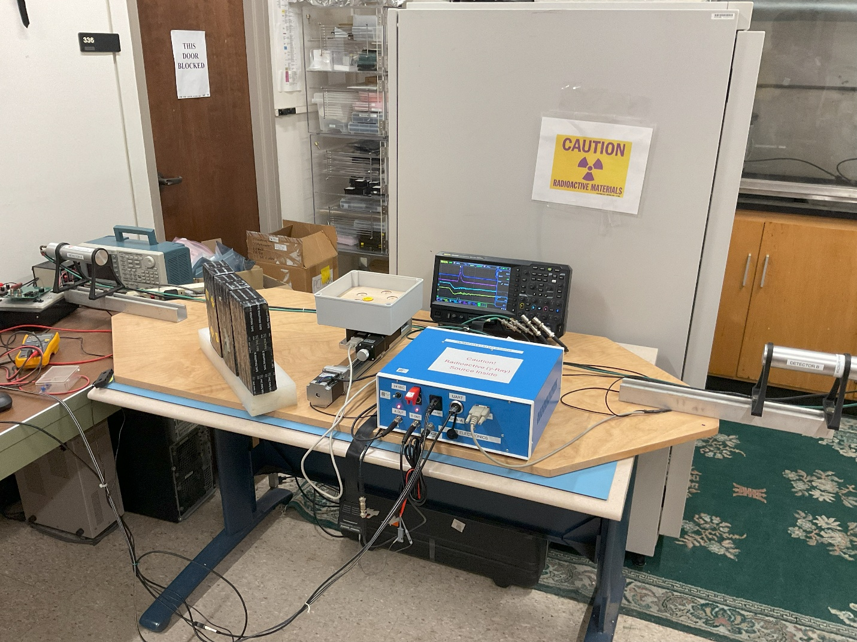
The experimental apparatus, apart from the PC, can be seen in Figure 1. Each of the two gamma-ray detectors is made up of a sodium-iodide crystal and a photomultiplier tube (PMT). They each require a positive high voltage, up to 1000 V maximum, to operate, which is supplied by two small high-voltage power supplies located on the custom printed circuit inside the blue box and controlled by the computer. Details of that circuit board, called the “coincidence board” can be found in the documentation of the apparatus. It includes a fast, inverting trans-impedance amplifier for each detector channel. Since a PMT delivers a short current-pulse of electrons, its signal is seen on the oscilloscope as a negative voltage pulse from the current flowing into the input impedance, which is typically set to 50 ohms, to match the coaxial cable characteristic impedance and to bring the signal back to the baseline relatively quickly. The transimpedance amplifier naturally turns a current pulse into a positive-going voltage pulse, which can be visualize in the GUI in digitized form. Each voltage pulse is then split into two paths (in such a way that each path retains half of the original voltage). One path leads to a fast digitizer located on a separate board (the Red Pitaya), and the other goes to a discriminator consisting of a comparator that compares the voltage against the output of a digital-to-analog converter (DAC) that can be set by computer control.
Figure 1. The apparatus used for the PET experiment, with the PC not shown. The source box (“patient”) is shown opened, so that the wooden holder of the 1-inch diameter sealed sources is visible. The oscilloscope is not necessary for operating the scan, but it is useful for visualizing the raw outputs of the gamma-ray detectors, visible at the far left and right of the photo, as well as the discriminated pulses and trigger signal from the blue box. The source box is mounted on top of a rotating stage, which in turn is mounted on a linear stage. Both stages are driven by stepper motors. All the electronics, including power sources, amplifiers, coincidence circuits, stepper-motor controllers, and an embedded computer, are in the blue box, which communicates with the PC via ethernet as well as a slow USB/UART connection. The three lead blocks partially shield the nearby operator from the sources, which is not a bad idea if one is going to be sitting there for hours at a time.
The discriminators outputs are digital signals of 5 V amplitude and lengths that vary, depending on the times that the signals spend above threshold. Each discriminator output goes into a specialized timing chip that outputs a pulse of predetermined length, with the length programmed by digital signals sent from the GUI via the Red Pitaya. Those two fixed-length outputs then go into a simple AND gate to form a coincidence pulse to trigger the digitization by the Red Pitaya. In that way, we can be sure to digitize only events with coincident gamma rays, with the coincidence window dictated by the settings of the two timing chips. On the other hand, if we want to measure the spectrum of gamma rays as seen by a single detector, the GUI can select to use an “internal” trigger, in which case the Red Pitaya digitizer will trigger itself whenever it sees the signal from the selected channel go above a preset level.
The box of sources sits on top of a rotating stage, which in turn sits on top of a linear stage. Each stage has a stepper motor to drive it, and each stepper motor has a controller inside of the blue electronics box. C++ code running in the Red Pitaya creates digital pulses that are sent to the controllers to make the motors step. Each step is a known angle or distance, so the GUI can control very precisely the position and orientation of the box. Optical stop switches at each end of the linear stage prevent it from trying to travel too far.
The distance of the detectors from the source box can be adjusted manually with wrenches. The spatial resolution improves when they are moved further apart, but that also increases the time required to accumulate data. The spatial resolution can also be improved by placing a collimator in front of one of the detectors, but again that will slow the data accumulation.

Starting the System
Turn on the AC power on the back of the blue electronics box. The Gen-2 Red Pitaya is powered by a USB-C supply that is plugged into the AC power. Therefore, it powers up and boots as soon as the AC switch is turned on. The Red Pitaya sends 5V, 3.3V, and $-5$V power to power the coincidence board. The 3.3V supply powers a red pilot light on the top of the blue box, near the back. If it is not lit, then either the AC is off or the Red Pitaya is not functioning. Be sure to turn off the AC switch when not using the setup.
Next, turn on the low-voltage (24V) power switch on the front panel. The LED below the switch should illuminate when it is turned on. The 24V switching regulator inside the blue box powers the stage controllers and the 12V regulator for the linear-stage stop switches and fan. The 24V also goes to the high-voltage supplies, but a separate switch on the front panel turns them on and off.
Note that the fan on top of the Red Pitaya will not turn on until the 24V DC power is turned on. (There is also a fan inside the 24V power supply that may be audible.) However, the Red Pitaya should be okay when the fan is off, as it will not be busy in that case and won’t generate much heat. The Red Pitaya board is mounted in an aluminum case that makes thermal contact with the CPU/FPGA chip, so it cools well passively. The fan just provides a little bit more heat dissipation. A button on the GUI allows you to check the CPU temperature. It should normally be in the mid 50 degrees Celsius when not busy, climbing to the upper 50s or low 60s when a data run is active. The software checks the temperature frequently during a CT scan and will abort if it climbs above 70 degrees. The Red Pitaya itself should go into a thermal protection shutdown if the temperature approaches 85 degrees, its rated absolute maximum.
The Red Pitaya is set up to start automatically the C++ program (named PET_RP_Slave) when the power is turned on and it boots. If communication between the GUI and Red Pitaya is not working, then you may need to power cycle the system to get the program running properly again. For example, killing the GUI on the PC while it is communicating with the Red Pitaya can leave the C++ program in a state in which it will never again look for a command from the GUI. Of course, if you are logged into the Red Pitaya, then you can kill the PET_RP_Slave process, in which case it will restart automatically (experts only!).
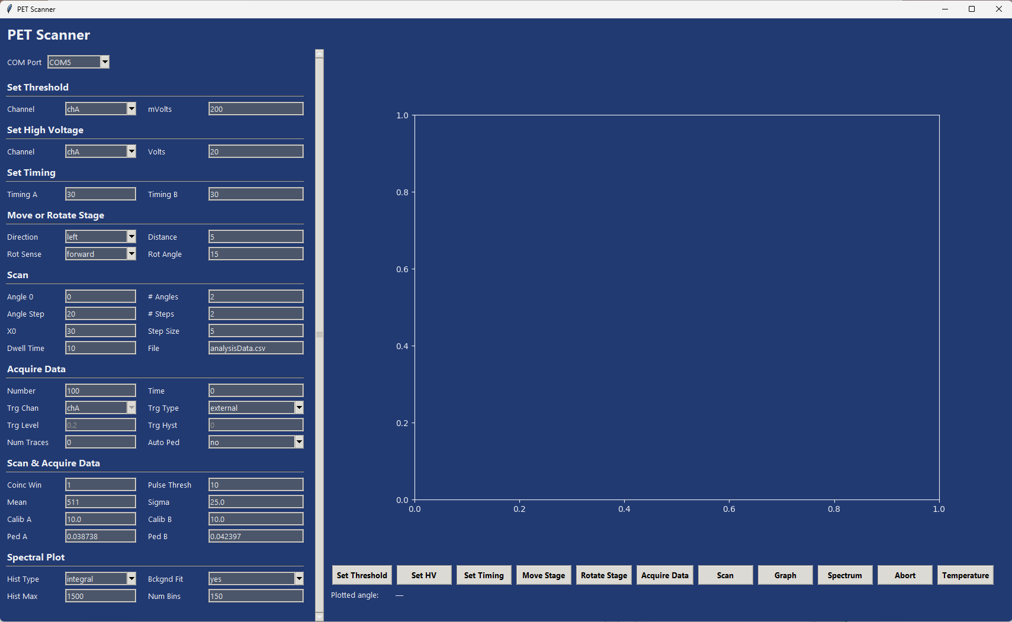
Figure 2. View of the PET GUI shortly after starting it up.
Log into the PC using the Physics134 account and open the Windows Command Prompt (or the Windows PowerShell). One way to do that is to type CMD into the Windows search box and hit return. Then, in the Command Prompt window that opened, type “Documents\PET\GUI.py”. Resize or maximize the PET Scanner window that opens, so that all the menu items are visible (see Figure 2). Note that you probably will have to wiggle the vertical scroll bar with the mouse pointer to get the menu items on the left to show. For at least the first time, answer “no” to the question about loading default settings from a file.
The default “COM Port” that shows at the top of the menu should normally be correct. However, if you get errors indicating that the COM (or UART) connection is failing, type “Device Manager” into the Windows search box and hit return. That should bring up the Device Manager window. Click “Ports (COM &LPT) to see the list of COM ports. There should be one named “SiliconLabs CP210x USB to UART Bridge”. If so, then you will see the appropriate COM port identifier to use. If not, then check the USB cable connection to the blue electronics box, as well as the low-voltage power indicator on the blue box. Another possible reason for connection failure is that the PET_RP_Slave process on the Red Pitaya is not running, see above.
A quick, safe action to initiate for checking whether communication is working is to click on the “Set Timing” button. It should quickly set the pulse lengths for the two timing chips and then print a confirmation on the bottom line of the GUI. If something went wrong, look for error messages in the Command Prompt window. If nothing happens, check the error messages in the PC CMD window. In general there is more print-out there than appears in the GUI. Most likely USB connection is bad or the PET_RP_Slave process is not running on the Red Pitaya.
Always pay attention to the messages. Occasionally the program fails to initiate the UART communication with the Red Pitaya when an action button on the GUI is clicked. In that case it will do nothing besides report in the terminal window a failure to open the COM port. Usually issuing the same command again will work fine. Only the last message or two from the Red Pitaya appears on the GUI display, but all the messages get archived in a simple text file named PET_LOG.txt.

Default Settings in the GUI
When the GUI is started, it fills the menus in the left panel with default values that are hard-wired into the Python code. As you progress with calibrating your setup prior to taking data, you will want to save your calibration values such that you don’t have to retype them each time you restart the system. You can do that by entering them into a JSON file via a text editor. There should be a file named PET_Defaults.json in the working folder that has in it all the default values. Edit the values as you wish. It must have the format of a Python dictionary, so be careful not to destroy the format. Also, do not delete any of the entries, as the GUI needs all of them. Then, when the GUI asks at startup whether you want to input default values from a file, answer “yes” and, upon the next prompt, enter the filename for your defaults. If the GUI program cannot then open the file, it will immediately terminate.

Recovering from Mistakes
It is easy to accidentally click a button that starts a process going that you don’t want and that will require many minutes or hours to complete. One way to recover is to delete the GUI window and start over. However, if you do that, you will almost certainly also need to power cycle the blue electronics box, to get the Red Pitaya to stop executing its code and start over. That is inconvenient and a waste of time.
In most cases, clicking the “Abort” button on the GUI will get you back to where you want to be fairly quickly and painlessly, although some patience will still be necessary. If the system is running a “Scan” the Red Pitaya will check after each acquisition whether an abort has been requested by the GUI. In that case you will have to wait for the ongoing scan to complete before the abort will take effect. If you are executing “Acquire Data”, the system will check for an abort after every 100 triggers. In either case, the abort will not corrupt or delete the data that have already been acquired. Just be aware that if you start a new scan or data acquisition, the old data files will be overwritten if you do not move them or rename them.
A different bad possibility is that you click “Acquire Data” with the system set up such that it never triggers, for example with the high-voltage set far too low. In that case, if no trigger occurs within 15 seconds, the acquisition will halt automatically. So just be patient for 15 seconds and then fix the problem. This automatic abort does not occur during scans, because some scan positions are expected to give few or zero counts. If you accidentally start a scan with the dwell time set to a huge value, then either you have to wait at least that long or else kill the program. Similarly, if you click “Acquire Data” with settings that give a very low count rate but still at least one count in the first 15 seconds, then you may have to wait up to 25 minutes before an abort signal will take effect, or else kill the program and start over.

Shutting Down the PET System
Before turning off any of the power switches, use the GUI to set the high voltage to 20 volts for each of the two channels. It’s also a good idea to drive the stage near to the center of the track and rotate it to angle zero. Then turn off the HV power switch, followed by the 24 Vdc power switch. Next, be sure to turn off the AC switch on the rear panel of the blue box. Otherwise, the Red Pitaya will remain powered on. All three of the red power LED lights should be off. Finally, you can exit the GUI simply by deleting its window.

Test Drive the GUI
Before starting the experiment, get acquainted with some aspects of the GUI. Try the following commands, which are executed by clicking on the appropriate button in the row of buttons located just below the large graph:
- Temperature: this command has no settings. Simply clicking the button will cause the Red Pitaya internal CPU temperature to be printed as a STATUS message below the row of buttons. Note that the temperature also gets printed regularly and automatically during a CT scan.
- Set Timing: this command sets the length in time of the digital pulse produced by each channel when its input (produced by the PMT and associated amplifier) goes above the discriminator threshold. Since the two digital signals must overlap to produce a coincidence for the data-acquisition trigger, the pulse width essentially establishes the coincidence window. Set the desired integer values, in units of nanoseconds, in the two windows on the left side of the GUI just under the label “Set Timing”. When you click this command, you should see confirmation in the status window after a short delay that it was successful. The system loads the specified values into the electronics and then reads them back to verify a successful load.
- Set Threshold: this command sets the hardware discriminator threshold for the specified channel, in units of millivolts (although for technical reasons involving positive feedback and hysteresis in the electronics, the true threshold is higher than the set value). Enter your value on the left side of the GUI under the “Set Threshold” label, and use the drop-down menu to select Channel A or Channel B. The digital settings go to DACs (digital-to-analog converters) on the custom PC board, and the DAC output voltages are, in turn, read by slow ADCs (analog to digital converters) in the Red Pitaya to verify the settings. When you click this command, after a short delay the value from the Red Pitaya digitizer is displayed in the status window.
- Move Stage: this command will move the linear stage according to the settings listed on the left side of the GUI under the “Move or Rotate Stage” label. Use the drop-down menu to choose the direction (“left” is away from the front edge of the experiment apparatus, and “right” is toward the front), and in the box enter the distance in millimeters. Fractional values are allowed. The stage will start moving as soon as you click the “Move Stage button”. Try moving it short distances left and right. Then give it a too-large distance (e.g. greater than the maximum travel of 230 mm). It should go only until it activates one of the optical stop switches. Then it should stop and print out how far it went. It is bad for the stage if it doesn’t stop before hitting the end of travel, but it is safe as long as those stop switches are in place. If they get unplugged, the stage will not move at all. However, if they get moved out of place, or if the plastic extension on the stage that moves into the switch to block the light beam is removed or broken off, then a disaster could occur. Therefore, verify visually that everything is in place before trying this.
- Rotate Stage: this command will rotate the stage according to the settings listed on the left side of the GUI under the “Move or Rotate Stage” label. Use the drop-down menu to choose the sense of the rotation (forward is clockwise when looking down at the stage, and backward is counterclockwise), and in the box enter the amount of rotation in degrees. Fractional values are allowed. The stage will start rotating rather slowly as soon as you click the “Rotate Stage button”. Try rotating it back and forth. Then try getting it rotated into its zero position (you can see the scale by peering under the source box).

Configuration and Calibration Procedures
Several software and hardware parameters need to be set to reasonable values before trying to measure the gamma-ray spectrum or make a CT scan with the apparatus. Please follow carefully the procedures in Section 6.1 before going on to Section 6.2.

Internal Trigger Threshold and High Voltage
The internal trigger of the Red Pitaya is used to acquire data from a single channel. Both channels will always digitize, but most often you will see a signal in only the channel used for the internal trigger. The other channel will typically show just noise. Your PET scan will use the external coincidence trigger, but the internal trigger is useful for seeing the full spectrum of gamma rays, including the 1.27 MeV photon.
Turn on the high-voltage switch on the front panel of the blue electronics box. You should see the LED below the switch illuminate. This does not by itself apply high voltage to the detectors, because the power-on default voltage setting is very low. So, on the GUI under the Set High Voltage heading, choose Channel A and a voltage setting of 600 volts, and click the “Set HV” button. Wait a few seconds for a confirmation message to return. It will report on a measurement of the high voltage made by a resistor-based voltage divider with its output sent to a slow ADC on the Red Pitaya. It tends not to be a very reliable measurement but should be in the ballpark of what you set.
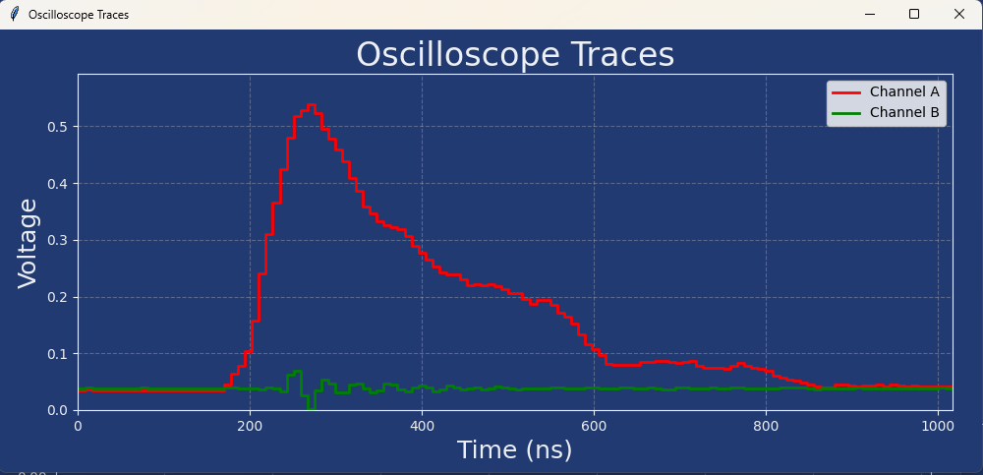
If available, start with a Cs-137 source, as it gives the simplest spectrum, with just a single 662-keV gamma-ray line. Otherwise, use a Na-22 source but be aware that there is a second peak about a factor of 2.5 to the right of the electron-positron annihilation line. The source can be in the PET source box at the center of the apparatus, but you can get much higher count rates and save some time by placing it close (e.g. around 20 cm) to the detector of interest, i.e. detector A.
Figure 3. A pulse from Channel A (in red) for which the Red Pitaya internally triggered on a signal created by a Cs-137 gamma-ray. Here the PMT high voltage was set to a nearly optimal value, not 600 volts. The readout from the other channel is shown in green and exhibits some noise but no gamma-ray signal. Note that the quiescent baselines, often called “pedestals”, are not zero but sit close to 50 mV.
If you have a radioactive source in the PET source box, then use the GUI to move the linear stage such that the middle of the source box falls roughly along a line connecting the two gamma-ray detectors. In the left menu, under the heading “Move or Rotate Stage,” set the direction and distance, in millimeters, of the translation. The direction “left” is away from edge of the apparatus along which the blue electronics box is mounted. Then click the “Move Stage” button.
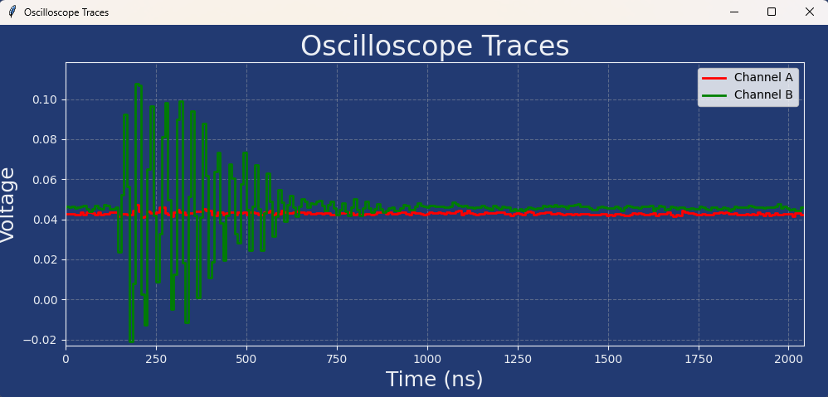
Under the “Acquire Data” header of the GUI, set “Number” to give a reasonable number of triggers, say 100 (with “Time” kept at zero), choose Channel A. Set the trigger type (“Trg Type”) to “internal” and the trigger level (“Trg Level”) to 0.10 volts (although see below about optimizing this value). Important: select “peak” for the histogram type. That will tell the Red Pitaya program to record the peak voltage of each signal pulse instead of the integral. Enter 5 into the “Num Traces” box, to tell it to send back five full oscilloscope traces. Then click the “Acquire Data” button to start the data acquisition. A message will alert you when it has finished, and five windows should pop up to display plots of voltage versus time for the first five triggers, each similar to what you would see on the screen of a digital oscilloscope. Figure 3 shows a typical example. Of course, you can set “Num Traces” to a larger value if you want even more windows to pop up, but be aware that you will have to delete them all manually. If many or all the oscilloscope traces look like noise (see Figure 4), then start over with a higher threshold. You can see in the traces the quiescent level of the signal. Typically it is around 0.05 volts, as evident in the figure, in which case a 0.10 volt threshold should avoid most noise triggers.
Figure 4. A pulse from Channel B (in green) for which the Red Pitaya internally triggered on noise in that channel. The other channel is shown in red. If many or most of your pulses look like this, then the internal trigger threshold should be raised, by 0.01 volts at a time. This kind of noise represents electronic pickup from a noise source outside of the analog signal detection and processing chain, e.g. switching power supplies and various digital activity, or even noise from the A/C plug. The red trace shows the level of voltage noise from the signal chain itself, which is very low. PMTs are remarkably low-noise devices, and the amplifiers do not add much voltage noise. Occasionally the PMT will emit a current pulse from a single electron or two spontaneously emitted from the cathode and then amplified, but such a pulse will look like a small signal, not a rapid oscillation as shown here. Also, note here that the signal baselines are not zero but rather sit at “pedestal” values of close to 50 mV.

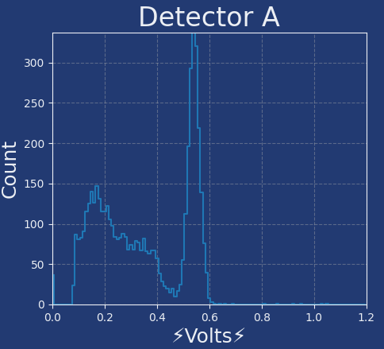
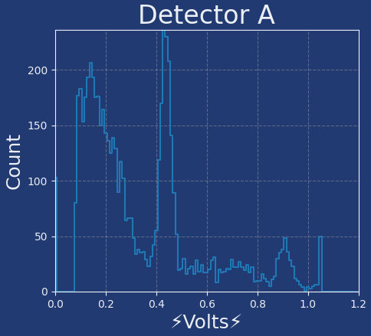
Then, click the “Spectrum” button to pop up a histogram of the pulse amplitudes from your data acquisition. The Red Pitaya digitizers will measure only up to 1 volt, which is why the histogram range defaults to 1.2 volts in the GUI. It is important that the signal does not stray above 1 volt very often, as that will truncate the energy measurement and create nonlinearity in the spectra that you later measure. You control this by varying the high voltage, but to do so, you need to be able to see the 662-keV peak or the 511-keV peak. A useful spectrum will show relatively high counts at the threshold and then fall off with increasing voltage, eventually rising to a peak at the gamma-ray line. See Figure 5 for a good example of results obtained from Cs-137 at an undisclosed high voltage. If you see just a maximum near the threshold that falls off but never makes another clear peak, then you need to raise the high voltage. Do so in steps of 10 to 20 volts until the 662-keV peak is at around 0.5 volts or the 511-keV peak is at around 0.4 volts. Be aware that the maximum voltage allowed for these gamma-ray detectors is 1000 volts, so do not exceed that setting (the software, in fact, should refuse any setting above that limit). You should find that an optimal high voltage setting is well below that upper limit. You should also see that 10 or 20 volt changes around the optimum make rather large changes in the peak position. Note that with the Na-22 source, the largest signals will come from the 1.27 MeV gamma rays (or the uncommon situation in which one detector gets hit simultaneously by the 1.27 MeV gamma and one of the 511 keV gammas). We want that 1.27-MeV line to fall within our spectral histograms, which is why we position the 511 keV line at around 0.4 volts. Once you think that you are seeing a gamma-ray peak, increase the number of triggers, to 10,000 or more, to get a clearer view of the spectrum.
Figure 5. An example spectrum from a Cs-137 source, showing clearly the 662 keV gamma-ray line at just above 0.5 volts pulse peak amplitude. The counts below the peak, which start at the 0.08-volt threshold, are “noise”. Such “noise” is mostly not simple electronic noise but rather comes from real gamma-ray signals not completely contained within the detector as well as real signals from other gamma rays, X-rays, and ionizing particles of the local environment. The PMT high-voltage setting used here is close to optimal, not the suggested starting value of 600 volts.
Figure 6. An example Na-22 spectrum of peak signal pulse heights from 30,000 triggers using the same high voltage setting as used for the Cs-137 spectrum shown in Figure 5.
If the internal trigger threshold is too low, then you will often see short noise pulses instead of long pulses from gamma rays. If many of your signals look like noise pulses, then raise the threshold setting. It is set by the “Trg Level” value under “Acquire Data” in the GUI. Note that this option is available only if the “Trg Type” setting is “internal.” Higher thresholds will eliminate noise, but if the threshold is set too high, then it will start cutting into the efficiency for detecting 511 keV gamma rays.
If you do not see any noise triggers, lower the threshold until you see mostly noise triggers. Then raise it in 0.01-volt steps just until you no longer see a noise trigger in five successive oscilloscope traces. Use that threshold setting to produce your gamma-ray spectra in the next section.
When you have finalized settings from Channel A, repeat the procedure for Channel B. The settings should be similar for the two channels, so when studying Channel B you can start with the settings found for Channel A. For a given high voltage, the two PMTs will not have the same gain, so the optimal settings will not likely be exactly the same. Ideally you will find high voltage settings that give the two channels roughly the same gain.
Finally, using your optimal threshold and voltage settings, make a nice spectrum for each channel using a Na-22 source with at least 10,000 triggers. Make sure that you can see clearly both gamma-ray peaks, as well as “noise” that peaks well below the 511-keV line. The 1.27 MeV line should be fully contained at a voltage less than unity. Figure 6 shows an example from 30,000 triggers, made using a 1 µC Na-22 source placed about 20 cm from Detector-A. The voltage setting that was used was close to being ideal. as the 1.27-MeV gamma line was just fully contained below one volt. The rise in “noise” below the peak is not due to electronics noise as see in Figure 4. Such noise tends to integrate to nearly zero. Instead, it is due to lower-energy signals caused mostly by 511 keV gamma rays that strike the detector but then scatter out before depositing all their energy in the NaI crystal. Similarly, a lot of the counts above the 511 keV peak are very likely due to 1.27 MeV gamma rays that are not fully contained in the NaI crystal.

The Gamma-Ray Spectrum and Energy Calibration
In this section, you produce gamma-ray spectra for the Na-22 and Cs-137 sources and use them to calibrate the energy scale for each of the channels, based on the known gamma-ray energies from those sources. The procedure makes use of the internal trigger to acquire spectra separately for each of the two channels, so the internal trigger threshold should be set according to the procedure of the previous section, and the two high-voltage supplies should be set such that the two channels have similar gain. The big difference from the procedure in the previous section is that here you must choose “integral” for the histogram type, and your objective is to establish a gain setting that gives you a scale properly calibrated in keV units.
Start this procedure with a Na-22 source. Under the “Acquire Data” heading of the GUI, keep “Time” set to zero and set “Number” to acquire tens of thousands of triggers, although it may be wise to start with a smaller number until you are confident that you are seeing the full spectrum withing the bounds of your histogram. Choose a channel for the trigger (“Trg Chan”) and later repeat the procedure for the other channel. The trigger type, “Trg Type” should be set to “internal”, with “Trg Level” set according to your calibration of the selected channel. The trigger hysteresis “Trg Hyst” can be left at zero, and the “Hist Type” must be set to “integral”. The source box should be roughly aligned between the two detectors, although if you would like to speed up the process, you can move the source closer to the chosen detector. Do not put it up against the detector, no closer than about 20 cm, as close proximity will produce a trigger rate way beyond the capability of the data acquisition and result, for the Na-22 source, in too many undesired coincidences between the 1.27 MeV gamma and the 511 keV gamma.
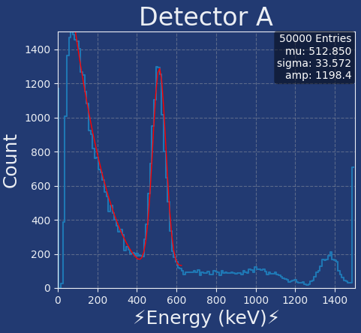
Click the “Acquire Data” button to start the data acquisition. When it is finished, clicking the “Graph” button will display the spectra for the two channels. Ignore the spectrum from the channel not used in the trigger. The spectrum from the selected channel should look more-or-less like the example shown in Figure 7, except that the energy calibration initially will not be correct. The GUI will attempt to fit a Gaussian curve or a Gaussian plus polynomial background, as shown in Figure 7, depending on whether “Bckgnd Fit” is set to “yes” or “no” in the GUI under the “Spectral Plot” heading. This nonlinear fit is sensitive to the initial guesses for the Gaussian mean and sigma, which are taken from the GUI settings under the “Acquire Data” heading. You can adjust those values to make the “Spectrum” button fit the 511 keV peak, the Cs-137 peak, or the 1.27 MeV peak. Just be careful to change the values back to correspond to the 511 keV annihilation peak before doing your PET scan, as the values set in the GUI are used to select events corresponding to electron-positron annihilation (see below) as well as to initialize the Gaussian fit.
Figure 7. An example of a Na-22 spectrum acquired, plotted, and fit by the PET GUI. The 511 keV peak is calibrated to appear at the correct energy, but then the 1.27 MeV peak appears at too high an energy, indicative of remaining nonlinearities in the energy measurement.
The Gaussian fit may fail due to the initial guesses being bad or because one or both peaks are out of range. In the former case you can alter the guesses and click “Spectrum” again. Also, the data that are plotted and fit are written by the “Acquire Data” process to the local PC folder under the name “histData.csv”, in case you would like to plot and fit the spectrum by other means. However, for the initial iteration of this procedure, estimating the peak positions by eye should be sufficient. If the energy calibration is so far off that you do not see the gamma-ray peaks at all within the histogram range, then either you will have to guess better values or enlarge the histogram range before trying again.
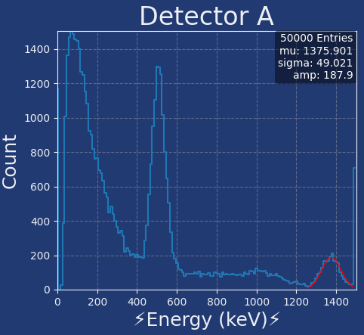
Either from Gaussian-fit results or by eye from the plots, find the locations of the two peaks. Calculate energy-calibration factors according to 511.0 divided by the estimated position of the 511 keV peak and multiply that ratio by the values that were in the “Calib A/B” GUI box for the selected channel under the heading “Scan & Acquire Data” when your data acquisition was executed. Type the result into the appropriate “Calib A/B” GUI box and repeat the above procedure. Then you should find the annihilation peak close enough to 511 keV that the Gaussian fits will work. Iterate this procedure until you are confident that the energy well is calibrated. What is the ratio of the fitted energies of the two gamma-ray peaks? In principle it should be reasonably close to $1275/511≈2.5$, but non-linearities in how the system measures energy will prevent the ratio from being spot-on.
Figure 8. This is the same Na-22 spectrum but with the gaussian fit (without background) applied to the 1.27 MeV peak, which appears about 9% high relative to where it should be if the energy measurement were linear.
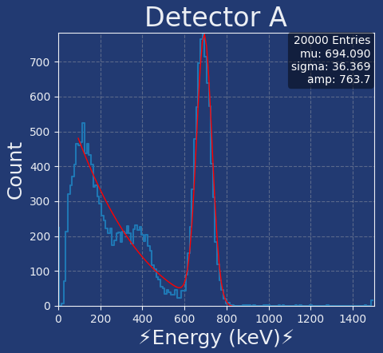
Figure 8 shows a Gaussian fit to the 1.27 MeV gamma-ray peak, illustrating the amount of nonlinearity that remains in the energy measurement. Repeat the procedure with the Cs-137 source and verify that the gamma-ray peak is consistent with the known energy of 661.7 keV. Again, the result will not be exact, due to some system non-linearities as well as statistical error. See Figure 9 for an example. To visualize the nonlinearity in the energy measurement it is interesting to plot the three results and fit a straight line, as is done in Figure 10. There you can see that the measurement is, in fact, fairly linear, with the apparent nonlinearity being due to a negative offset in the measured value. That would seem to suggest a problem with the pedestal subtraction, but the pedestals values used were correct. The problem seems to be more connected with the pulse integral not being a reliable estimator of energy. An alternative would be to use the peak pulse height instead, but that tends to error in the opposite direction, as can be seen in Figure 6. Nevertheless, Figure 10 shows that simply adding a constant value to all the measured energies would give a fairly nice linear fit passing through the origin. The system could be improved for spectroscopy by replacing the transimpedance amplifiers by slower charge-integrating amplifiers, but for the PET scans it doesn’t matter, since the only important energy range is that which includes just the annihilation peak. We just need a good measurement of the location of the 511 keV peak and its width.
Figure 9. The measured Cs-137 spectrum. The fitted peak position is about 5% high relative to where it should be if the energy measurement were linear.
When finished with this section, the “Calib A” and “Calib B” values in the GUI should be set such that the spectral plots appear correctly in units of keV, as long as you continue to operate at the same high-voltage values used in the calibration procedure. From the fitted mean and width of the Gaussian fit to the 511 keV peak, set the “Mean” and “Sigma” values under “Scan & Acquire Data” in the GUI. Those are important, because they are used during a PET scan to select events that clearly have a 511 keV photon in each detector. Only those events will be used for making the final image. Of course, the “Mean” value should be 511, or very close to that. The “Sigma” is assumed to be the same for the two detectors, but that will not be exactly true. You can just use the average of the fit values from the two channels.

External Trigger Threshold and Coincidence Window
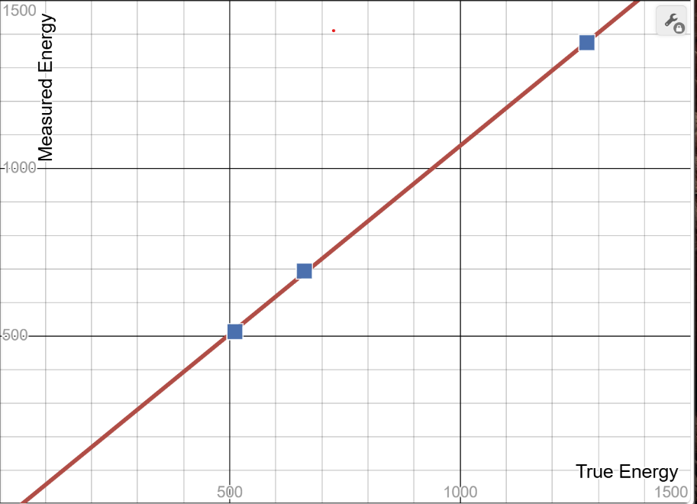
PET scans require use of an external trigger generated by the coincidence board. That board has two threshold settings, one for each channel, which are set by loading digital numbers into two of the DACs located on the board. If you managed to calibrate the gains of the two channels to be roughly the same, then the two DAC settings can likewise be equal. They are established by entering the values in millivolts under “Set Threshold” and then clicking the “Set Threshold” button. The analog value output by each DAC gets digitized by a slow ADC in the Red Pitaya, with the result reported back to the GUI. It is always close to the selected setting, within a few millivolts, except when the setting falls below about 70 mV.
Figure 10. Plot of the actual gamma-ray energy versus the measured energies from the Gaussian fits. The red line represents a linear regression, or line-fit, to the three points.
Note that the discriminators for the external trigger see a signal twice as high as those internal to the Red Pitaya (as used for the internal trigger) because of the 6 dB attenuators placed between the amplifiers on the discriminator board and the Red Pitaya digitizer inputs. Furthermore, requiring a tight time coincidence gives a powerful suppression of noise, allowing the thresholds in principle to be set quite low. However, the true threshold is about 150 mV higher than the digital setting, because of the positive feedback applied to the discriminators, so you will not be able to apply a very low threshold. In any case, you should not expect the optimal external threshold settings to be equal to your internal threshold settings.
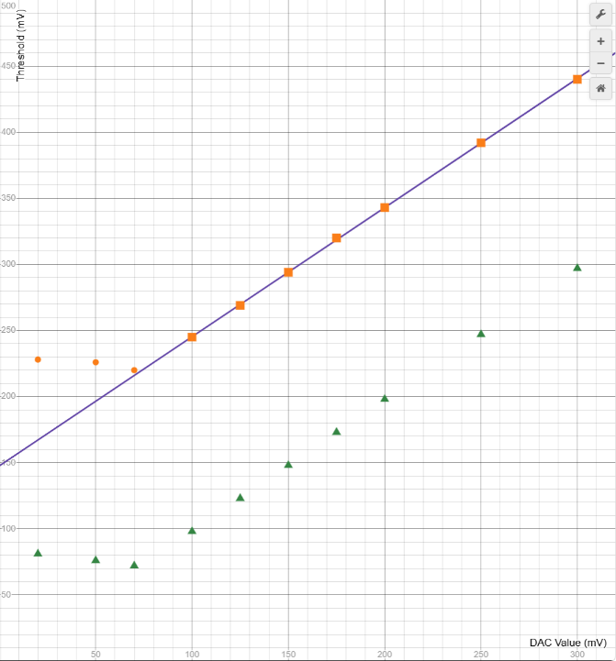
The timing chips used to set the coincidence window (see below) cause a practical limit to be set on the thresholds, however. When the PMT pulse is falling from its peak value, it frequently makes upward fluctuations that can cause the discriminator to create extra output pulses following the initial pulse. That confuses the logic of the timing chips, which then tend to get stuck in a high output state. Therefore, we had to create a strong “hysteresis” in the threshold, such that the downward-going threshold is lower than the upward-going threshold by nearly 150 mV. That ensures that after-pulses are very unlikely to occur. Figure 11 shows measurements of the threshold versus DAC setting. The lower threshold, for a downward-going signal, is very close to the DAC setting, whereas the upper threshold, for an upward-going signal, is 148 mV higher. For unknown reasons, the measured DAC output fails to reflect the setting below about 70 mV, so the lowest achievable threshold setting is 220 mV, corresponding to a DAC setting of 70 mV. In the following procedure, you will verify that, nevertheless, this minimum threshold is fully efficient for 511 keV gamma rays, by showing that the counting rate of good coincidences (i.e. both energies measuring close to 511 keV) does not immediately fall as the threshold is raised.
Figure 11. Measurements of the threshold voltage versus DAC setting, made using a DVM to probe the printed circuit. The green triangles show the measured DAC output voltage (as digitized by the Red Pitaya), which is always very close to the setting until it falls below about 70 mV. Orange squares and circles show the threshold voltage applied to the comparator when its output is low. The regression line is $y=0.977∙x+148$.
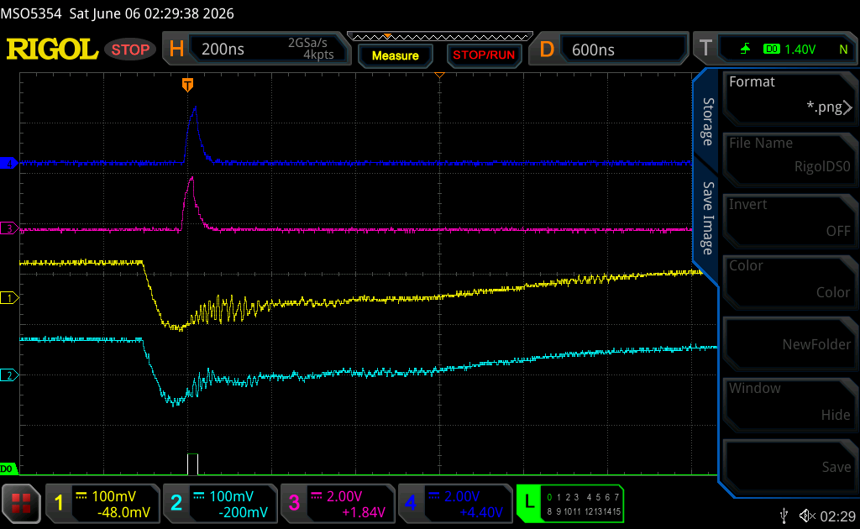
To study the external trigger thresholds, make sure that the source is well centered between the detectors. The surest way to do this is to acquire data with the external trigger at several locations around what looks centered and then choose the location with the highest coincidence rate. (That can even be automated by running a “Scan” for a single angle; see Section 8 for details). Then, run “Acquire Data” for a fixed live time, e.g. 5 minutes, and successively change the thresholds, keeping them equal for the two channels. Most of the triggers should yield a back-to-back pair of 511 keV gamma rays, until perhaps the thresholds get too low, allowing a lot of random coincidences with background. In practice, at the lowest achievable setting you will very likely see little to no background, and only above some significantly higher setting will you start to see loss of efficiency. Make a plot of the number of positron-electron annihilations detected (as printed out by the GUI in the status window at the end of the acquisition) versus threshold, from 70 mV up to at least 400 mV. Be sure to use your calibrations so that the annihilation peak appears at the right energy with a width consistent with the “Sigma” value shown in the GUI. Otherwise, the annihilation count will not be correct. Include statistical error bars on your points (i.e. equal to the square root of the counts).
Figure 12. Example oscilloscope view of a 511 keV gamma-ray coincidence. The yellow and cyan traces are respectively the raw detector signals (prior to amplification) for Channels A and B. The magenta and blue traces are the respective discriminated pulses with fixed length of 30 ns each. The digital signal labeled “D0” is the coincidence pulse that is fed to the Red Pitaya as the external data-acquisition trigger to capture the digitized data.
The effectiveness of the coincidence for background rejection is enhanced by decreasing the width of the coincidence window. However, if the window is too narrow, valid events can be lost due to time fluctuations in the signals from the two channels. The widths of the two pulses from which coincidences are formed are set by entering values, in nanoseconds, under “Set Timing” and then clicking the “Set Timing” button. If you have an oscilloscope handy, you can view the two pulses from the “A” and “B” BNC connectors on the front panel of the blue electronics box, and the “Trigger” BNC connector will give you the digital coincidence signal to view as well. Figure 12 shows an example with 30 ns pulse widths. Due to the finite rise and fall times, significantly shorter settings may not work at all. Larger settings will give blue and magenta pulses that are flat on top.
To optimize the coincidence window, set “Coinc Win” to a large value, e.g. 50, in the GUI under “Scan & Acquire Data”. That value sets a software cut applied after the data are acquired, and a small value can mask the effect of a large hardware window. Then, using your preferred threshold setting, run acquisitions for fixed lengths of time (at least several minutes for good statistical precision) using the external trigger, while decreasing the values under “Set Timing.” Always keep the timing windows equal for the two channels. When the window gets too narrow, the number of coincidences within the 511-keV peak region in a given elapsed time will decrease. Too large a window will allow all the 511-keV coincidences to get through but could also show additional background rubble, which is what we want to eliminate. For each acquisition, record the number of events in the annihilation peak and the number of events in the entire histogram. Based on your observations, set the window as narrow as possible without any significant, noticeable loss of efficiency.
Then, repeat the process keeping the hardware window fixed but decreasing the “Coinc Win” value in the GUI. It should also be set as low as possible without loss of efficiency. It is an integer value with units corresponding to the digitization period of 8.1 ns, so the lowest possible setting is unity, which would have the effect of requiring the two pulses to cross the software threshold determined by the GUI “Pulse Thresh” parameter within 8.1 ns of each other. The “Coinc Win” parameter clearly is nearly redundant with the hardware window, but it is not identical. It has larger increments in its possible values and relies on a threshold that is different from the hardware threshold.

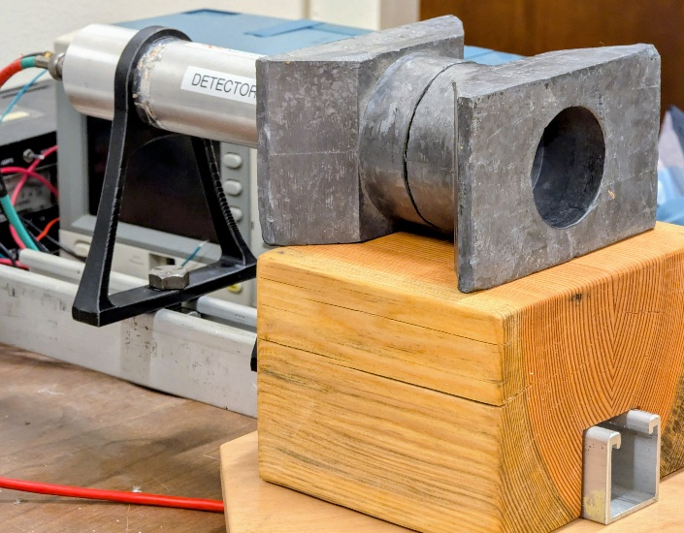
Measuring the Activity of the Source
Figure 13. Placement of two lead collimators, each with half-inch diameter holes (not visible), with the Na-22 source placed along the symmetry axis a short distance away. This arrangement is for measuring the source activity.
This procedure is not necessary for making PET scans but is pedagogically useful. Place two lead collimators in front of one of the detectors as shown in Figure 12, making use of the special wooden block as support. (Wash your hands afterwards if you have touched the lead with bare skin.) Set up a single Na-22 source at a measured distance from the entrance to the smallest diameter hole in the collimator. Keep the distance large enough that the probability of getting two gamma rays simultaneously in the same detector is small. A single 1-µC source located 20 to 30 cm from the collimator hole would serve well. Run “Acquire Data” for a fixed length of time. From the number of counts in the 511-keV peak, estimate the activity of the source. How well does your result agree with the initial activity and date printed on the source? You must account for the decay of the source over the intervening years and months since it was created.
Besides the source half-life, there are several other details that must be quantitatively considered for this measurement to make sense:
- Data acquisition deadtime. During a run the data acquisition misses triggers if they occur while the system is working on reading out the previous trigger. This should already be accounted for by the timing in the C++ code. When you specify the run time (and set the number of desired counts to zero), the system counts the time during which the system is ready to accept a trigger as well as the total run time. The ratio of the two is the live-time fraction, and the live time is what the software uses to stop the run. However, the live time may be slightly longer than requested, because for reasons of efficiency, the code does not check the time at every trigger iteration. You may request, instead, a given number of triggers. In either case the system will report at the end the elapsed clock time and the fraction of time for which the trigger was “dead”. The product of the two is the live time.
- The solid angle subtended by the detector (the area of the detector divided by the square of the distance from the source). The source emits gamma rays randomly over the full 4π solid angle, but don’t forget to account for the fact that each decay results in two gamma rays that are exactly back-to-back. Also, remember that 10% of the decays are electron capture and therefore give no annihilation gamma rays. Note that the sodium-iodide crystals of the gamma-ray detectors are 1.5 inches in diameter, and the smallest collimator hole is 0.5 inches in diameter. The entrance to the smaller hole in the collimator is an inch or more from its exit, because that much lead is needed to stop most 511 keV photons. It is hard to say without detailed simulation exactly what distance should be used in the solid-angle calculation. The average of the minimum and maximum is a reasonable choice for our purposes.
- The thickness of the sodium-iodide crystals (2.25 inches). A fraction of the 511 keV gamma rays will pass through the crystal without any interaction at all. The thickness of NaI needed to reduce the gamma-ray intensity by one half is about 1.1 cm. From that you can show that this effect is small and fairly negligible compared with the uncertainty in some other effects.
- Overlap of the 1.27 MeV gamma ray with the 511 keV gamma ray. This should be rare unless your source is quite close to the detector, but when it happens you may see a count at the sum of the two energies. Because of the much larger uncertainty below, this effect can be neglected.
- Edge effects unfortunately are significant. That is, if the gamma-ray hits the crystal close to an edge, some of the energy may leak out, thus reducing the light signal and moving the count out of the 511 keV peak. The collimator reduces this effect but does not eliminate it. In this energy range gamma rays interact with the crystal primarily by Compton scattering, with a mean free path of about 1.6 cm. In fact, several Compton scatters typically occur before the remaining photon energy gets absorbed by other means, such as photoelectric absorption. Each scatter will deposit some energy in the crystal and produce some light as the scattered electron slows down and stops. The scattered photon may exit the side or back of the crystal. Therefore, counting only events that fall within the 511 keV peak gives a rough underestimate of the source activity. However, estimating the size of this effect is not possible without extensive “Monte Carlo” computer simulations. A simpler solution is to make a “background” run with the source put away in its cabinet. Compare the spectrum below 511 keV with that obtained from the Na-22 source and count the difference, as well as the Gaussian peak, as being due to valid 511 keV photons hitting the detector. In this way you can get at least an order-of-magnitude estimate of the source activity.

PET Scan Procedure
Once the system is set up and calibrated, running a PET scan is highly automated by the GUI and the Red Pitaya software. That is important, as the procedure is slow, due to the limitation that we instrument a very small fraction of the full solid angle, with just two small gamma-ray detectors. The time required will depend on the distance from the source box to the detectors. Moving the detectors closer will speed up the process but will also decrease the angular resolution in the final image.
Before starting a scan, make sure that all the correct calibration information, pedestals, voltages, etc. are set in the GUI according to values determined in the preceding sections. Beware that if you restart the GUI, your values will be lost, as it will revert to the defaults. As explained in Section 5, you can avoid this problem by keeping your values in a JSON file for the GUI to read upon startup.
Also, before starting you should zero the rotation stage. You can do that manually if the power is turned off, but please do not turn the knob manually while the 24V power is on. The GUI “Rotate Stage” control can be used to rotate the stage by specified amounts, in degrees, either forward (clockwise, looking down) or reverse. Look under the grey source box to see the degree marking on the stage. We recommend that you get it positioned such that $-90$ degrees aligns with the pen marking that should be visible on a piece of tape applied to the stage. Then zero is aligned with the line passing between the two detectors, and you can enter zero for the starting angle of the scan.
In the “Scan” menu, specify the initial angle of the stage (“Angle 0”), the number of angles, and the step in degrees between angles (“Angle Step”). Probably you will want to make a scan every 10 to 20 degrees, up to 180 degrees (because of symmetry, there is no need to go to 360 degrees). Then, for each angle you specify the number of linear steps (“# Steps”), the initial position (“X0”), and the “Step Size”, plus the “dwell time”, which is the live time spent acquiring data at each step. You need to be sure to make the linear-scan range large enough to pass all the Na-22 sources in the box through the region between gamma-ray detectors at any angle. It is a good idea to test the scan with fewer angles, a larger step size, and a shorter dwell time to make sure it is going to work before starting a scan that will require multiple days to complete. In particular, make sure that at the beginning and end of each linear scan for a given angle the annihilation count is zero or close to zero. That will indicate complete coverage of the sources.
In your final, long run, take care in selecting an appropriate dwell time. It is crucial that the acquisition run for the same live-time at each position and angle, and the longer this time is, the better will be the statistical precision of the final image. However, your time is limited. Decide on the maximum time available to do your run, e.g. 48 hours, and then divide the time in seconds by the product of the number of position steps and the number of angles. Decrease it by about 10% to account for data-acquisition deadtime. In general it should be at least a couple of minutes.
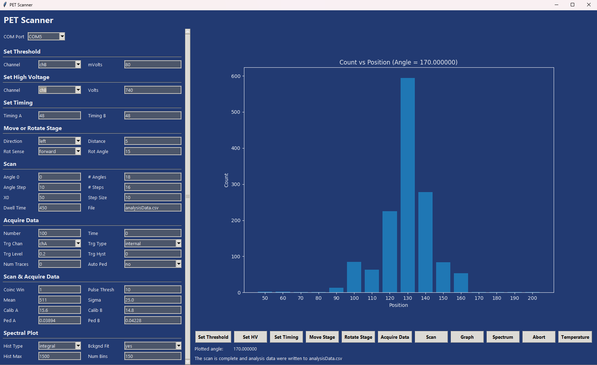
When all the parameters are set, click the “Scan” button to start the PET scan. After each full linear scan you will see the profile of the number of 511-keV pairs versus box position on the GUI screen. See Figure 14 for an example plot. The plot information is also added to the output data file whose name is specified in the “Scan” menu. At the end of every data acquisition at a given angle and position, the observed gamma-ray spectrum will pop up in a new window. Each spectrum should show little more than the 511-keV peak, because the system is set up to trigger on only gamma-ray coincidences. When the scan finally finishes, the output data file should contain all of what you need for your image reconstruction. It will be essentially a table of counts in which each row corresponds to a particular angle, and each column corresponds to a linear position.
Figure 14. View of the GUI plot that appears after a linear scan has completed. On the left are the data as they appear in the file tempData.csv. (Note: the angle listed here should be 80 degrees, as indicated in Figure 15. The initial value was set wrong in the GUI and corrected after the fact.)
If the scan terminates prematurely, for example because of a power failure, nearly all the data already taken should be safely stored in the output file (default name “analysisData.csv). You can restart the scan at the angle it was working on when it terminated. Just be careful not to overwrite the old output file. Either rename it or give the new output file a different name. Later, you can combine them in a text editor. Figure 15 shows the output from an example scan (which was started from angle $-90°$ instead of zero).
Figure 15. Example output data file from a scan that lasted a couple of days.

Image Reconstruction
There are multiple methods to reconstruct an image from PET data. In fact, the methods are essentially the same as are used to reconstruct X-ray CT images. They rely on the mathematical concept of a “Radon Transform”, analogous to the more familiar Fourier transform. It is an integral transform that maps a function defined on a plane to a function defined on the space of lines in that plane. For each line, the transform gives the line integral of the function along that line. Image reconstruction corresponds to an inverse Radon transform. That is, given the line integrals of all lines in the plane, one can reconstruct the original function. A PET data acquisition at a given point and angle provides a count of annihilations occurring along a line passing through that point and going from one gamma-ray detector to the other. That is essentially an integral along that line of the quantity of positron-emitting radioactive material, except that it is, of course, a statistical sample reflecting the random nature of radioactive decay. The PET scan provides a finite set of such line integrals. A true inverse Radon transform would require an impossible uncountably infinite set. Therefore, your image reconstruction will necessarily be approximate, reflecting the finite number of scan angles, the discrete steps of each scan, the statistical fluctuations of the counts at each point, the fairly course angular resolutions of the detectors themselves, and the presence of a small number of background counts.
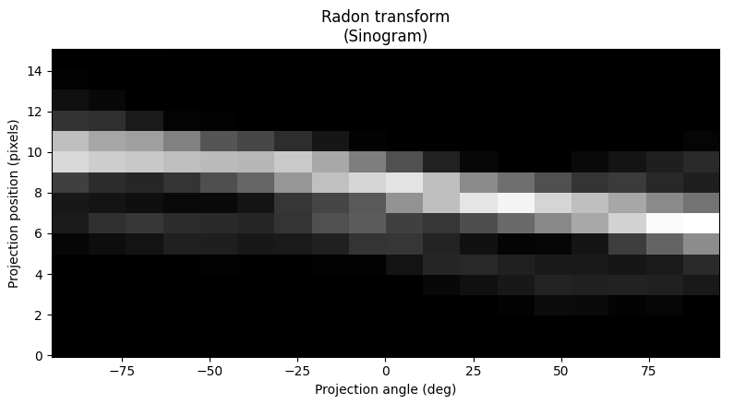
The most common method of image reconstruction in computed tomography is the “filtered back-projection”, or “FBP”. Nice, simplified explanations can readily be found online, so we will not attempt a detailed explanation here. Back-projecting the data is itself a pretty simple idea and may at first appear to be sufficient. The problem with it is one that is endemic to all methods in which one tries to reconstruct a continuous distribution from a finite set of data by “inverting” the experimental effects (such as resolution, efficiency, discreteness, etc.). Noise of high spatial frequency will enter and blur the result. It is necessary to filter or regularize the data first, to eliminate the higher frequencies that are beyond the statistical and resolution limits of the measuring apparatus. Computation-intensive iterative reconstruction methods, such as the “simultaneous algebraic reconstruction technique” (SART), can in some cases outperform the FBP, but we recommend for this experiment to stick with the FBP.
Figure 16. Graphical representation of a sinogram from the PET scanner, in which the annihilation counts are represented as shades of gray. The data are from Figure 15, but matrix-transposed.
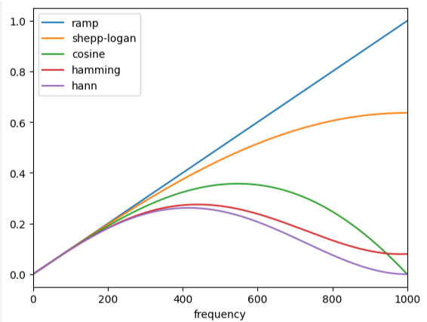
Good implementations of the FBP exist in Python (e.g., import “iradon” and “rescale” from the package “skimage.transform”), so the recommended way to do your image reconstruction is within a Jupyter notebook using Python coding. If you take the counts data from your PET scan, as written out in the .csv file, but with the dates and header information removed, and then transpose the matrix so that the columns correspond to angles and the rows to positions, then you will have what is known as a “sinogram”. Use “loadtxt” in the “numpy” package to read the data from the .csv file. The “delimiter” option should specify the comma as the separator, and the “skiprows” and “usecols” options can be used to pick out just the counts. Numpy can also easily do the matrix transpose. Figure 16 shows an example sinogram in graphical format. We use the “Matplotlib” package to do all plotting. For example, the code used to produce Figure 16 is as follows. Note again the angle range starting from $-90°$. You may want to start from zero, as suggested above, but just be consistent. Here, “sinogram” is the array of data from the scan, with the first index being the set of angles and the second being the set of positions along that angle.
Figure 17. Various filters available for use in the FBP.
import numpy as np
import matplotlib.pyplot as plt
fig, ax = plt.subplots(1, 1, figsize=(8, 4.5))
theta = np.linspace(-90, 90, sinogram.shape[1], endpoint=False) #set of all the rotation angles
dx, dy = 0.5 * 180.0 / sinogram.shape[1], 0.5 / sinogram.shape[0] #just some offsets at axes ends
ax.set_title("Radon transform\n(Sinogram)")
ax.set_xlabel("Projection angle (deg)")
ax.set_ylabel("Projection position (pixels)")
ax.imshow(
sinogram,
cmap=plt.cm.Greys_r,
extent=(-90-dx, 90 + dx, -dy, sinogram.shape[0] + dy),
aspect='auto',
)
fig.tight_layout()
plt.show()
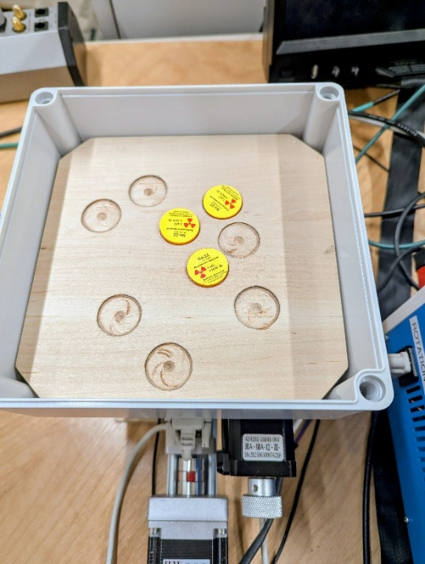
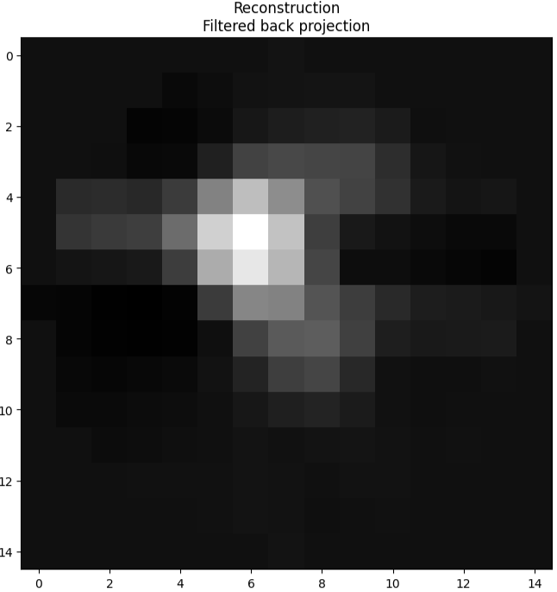
Figure 18. Example reconstructed image from the PET scanner. The two scales are labeled by pixel number rather than in mm, but each pixel is 10 mm square in this case. The “hamming” filter was used in the back-projection. On the left is a photo of the sources in the same orientation as the reconstructed image (i.e. the starting angle of $-90°$).
The skimage package has several choices of filter to use with the FBP algorithm. The following code makes plots of all of the choices (see Figure 18):
import matplotlib.pyplot as plt
from skimage.transform.radon_transform import _get_fourier_filter
filters = ['ramp', 'shepp-logan', 'cosine', 'hamming', 'hann']
for ix, f in enumerate(filters):
response = _get_fourier_filter(2000, f)
plt.plot(response, label=f)
plt.xlim([0, 1000])
plt.xlabel('frequency')
plt.legend()
plt.show()

Doing the FBP and plotting the final reconstructed image is simple, given the tools available. For example, the following code will run the iradon algorithm and plot the results (see Figure 18):
from skimage.transform import iradon
reconstruction_fbp = iradon(sinogram, theta=theta, filter_name='shepp-logan')
imkwargs = dict(vmin=-0.2, vmax=0.2)
fig, ax = plt.subplots(1, 1, figsize=(8, 8))
ax.set_title("Reconstruction\nFiltered back projection")
ax.imshow(reconstruction_fbp, cmap=plt.cm.Greys_r)
plt.show()

When you have finished your image reconstruction, open the source box and measure the source locations. For each source estimate the activity based on the original activity and the date that the source was made. It is not possible to see within a given source exactly how the radioactive material is distributed, but it is probably safe to assume that it is nearly a point at the center of the circular source. Compare with your reconstructed image. Are the centers of the image peaks at the correct source positions, and do their relative height reflect reasonably well the different activities?

Conclusion
We hope that this experiment has been an educational introduction to a technology that has had, and continues to have, a major impact in modern medicine, as well as an introduction to experimental techniques for gamma-ray detection, coincidence counting, calibration, etc. The image that you reconstructed is two-dimensional. If the arrangement of sources were three-dimensional, the same technique can be used, but with an additional, vertical scan direction. That is, just repeat the same procedure at a set of different heights. Each such scan at a given height would image a slice of the overall object. In fact, the word “tomography” is derived from an ancient Greek word for “slice” or “section”. A set of image slices or “tomograms” can be put together to form a true three-dimensional image, but perhaps just as often it is useful for a doctor to look at the individual slices.

John Sunderland, Imaging with Antimatter, Physics Today Volume 78, Issue 9 (Sep. 2025) p. 28, (https://doi.org/10.1063/pt.pswd.fhis).
Its biological half-life, however, is typically only around 11 days, since the body actively excretes sodium salts. In that sense, it is safer than, for example, Cesium-137. Nevertheless, it should never be ingested!
The sodium iodide is “doped” with a small amount of thallium. These impurity atoms absorb energy from electrons scattered by the gamma ray, and when they de-excite they emit optical photons that can be detected by a PMT.
The fast but complex USB protocol is not directly used. Instead, an old-fashioned, asynchronous, and relatively slow UART protocol is used (115200 bits per second). An Adafruit Industries USB to TTL module is used to interface the USB cable to the Red Pitaya UART signals. Special drivers on the PC then implement the UART protocol at that end of the USB cable.
There is also a Gen-1 STEM-Lab 125-14 Red Pitaya available to use as a spare, in case the Gen-2 device breaks.
It helps that most of the gamma rays pass right through us without any interaction!
Some of the natural radiation exposure comes from radioactive isotopes in your body, such as potassium-40 (~0.1µCi) and carbon-14 (also ~0.1µCi).
If you simply input the PMT signal into the oscilloscope’s one-megohm input impedance without the 50-ohm termination, it will rise quickly to a maximum negative voltage and then decay very slowly with a time constant determined by the product of the PMT plus cable capacitance times the one megohm resistance.
Each signal going to the digitizers first passes through a 6 dB attenuator, cutting its voltage by one half, to minimize overflow of the digitizer, which digitizes up to only one volt. Of course, lowering the high voltage would have a similar effect but would also decrease the amplitudes seen by the discriminators on the coincidence board.
A technical detail is that the comparator makes use of positive feedback to produce a hysteresis effect, such that the threshold for an upward-going pulse is higher than the downward-going threshold. This prevents rapid multiple transitions produced by noise fluctuations in the signal. Another technical detail is that the comparator does a logic inversion (its output is high when its input is below threshold), so a simple digital inverter chip follows the comparator to make the 5 V positive digital pulse.
The C++ code, the Python GUI code, the documentation, and the electronics design are all archived on github. Anybody can freely obtain everything from https://github.com/robertprestonjohnson/Physics134-PET. Within the Red Pitaya, the code is in the folder /root/PET. The account is password protected, because some careless code modifications could destroy hardware, for example by applying too high voltage to the PMTs or driving the linear stage past its limits.
An earlier version of the setup had a Gen-1 Red Pitaya that was powered by a 5V switching regulator, which was in turn powered by the 24V supply. The Gen-2 Red Pitaya, however, makes use of the sophisticated USB-C power protocol. We felt that it would be safest to use the power adapter that came with the device. The Gen-1 device is still available as a spare. Functionally, the two are practically equivalent.
If the Gen-1 Red Pitaya is in use, an expert trying to log into the device via ethernet must be aware that the ethernet connection will fail to start (due to a design error) if the USB-UART cable is plugged into the computer. One would have to unplug the cable before booting and then plug it back in. The design error was fixed in the Gen-2 board, and in any case, it should not be an issue for students, who have no need to log into the Red Pitaya.
For expert debugging only, printout from the Red Pitaya C++ code gets logged in /tmp/RP_PET_Log.txt. Be aware that this file vanishes if the power is turned off, as it is located in RAM, not on the SD card.
The high voltage is controlled by two DACs (digital-to-analog converters) located on the custom PC board inside the blue box. The software communicates with the DACs via a standard two-wire protocol called I2C. Each DAC has a power-on setting value that can be modified via the I2C protocol. We have set it to a low value, and it should not be changed (the GUI doesn’t allow one to change it, but python commands issued from outside the GUI could do it). The DAC output voltages control the two high-voltage supplies.
At the time of this writing, Channel B picks up a lot more noise bursts, such as what is seen in Figure 4, than does Channel A.
Six hundred volts is almost certainly too low but is given here only as a starting point. We could hand you an optimal voltage, but for pedagogic reasons, we want you to do the work to find it yourself.
Random noise, that is, with no correlation between channels. Occasionally, a blast of electrical noise originating outside the system, e.g. on the AC power lines, will hit both channels simultaneously, in which case the coincidence circuit will not give any suppression. Such noise, however, is highly unlikely to give an energy reading near 511 keV simultaneously for both channels.
The amount of hysteresis is set by voltage dividers on the coincidence board, one for each channel, so it can be changed by replacing resistors R62 and R64, unfortunately a laborious process that risks damage to the system. The amount of hysteresis is approximately proportional to the values of those resistors.
Sometimes a false stage stop signal (from noise?) causes the stage to stop prematurely and the scan to abort.
e.g.: https://howradiologyworks.com/filtered-backprojection-fbp-illustrated-guide-for-radiologic-technologists/
Historically, “focal-plane tomography” was invented in the 1930s to image just a slice of an object by positioning the X-ray generator and X-ray detector appropriately to focus only the image from the planar slice. That was done to reduce the confusing superposition of structures inherent in projection radiography. By the late 1970s focal-plane tomography was largely replaced by “computed tomography” or “CT”.

