Local server set-up

If you want to work locally on projects which use network resources such as the Powerview database and the ISEC Oracle databases or you wish to include any of the common files on the network you’ll need to carry out at least some of the steps below to install the relevant drivers and prepare your machine to do so.

First up, if you haven’t already done so as part of your PHP installation, add your PHP directory path to the ‘PATH’ environment variable. Click here for instructions if you’re unsure of how to do this.

Go through the relevant sections below to set up your machine for access to the SQL Server Powerview database, the ISEC Oracle database and to enable single sign-on to the network.

### Include common files stored on the network:

* Use the full server path in your ‘include’ statement
* Escape the first backslash with a backslash – eg "\\\kwlwgd704376\..." ("\\\\kwlwgd704376\..." also works)

### **Enable connections to the SQL Server Powerview database**:

* Install the following drivers:
  + Microsoft Drivers for PHP for SQL Server from [here](https://www.microsoft.com/en-us/download/details.aspx?id=20098). (Please note that there are several versions of the PHP drivers. Determine which to install by using phpinfo() to check your PHP version)
  + Microsoft ODBC Driver 11 for SQL Server from [here](https://www.microsoft.com/en-us/download/details.aspx?id=36434).
* Open the ‘.ini’ file for your PHP installation, locate the ‘Dynamic Extensions’ section and add the following lines, amending to the driver version you installed:
  + extension=php_sqlsrv_56_ts.dll
  + extension=php_pdo_sqlsrv_56_ts.dll
* Ensure you use the right PHP functions (‘sqlsrv_’rather than ‘mssql_’) in your code
* If including the common ‘mod_database.php’ file use the ‘connect_SQLSRV_PVDB()’ function instead of ‘connect_PVDB()’

### Enable connections to the ISEC Oracle database:

* Install the Oracle 11g drivers by running ‘setup.exe’ from here. (You need only install the ‘InstantClient’ for the connection)
* Run Microsoft ODBC Administrator and enter your database connection details on the System DSN tab. For detailed instructions on this click here.

### Enable single sign-on:

* Copy the ‘mod_authnz_sspi.so’ file from here and paste it into the modules folder of your Apache server installation folder (eg “C:\xampp\apache\modules”)
* Copy the ‘sspipkgs.exe’ file from here and paste it into the bin folder of your Apache server installation folder (eg “C:\xampp\apache\bin”)
* Open the ‘http.conf’ file for your Apache installation and follow the instructions below:
  + Locate the DSO Support section and add the following text:
    - LoadModule authnz_sspi_module modules/mod_authnz_sspi.so
  + Check that the following lines of code are present and not commented out with ‘#’:
    - LoadModule authn_core_module modules/mod_authn_core.so
    - LoadModule authz_core_module modules/mod_authz_core.so
  + Add the following lines at the end of the file:
    - <Directory "C:/xampp/htdocs">
    - Options None
    - AllowOverride All
    - Order allow,deny
    - Allow from all
    - #AuthName "SSPI Protected Place"
    - AuthType SSPI
    - SSPIAuth On
    - SSPIAuthoritative On
    - SSPIOfferBasic On
    - SSPIOmitDomain Off
    - SSPIUsernameCase upper
    - Require valid-user
    - </Directory>

### Adding the PHP directory path to the ‘PATH’ environment variable:

* From the Control Panel, launch ‘System’ settings
* Click on ‘Advanced system settings’ in the menu on the left of the screen, then click on the ‘Environment Variables…’ button

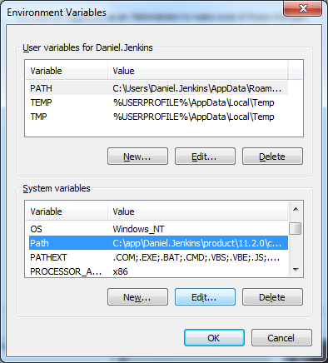

* Locate the ‘Path’ variable in the ‘System variables’ list and click the ‘Edit…’ button
* Add the directory path to the ‘Variable value’ filed, separating it from the other values with a semi-colon

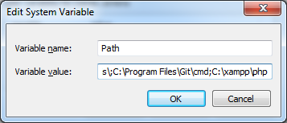

* Click ‘OK’ to confirm, then ‘OK’ in the ‘Environment Variables’ and ‘System’ dialog boxes

### Adding a new system data source for Oracle

* Open the ‘Microsoft ODBC Administrator’ from ‘Start -> All Programs -> Oracle -> Configuration and Migration Tools
* Select the ‘System DSN’ tab and click the ‘Add…’ button
* You’ll be prompted to choose a driver for which to set up a data source, highlight ‘Oracle in OraClient11g_home1’ and click finish

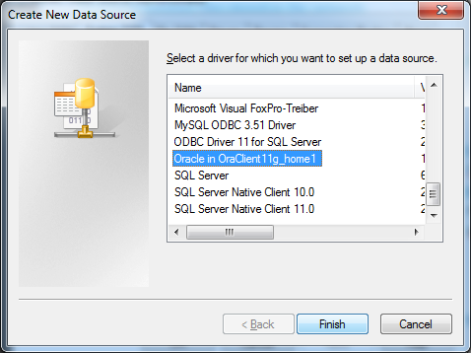

* To set up a ‘SPAN’ database connection, enter the details shown below on the driver configuration screen. Data Source Name, Description & TNS Service Name should all be ‘SPAN’. User ID should be ‘readonly’

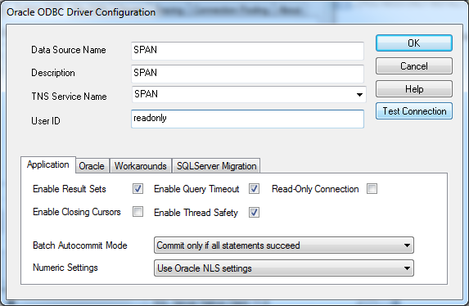

* Click ‘Test Connection’ to confirm the connection has been successfully created, then click ‘OK’. All being well you will be returned to the ODBC Data Source Administrator which will show your newly created data source:

