Freelanceo
Features & User Flows
Product + Engineering Reference
2026-07-07

1. Overview
This document describes every feature in Freelanceo and the flows that power it. Each section includes a diagram, the behaviour, and the backend endpoints (all under the /api prefix).
Stack: React frontend, FastAPI backend, MongoDB/Cosmos data, JWT + session-cookie auth, and Stripe for subscriptions. Project milestone payments are currently tracked only - no money moves yet; a Stripe escrow phase is planned.

Feature Inventory
# | Feature | Primary actor
1 | Sign up / registration (client or freelancer) | Guest
2 | Login (email + Google OAuth) | Guest
3 | Freelancer onboarding (build profile) | Freelancer
4 | Client onboarding (company profile) | Client
5 | Browse talent (gated preview for guests) | Guest / Client
6 | Freelancer profile, portfolio & reviews | All
7 | Follow a freelancer | Logged-in user
8 | Post a job (multi-step wizard) | Client
9 | Browse jobs (gated preview) | Freelancer
10 | Apply to a job with a proposal | Freelancer
11 | Review applicants: shortlist / decline / hire | Client
12 | Direct hire request (from a profile) | Client
13 | Contract: terms & milestone negotiation | Client + Freelancer
14 | Milestone lifecycle (fund to release) | Client + Freelancer
15 | My Jobs & My Applications tracking | Client / Freelancer
16 | Messaging between users | All
17 | Social feed (posts, likes) | All
18 | Notifications + bell | All
19 | Reviews & ratings | Client to Freelancer
20 | Subscription / membership (Stripe) | Freelancer
21 | Admin console (users, jobs, categories) | Admin

2. Roles
Guest - not logged in; sees limited previews of talent and jobs.
Client - posts jobs, reviews applicants, hires, funds and approves milestones.
Freelancer - builds a profile, applies to jobs, delivers milestones.
Admin - platform management.
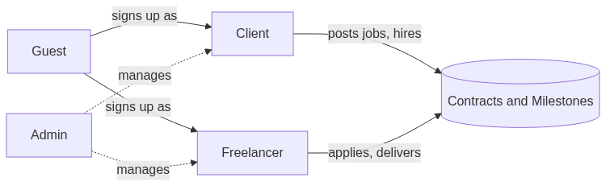

3. Sign-up & Authentication
Guests register as a Client or Freelancer, or sign in with Google. A duplicate email is rejected; otherwise the user is created and a 7-day session cookie plus JWT is issued, then the user is routed to role-specific onboarding.
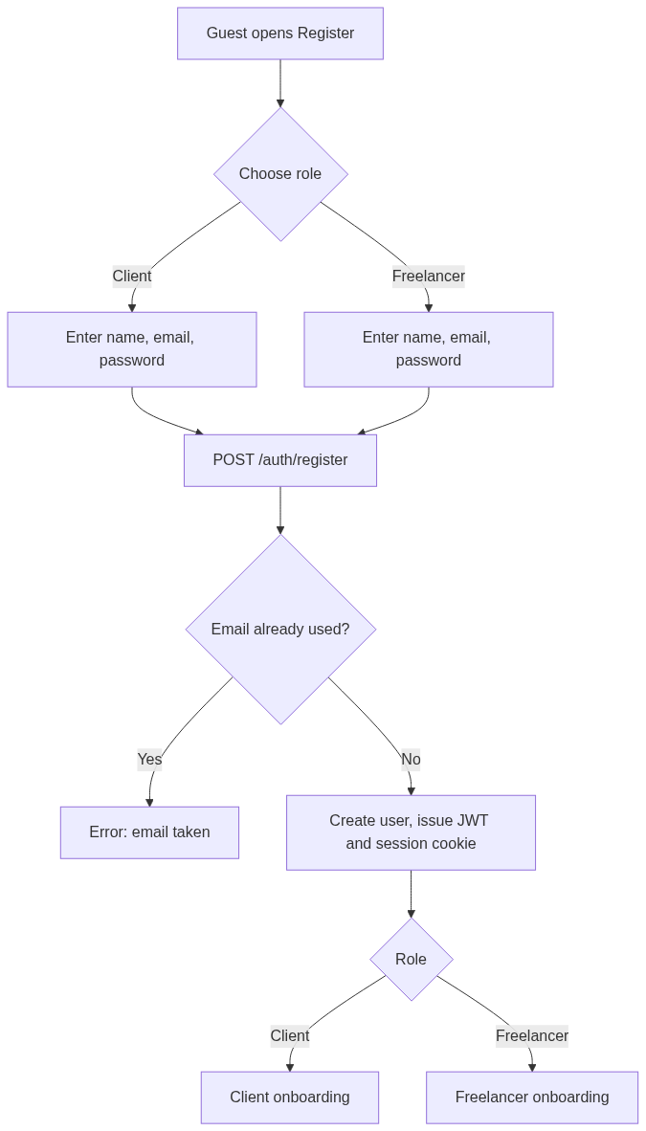
Endpoints: POST /auth/register, POST /auth/login, POST /auth/google-session, GET /auth/me, POST /auth/logout

4. Onboarding

4.1 Freelancer onboarding

4.2 Client onboarding
Endpoints: GET/POST/PUT /freelancers/profile, GET/POST/PUT /clients/profile, PUT /auth/me

5. Discover Talent (Browse Freelancers)
Guests get a server-side redacted preview (title + rating only). Logged-in users see full cards and can filter by category, country, and free-text search on name/title/skills.
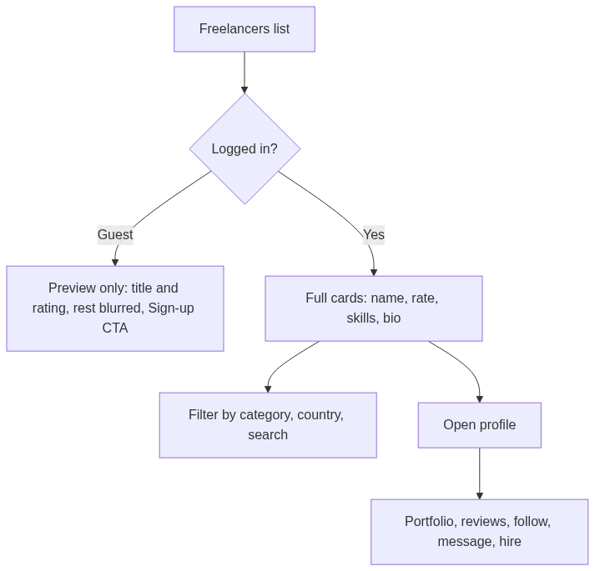
Endpoints: GET /freelancers, GET /freelancers/featured, GET /freelancers/{id}, GET /freelancers/countries

6. Follow a Freelancer
Following a freelancer records the relationship and pushes a notification to that freelancer's bell.
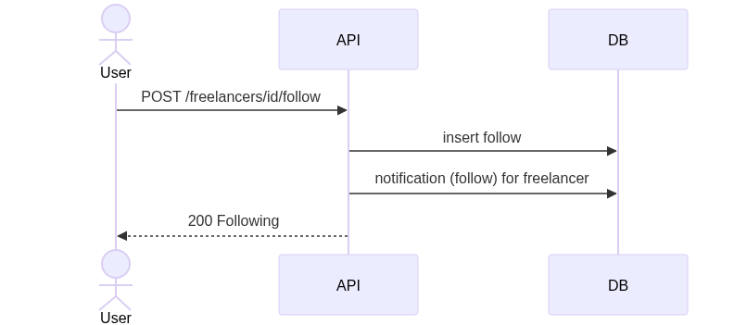
Endpoints: POST/DELETE /freelancers/{id}/follow, GET /freelancers/{id}/is-following, GET /following

7. Post a Job
A client fills a five-step wizard. On submit the job becomes Open on the board and appears in the client's My Jobs.
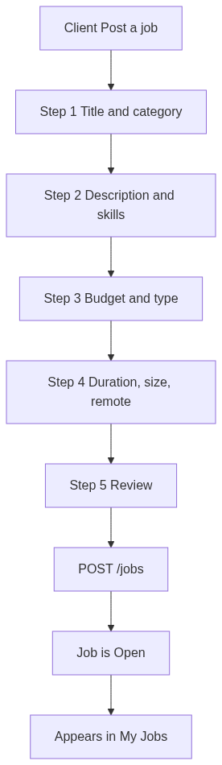
Endpoints: POST /jobs, GET /jobs/my-jobs, PUT /jobs/{id}, DELETE /jobs/{id}

8. Browse Jobs (Job Board)
Guests and unsubscribed freelancers see titles only; subscribed freelancers see full cards and can apply. The job owner (client) can also open their own job to review applicants.
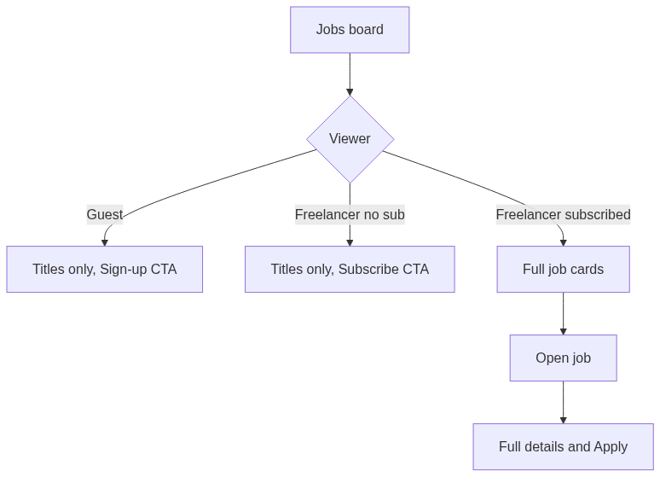
Endpoints: GET /jobs, GET /jobs/featured, GET /jobs/{id}

9. Apply to a Job (Proposal)
A freelancer submits a proposal (cover letter, proposed rate, rate type, estimated duration). The client is notified and the freelancer can track status in My Applications.
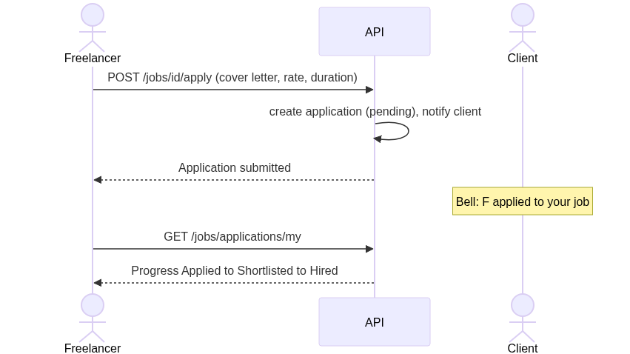
Endpoints: POST /jobs/{id}/apply, GET /jobs/applications/my, PUT /applications/{id} (withdraw)

10. Review Applicants and Hire
The client opens their own job, reviews each proposal, and can shortlist, decline, message, or hire. Hiring creates an ACTIVE contract linked to the job and notifies the freelancer.
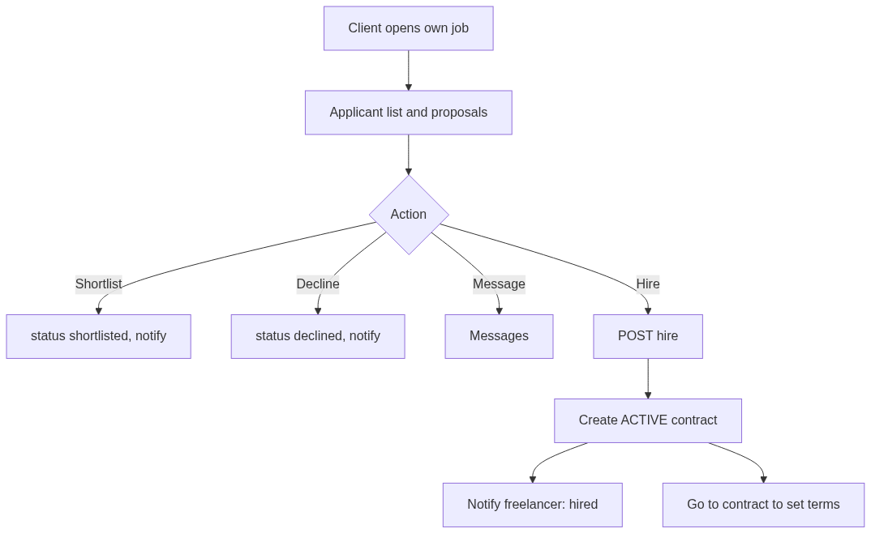
Endpoints: GET /jobs/{id}/applications, PUT /applications/{id}, POST /jobs/{jid}/applications/{aid}/hire

11. Direct Hire Request (from a profile)
A client can engage a freelancer without a job posting. The freelancer is notified and accepts or rejects; acceptance creates an ACTIVE contract.
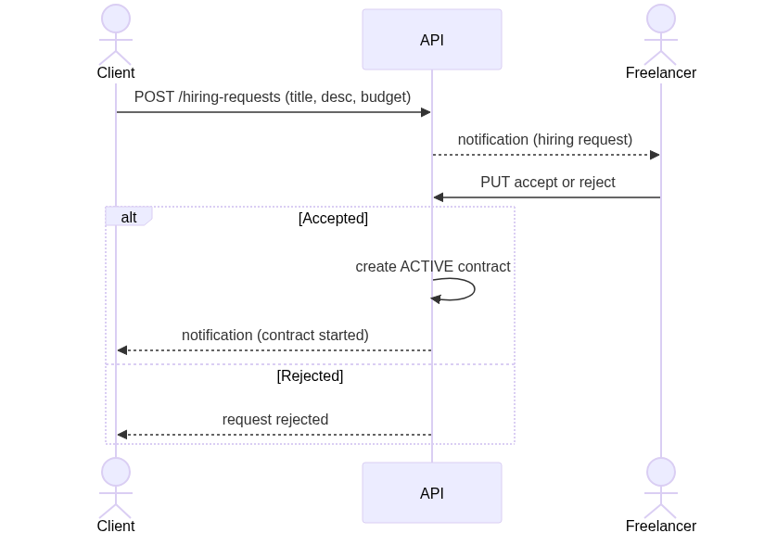
Endpoints: GET /hiring-requests, POST /hiring-requests, PUT /hiring-requests/{id}

12. Contract - Terms & Milestone Negotiation
Both the hire path and the hire-request path create a contract in negotiating state. Either party proposes terms (payment type, timeline, milestone amounts and due dates); the other accepts, declines, or counters. Acceptance seeds the milestones and activates the engagement.
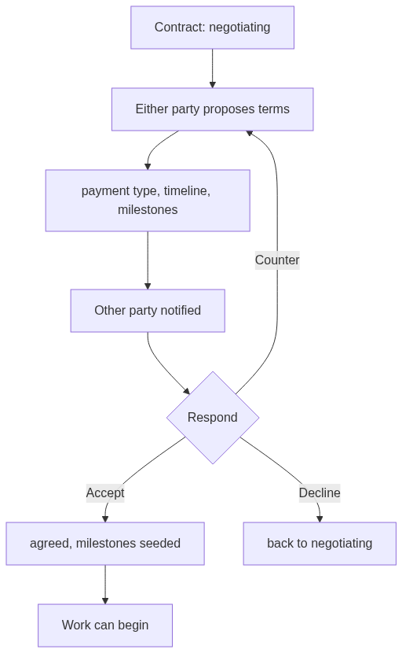
Endpoints: POST /contracts/{id}/terms, POST /contracts/{id}/terms/accept, POST /contracts/{id}/terms/decline, GET /contracts, GET /contracts/{id}

13. Milestone Lifecycle
Once terms are agreed each milestone advances through the states below. Client actions: fund, approve, release, request changes. Freelancer actions: start, submit. Invalid transitions are rejected, and when all milestones are released the contract auto-completes.
Payments are tracked only for now - fund and release change status but do not move money (Stripe escrow is a future phase).
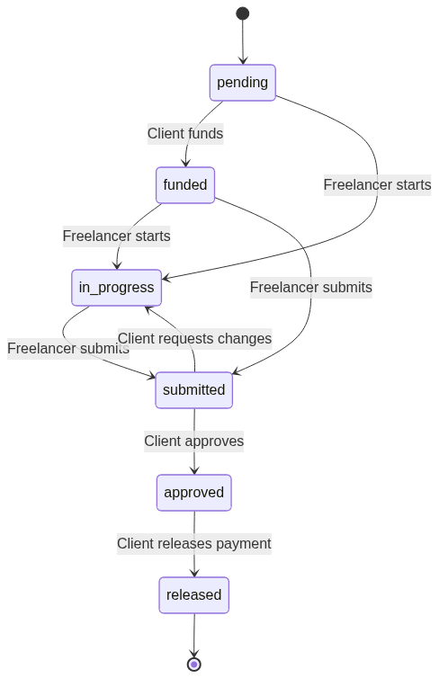
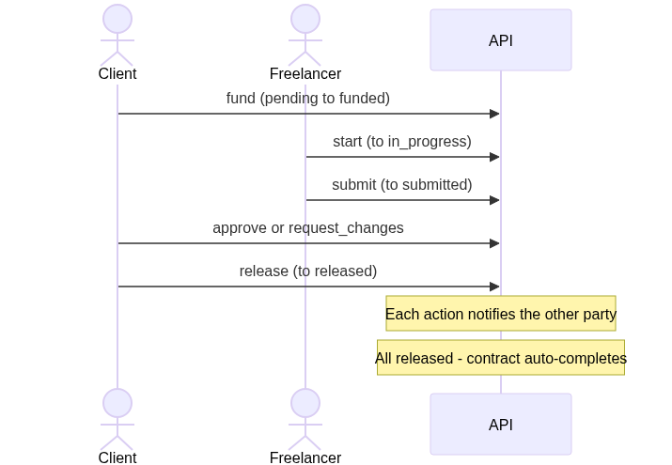
Endpoints: POST /contracts/{id}/milestones/{mid}/action (fund | start | submit | approve | release | request_changes); POST/DELETE /contracts/{id}/diary

14. Tracking Dashboards
Freelancers track every application and its progress; clients track each job's applicant, shortlisted and hired counts.
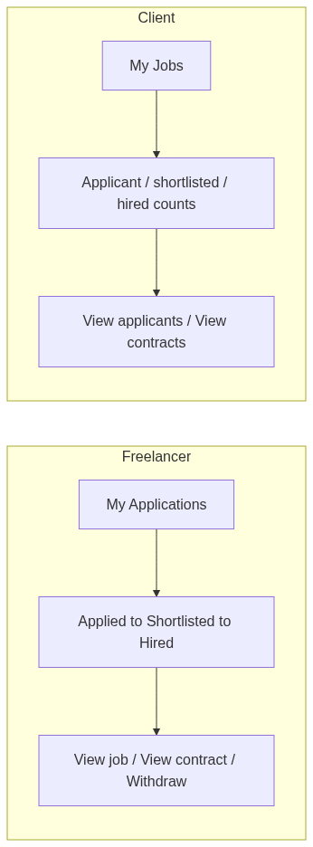
Endpoints: GET /jobs/applications/my, GET /jobs/my-jobs (enriched with counts)

15. Messaging
Users exchange direct messages. Sending a message notifies the recipient; opening a thread marks it read.
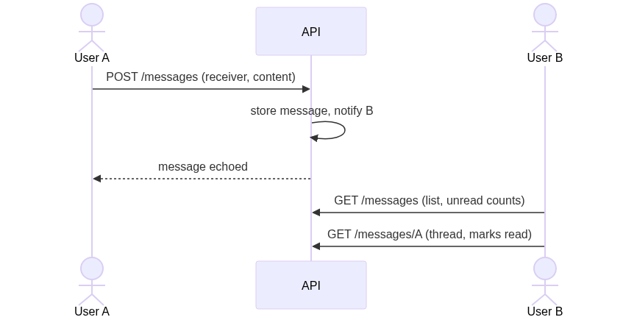
Endpoints: GET /messages, GET /messages/{other_user_id}, POST /messages

16. Social Feed
Users post updates, like posts (author notified), and follow others for a personalised feed.
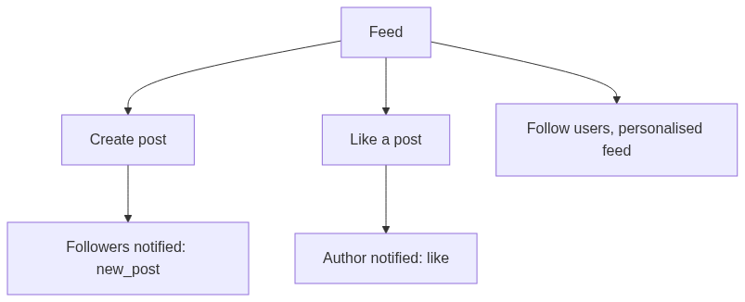
Endpoints: POST/GET/DELETE /posts, GET /feed, POST /posts/{id}/like, GET /posts/{id}/is-liked

17. Notifications
A single notification stream powers the bell (unread badge + dropdown) and the notifications page. The bell polls the unread count about every 45 seconds; clicking an item marks it read and navigates to its target.
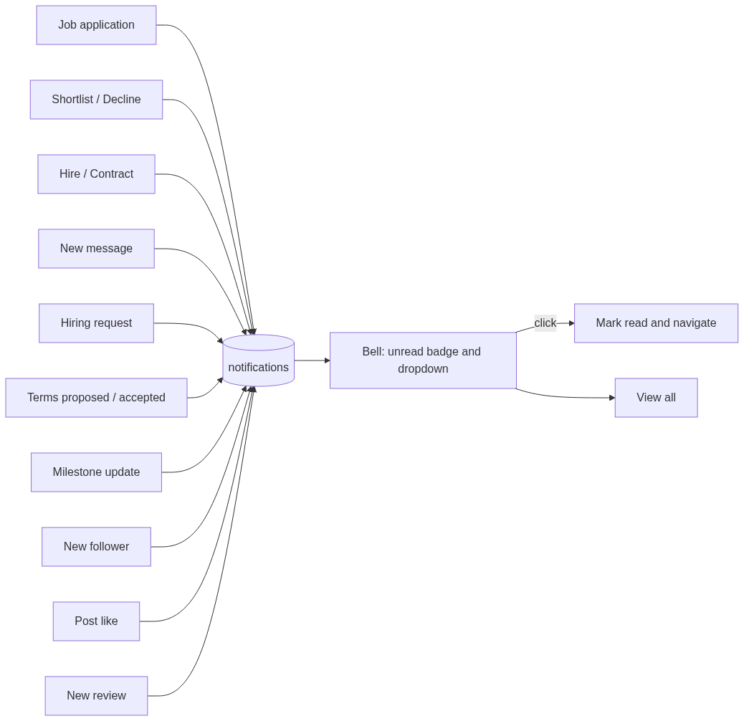
Endpoints: GET /notifications, GET /notifications/unread-count, PUT /notifications/{id}/read, PUT /notifications/read-all

18. Reviews & Ratings
A client leaves a rating and comment; the freelancer's average rating is recomputed and the freelancer is notified. Ratings appear on profiles and in gated previews.
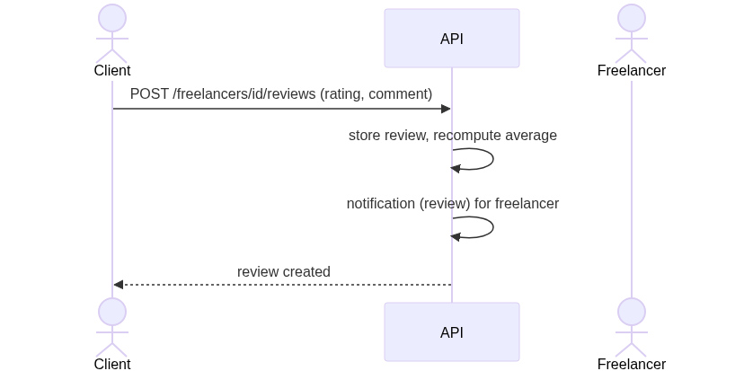
Endpoints: POST /freelancers/{id}/reviews

19. Subscription / Membership (Stripe)
Freelancers subscribe (monthly or yearly) to unlock full job details and applying. A Stripe webhook activates the subscription. Project milestone payments are separate and currently tracked-only.
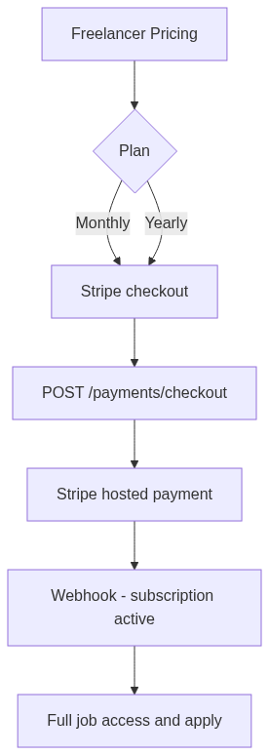
Endpoints: POST /payments/checkout, GET /payments/status, Stripe webhook

20. Admin Console
Platform management: users (role, ban, delete), freelancers (feature, subscription), jobs, categories, and stats/payments overview.
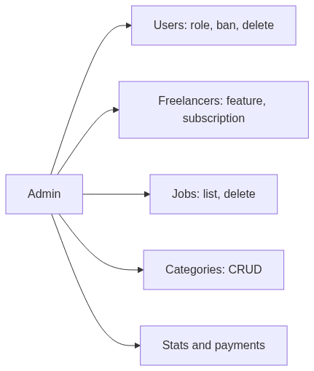
Endpoints: GET /admin/stats, GET /admin/users, PATCH /admin/users/{id}/role|status, DELETE /admin/users/{id}, GET/DELETE /admin/freelancers, GET/DELETE /admin/jobs, GET/POST/DELETE /admin/categories, GET /admin/payments

21. End-to-End Happy Path (job to delivery)
Every arrow raises a notification to the counterparty, surfaced through the bell.
