Assignment4_Lobsters

Thomas Butera, James Fuller and Robert Saldivar

November 13, 2018

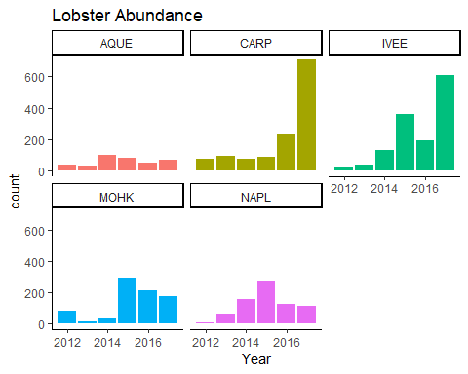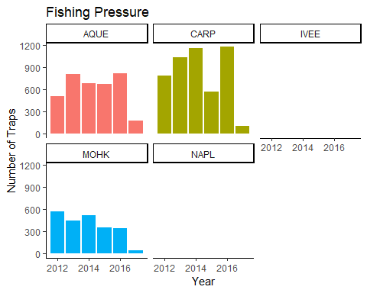

Table 1(2012)

|  |  |  |  |
| --- | --- | --- | --- |
| Site | Mean Lobster Size (mm) | Standard Deviation of Size (mm) | Abundance |
| AQUE | 71.00 | 10.15 | 38 |
| CARP | 74.36 | 14.62 | 78 |
| IVEE | 66.08 | 12.09 | 26 |
| MOHK | 77.25 | 10.59 | 83 |
| NAPL | 73.00 | 11.75 | 6 |

## Levene's Test for Homogeneity of Variance (center = median)  
## Df F value Pr(>F)   
## group 4 8.3893 1.065e-06 ***  
## 1663   
## ---  
## Signif. codes: 0 '***' 0.001 '**' 0.01 '*' 0.05 '.' 0.1 ' ' 1

## Df Sum Sq Mean Sq F value Pr(>F)   
## SITE 4 2355 588.6 3.424 0.0085 **  
## Residuals 1663 285871 171.9   
## ---  
## Signif. codes: 0 '***' 0.001 '**' 0.01 '*' 0.05 '.' 0.1 ' ' 1

## Tukey multiple comparisons of means  
## 95% family-wise confidence level  
##   
## Fit: aov(formula = SIZE ~ SITE, data = lobster_case_format2017)  
##   
## $SITE  
## diff lwr upr p adj  
## CARP-AQUE -1.6657352 -6.24294710 2.911477 0.8582355  
## IVEE-AQUE -2.4433772 -7.05292315 2.166169 0.5968998  
## MOHK-AQUE -1.8955224 -7.02720717 3.236162 0.8514711  
## NAPL-AQUE 2.3366205 -3.19311600 7.866357 0.7775633  
## IVEE-CARP -0.7776420 -2.76097123 1.205687 0.8216104  
## MOHK-CARP -0.2297872 -3.23309697 2.773523 0.9995765  
## NAPL-CARP 4.0023556 0.36042398 7.644287 0.0228728  
## MOHK-IVEE 0.5478548 -2.50450730 3.600217 0.9882889  
## NAPL-IVEE 4.7799976 1.09751057 8.462485 0.0037001  
## NAPL-MOHK 4.2321429 -0.08607271 8.550358 0.0579286

Table 2(2017)

|  |  |  |  |
| --- | --- | --- | --- |
| Site | Mean Lobster Size (mm) | Standard Deviation of Size (mm) | Abundance |
| AQUE | 73.90 | 11.89 | 67 |
| CARP | 72.23 | 13.21 | 705 |
| IVEE | 71.45 | 14.32 | 606 |
| MOHK | 72.00 | 9.28 | 178 |
| NAPL | 76.23 | 11.39 | 112 |

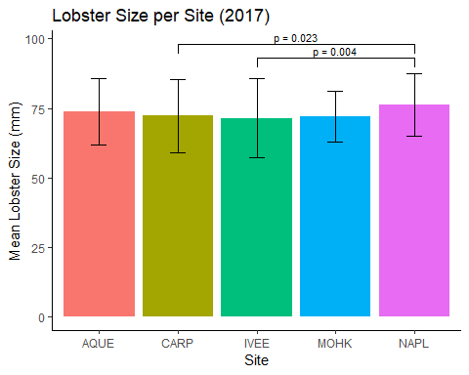

##   
## F test to compare two variances  
##   
## data: lobster_NAPL_2012$SIZE and lobster_NAPL_2017$SIZE  
## F = 1.064, num df = 5, denom df = 111, p-value = 0.7685  
## alternative hypothesis: true ratio of variances is not equal to 1  
## 95 percent confidence interval:  
## 0.3966019 6.4626426  
## sample estimates:  
## ratio of variances   
## 1.064048

##   
## F test to compare two variances  
##   
## data: lobster_IVEE_2012$SIZE and lobster_IVEE_2017$SIZE  
## F = 0.71311, num df = 25, denom df = 605, p-value = 0.307  
## alternative hypothesis: true ratio of variances is not equal to 1  
## 95 percent confidence interval:  
## 0.4322948 1.3698611  
## sample estimates:  
## ratio of variances   
## 0.713111

##   
## F test to compare two variances  
##   
## data: lobster_AQUE_2012$SIZE and lobster_AQUE_2017$SIZE  
## F = 0.72863, num df = 37, denom df = 66, p-value = 0.2986  
## alternative hypothesis: true ratio of variances is not equal to 1  
## 95 percent confidence interval:  
## 0.419142 1.327868  
## sample estimates:  
## ratio of variances   
## 0.7286314

##   
## F test to compare two variances  
##   
## data: lobster_MOHK_2012$SIZE and lobster_MOHK_2017$SIZE  
## F = 1.3015, num df = 82, denom df = 177, p-value = 0.1509  
## alternative hypothesis: true ratio of variances is not equal to 1  
## 95 percent confidence interval:  
## 0.9085131 1.9131403  
## sample estimates:  
## ratio of variances   
## 1.301535

##   
## F test to compare two variances  
##   
## data: lobster_CARP_2012$SIZE and lobster_CARP_2017$SIZE  
## F = 1.2244, num df = 77, denom df = 704, p-value = 0.2043  
## alternative hypothesis: true ratio of variances is not equal to 1  
## 95 percent confidence interval:  
## 0.896208 1.750406  
## sample estimates:  
## ratio of variances   
## 1.224405

##   
## Two Sample t-test  
##   
## data: lobster_NAPL_2012$SIZE and lobster_NAPL_2017$SIZE  
## t = -0.67636, df = 116, p-value = 0.5002  
## alternative hypothesis: true difference in means is not equal to 0  
## 95 percent confidence interval:  
## -12.697051 6.232765  
## sample estimates:  
## mean of x mean of y   
## 73.00000 76.23214

##   
## Two Sample t-test  
##   
## data: lobster_IVEE_2012$SIZE and lobster_IVEE_2017$SIZE  
## t = -1.885, df = 630, p-value = 0.0599  
## alternative hypothesis: true difference in means is not equal to 0  
## 95 percent confidence interval:  
## -10.9750916 0.2246473  
## sample estimates:  
## mean of x mean of y   
## 66.07692 71.45215

##   
## Two Sample t-test  
##   
## data: lobster_AQUE_2012$SIZE and lobster_AQUE_2017$SIZE  
## t = -1.2622, df = 103, p-value = 0.2097  
## alternative hypothesis: true difference in means is not equal to 0  
## 95 percent confidence interval:  
## -7.445357 1.654312  
## sample estimates:  
## mean of x mean of y   
## 71.00000 73.89552

##   
## Two Sample t-test  
##   
## data: lobster_MOHK_2012$SIZE and lobster_MOHK_2017$SIZE  
## t = 4.0689, df = 259, p-value = 6.276e-05  
## alternative hypothesis: true difference in means is not equal to 0  
## 95 percent confidence interval:  
## 2.710776 7.795248  
## sample estimates:  
## mean of x mean of y   
## 77.25301 72.00000

##   
## Two Sample t-test  
##   
## data: lobster_CARP_2012$SIZE and lobster_CARP_2017$SIZE  
## t = 1.3361, df = 781, p-value = 0.1819  
## alternative hypothesis: true difference in means is not equal to 0  
## 95 percent confidence interval:  
## -0.998958 5.257332  
## sample estimates:  
## mean of x mean of y   
## 74.35897 72.22979

##   
## Cohen's d  
##   
## d estimate: -0.2834216 (small)  
## 95 percent confidence interval:  
## inf sup   
## -1.1141889 0.5473456

##   
## Cohen's d  
##   
## d estimate: -0.3775177 (small)  
## 95 percent confidence interval:  
## inf sup   
## -0.77136540 0.01633002

##   
## Cohen's d  
##   
## d estimate: -0.2563169 (small)  
## 95 percent confidence interval:  
## inf sup   
## -0.6606014 0.1479675

##   
## Cohen's d  
##   
## d estimate: 0.5408116 (medium)  
## 95 percent confidence interval:  
## inf sup   
## 0.2749635 0.8066597

##   
## Cohen's d  
##   
## d estimate: 0.1594364 (negligible)  
## 95 percent confidence interval:  
## inf sup   
## -0.07493682 0.39380971

##   
## F test to compare two variances  
##   
## data: lobster_MPA_2012$SIZE and lobster_nonMPA_2012$SIZE  
## F = 0.95857, num df = 31, denom df = 198, p-value = 0.9306  
## alternative hypothesis: true ratio of variances is not equal to 1  
## 95 percent confidence interval:  
## 0.5875826 1.7418980  
## sample estimates:  
## ratio of variances   
## 0.958571

##   
## F test to compare two variances  
##   
## data: lobster_MPA_2017$SIZE and lobster_nonMPA_2017$SIZE  
## F = 1.261, num df = 717, denom df = 949, p-value = 0.0008682  
## alternative hypothesis: true ratio of variances is not equal to 1  
## 95 percent confidence interval:  
## 1.099982 1.447439  
## sample estimates:  
## ratio of variances   
## 1.260969

##   
## F test to compare two variances  
##   
## data: lobster_MPA_2012count$COUNT and lobster_nonMPA_2012count$COUNT  
## F = 0.15132, num df = 29, denom df = 154, p-value = 1.607e-07  
## alternative hypothesis: true ratio of variances is not equal to 1  
## 95 percent confidence interval:  
## 0.09046774 0.28284551  
## sample estimates:  
## ratio of variances   
## 0.1513157

##   
## F test to compare two variances  
##   
## data: lobster_MPA_2017count$COUNT and lobster_nonMPA_2017count$COUNT  
## F = 0.32029, num df = 442, denom df = 445, p-value < 2.2e-16  
## alternative hypothesis: true ratio of variances is not equal to 1  
## 95 percent confidence interval:  
## 0.2658382 0.3859245  
## sample estimates:  
## ratio of variances   
## 0.3202926

##   
## Two Sample t-test  
##   
## data: lobster_MPA_2012$SIZE and lobster_nonMPA_2012$SIZE  
## t = -3.202, df = 229, p-value = 0.001558  
## alternative hypothesis: true difference in means is not equal to 0  
## 95 percent confidence interval:  
## -12.19530 -2.90395  
## sample estimates:  
## mean of x mean of y   
## 67.37500 74.92462

##   
## Welch Two Sample t-test  
##   
## data: lobster_MPA_2017$SIZE and lobster_nonMPA_2017$SIZE  
## t = -0.16104, df = 1442.5, p-value = 0.8721  
## alternative hypothesis: true difference in means is not equal to 0  
## 95 percent confidence interval:  
## -1.402988 1.190110  
## sample estimates:  
## mean of x mean of y   
## 72.19777 72.30421

##   
## Welch Two Sample t-test  
##   
## data: lobster_MPA_2012count$COUNT and lobster_nonMPA_2012count$COUNT  
## t = -3.1061, df = 115.16, p-value = 0.002387  
## alternative hypothesis: true difference in means is not equal to 0  
## 95 percent confidence interval:  
## -0.35571770 -0.07869091  
## sample estimates:  
## mean of x mean of y   
## 1.066667 1.283871

##   
## Welch Two Sample t-test  
##   
## data: lobster_MPA_2017count$COUNT and lobster_nonMPA_2017count$COUNT  
## t = -3.8207, df = 704.51, p-value = 0.0001448  
## alternative hypothesis: true difference in means is not equal to 0  
## 95 percent confidence interval:  
## -0.7709789 -0.2475758  
## sample estimates:  
## mean of x mean of y   
## 1.620767 2.130045

##   
## Cohen's d  
##   
## d estimate: -0.6098605 (medium)  
## 95 percent confidence interval:  
## inf sup   
## -0.9892805 -0.2304404

##   
## Cohen's d  
##   
## d estimate: -0.008092361 (negligible)  
## 95 percent confidence interval:  
## inf sup   
## -0.10508515 0.08890043

##   
## Cohen's d  
##   
## d estimate: -0.3579647 (small)  
## 95 percent confidence interval:  
## inf sup   
## -0.7532141 0.0372846

##   
## Cohen's d  
##   
## d estimate: -0.2558404 (small)  
## 95 percent confidence interval:  
## inf sup   
## -0.3880284 -0.1236524

##   
## Pearson's Chi-squared test  
##   
## data: lobster_legal  
## X-squared = 10.99, df = 4, p-value = 0.02668