Assignment4_Lobsters

Robert Saldivar

November 13, 2018

#2 Initial Data Editing  
lobster_size_edits <- lobster_size %>%  
 filter(SIZE !=-99999) %>%  
 select(YEAR, MONTH, DATE, SITE, SIZE, COUNT) # Edit Lobster Size data to remove -99999 data from size column and remove transect information  
  
lobster_traps_edits <- lobster_traps %>%  
 filter(SITE=="AQUE" |SITE =="NAPL" |SITE=="MOHK" |SITE=="IVEE" |SITE=="CARP") %>%  
 select(YEAR, MONTH, DATE, SITE, TRAPS)

#3 checking data for normality  
  
lobster_size_hist <- ggplot(lobster_size_edits, aes(x=SIZE)) +  
 geom_histogram() +  
 facet_wrap(~SITE)  
  
lobster_size_hist

## `stat_bin()` using `bins = 30`. Pick better value with `binwidth`.

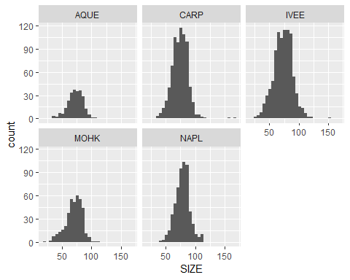

lobster_size_qq <- ggplot(lobster_size_edits, aes(sample=SIZE)) +  
 geom_qq() +  
 facet_wrap(~SITE)  
  
lobster_size_qq

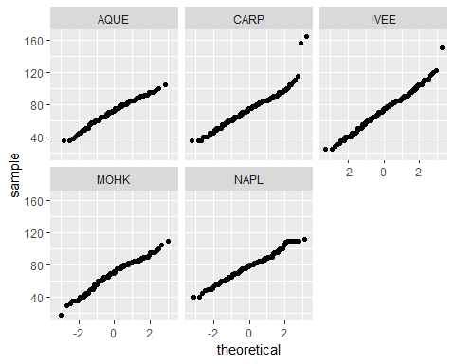

lobster_traps_hist <- ggplot(lobster_traps_edits, aes(x=TRAPS)) +  
 geom_histogram() +  
 facet_wrap(~SITE)  
  
lobster_traps_hist

## `stat_bin()` using `bins = 30`. Pick better value with `binwidth`.

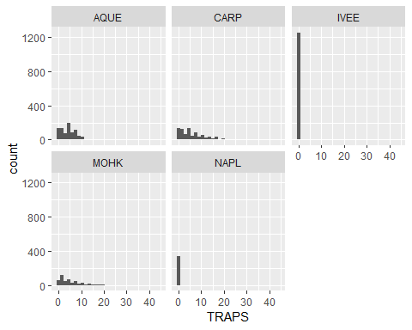

lobster_traps_qq <- ggplot(lobster_traps_edits, aes(sample=TRAPS)) +  
 geom_qq() +  
 facet_wrap(~SITE)  
  
lobster_traps_qq

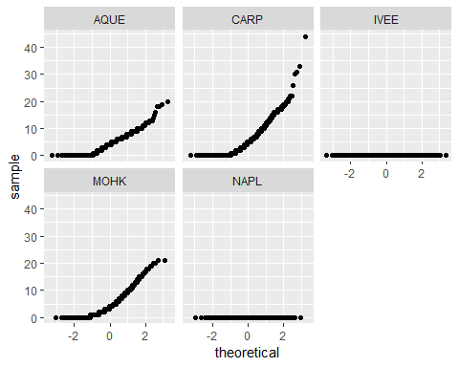

abundance_col <- ggplot(lobster_size_edits, aes(x=YEAR, y=COUNT)) +  
 geom_col() +  
 facet_wrap(~SITE)  
  
abundance_col

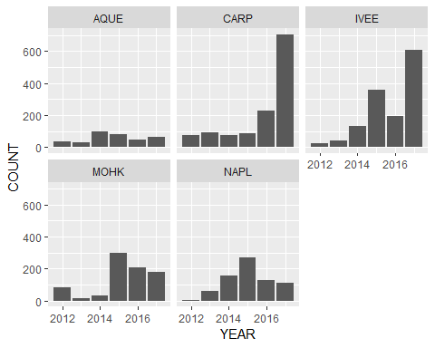

fishing_pressure_col <- ggplot(lobster_traps_edits, aes(x=YEAR, y=TRAPS)) +  
 geom_col() +  
 facet_wrap(~SITE)  
  
fishing_pressure_col

