HW2

Robert Saldivar

January 27, 2020

# plotting the function  
  
#loading the variables of the function  
r <- 0.05  
K <- 2000  
P <- 4  
a <- 0.05  
h <- 0.2  
full <- function(N) r * N * (1 - N/K) - (P * (a * N)/(1 + a * h * N)) # Here is defined the function  
f <- function(N) r * N * (1 - N/K) #this is the first part of the function defined  
  
  
fun <- ggplot(data.frame(N = 0:1600), aes(x = N)) +  
 stat_function(fun = full, color ="red") +  
 geom_hline(yintercept = 0) +  
 ylab("dN/dt")  
  
fun

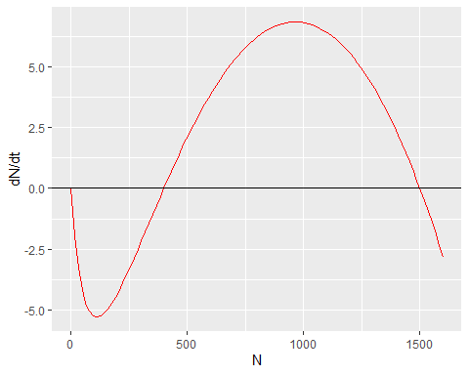

1. Based on the graph there are three equilibria for this population. There are stable equilibria at population sizes of 0 and 1500. There is an unstable equilibria at a population size of 375.

5a.

fp <- function(N) P * ((a * N)/(1 + a * h * N)) #This defines the hunting rate  
  
fun_p <- ggplot(data.frame(N = 0:2100), aes(x = N)) +  
 stat_function(fun = f, color ="red") +  
 stat_function(fun = fp, color = "blue") +  
 geom_hline(yintercept = 0) +  
 ylab("dN/dt")  
  
fun_p

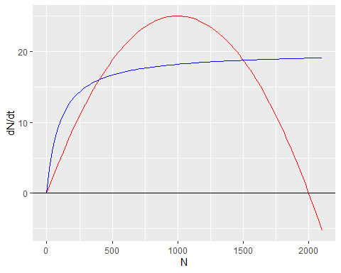

5b. When the hunting rate is greater than the intrinsic growth rate then the population will decline. When the hunting rate is less than the intrinsic growth rate then the population will increase. When hunting rate is equal to the intrinsic growth rate then the population will be in a state of equilibrium.

5c. Where the graphs intersect on this graph is where the graph in problem crosses 0 on the x-axis. This means where the above graphs intersect are locations where the population is at equilibrium.

P <-1 #This will set the P value to 1 for the following function  
  
fun_p1 <- ggplot(data.frame(N = 0:2100), aes(x = N)) +  
 stat_function(fun = f, color ="red") +  
 stat_function(fun = fp, color = "blue") +  
 geom_hline(yintercept = 0) +  
 ylab("dN/dt") +  
 ggtitle("Population dynamics when P = 1")  
  
fun_p1

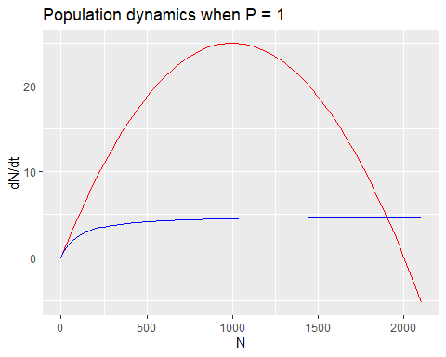

P <- 6 #This will set the P value to 6 for the following function  
  
fun_p6 <- ggplot(data.frame(N = 0:2100), aes(x = N)) +  
 stat_function(fun = f, color ="red") +  
 stat_function(fun = fp, color = "blue") +  
 geom_hline(yintercept = 0) +  
 ylab("dN/dt") +  
 ggtitle("Population dynamics when P = 6")  
  
fun_p6

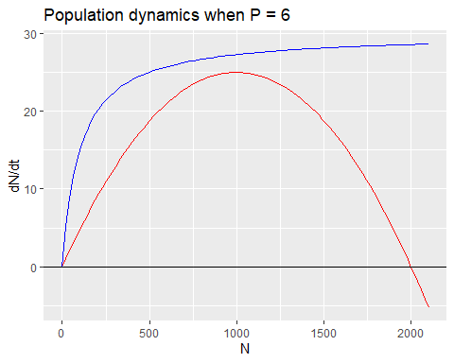 When the P value is 1 ther are two equilibria, one at 0 and one at … The 0 equilbria is unstable and the … equilibria is stable. When the P value is 6 then there is only one equilibria at 0. This is a stable equilibria.

7a. The domain of of attraction for the zero equilibrium is is from zero to the next equilibrium point which is approximately 375 based on the graph. The domain of attraction of the largets equilibrium point is anything above the previous equilibrium point, approximately 375.

7b. If the population of the species was 100 individuals then then 4 hunters would be able to extirpate the species as the hunting rate would be greater than the intrinsic growth rate.

7c. If the population was already at carrying capacity then 4 hunters would not be enough to extripate the species. At this population level the growth rate would grow as the population shrunk until it equaled the hunting rate. Four hunters would cause the population to reach an equilibrium at 1500 individuals.

8a.

8b.

8c.