**Outplanting Field Experiment for *Lupinus nipomensis* Year 5at Black Lake Ecological Area, Land Conservancy of San Luis Obispo County**



**Prepared by Justin Luong**

**In cooperation with the Cheadle Center for Biodiversity: Lisa Stratton**

**Prepared for: U.S. Fish and Wildlife Service**

**Ventura, California**

**Cooperative Agreement Award #F12AC00683**

**Project Officer: Kristie Scarazzo**

**December 2019**

**Introduction**

*Lupinus nipomensis* is a federally endangered annual species of lupine that is endemic to coastal dunes in San Luis Obispo County, California. It grows as a basal rosette reaching 10-20 cm in height with somewhat succulent leaves and stems (Sholars 2016). *L. nipomensis* produces standard papilinoid flowers which fruits with dehiscent pods as they mature, with an average of 3-5 seeds per pod. Within the dune complex *L. nipomensis* was historically observed in back dunes and occasionally in inter-dune habitat. The loss of coastal back dune habitat has restricted the range of *L. nipomensis* to a 2mi2 area along the central California coast in the Guadalupe-Nipomo Dune Complex (**Fig**. 1; Wilken 2009; Skinner and Pavlik 1994). Since 2000 it has been listed as an endangered species and conservation efforts have been ongoing (Clark, 2000).

In 2015, The Cheadle Center for Biodiversity and Ecological Restoration began an outplanting experiment that received a second seed treatment in 2016 at Black Lake Ecological Area. All outplanted plots were monitored annually with ongoing effort. This report will provide information about the 2018-2019 monitoring efforts.

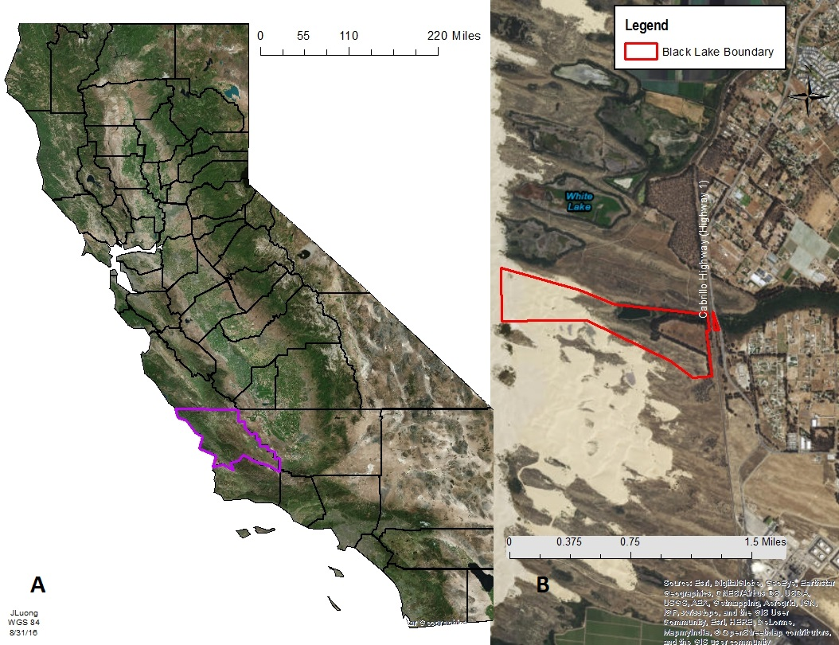**Fig. 1** *Lupinus nipomensis* microhabitat study area. A) *Lupinus nipomensis* is endemic to San Luis Obispo County (outlined in purple), which is located in Southern California north of Sana Barbara County. B) The study area is located in Blake Lake Ecological Area, which is along the southwest coast of San Luis Obispo County.

**Methods**

*Seed Source and Area Description*

Seeds were collected from wild *Lupinus nipomensis* populations on the Nipomo Mesa by the Santa Barbara Botanical Garden in 2005. Seeds from 2005 were collected from a random sample of individuals in all known colonies, limited to 5% take sanctioned by USFWS permitting and stored in cool, dry conditions at the Botanic Garden. In 2012, wild collected seeds were germinated via cold stratification (including scarification) and grown by the Cheadle Center for Biodiversity and Ecological Restoration (CCBER) to increase the seed stock. All individuals collected in 2005 had ten seeds from every individual started in 2012 outdoors in a mix of native dune sand and potting soil. Plants received weekly watering throughout until senescence and seeds were collected as seed pods dehisced. All seeds were handled and stored based on standard protocol from the Center for Plant Conservation adapted by Rancho Santa Ana Botanical Garden for California. Seeds used in this outplanting experiment were from the seed bulking effort in 2012. Seeds were randomly selected by parent using a random number generator from 2012 parents to create seed packets with 20 seeds per pack for the experiment.

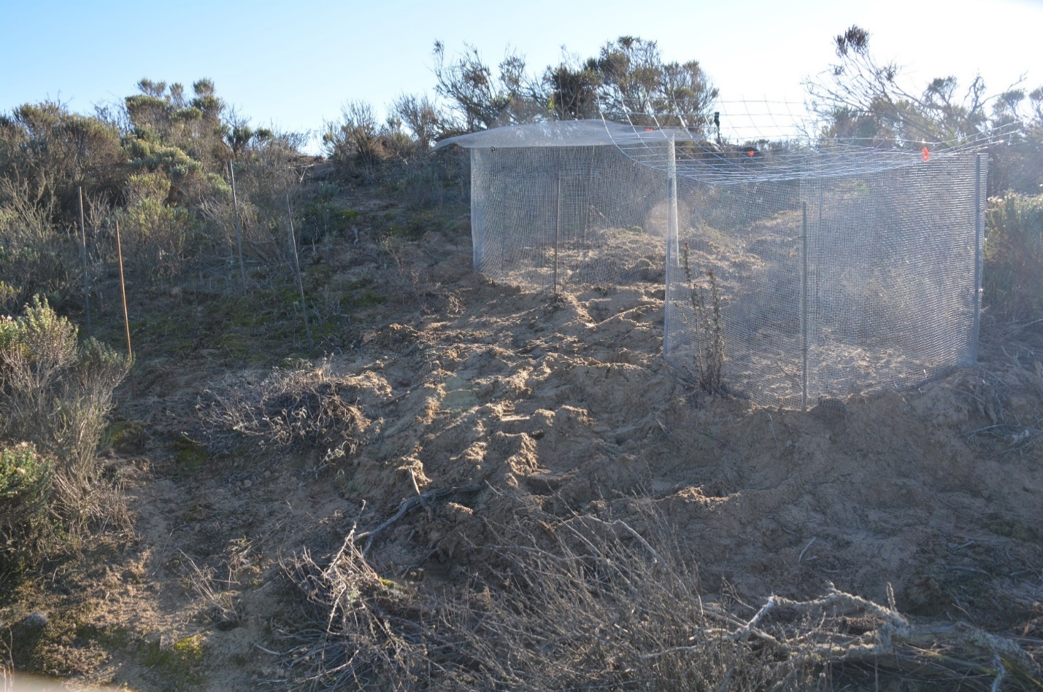

**Fig. 2** A picture of the three different types of cages used for the caging treatments. From left to right: the no cage treatment (4 rebar posts), the small cage (0.25in2 hardware cloth wrapped around 4 rebar posts and 0.25in2hardware cloth as a top), and the big cage (0.25in2 hardware cloth wrapped around 4 rebar posts and 2x4in hardware cloth as a top).

The experiment took place in Black Lake Ecological Area (35.056408, -120.604279), a back-dune ecosystem near Nipomo, CA in San Luis Obispo County (**Fig**. 1). Black Lake is characterized by a Mediterranean climate with wet, cool winters and dry, hot summers that are tempered by coastal fog events (Fayram and Fyre 2014). Back dunes are the oldest part of a dune complex where plant establishment has increased dune stability. They are characterized by low relief (25 m or less), sinuous dune ridges, and have higher plant diversity than the other parts of the dune complex (Buckler 1979; Miller et al. 2010). The soil profile of the back-dune area is fine sand (125-250 µm) from 0 – 18 meters in the profile and has no hydric soils (Soil Survey Staff, 2016). The texture of the soil across the experimental area is sandy loam with a pH, electroconductivity (EC), and nutrient content (pH = 6.12, EC = 31.13, dS, soil organic matter = 3.27 grams/100 gram of soil, % nitrogen = 0.0402% and % carbon = 0.7005%) characteristic of stabilized dunes (Provoost et al. 2004). There is an on-going effort to control the exotic veldt grass, *E. calycina,* population using a graminoid specific herbicide, Fusilade DX (fluazifop-p-butyl). To minimize the effects of herbicide on the experiment, herbicide was not used within 50 feet of the experimental plots. Precipitation and solar insolation data was taken from a nearby station, CIMIS #202, accessed online from University of California Agriculture and Natural Resources Statewide Integrated Pest Management Program (<http://ipm.ucanr.edu/>).

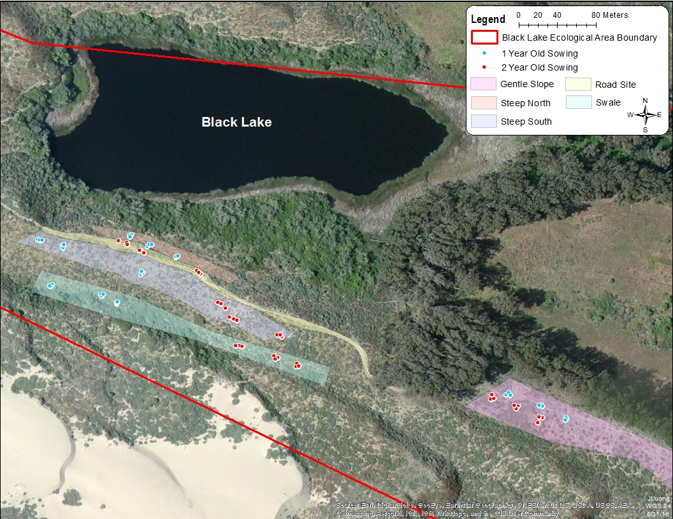 **Fig. 3** The location of the five different aspect/slope treatments and the corresponding replicates in the Black Lake Ecological Area study site. The gentle south facing slope treatment is highlighted in pink, the swale no aspect treatment is highlighted in green, the steep south facing slope treatment is highlighted in blue, and the steep north facing slope is highlighted in orange.

*Experimental Treatments*

Aspect and Slope Treatment

To determine if *Lupinus nipomensis* preferred specific microhabitat conditions, we chose sites that varied in their slope and aspect. We chose slope and aspect because lupine species are known to be sensitive to water and light and both slope and aspect are known to impact the exposure of plants to these environmental variables (Braatne and Bliss 1999; Bennie et al. 2006). We had three slope treatments (steep slope, gentle slope and swale) and three aspect treatments (north facing, south facing, and no aspect). We crossed the aspect treatment with the slope treatment for a total of four different treatments: steep south facing, steep north facing, swale no aspect and gentle south facing. We could not include a north facing gentle slope because one did not exist within the experimental area.

Caging Treatment

Herbivory is a common problem in restoration efforts because, when excessive, herbivory can lead to a reduction in seedling survival and population persistence (Rausher and Feeny 1980; Salihi and Norton 1987). To determine if herbivory was negatively impacting *L. nipomensis*, we had three different caging treatments. The caging treatments differed in the size of the top screen with one treatment consisting of a 0.25in2 mesh size (small cage) and the second treatment consisting of a 2 × 4 in2 mesh top (large cage; **Fig**. 2). The small caging treatment blocked most herbivores except small insects while the large caging treatment only prevented herbivory from large mammals such as deer. All cages were fully enclosed, 90cm in diameter, and 60cm tall. The sides of all cages were constructed from 0.25 in2 mesh hardware cloth wrapped around rebar buried 7.5cm deep. The third treatment, the control, had rebar present at the four corners but no type of mesh barriers. We replicated each caging treatment six times for a total of 18 plots in each topographical site (**Fig**. 3).

*Experimental Monitoring*

In total there were 72 research plots with six replications per treatment type. Each treatment of aspect × slope × caging × scarification received 20 seeds, totaling 40 seeds per plot as each caging treatment was split for pairwise test of scarification on germination. Plots were monitored every two weeks during the growing season after *Lupinus nipomensis* was sowed on Dec 18th, 2014 and first germinated Jan 25th, 2015. New germinants were monitored biweekly until the plant died. Herbivory was measured using a 4-point scale. In 2019, separate herbivory classifications were created for vegetative and reproductive herbivory. For vegetative herbivory (stem or leaves) herbivory was classified by this scale: 0 = no herbivory, 1 = mild herbivory, 2 = major herbivory. Reproductive output was quantified as soon as seeding phenology set and was determined by the number of seed pods per plant throughout the season. For the purposes of estimating the seedbank developed in each plot throughout time, it was conservatively estimated that *L. nipomensis* produces two seeds per pod, although it has been noted in optimal conditions during seed bulking, individuals can produce anywhere from one to five seeds per pod.

*Data Analysis*

R statistical software was used to create all figures except maps and used for all statistical analyses (Version 3.40, R Development Core Team 2007). ArcGIS was used to create all maps (Version 10.4, Environmental Systems Research Institute 2012). A multi-way analysis of covariance (ANCOVA) was used to determine if there were significant interactions between aspect, slope, and herbivory on the reproductive output of *Lupinus nipomensis.* These were followed by a Tukey’s honest significant difference test (TukeyHSD). Student’s T-test was used to determine the differential effect of scarification treatments on germination of *L. nipomensis* regardless of aspect, slope or caging. Pearson’s correlation tests and variables were obtained using the Hmisc and corrplot packages in R.

**Results**

|  |  |  |  |  |  |  |  |  |  |  |
| --- | --- | --- | --- | --- | --- | --- | --- | --- | --- | --- |
| Monitoring Year | 2014-15 | | | 2015-16 | | | | 2016 -17 | | |
| Total Number of: | Germ. | Reprod. | Seed pods | Germ. | | Reprod. | Seed pods | Germ. | Reprod. | Seed pods |
| 2014-15 Trial plots | 118 | 2 | 5.5 + 2.5 | 65 | | 11 | 84.4 + 21.4 | 26 | 3 | 140 + 46.6 |
| 2015-16 Trial plots | N/A | N/A | N/A | 278 | | 10 | 46.1 + 17.1 | 53 | 12 | 181.5 + 71.6 |
| All plots | 118 | 2 | 5.5 + 2.5 | 343 | | 21 | 66.2 + 19.3 | 81 | 43 | 173.2 + 59.1 |
| Monitoring Year | 2017-18 | | | | 2018-19 | | |
| Total Number of: | Germ. | Reprod. | Seed pods | | Germ. | Reprod. | Seed pods |
| 2014-15 Trial plots | 30 | 3 | 18 + 15.0 | | 60 | 28 | 86.1 + 33.6 |
| 2015-16 Trial plots | 59 | 11 | 140 + 83.9 | | 134 | 87 | 130.6 + 19.8 |
| All Plots | 89 | 14 | 99 + 59.3 | | 194 | 111 | 96.2 + 21.5 |

Table 1. Total germination, reproductive individuals and seed pods produced by Lupinus nipomensis individuals at Black Lake separated by sowing year. A reproductive individual is one that produces reproductive organs, such as flowers, regardless of seed production.

During the fifth year of monitoring we found that the number of individuals germinating and reaching reproductive potential continues to steadily increase from previous years (**Fig** **4**; **Table** **1**). Individuals sowed in the second year (2015-16) continue to have greater reproductive output compared to those sowed in the first year (2014-15; **Table 1**). We also find a significant legacy effect in successful plots, where plots that had previously seeded had higher counts of germinants and reproductive individuals (p < 0.05).

Percent germination is determined by dividing the total germination in a plot by the estimated seedbank. Percent germination decreases with each succeeding year where year 4 and 5 were significantly lower than all others, year 3 was lower than year 2 and 1 (p < 0.05; **Fig. 4**). Seedbank accumulation was weakly correlated with patterns of percent germination (r2 = 0.26, p < 0.05; **Fig. 5**). For seedpod production, years 3 and 5 produced more seed than year 2 and 1. For average proportion of germinants that reached reproductive capability, year 5 and year 3 had higher proportions than year 2 and 1 (p < 0.05; **Fig. 4**).

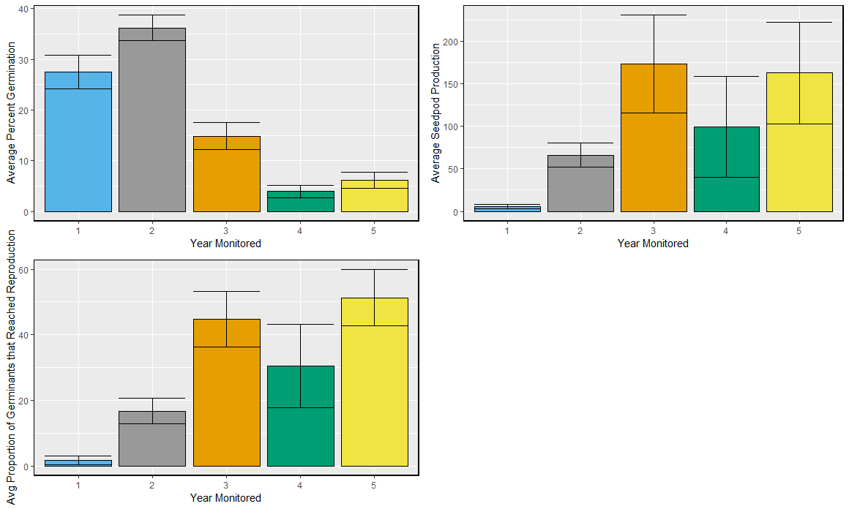

**Figure 4**. Upper left panel shows average percent germination of Lupinus nipomensis at a plot level by year monitored. Percent germination is a ratio of total germinants in a plot compared to the total estimated seedbank of a plot. The upper right panel shows average seed production by individuals at a plot level by year monitored. The lower left panel shows the average proportion of individuals that reached reproductive potential within a plot given that there were germinants in that plot.

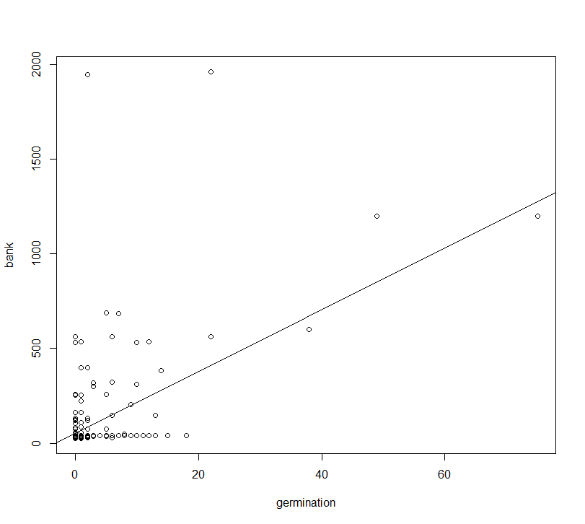

**Figure 5**. A plot showing the relationship between percent germination and seedbank accumulation.

**Topography, Aspect and Slope**

Topography had no significant effect on average percent germination within a plot (p > 0.05; **Fig. 6**). When topography was separated into its aspect and slope components, we still did not find significant differences (p > 0.05; **Fig. 6**). Although non-significant, there appears to be a trend that more moist areas, such as swales and north facing, have greater percent germination.

Topography was found to significantly affect seedbank accumulation (p < 0.05; **Fig. 7**). In particular, north facing steep slopes had greater seed bank accumulation compared to any other topography (p < 0.05). When topography was separated into its component parts, aspect seems to play a stronger role as it remained as a significant effect (p < 0.05), whereas the slope component was not (p > 0.05). In terms of aspect, it appears north-facing slopes significantly accumulated more seeds in their seedbank than any other aspect (p < 0.05; **Fig. 7**).

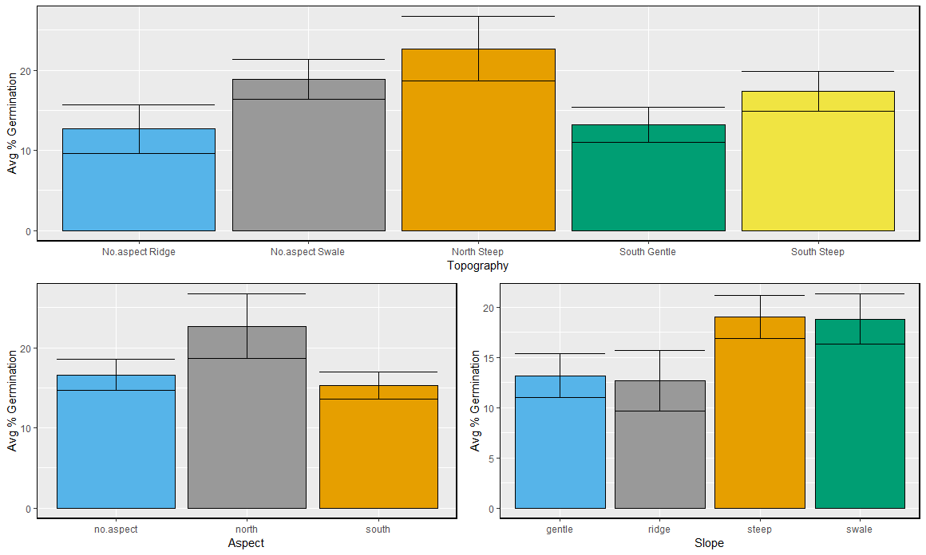

**Figure 6**. Upper panel shows average percent germination of Lupinus nipomensis at a plot level by Topography treatment. Percent germination is a ratio of total germinants in a plot compared to the total estimated seedbank of a plot. The lower left panel shows the average percent germination of individuals within a plot by plot aspect. The lower right panel shows average percent germination by individuals at a plot level by slope treatment.

**Caging and Herbivory**

We found that there was no difference in seed production or percent germination between the small (0.25 in2 mesh) and big (2 × 4 in mesh; p > 0.05); instead differences were only between small cage and no cage and big cage and no cage, so small and big cage types were combined into ‘caged’ for the purposes of analyses. Using a two-sample t-test, we found that caging was significant in improving percent germination, average seed pod production (p < 0.01; **Fig. 8**) while decreasing the chance of severe herbivory (p < 0.05; **Fig. 9**)

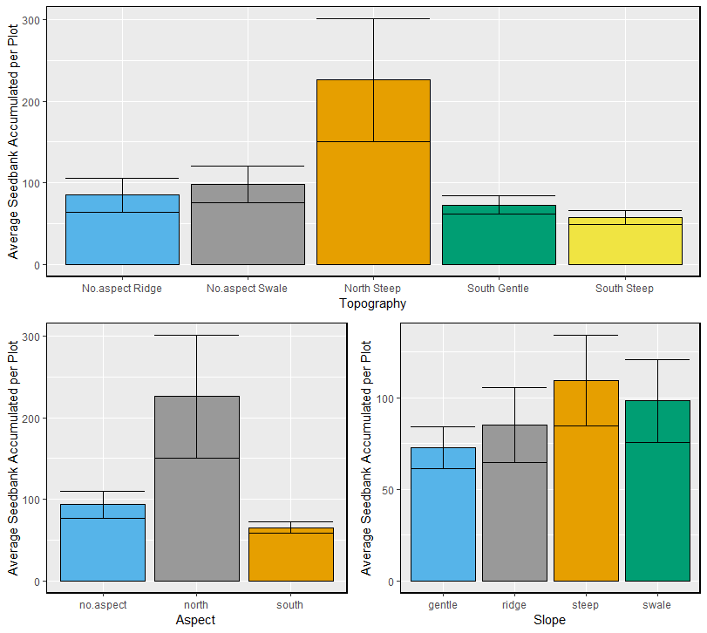

**Figure 7**. Upper panel shows average seedbank accumulation of Lupinus nipomensis at a plot level by Topography treatment. Seedbank accumulation the total number of seed added to a plot accounting for germinated individuals. The lower left panel shows the average seedbank accumulation of individuals within a plot by plot aspect. The lower right panel shows average seedbank accumulation by individuals at a plot level by slope treatment.

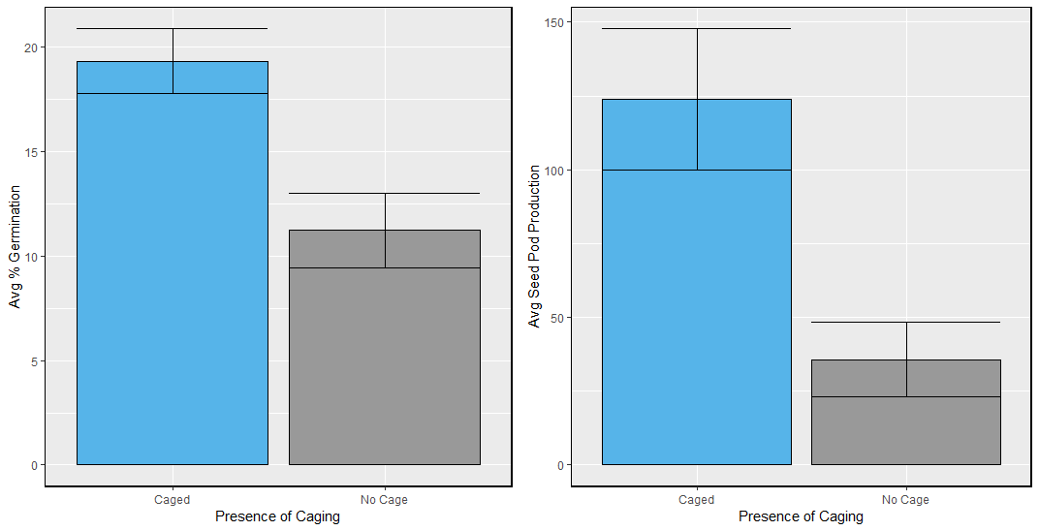

**Figure 8**. Left panel shows average percent germination based on caging presence. Right panel shows average seed pod production based on caging presence. Analyses are at plot level.

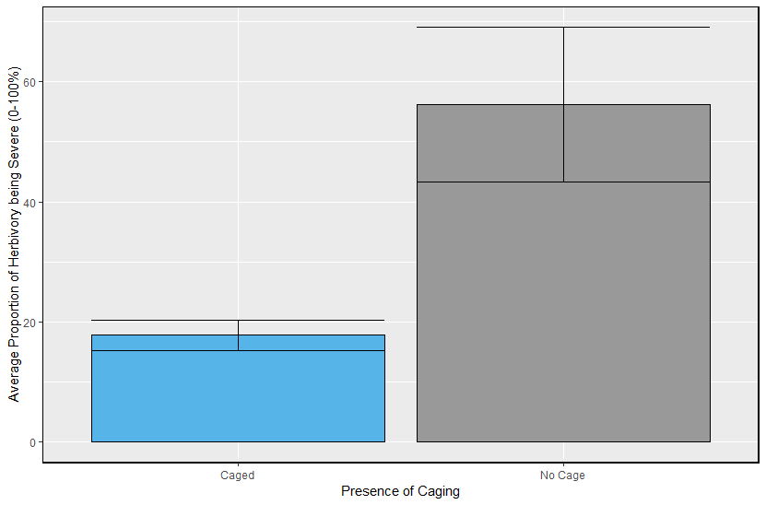

**Figure 9**. Average proportion of a Lupinus nipomensis individual experiencing severe herbivory based on caging presence. Analysis are at plot level.

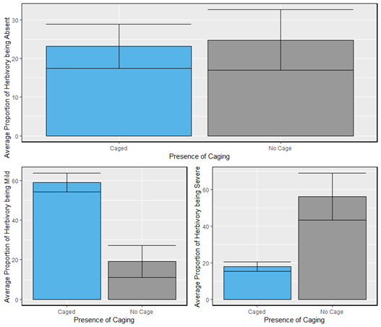

**Figure 10**. All plots are based on presence of caging and were completed at plot level. Upper panel shows chance herbivory being absent in a plot. Lower left panel shows proportion of individuals experiencing mild herbivory. Lower right panel shows chance of individuals experiencing severe herbivory.

Caging did not prevent individuals from experiencing herbivory, but individuals from plots that were not caged experienced significantly higher severe herbivory whereas individuals from plots that were caged on average experienced significantly higher mild herbivory (**Fig. 10**). This likely indicates that small mammals and other similar size herbivores are predating on *L. nipomensis* when uncaged, and when they are caged, they are unreachable to herbivores of that size and herbivory becomes milder, likely caused by smaller herbivores such as insects. Using an ANOVA, we found that degree of herbivory significantly affected average seed production at the plot level (p < 0.05; **Fig. 11**). General contrasts show that herbivory does not uniformly decrease seed production and that mild herbivory is significant in increasing seed production compared to plots that experience severe herbivory or no herbivory (p < 0.01).

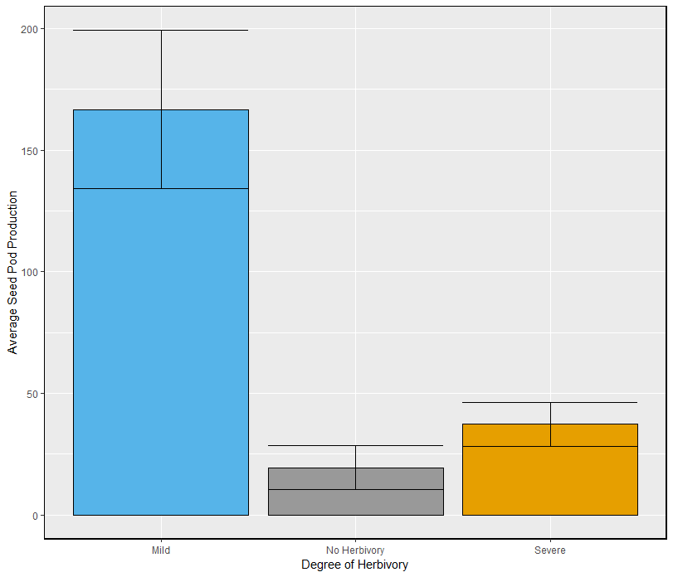

**Figure 11**. Plot compares average seed pod production based on level of herbivory. Plants that experience mild herbivory produce the most seed pods.

**Discussion**

We find that originally sowed populations of *Lupinus* *nipomensis* are successfully sustaining, but only in specific habitat types. The continued monitoring and results of the 5th year of the Black Lake Nipomo outplanting demonstrate the importance of determining potential microhabitat preferences of sensitive species before undertaking a full recovery effort. Ideal habitat at Black Lake Ecological Area (BLEA) is approximately 10% of the entire conservation area. Without careful planning and understanding of species preferences, 90% of a potential recovery effort could have been in vain.

By the 5th year, we see that average percent germination of individuals decrease. This can be misleading and potentially lead us to believe that there is lower success, however, this is because each year, there is a greater number of seeds added to the seed bank. These seeds do not always germinate the next year because lupines are known to have hard seed coats to delay germination. Therefore, the increasing seedbank, but consistent absolute germination, cause this trend. We also find that by the 5th year topography has a low effect on percent germination (**Fig. 6**), but still plays a major role in seed pod production, consistent throughout the duration of the experiment (**Fig. 7**). In particular, we find that the north facing aspect plays a determining factor, more so than topography or slope on its own. North facing slopes often have lower exposure, allowing greater soil moisture and lower drought stress. Parallel with greenhouse studies (Luong et al. 2018, unpublished data), this indicates that *L. nipomensis*, may not require large water input for germination, but is important for long-term survival and reproduction.

Although caging mesh size was not significant, presence of caging continues to be an important factor in determining overall percent germination and seed pod production (**Fig. 8**, **9**). Caging, on its own, did not remove all herbivory, but instead affected the intensity of herbivory (**Fig. 10**). Caged plots had greater germination and seed pod production which was likely linked to the decrease in severe herbivory. Caged plots also had milder herbivory, which was found to be linked to increased seed production (**Fig. 11**), likely induced through compensatory growth. Compensatory growth occurs when plants adapted to herbivory, can overcompensate for loss damage by increasing growth after mild herbivory. However, it is notable that a small number of uncaged individuals did survive in the 5th year that naturally recruited from the original sowing in caged plots.

Results from this experiment are promising because they demonstrate that reintroduction can be successful given careful planning. Notably different from previous years, we found that *Lupinus nipomensis* individuals that germinated were consistently consolidated within a few plots that were successful in previous years. This indicates that there needs to be further investigation within these specific plots and how they differ from other plots within and with different topographies. Furthermore, it is still unclear if individuals in the caged plots are truly experiencing compensatory growth or if they have greater success due to a potential interaction between the cage and coastal fog influence causing fog drip, improving soil moisture content. Although this is a possibility, it is unlikely, because we found no differences in the two caged treatments which have different mesh toppers which would affect potential fog drip. However, future studies should focus on disentangling this possibility. Future studies should also focus on potential genetic inbreeding depression and potential ongoing management actions that can benefit species recovery.

I recommend that this project continues its active monitoring protocol for at least 10 years (ending in 2025) in order to determine the long-term trajectory of the outplanting experiment and to ensure results are consistent. Furthermore, a longer-term data set is needed to better assess meteorological and climate effects on the population. Reintroduction into other areas such as the Guadalupe Nipomo Dunes National Wildlife Refuge, Oceano Dunes or a County Park in the back dune areas will help secure the future of this plant against the vagaries of herbivory, invasive species, environmental stochasticity and will help us understand whether results from Black Lake are more broadly applicable.

**Supplemental Data**

|  |  |
| --- | --- |
| **Rainfall Year** | **Total Dec-May Precipitation** |
| Average Dec-May Rainfall During Study | 29.58 cm |
| 2014-2015 | 14.47 cm |
| 2015-2016 | 25.27 cm |
| 2016-2017 | 58.65 cm |
| 2017-2018 | 24.82 cm |
| 2018-2019 | 24.57 cm |

**Table S1**. Total precipitation within the Nipomo lupine growing season (December to May) for the duration of the experiment, sorted by year.