# Exercise 2: Physical environmental controls on land cover pattern

The purpose of this exercise is to familiarize you with data and tools for exploring the relationship between geology, soils, topography and land cover pattern. You will beusing data modeling and visualization tools in ArcGIS and R to examine landscapes of the western Santa Ynez Valley in Santa Barbara County.

## 1) Gettting started

A. Create an ESM215 course folder on your H drive (e.g. ‘H:/ESM215’)

B. Open ArcGIS (Programs -> ScienceApps -> ArcGIS -> ArcMap 10.7.1)

C. Connect the H:/ESM215 course folder to your ArcMap working environment (in the ArcCatalog side window) via right clicking Folder Connections>Connect to Folder and navigating to your folder. This will enable you to quickly access your data throughout the semester.

D. Navigate to the File tab in ArcMap and click Open. Then, under ‘This PC’, navigate to the R:\Winter2020\ESM215\data\datavu.mxd file and open the project.

E. The legend of the ‘datavu’ project includes a variety of data files, which can be found in R:\Winter2020\ESM215\data\. We will be using data from this file (‘data’) for the remainder of the semester. Copy the ‘data’ folder ONLY from the R drive (if you copy all ESM215 R drive files you will use up unnecessary space on your H drive) to your course folder (‘H:/ESM215’). This takes some time, which is why we opened the ‘datavu.mxd’ project in the previous step to begin working with it while we wait.

Project layers for ‘datavu.mxd’:

**airphoto04** – 2 m resolution raster: true color air photo mosaic, 2004

**naip14 –** 1m resolution raster, true color air photo, 2014

**casubsect** - ecological subsections: feature (polygon) data. We will focus on subsection 261Ba, Santa Ynez Hills and Valleys. (<https://databasin.org/datasets/4996c7e61a0e48f2bef646903f51b82b>)

**subgeol2g**– A subregion of the 1:250,000 scale geologic map of CA. 94 ft. raster. A more detailed map with legend is available [here](http://www.quake.ca.gov/gmaps/GAM/santamaria/santamaria.html).

**subsoil –** A subregion of the1:24,000 scale soil survey map ([SSURGO](https://www.nrcs.usda.gov/wps/portal/nrcs/detail/soils/survey/?cid=nrcs142p2_053627)), 28 m raster data. SSURGO maps are the most detailed soil survey maps available for most of the U.S. and are used extensively for landscape-scale analysis.

**subsynezdem** – Digital elevation model, 28m raster: Shuttle imaging radar topographic data. Values are elevations in meters above sea level.

**subslope** - 28 m raster: slope angle in degrees derived from subsynezdem

**subshade** -  28 m raster: shaded relief image, derived from subsynezdem

**subwintrad -** 28 m the data raster**:** integrated clearsky shortwave radiation, units are watts/sq. m., for December-Feb.

**subwinrad3** – subwintrad reclassified into 3 radiation classes. Use this grid for the exercise.

**subsumrad -** 28 m the data raster**:** annualclearsky shortwave radiation, units are watts/sq. m.

**subflocum** –28 m raster: flow accumulation model, derived from synezdem for a subregion corresponding to subsoil30. Pixel values are the drainage area for each pixel. (The data are noisy because errors in the dem propagate to disrupt drainage topology.)

**subflocum3c** – **subflocum** reclassified into 3 accumulation classes. Use this grid for the exercise.

**subfire18** – fires from 1900-1918 (incomplete), compiled by the CA Dept of Forestry and Fire Protection and available [here](https://frap.fire.ca.gov/frap-projects/fire-perimeters/).

**subveg15**   - 28m raster: 1990-2014 vegetation/land cover map produced (mainly) from Landsat Thematic Mapper satellite imagery. California Wildlife Habitat Types are shown here. I merged some agricultural classes to reduce the number of land cover classes to 15. [Here](https://map.dfg.ca.gov/metadata/ds1327.html) is a description of the data.

Spend some time learning to display the data. Overlay individual layers and combinations on the air photo. Zoom in and out. Play with the symbology. Get the feel for ArcGIS as a visualization environment. In particular, examine apparent land cover pattern (air photo) and vegetation pattern (subveg) in relationship to geology, soils, fire history and topographic factors like elevation, slope, radiation and flow accumulation.

## 2) Quantitative association of thematic (categorical maps)

What controls land use/land cover pattern in the Santa Ynez Hills and Valley subsection? Landscape theory posits that pattern could vary from one landscape to another and reflect interacting local physical controls, disturbance history and population processes such as plant dispersal.

Various techniques exist to quantify the spatial relationship between land cover and environmental factors at different scales (Wagner and Fortin 2005). Here you will learn a method known as “mutual information analysis” useful for measuring the association between categorical maps (e.g., association of land use and soil type). The theoretical underpinnings of the technique are described by Phipps (1981) and example applications to landscape analysis include Davis and Dozier (1990) and Ernoult et al. (2003).

You will be analyzing vegetation pattern in the area covered by the 30 m grid **subveg15** in your project legend. Here are the steps:

1) Generate a random sample of points at which you will collect information on land cover class (**subveg15**), geology (**subgeol2g**), flow accumulation (**subflocum3c**), and winter radiation (**subwinrad3**). *OR,* you can use the set of 10,000 random points that I generated using the “Create random points” tool in the Data Management folder of Arc toolbox. The sample locations are already in your map legend as **ex2_sample**.

2) The sample points can be used to extract values at those locations from multiple grids using the Spatial Analyst Extension tools. To activate Spatial Analyst, navigate to the Customize tab at the top of the ArcMap window and select Extensions, and check the Spatial Analyst extension in the pop-up window. Now in the ArcToolbox Spatial Analyst folder, navigate to Extraction -> Extract Multi Values to Points. Use this tool will add the analysis output to the attribute table for your sample points. *OR*, use values already added to ex2_sample. You can open the tables and export the table to your work directory (‘H:/ESM215’). *OR*, you can copy the data from gauchospace.

3) The remainder of this exercise can be completed using Excel or R, but it is much faster in R. Import the data into R using the function read.csv(). Load the package **entropy**. From here you can use the function table() to cross-tabulate vegetation and other categorical variables for mutual information analysis. Use mi.empirical() to calculate pairwise mutual information of vegetation with geology, winter radiation and flow accumulation.

What is Mutual information? In a nutshell:

a. The spatial heterogeneity (or complexity) of a categorical map can be measured using Shannon's entropy statistic

$$H_{j}= -\sum_{j=1}^{u}{p_{j}ln \left(p_{j}\right)}$$

where pj is the proportion of the map in map class j, j=1,2…u.

b. When the area is jointly categorized by two variables *x* and *y* (for example vegetation and geology), a more complex map will result unless the variables are perfectly associated. The joint entropy of the combined variables is:

$$H(x,y)=-\sum_{j=1}^{u}{ }\sum_{k=1}^{v}{p_{jk}}ln\left(p_{jk}\right)$$

where pjk is the proportion of the map where *x* is in class *j* and *y* is in class *k*.

*H(x,y)* is maximized when *x* and *y* are spatially independent. Conversely, a measure of the strength of association or "mutual information" between two mapped categorical variable is the difference between the maximum and the observed joint entropy.

c. For a large sample size *N*, the mutual information between *x* and *y* can be estimated as:

$$MI\left(x,y\right)=H\left(x\right)+H\left(y\right)-H\left(x,y\right)$$

d. Here we are interested in determining which environmental variables are most strongly associated with vegetation pattern in the study area. Calculate *MI* for each environmental variable jointly with land cover.

e. As explained in Phipps (1981) or Davis and Dozier (1990), identify the variable with the highest I and then stratify the samples based on that variable. Then do one more level of the hierarchy by testing the mutual information of each remaining variable within your strata.

4) Report your work by answering the following:

1. Summarize your results using a tree diagram like that in the papers or this example:

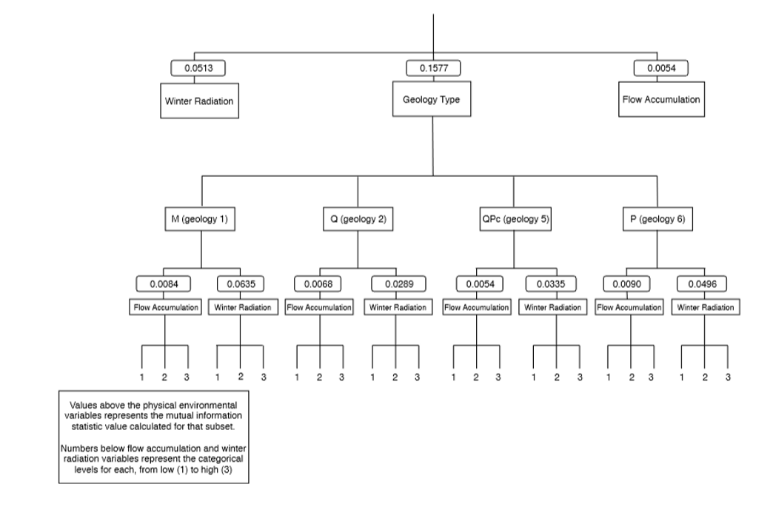

Levels of the environmental variable analyzed

Environmental variables analyzed

Mutual information statistic from second level analysis

Levels of the environmental variable with the highest mutual information statistic (e.g. if geology, geology 1, 2, 5, and 6)

Environmental variables analyzed

Mutual information statistic

Env Var3

Env Var2

Env Var1

The analysis for this lab requires two mutual information statistical analyses. The first determines which variable (Var 1, e.g. solar radiation) best predicts the vegetation, and the second analyzes the environmental variable which best predicts the levels of Var 1 (e.g. 1, 2, & 3 of solar which represent low to high radiation). To coordinate this analysis:

* 1. Use the table function in R to create counts of co-occurrence of the respective variables (vegetation with geology, vegetation with flow, vegetation with radiation). The result is 3 tables.
  2. Conduct a mutual information analysis on each table and derive the mutual information statistic (I) for each. Summarize this data in a new data frame with the column headers ‘Geology, Flow, Radiation’, and a row of mutual information statistic values.
  3. Conduct a second level analysis which evaluates the co-occurrence of the data levels of the variable with the highest mutual information statistic (Var 1), with the other environmental variables under investigation. For instance, solar has three levels, 1,2, & 3. To conduct the second tier mutual information analysis using the solar example, we seek to evaluate the co-occurrence of each data level of solar with each data level of geology (6, 5, 2, 1) and flow (1, 2, 3). To do this create co-occurrence tables as in step i. This will render 8 tables. Example equations to derive the table with which to calculate the second mutual information statistic of solar as related to vegetation and flow is using the table function in R with the data frame provided below is:

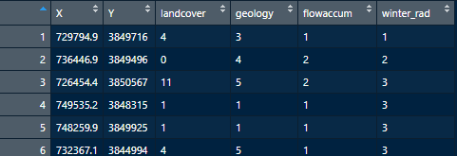

Solar1_VegFlow -> table(df[df[,6]==1,3], df[df[,4]==1,5]))

Solar2_VegFlow -> table(df[df[,6]==2,3], df[df[,4]==2,5]))

1. Discuss your results. How strong is the relationship between land cover and physical environmental variables?
2. Compare your findings to those of Davis and Dozier (1990).
3. Summarize the strengths and weaknesses of Mutual Information Analysis for establishing land cover-environment associations? What alternatives would you consider?

## Literature Cited

Davis, F. W., and J. Dozier. 1990. Information Analysis of a Spatial Database for Ecological Land Classification. Photogrammetric Engineering and Remote Sensing 56:605–613.

Ernoult, A., F. Bureau, and I. Poudevigne. 2003. Patterns of organisation in changing landscapes: implications for the management of biodiversity. Landscape Ecology 18:239–251.

Phipps, M. 1981. Entropy and community pattern analysis. Journal of Theoretical Biology 93:253–273.

Wagner, H. H., and M.-J. Fortin. 2005. Spatial analysis of landscapes: concepts and statistics. Ecology 86:1975–1987.