LBR-EX

Enhanced Part Libraries, Scripts and User Language Programs
for Eagle

Document Version 1.03

August 5, 2013

Copyright © 2013, Robert E. Starr, Jr.

http://www.bobstarr.net

Atlanta, GA USA

Introduction
This document describes using the LBR-EX libraries and scripts as a global replacement to the default libraries and scripts that ship with Eagle. In most cases, you can globally update/upgrade designs that use the original Eagle libraries via the "Update All" command in the schematic or board editor. These library parts have been carefully updated and maintained to minimize drill size difference, silkscreen text/widths and standardize package uses wherever possible for consistency and accuracy. While it is likely mistakes do exist, many commercial designs have been verified and placed into production using these libraries. Great pain has been taken to assure the accuracy and consistency across all the libraries contained in this package.

Perhaps one of the most useful upgrade libraries is the rc-master libraries which replace the default rcl.lbr library that ships with Eagle. The library rc-master-smd.lbr is designed specifically for SMD components while the library rc-master.lbr contains SMD and through hole components. Great attention has been given to these important libraries to provide a cleaner solution with consistent silkscreen appearance and pad size/spacing suitable for commercial type work. The ULP migrate-rc-master.ulp can be used to globally replace and migrate most all parts in existing designs from rcl.lbr to the rc-master libraries. A general description of the additional SCR and ULP utilities provided are also described in this document.

General Parts Library Architecture
The LBR-EX libraries were initially based on various versions of the default Eagle libraries that shipped with Eagle. However, all part footprints, silkscreens and symbols have been modified, tweaked or adjusted as needed to give consistent usage and appearance. All silkscreen elements have been adjusted to keep the silkscreen line widths at 8 mil or 10 mil where practical. In general, most parts have 8 mil silkscreen line widths while larger parts typically use 10 mil line widths. Some parts have different line widths or silk elements depending on special requirements or needs.

Nearly all part ID names using the >NAME field are either 40 mil, 32 mil or 24 mil in size depending on the part footprint size with text size ratios of 18 or 21 to make the text more legible. Most all of the part >VALUE fields are 32 mils with a ratio of 10 as these are used for display purposes in the board editor and not generated as part of the silkscreen output.

A major issue with the default Eagle libraries is the wide variety of drill hole sizes used. The number of drill hole sizes required for any particular board can quickly grow as result which can impact board cost in some cases. All drill sizes have been adjusted where possible to reduce the number of drill sizes required or used consistent sizes where possible (usually in connectors and such). Where possible, we most commonly use drill sizes of 10, 12, 16, 24, 28, 32, 36, 40, 50, 56, 66, 76, 86, 125, 150 and 200 mils. In many cases specific metric or other hole sizes will be required for specific connectors and other parts and are used on an as needed basis.

You will also find many new parts and libraries that are not a part of the original Eagle distribution. Be sure to browse the libraries to get a feel for the various parts that are available. You can also use the “USE *” command in the schematic or library editors and search for parts with wildcard names. Use the ADD or REPLACE command in the SCHEMATIC editor to search for particular parts by device name (eg ATMEGA*). Likewise, the ADD or REPLACE command can be used in the BOARD EDITOR to search for a particular footprint by footprint name (eg TQFP*). Note you must use the “USE *” command to select which libraries are currently active for searching, adding or updating in a design.

General Library Descriptions
In general, I do not recommend using rcl.lbr for generic discrete resistor, capacitors and common inductor type parts. Instead, the rc-master libraries listed below have been developed and commercially proven to allow for optimum routing space while meeting the needs of SMD pick and place equipment. A few common libraries to note are listed below:

Library Name | Description
rc-master.lbr | This library contains generic thru-hole RCL type parts along with common SMD type footprints.
rc-master-smd.lbr | This library contains SMD only RCL type parts which are optimized for space usage and wherefine detailed routing is required.
dframes.lbr | Generic drawing frames for schematics.
dpads.lbr | Various common wire pads for boards.
holes.lbr | Various drill and mount holes for boards.
jumpers.lbr | Various types of jumpers and jumper blocks.
con-headers-jp.lbr | Common board-to-board connectors and headers.
op-amp.lbr | A collection of various op-amp parts.

Migrating drawings from RCL to RC-MASTER Libraries
The ULP migrate-rc-master.ulp is provided to allow quickly migrating rcl.lbr parts to either of the rc-master libraries. This ULP will replace all rcl footprints and symbols in drawings and allow you to quickly upgrade these parts. However, your schematic and board drawings will require some touch up by hand afterwards depending on the parts used. Unfortunately, the original rcl.lbr library has capacitor symbols drawn at an odd angle from other parts and these may need to be rotated in your drawing after migrating.

Power Supply Symbol Libraries
I have also developed a number of high quality power symbol libraries. Please review the following power supply libraries and consider using these instead as these are generally compatible across each of the supply libraries and allow globally switching between the power symbol libraries with the UPDATE command.

Library Name | Description
supply.lbr | This is designed to replace the standard Eagle supply library.
supply0.lbr | Bar/Buss type power symbols.
supply1.lbr | Thin arrow type power symbols.
supply2.lbr | Wave type power symbols.
supply3.lbr | Inverted arrow type power symbols.
supply4.lbr | Thick arrow type power symbols.

Note you can also use the ULP make-supply-symdev.ulp to create any new power symbols needed with symbol options compatible with any of the supply symbol libraries above.

Recommended File/Directory Structure
We’ve found it is best to place all project and user libraries, scripts, ULP’s, etc. outside the Eagle program installation directories. This avoids loss of data and extra work copying/moving files when new versions of Eagle are installed or upgraded. So, we recommend placing all user project, libraries, etc in a root directory such as “C:\Eagle\” to avoid problems when upgrading Eagle.

We use the following directory structure and configuration as shown below in our Eagle setup:

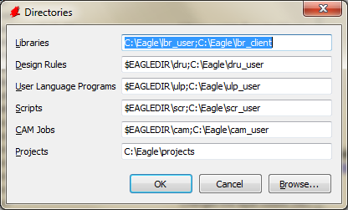
Note additional paths are specified by using the semi-colon character between each path as shown above. Thus, you can also add the “$EAGLEDIR\lbr;” specifier to the library path if you wish to use the default Eagle libraries and the LBR-EX libraries in your work.

You should copy and create the following files and directory structures as listed below:

C:\Eagle\lbr_user (all lbr_user files from LBR-EX go here)
C:\Eagle\scr_user (all scr_user files from LBR-EX go here)
C:\Eagle\cam_user (all cam_user files from LBR-EX go here)
C:\Eagle\ulp_user (all ulp_user files from LBR-EX go here)
C:\Eagle\projects (all Eagle user and other project subdirectories go within here)

Configuring the Eagle Environment and Editors
The Eagle install only configures the most basic features of Eagle initially. Many configuration options exist that will improve performance and make life Easier within Eagle. We have provided several scripts in the scr_user directory that will provide you with the features and settings we commonly use on a daily basis. This section describes the recommended settings and configurations we use and recommend.

Eagle Control Panel Settings
First open the Eagle control panel and select the Options->User Interface… menu option and set the options to match as shown below:

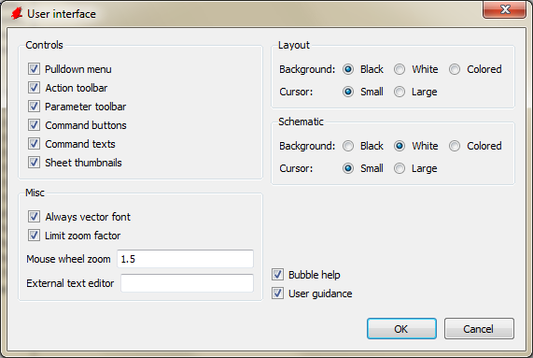

In particular, make sure the options “Always vector Font”, “Command texts” and “Sheet thumbnails” are enabled. The “Command texts” option is needed to enable additional text menu commands we will add the schematic, library and board editor menus.

Editor Settings
Next open a schematic file and select the Options->Misc menu item and configure the settings as shown below:

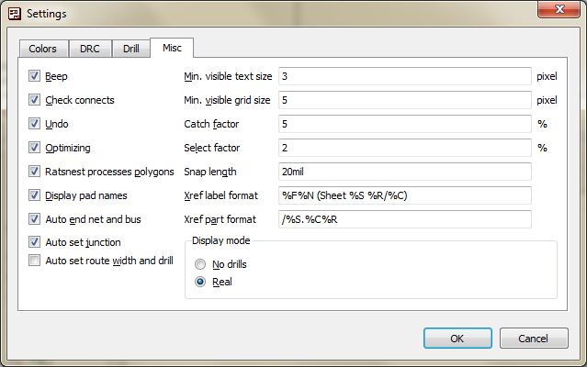

Make sure the “Display pad names” option is enabled so that pad names will be displayed in the board editor.

Configuring the Editors via Scripts
The default Eagle configuration eagle.scr installed during installation configures Eagle in its most basic form. Eagle allows customization of all the default grid sizes, drill sizes, line widths, line styles, text menus, etc. I have provided the script bobstarr.scr that can be used to configure all the editors and text menu commands for use with LBR-EX and the associated ULP’s and scripts. This script will add menu commands for the most commonly used ULP’s and commands I use in my daily work environment.

Open the file C:\Eagle\scr_user\bobstarr.scr and save this to your Eagle install directory script directory as eagle.scr. (you must have write permissions to this directory on Windows 7). You can make a backup of the original eagle.scr file or simply overwrite this if you like. Next open a blank or existing schematic file in the schematic editor and use the File->Script… menu command and execute eaglerc.scr from the Eagle script directory. This script configures some default grid settings, drill/hole sizes and line widths that we will commonly use. Make sure you enabled the “Command Texts” check box in the main Eagle Control panel option settings so the text command toolbar will be shown.

NOTE
You must grant “Write” permissions to your user login account in order to modify the eagle.scr on Windows 7. I suggest granting write permission for your user account to all files and sub directories in the Eagle directory.

Your board editor window should look similar to the following, note the text menu’s added on the right:

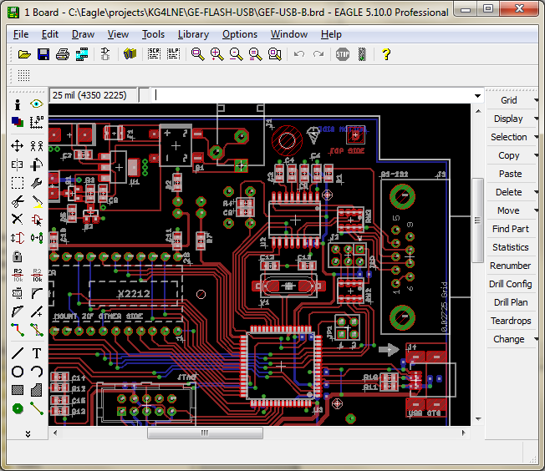

Note that the Eagle toolbars are draggable and dockable and can be placed on any side of the application window. Your schematic editor window should look similar to the following screen:

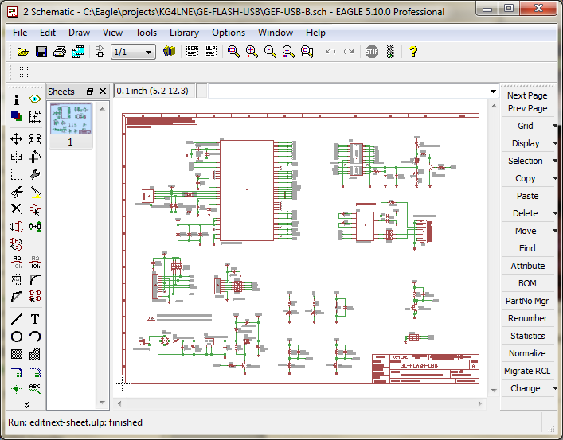

Note the new text menu commands on the right hand side of the editor window. Several of these commands are hooked to ULP scripts in the “user_ulp” directory. Please make sure you have directory paths properly configured and described in the first part of the document or these commands won’t work.

LEGAL NOTICE - NO WARRANTY
THESE LIBRARIES, SCRIPTS AND CAM JOBS ARE PROVIDED AS IS WITHOUT WARRANTY OF ANY KIND, EXPRESSED OR IMPLIED; WITHOUT EVEN THE IMPLIED WARRANTY OF MERCHANTABILITY OR FITNESS FOR A PARTICULAR PURPOSE. THE ENTIRE RISK AS TO THE QUALITY AND PERFORMANCE OF THESE LIBRARY COMPONENTS AND SCRIPT FILES ARE WITH YOU. SHOULD ANY COMPONENT PROVE DEFECTIVE, YOU ASSUME THE COST OF ALL NECESSARY REPLACEMENT, SERVICING, REPAIR OR REWORK. THE USER ASSUMES ALL RISK BY USING THE FILES.

