|  |  |
| --- | --- |
| 1 | VCC |
| 2 | GPIO4 / D2 / SDA |
| 3 | GPIO5 / D1 / SCL |
| 4 | RX |
| 5 | TX |
| 6 | GND |

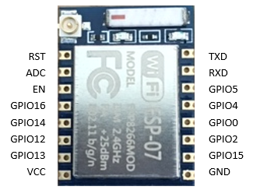

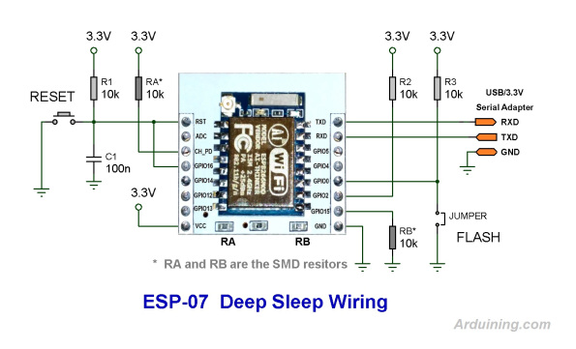

|  |  |  |
| --- | --- | --- |
| 1 | Reset |  |
| 2 | Vcc |
| 3 | GPIO-0 |
| 4 | GPIO-13 |
| 5 | GPIO-14 |
| 6 | Gnd |
| 7 | TX |
| 8 | RX |

rx

tx

gnd

Vin+

Vin-

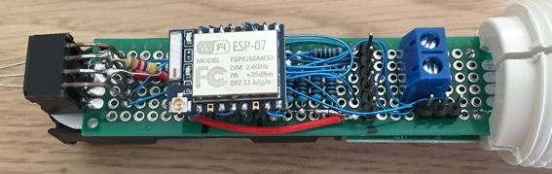

gnd

vcc

gpio 13

gpio 14

gpio 5

gpio 4

vcc

gpio 0

reset

gnd