Lab 2 – More HTML

Lab Exercise Instructions
BEFORE you start this Lab 2 exercise - copy bruce.html and ownwebpage.html from lab1 into a new folder called ‘lab2’
There is a summary of all the exercises at the end of this document
Download Lab2.zip from GCULearn– this contains files required for these following exercises

Exercise 2a
Add the following table to bottom of Bruce.html :
Note that the first cell of the top row spans two columns
Build up the table gradually
(Use the image called – borntorun.jpg)
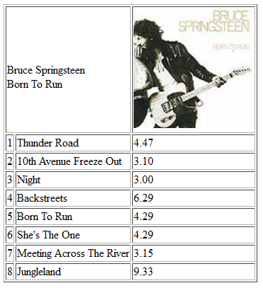

Exercise 2b

Update OwnWebPage.html display the information and images about Glasgow Landmarks.
Under the heading “Glasgow Information” :
Copy the relevant text for each landmark from Glasgow_Landmarks.txt.
Ensure that each paragraph uses separate <p> tags
The Landmark images are :
- George_Square.jpg
- Clyde_Arc.jpg
Ensure you save the file

Exercise 2c –Links to External Sites

At the BOTTOM of the OwnWebPage.html page – add a section called ‘Glasgow Web Sites’

These links should be an Ordered List

In this section - add links to :
- Glasgow Science Museum ( http://www.glasgowsciencecentre.org/ )
- Glasgow Caledonian University ( http://www.gcu.ac.uk/ )
- Glasgow Airport (http://www.glasgowairport.com/ )

Exercise 2d – Internal Links

At the TOP of the OwnWebPage.html page, create a section called ‘Quick Links’.

Add internal links to :
- “Glasgow Information” Heading ( from exercise 2b)
- “Glasgow Web Sites” Section ( from exercise 2c)

These Internal Links should be an Unordered List

Exercise 2e – Web Site Links
Also :
- update OwnWebPage.html so that is in linked to Bruce.html.
- update Bruce.html to link back to OwnWebPage.html

You MUST check that ALL the web links on each page works correctly

Summary

You will now have the following files (with corresponding exercises) :
- Bruce.html
  - Image (ex 1b)
  - Lyrics (ex 1a)
  - Table (ex 2a)
  - Image (ex 1b)
- OwnWebPage.html
  - Quick links ( ex 2d)
  - Information about yourself (ex 1c)
  - Glasgow Information ( ex 2b)
    - Text
    - Images
  - Glasgow Websites (ex 2c)

- Both files should also be linked to each other ( ex 2e)

Ensure that these files have been validated and all errors have been rectified.
(IGNORE validation warnings/errors for Table ‘border’ and ‘width’ – these will be rectified during later CSS labs)

Also ensure that you have used a wide range of HTML tags within these files ( e.g. various level of Heading tags, ‘strong’ tags , ‘em’ tags and extensive use of ‘p’ tags )

