GSMPR 622-S13: Data Analysis, Modeling, and Decision
Making
Fall 2024

Instructor
Robert W. Walker, Ph. D. Office: Mudd Hall 401, Salem
Email: rwalker@willamette.edu Correspondence policy: Within 24 hours on
Preferred contact: Email/Discord DM weekdays; 48 hours on weekends Office Hours: 4:00-5:00 p.m. M

Class information
Classroom: Kilkenny Lecture Hall [Mudd 201]
Class Hours: 18:00 - 22:00 pm M

Course description
Quantitative analysis is ubiquitous in management. Used for financial management and resource allocation, quality control, policy analysis, program evaluation, forecasting, public budgeting, market research, or preparing compensation and employee evaluation, quantitative tools are deployed for value creation in the for-profit, nonprofit, and public sectors. All organizations employ quantitative methods and advanced data analytic capabilities can be a key component in one’s employment market and are commonplace in management education. Despite this, many opportunities for the effective application of powerful quantitative ideas and tools still remain largely underexploited.
Information is a resource; it should be used judiciously and efficiently. While a wealth of information is available at our fingertips, high quality information can remain a surprisingly scarce resource. We are inundated with data, facts, and figures that only become actionable through identifying meaningful patterns and trends, developing fundamental managerial insights, and extracting information essential to inform effective managerial decisions. Our firm grasp of quantitative concepts, particularly as they relate to the practice of management, is the critical link between the data that are so readily available and the valuable information that we prize. In other words, the tools of this course are among the most important tools of effective managers.

Important Dates
September 9th, 2024 - Last day to add a course
October 25th, 2024 - Last day to drop or withdraw
See the Academic Calendar for more information.

Course goals
Upon successful completion of this course, you should –
- Understand different types of data and how they are obtained.
- Understand statistical processes for transforming data into managerial insight and actionable information.
- Understand the notion of statistical sampling error and what inferences can reasonably be drawn from data.
- Construct and interpret basic statistical interval estimates and tests of hypotheses.
- Understand concepts of statistical association and be able to build, evaluate and deploy basic statistical models.
- Develop a working familiarity with essential computational tools for data summarization, analysis, and statistical modeling along with a level of self-sufficiency in their use.
- Be an intelligent interpreter and user of data and statistical information.
- Be able to effectively communicate the results of quantitative analyses and statistical models, especially through the use of statistical graphics and visualization tools.
- Be able to creatively and effectively exploit statistical opportunities to advance your own professional objectives and those of your enterprise.
- Understand the ethical challenges presented by actions premised on data analysis and modeling.
Data Analysis, Modeling, and Decision Making marries two important academic elements – decision theory and probability and statistics – toward the end of being able to carefully apply these tools to make important managerial decisions. Decision theory is the use of scientific notions of uncertainty to quantify essential decision-making inputs and to be precise about the process of translating them into outputs. In two words we build models. Probability is crucial; it is how we quantify the uncertainty that faces virtually all inferences from data. Statistics, as summaries of information, inform our expectations about quantitative inputs into decisions. Both tools interact to yield evidence and decision support for managers. This is a course about ‘a way of thinking’ with the tools to make it so. It is not the only way of thinking but it must play a key role in management science. I argue for what is a new way of thinking for many students. For our purposes, that is not optional.
Among our immediate, short-term objectives is to equip all Willamette MBA students with the fundamental quantitative foundation essential to support your analytical work in subsequent courses, and, ultimately, in your career. Of even more lasting, long-term significance is that we learn to recognize and appreciate the value of quantitative and analytic frameworks in managing and controlling organizations. In this course, we strive to identify and exploit the many opportunities for the effective application of essential quantitative tools.
We begin by addressing the data pipeline, importing data and some background in Microsoft Excel. That ends quickly; I am no fan of Excel. Next, we turn to description and summarization of data (the tools of information extraction), essential probability distributions, and sampling distributions. Our initial work in data summarization and probability will form the foundation for our subsequent work in estimation, decision making, and statistical modeling. We spend roughly half of the course building to the regression model and the other half of the course employing it. This is because modern data analysis is rooted in covariance analysis and computational advances have merely facilitated more advanced and automated application of the same basic tools. Throughout, we will concentrate on a method for integrating data analysis into managerial decisions.

The Course
Our course is reasonably self-contained and assumes little at the outset, in the sense that we begin with the most fundamental of statistical concepts and proceed systematically to build a foundation of increasingly sophisticated and useful ideas. However, we will move rather briskly across our statistical landscape in order to embrace a relatively broad range of ideas over short period. You will have to do math and think in mathematical terms. That also is not optional; the math is multivariate algebra but you also will not have math tests or anything like it; we solve problems with data.
The approach is modern and designed to exploit modern computing resources as essential tools of information extraction. Though much of our work is conceptual in nature and many of our modest computational objectives can be met using only paper and pencil (perhaps with calculation assistance), sometimes computers are required. Computation has enabled enormous advances in statistics in the last two decades.
Computers rely on software; we will deploy freeware R and Microsoft Excel. R is available for every platform and has a very nice graphical user interface [add-on] that will allow us to calculate the statistics we need but also has the flexibility to enable much more advanced statistics and simulation that can prove useful throughout your managerial life. The core software will be R and the RStudio. The most important feature of R is that it is available cross-platform, simply works, and is freely available. The course text makes all the R code freely available to both learn and do. Radiant will make working with R quite easy.

Course Materials
The primary organizing resource for the course is the Open Introduction to Statistics. Given our work in the R language for data and the facts that the Open Intro is well written, concise, and supports R.
Diez, David M., Christopher D. Barr, and Mine Cetinkaya-Rundel. 2019.
OpenIntro Statistics: Fourth Edition.
Additional course materials – readings, examples, and exercises – will be posted regularly to our Canvas course site.
To access these sites, you will be prompted for your Willamette University login in order to gain access to course materials. The course will combine the use of Excel for many tasks and will introduce the R environment for statistical computing. R is open-source and we can use it to produce a broad array of beautiful graphics. You may also find it used in other courses at Atkinson that require an environment for more advanced statistical and mathematical computation.
OpenIntro Stats supports R and is portable. There are tablet and portable versions of the text in addition to the actual physical copy that is supplied and the source code for the examples, in R, are all available from the website for OpenIntro Statistics. A link to this and the tablet versions of the text are on Canvas. Slides are always posted before class. Supplemental resources can be found on Canvas.
Table 1: Course Schedule.
Date | Class | Week | Lecture [Chapters, S for Supplements]
2024-08-26 | 1 | 1 | Introduction
2024-09-09 | 2 | 3 | Introducing and Summarizing Data [1-2, S]
2024-09-16 | 3 | 4 | Visualization [1-2, S]
2024-09-23 | 4 | 5 | Probability [3, S]
2024-09-30 | 5 | 6 | Distributions [4]
2024-10-07 | 6 | 7 | Inference [5]
2024-10-14 | 7 | 8 | Categorical Inference [6]
2024-10-21 | 8 | 9 | Numerical Inference [7]
2024-10-28 | 9 | 10 | Summarizing Inference [6-7]
2024-11-04 | 10 | 11 | Correlation and Regression [8]
2024-11-11 | 11 | 12 | Regression Models [8-9]
2024-11-18 | 12 | 13 | Regression Extensions [9]
2024-11-25 | 13 | 14 | Generalizing Regression Models
2024-12-02 | 14 | 15 | Final Presentations

Student conduct
We are a community of learners. Our professional commitment is to create an environment that advances the science and practice of managing organizations. As individuals, we conduct ourselves with honor and integrity, treat everyone with respect, take responsibility for our actions, and fulfill our promises. Examples of conduct consistent with this expectation include:
- Taking initiative
- Crafting solutions
- Completing assignments according to an agreed schedule
- Offering constructive criticism and accepting it appreciatively
- Taking responsibility for our own learning and that of others
We expect someone who observes or learns about behavior inconsistent with our expectations of conduct to initiate corrective action by clarifying the situation and encouraging the responsible party to act appropriately. In the case of a violation of School or University policies or the laws of relevant jurisdictions, notify the appropriate enforcement authorities.

Attendance policy
• Because Zoom recordings of every course meeting are available, there are opportunities for making up missed classes; I take this as license to assume you are familiar with the complete contents of every class meeting.
You should attend. You are also adults. My philosophy is best summarised by the person that so eloquently stated it.
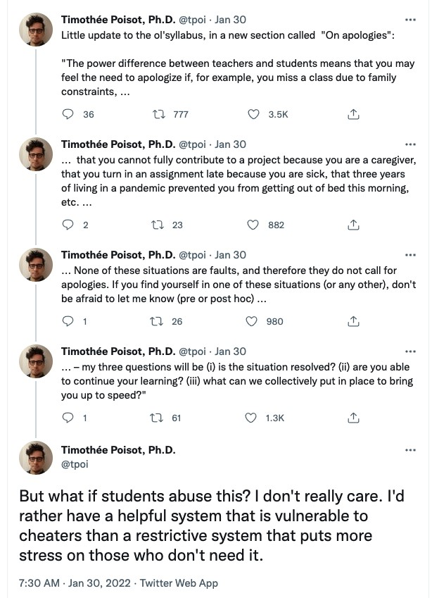

Grading
Grade | Range
A | 95-100
A- | 92-94
B+ | 89-91
B | 85-88
B- | 82-85
C | 76-81
F | 0-75
Assignment weighting will follow:
Item | Weight
Complete/Non-Complete | 30 %
Semester Project | 35 %
Assessments | 35 %
Individual assessments are designed for each of the three course modules; each comprises 10% of the total score. These assessments will be delivered in the course meeting following the last lecture of each module. A final project can be completed in pairs or individually with the weight assigned above. Finally, weekly exercises will arise outside of assessment periods. Each is simply submitted or not and the numeric score is weighted as a percent of the total number – the proportion complete.

Late policy
Much of the course is cumulative; assignments build on past assignments. It is not wise to fall behind. Most of the assignments are hard to evaluate beyond completed or not yet completed. Unless otherwise noted, this applies to all such assignments. The gradebook on Canvas reflects your progress in a timely fashion as detailed above.

Modules and Associated Assignments

Data, Summary, and Visualization
Class 1 provides an introduction to the course.
Class 2 is an exploration of data and the key elements of numerical summary. I will also talk a bit about data organization riffing off of Spreadsheets by Woo and Broman and have us think a bit about How to Measure Anything excerpts.
Class 3 examines data visualization motivated by Hadley Wickham’s Grammar of Graphics. You can read this if you wish but it forms the conceptual foundation supplied by radiant.
Class 4 introduces probability, perhaps the most important course concept. A set of supplements by ET Jaynes, Probability: The Logic of Science are worth reading.
Class 5 presents statistical distributions.

Inference
Class 6 introduces statistical inference, the concept linking probability and data.
Class 7 explores inference for categorical data.
Class 8 explores inference for numerical data.
Class 9 summarizes inference.

Regression and Models
Class 10 introduces correlation and regression – association with two variables.
Class 11 extends the regression model to multiple variables
Class 12 and 13 extend the regression model to other use cases.

Semester project
Class 14 summarizes our term and you present the findings of your project.
• We can negotiate the details. This is a letter graded exercise.

Willamette Code of Conduct
Every MBA for Professionals student is expected at all times to abide by the Willamette University Atkinson Graduate School of Management Honor Code, Academic Integrity Policy, and Expectations of Academic and Professional Behavior as detailed in the current student handbook (https://willamette.edu/mba/students/professionals/mbap-student- handbook/index.html).
Diversity and Inclusion Statement:
I intend for students from all backgrounds and perspectives to be well served by this course. The Diversity of thought and experience that everyone brings to this class should be viewed as a resource, strength, and benefit. As such, we will strive to be open-minded and understanding of everyone’s perspectives and polite to each other when we disagree.

Zoom Recordings
I will do my very best to insure useful Zoom recodings for every class. They are accessible via Canvas.

Solicitation of Input
Student input for the purpose of course improvement is taken very seriously and will potentially be done periodically. Please take the time to evaluate this course and the instructor, especially at the end of the semester. Evaluations will in no way affect your grade. I simply cannot know the student experience in the classroom without your perspective.

COVID policy
I have grown weary of including this part of a syllabus, but these times demand special attention. Keeping each one of us and the community safe is our first priority. Spreading a deadly or longterm debilitating condition to fellow members of a close-knit community is surely something that we would all regret tremendously. I will assure that I weigh this heavily; I also teach in the daytime program with some students deeply interwoven in campus affairs and I remain deeply concerned that I might act as a vector of transmission among populations if we all are not first and foremost concerned with the health and safety of the community. We may cohabitate with people with particular vulnerabilities and, in my view, we owe it to each other to respect and support the community’s maintenance of safety.
As a responsibility to the public health of the community, I will support students that cannot attend in-person for basically any reason. Should you elect to participate remotely, I am happy to support you in obtaining the experience you desire. Please notify me of challenges you are facing so that we can navigate them in a timely fashion. The class discord is great for this but be proactive. Zoom sessions are available for every meeting and I will do everything I can to support us in first and foremost maintaining community safety.
We cannot control the progression and transmission of the virus that causes COVID-19 in the broader community. I remain fully committed to delivering the highest quality in-person learning experience through these unprecedented times. However, you can rest assured that I am fully prepared to continue instruction entirely online should circumstances dictate this transition for the safety of the Willamette community.

Campus resources

Disabilities
Students with disabilities who require accommodation should notify the instructor of the nature of accommodation in the first week of class. Additional support is available from the Willamette University Accessible Education Services Office. They can be reached by telephone: 503-370-6737.

Educational Philosophy
As candidates for the Masters of Business Administration, I expect you to be occupied first and foremost with managing your own learning. I am very much available to assist you in accomplishing our learning objectives but you must take an active role and that includes being proactive about knowledge gaps, struggles, and shortcomings before we can develop strategies for solving them. Indeed, the ability to recognize the limits of one’s own knowledge and expertise and seek out expert counsel is widely regarded as a key trait among successful professionals. As a matter of logic, managing your own success in the course cannot fall to anyone but you. I promise to do all that I can to assist you when you actively manage your mastery of course objectives.
The first class meeting engages a discussion about my philosophy on assessments, grading, and how learning occurs.

Final thoughts
This document is a roadmap for our semester. We learn about data together and our individual experiences shape how we interpret and value data. Like all your classes, you will get out what you put into this course. Asking for help from one another and your instructors is important, don’t be afraid to ask a question about something you don’t know or if you want to check your knowledge about something you think you know.
NB: There are a few universally applicable policies across all campus units at Willamette University detailed herein. Otherwise, as a faculty member in the Atkinson Graduate School of Management, the syllabus is intended to comply with the requirements of Atkinson syllabi.
If this document is updated, a copy will be supplied to you via Canvas and changes will be announced in class.. This version was rendered 2024-08-26 13:12:07.392088. I would like to acknowledge the RmdSyllabus package and @TheFallingDuck - Ben Linzmeier of the University of South Alabama for an excellent and easy to use tool for creating syllabi in R using markdown.

