The accuracy and replicability of data analysis performed with large language models

Dear Editor:
Albeit a surprising idea just several years ago (Bie et al. 2022), automating data analysis via artificial intelligence (AI) now features in introductory courses (Bien and Mukherjee 2025) and researchers muse that future data scientists will orchestrate AI production processes in lieu of performing analytics themselves (Tu et al. 2023). Do these developments indicate that automated AI systems can perform data analyses accurately and others can replicate those analyses with confidence?
Over the past several years, we have explored that question by testing large language models (LLMs)—i.e. the type of AI widely used in popular applications such as ChatGPT—on a key task in parametric statistics: assessing which distribution to use to model the values of a random variable. As any data analyst or statistician knows, such a test is difficult because one cannot know with certainty which distribution generated data from everyday processes beyond our control (say, weather patterns, stock prices, sports outcomes, and so on). As a result, we created an independently verifiable “ground truth” by randomly generating data from a known distribution though it is worth noting that, with positive probability, multiple “ground truth” distributions could have generated some of our observed samples. We, then, presented salient information about those data to four off-the-shelf LLMs (OpenAI’s gpt-4-0613, gpt-4-turbo-2024-04-09, gpt-4o-2024-08-06, and gpt-5.2-2025-12-11) to see if they could accurately assess this which distribution generated the data.
Table 1. Values of key distribution parameters in the study
Beta | Binomial | Chi-square | Gamma | Geometric | Lognormal | Normal | Poisson | Uniform
1,2 | p=0.1; size=5, 10, 20, 40 | df=1 | 1,2 | p=0.1 | log-Mean=0; log-SD=1 | Mean=0; SD=1 | lambda=0.5 | min=0; max=1
2,2 | p=0.2; size=5, 10, 20, 40 | df=2 | 2,2 | p=0.2 | log-Mean=-5; log-SD=1 | Mean=-5; SD=1 | lambda=1 | min=0; max=2
3,2 | p=0.3; size=5, 10, 20, 40 | df=3 | 3,2 | p=0.3 | log-Mean=5; log-SD=1 | Mean=5; SD=1 | lambda=2 | min=0; max=3
4,2 | p=0.4; size=5, 10, 20, 40 | df=4 | 4,2 | p=0.4 | log-Mean=0; log-SD=5 | Mean=0; SD=5 | lambda=3 | min=0; max=4
5,2 | p=0.5; size=5, 10, 20, 40 | df=5 | 5,2 | p=0.5 | log-Mean=-5; log-SD=5 | Mean=-5; SD=5 | lambda=4 | min=0; max=5
 | p=0.6; size=5, 10, 20, 40 | df=6 | 6,2 | p=0.6 | log-Mean=5; log-SD=5 | Mean=5; SD=5 | lambda=5 | min=0; max=6
 | p=0.7; size=5, 10, 20, 40 | df=7 | 7,2 | p=0.7 |  |  | lambda=7.5 | min=0; max=7
 | p=0.8; size=5, 10, 20, 40 | df=8 | 8,2 | p=0.8 |  |  | lambda=10 | min=0; max=8
 | p=0.9; size=5, 10, 20, 40 | df=9 | 9,2 | p=0.9 |  |  |  | min=0; max=9
 |  |  |  |  |  |  |  | min=-1; max=1

Table 1 lists the distributions from which we drew samples along with the parameters we varied. We also systematically varied sample size, n, to each value in the set, N = {10, 20, 35, 60, 100}. Drawing 100 samples for each combination of parameter settings and sample sizes, we constructed a data set consisting of 100 iterations x 98 parameter settings x 5 sample sizes equaling 49,000 test iterations (i.e. observations) for a given model. Please find replication materials (including R code (R Core Team 2019) for implementation) at: https://robertwwalker.github.io/LLM_Distributions.
To obtain 196,000 observations, we presented four models with identical prompts that, first, introduced the LLM to the task by stating, “Below, I am going to provide you a stem-and-leaf-plot of a variable and the summary statistics for that variable. I would like you to tell me which distribution you think generated the data.”
Next we presented the model with the stem-and-leaf plot from a sample generated by a given parameter-setting-sample-size combination and the summary statistics (minimum, 1st-quartile, median, mean, 3rd-quartile, and maximum) from that particular random sample. We also indicated whether the data were discrete or not discrete. We then repeated our description of the task that we wanted the LLM to perform and specified the format that we wanted the LLM to use when generating output. An example of these instructions, in their entirety, appears below:

Below, I am going to provide you a stem-and-leaf-plot of a variable and the summary statistics for that variable. I would like you to tell me which distribution you think generated the data.

The decimal point is 1 digit(s) to the left of the |

0 | 392
2 | 0473
4 | 3
6 | 5
8 | 4

Here are the summary statistics: Min. = 0.03441; 1st Qu. = 0.141; Median = 0.2508; Mean = 0.3191; 3rd Qu. = 0.4031; Max. = 0.8438
The data type is: not discrete.

Please use the above information to predict which distribution generated the data. Please do not provide an explanation in your response. Please only state the name of the distribution in one word. Do not include the word 'distribution' following the name of the predicted distribution. Indeed, please read your response after writing it and ensure that you only provide the name of the distribution in your response.

Each test iteration contained a prompt, such as the one above, with a stem-and-leaf plot and summary statistics from a unique random draw from the study’s generating distributions. The model responses contain considerable metadata that allows us to track input and output tokens and, most importantly, the model responses.
There is some variation in spelling and other aspects of these recorded outcomes. We obtained LLM output for the Lognormal distribution as “Log-normal”, “Lognormal”, and “Log-normal” and regarded all such values as specifying “Lognormal.” The “Negative Binomial” also appeared as the “NegativeBinomial,” which we treated as a specification of the Negative Binomial Distribution. Finally, we obtained peculiar results—if not errant ones—relating to the skewness of the distribution—specifically, responses listing “SkewNormal”, “Skew-normal”, “Skew-right”, “Skewed”, “Skewness”, and “Skewnormal.” We combined all of these findings under a global category, “Skewed.”
Figure 1 presents our results. Model choices appear on the vertical and the ground truth distribution appears on the horizontal axis, with each panel of the plot presenting results from one model. The oldest model in our set, gpt-4-0613, which was released on June 13, 2023, regularly chooses the Normal distribution, thus creating high rates of accuracy (100%) when presented with data from a Normal distribution, but otherwise rarely succeeds at accurately choosing which distribution generated the data, save for when facing a Lognormal (88% accuracy) and Poisson (55%). The second oldest model in the set, gpt-4-turbo-2024-04-09, consistently recovers the Beta (97%) and Poisson (96%) distributions, performs similarly with the Lognormal (86%), is considerably worse with the Normal distribution (58%), seldom recovers the Binomial (10%), and rarely recovers the Uniform (4%) or Gamma (4%) distributions. This improved performance continues with the second newest model in our test set, gpt-4o-2024-08-06, which accurately identifies data generated from a Normal distribution (98%), performs well for the Beta (73%) and Poisson (73%) distributions, seldom recovers the lognormal (18%) or uniform (12%), and rarely recovers the binomial (5%) and Gamma (.1%) distributions. As the lower-right panel of Figure 1 indicates, gpt-5.2-2025-12-11, the newest model among the set that we tested, exhibits an ability to accurately identify data from the Beta (99.7%), Binomial (72.8%), Lognormal (93.5%), and Normal (89.2%). No model proves capable of accuracy in all instances in our test, but we caution against “over interpreting” these findings.

Figure 1.
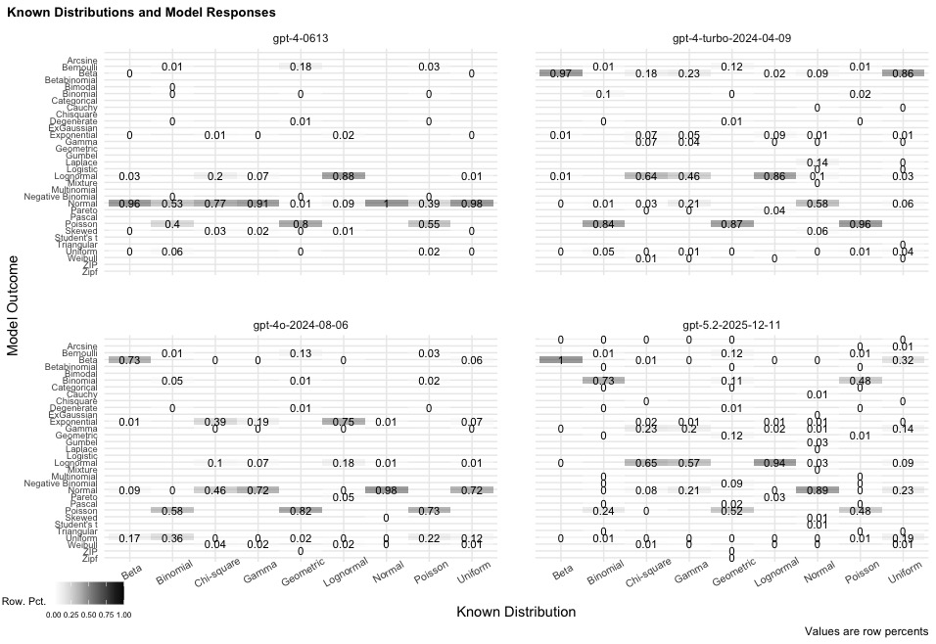

Ultimately, one could rightly criticize these findings as the by-product of particular prompts we used, the models from a single company that we tested, the fact we did not deploy advanced techniques such as tool use, or the challenging nature of the task that we studied. We agree with each criticism, yet each criticism also highlights the judgment required to use LLMs for data-analytic tasks and, thus, the degree to which automation of data analysis remains on the horizon. Crafting better prompts, assessing the appropriateness of models for analytic tasks, and guiding models to utilize the right tools requires analytic know-how, thus implying that the automation of data analytics is not possible in the near term.
The discretion associated with this judgment also speaks to the challenges of replicating the results of data analyses conducted using LLMs. Although researchers can replicate features of our test due to the ease of documenting our study’s prompts and procedures, other aspects of sound replication remain outside of our control. We do not possess intricate knowledge of the LLMs that we used (e.g., the weights of the underlying models) and the private enterprise hosting the LLMs that we studied can remove them from access at any point thus preventing replication (Johnson and Obradovich 2024).
In addition to raising questions about replication, the prospect of complete automation leaves us wondering about how human users would be able to interpret analyses that they did not play a role in producing. As we performed the above tests, we often found ourselves contemplating whether particular off-the-mark choices by LLMs were due to particular attributes of the randomly generated samples that we tasked the models with categorizing. We had few means of exploring those suspicions, despite designing the test itself, and should fully autonomous analytic systems emerge, such challenges will grow more salient. While developers might design AI models to output information to facilitate interpretation, users would find themselves in the need to check that information, too, thus again implying the need for data-analysis knowledge and questioning the possibility of complete automation unless individuals simply decide to assume, on grounds of faith, that the outputs of AI models are accurate.
Taken alongside the results of our systematic test of LLMs’ performance in a key task of parametric statistics, the potential impediments to interpretation and replication speak to challenges facing individuals who seek to automate data analysis via AI systems. How these challenges evolve or abate in the years ahead will provide a fascinating subject of ongoing attention and investigation in statistics and data science.

References
Bie, T. D., Raedt, L. D., Hernández-Orallo, J., Hoos, H. H., Smyth, P., and Williams, C. K. I. (2022), "Automating Data Science," Communications of the ACM, 3 (3), 76-87.
Bien, J., and Mukherjee, G. (2025), "Generative AI for Data Science 101: Coding Without Learning to Code," Journal of Statistics and Data Science Education, 33 (2), 129-142. DOI: 10.1080/26939169.2024.2432397.
Bubeck, S., Chandrasekaran, V., Eldan, R., Gehrke, J., Horvitz, E., Kamar, E., Lee, P., Lee, Y. T., Li, Y., Lundberg, S., Nori, H., Palangi, H., Ribeiro, M. T., and Zhang, Y. (2023), "Sparks of Artificial General Intelligence: Early experiments with GPT-4," arXiv. DOI: https://doi.org/10.48550/arXiv.2303.12712.
Johnson, T., and Obradovich, N. (2024), "New methods for deprecating artificial intelligence systems will preserve history and facilitate research," Nature Communications, 15 (1), 10254. DOI: 10.1038/s41467-024-54758-1.
R Core Team. 2019. R: A language and environment for statistical computing. edited by R. F. f. S. Computing. Vienna, Austria.
Tu, X., Zou, J., Su, W. J., and Zhang, L. (2023), "What Should Data Science Education Do with Large Language Models?," arXiv. DOI: https://doi.org/10.48550/arXiv.2307.02792.

