A Nifty Plot for Tables

RWW

April 22, 2019

## Alluvial and Sankey Diagrams

The aforementioned plots are methods for visualising the flow of data through a stream of markers. I was motivated to show this because enough of you deal in orders, tickets, and the like the flow visualisation of a system might prove of use. I will work with a familiar dataset. These are data on Admissions at the University of California Berkeley. The data exist as an internal R file in tabular form.

library(tidyverse)

## ── Attaching packages ─────────────────────────────────────────────────────────────────────────────────────────────────── tidyverse 1.2.1 ──

## ✔ ggplot2 3.1.1 ✔ purrr 0.3.2   
## ✔ tibble 2.1.1 ✔ dplyr 0.8.0.1  
## ✔ tidyr 0.8.3 ✔ stringr 1.4.0   
## ✔ readr 1.3.1 ✔ forcats 0.4.0

## ── Conflicts ────────────────────────────────────────────────────────────────────────────────────────────────────── tidyverse_conflicts() ──  
## ✖ dplyr::filter() masks stats::filter()  
## ✖ dplyr::lag() masks stats::lag()

library(ggalluvial) # if this is not installed, install.packages("ggalluvial")  
data("UCBAdmissions") # This dataset is built in as a set of tables.  
UCBAdmissions # What does it look like?

## , , Dept = A  
##   
## Gender  
## Admit Male Female  
## Admitted 512 89  
## Rejected 313 19  
##   
## , , Dept = B  
##   
## Gender  
## Admit Male Female  
## Admitted 353 17  
## Rejected 207 8  
##   
## , , Dept = C  
##   
## Gender  
## Admit Male Female  
## Admitted 120 202  
## Rejected 205 391  
##   
## , , Dept = D  
##   
## Gender  
## Admit Male Female  
## Admitted 138 131  
## Rejected 279 244  
##   
## , , Dept = E  
##   
## Gender  
## Admit Male Female  
## Admitted 53 94  
## Rejected 138 299  
##   
## , , Dept = F  
##   
## Gender  
## Admit Male Female  
## Admitted 22 24  
## Rejected 351 317

UCBADF <- data.frame(UCBAdmissions) # For it into a data.frame  
UCBADF # This is what the data structure needs to look like.

## Admit Gender Dept Freq  
## 1 Admitted Male A 512  
## 2 Rejected Male A 313  
## 3 Admitted Female A 89  
## 4 Rejected Female A 19  
## 5 Admitted Male B 353  
## 6 Rejected Male B 207  
## 7 Admitted Female B 17  
## 8 Rejected Female B 8  
## 9 Admitted Male C 120  
## 10 Rejected Male C 205  
## 11 Admitted Female C 202  
## 12 Rejected Female C 391  
## 13 Admitted Male D 138  
## 14 Rejected Male D 279  
## 15 Admitted Female D 131  
## 16 Rejected Female D 244  
## 17 Admitted Male E 53  
## 18 Rejected Male E 138  
## 19 Admitted Female E 94  
## 20 Rejected Female E 299  
## 21 Admitted Male F 22  
## 22 Rejected Male F 351  
## 23 Admitted Female F 24  
## 24 Rejected Female F 317

## An Alluvial

I will load in those data. This is the tidy version that we worked with at the individual level. To make this code work, change the below locations to import the same data.

load(url("https://rww.science/data/UCBtidy.RData")  
head(DiscriminationUCB)  
DUCBT <- DiscriminationUCB %>% group_by(M.F,Dept,Admit) %>% summarise(count = n()) %>% ungroup()  
DUCBT

The alluvial requires an additional package ggalluvial. We can install it through install.packages("ggalluvial"). What can it do? It needs data. The y axis is always the total counts in the cells. Then we set axes with a number after to show the phases from left to right. So here, axis1 will be gender and axis two will be Department. Admitted and non-admitted students will be flowed with colors depicting them move through the system. We want to track them by their admitted status.

## With the system data

This is the vignette solution to these data with the package. Extending it to any data is a two step process.

ggplot(UCBADF,  
 aes(y = Freq, axis1 = Gender, axis2 = Dept)) +  
 geom_alluvium(aes(fill = Admit), width = 1/12) +  
 geom_stratum(width = 1/12, fill = "black", color = "grey") +  
 geom_label(stat = "stratum", label.strata = TRUE) +  
 scale_x_discrete(limits = c("Gender", "Dept"), expand = c(.05, .05)) + # Fix the x axis  
 scale_fill_brewer(type = "qual", palette = "Set1") + # Give it nice colors  
 ggtitle("UC Berkeley admissions and rejections, by sex and department") # give it a title

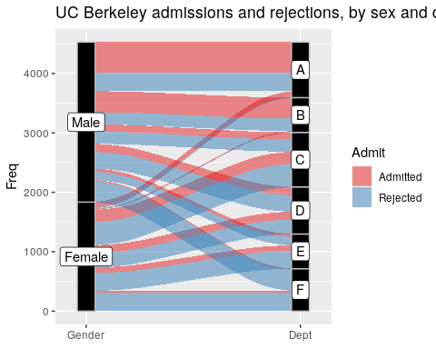

# A simple one [or as simple as I can]

A lot of the code is just prettying. The most basic plot needs this:

ggplot(UCBADF, # plot the data  
 aes(y = Freq, axis1 = Gender, axis2 = Dept)) + # what are the named axes  
 geom_alluvium(aes(fill = Admit), width = 1/12) + # what variable will fill the paths; Admission here.  
 geom_stratum(width = 1/12, fill = "black", color = "grey") + # This set the strata that our people will move through The one 12 is 12 combinations; the two colors here dfine the background and text for the labels.  
 geom_label(stat = "stratum", label.strata = TRUE) # This labels them.

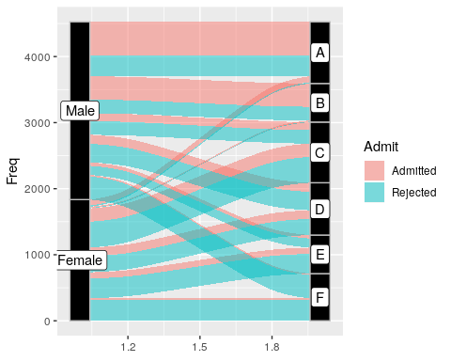

Same with our data.

ggplot(DUCBT,  
 aes(y = count, axis1 = M.F, axis2 = Dept)) +  
 geom_alluvium(aes(fill = Admit), width = 1/12) +  
 geom_stratum(width = 1/12, fill = "black", color = "grey") +  
 geom_label(stat = "stratum", label.strata = TRUE)