Required reading for this homework:

On_Scaling.ipynb

rolling_regression_centering.xlsx

on_regularization_lasso_ridge.ipynb

Start from CocacolaStart.ipynb:

Cocacola sales seem to follow a cycle of four quarters (using quarterly data).

Model the sales of CocaCola using the multiplicative model of seasonality, after taking logs.

by using pandas.read_csv('CocaCola.csv', parse_dates=['Date'], infer_datetime_format=True) function

read the data in "CoCaCola.csv" and save it into a pandas dataframe called df

Use pandas.to_datetime(df['Date']) function

to convert the original Date column in df to a datetime data type

save the converted datetime as df["datetime"]

use df.set_index('datetime', inplace=True) to set the datetime column as index of the df

get rid of the original Date column in df

by using df.drop(["Date"], axis=1, inplace=True)

print df.head(), it should look like this:

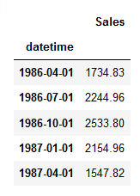

use the tsplot() function to plot the Sales column of df with lags=29

try to determine the number of quarters in a seasonal cycle

in the autocorrelation plot

using df.dropna(inplace=True) to get rid of any Nans

Using the detrendPrice() function

detrend the df and save it in a new df_detrended dataframe

use the tsplot() function to plot the sales column of df_detrended with lags=29

try to determine the number of quarters in a seasonal cycle

in the autocorrelation plot

Prepare the data for the multiplicative seasonal model

using np.log(df["Sales"]), transform the Sales data in the df into its natural log

save the result back in df["Sales"]

Using dft.index.quarter generate a column of quarters

save the resulting column into a new df["quarter"] column

print the df.head() to get:

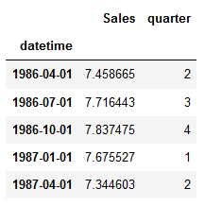

Using the pd.get_dummies(df["quarter"], prefix="quarter") function

“one-hot-encode” the df["quarter"] column and

save the resulting dummy variables in a new df_dummies dataframe

print the df_dummies.head(), it should look like this:

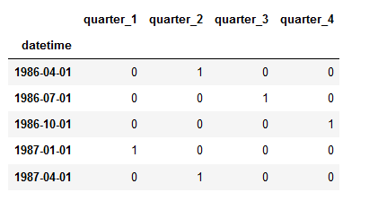

using df.join(df_dummies), join the dummy variables to the original data

and save the result back in df

print the df.head(), it should look like:

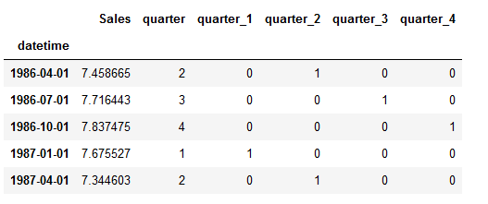

using df.drop(["quarter","quarter_4"], inplace=True, axis=1) drop these two columns

print the df.head(), it should look like:

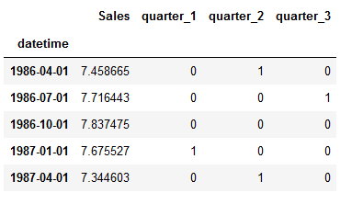

declare an empty list = []

using the list(range(0, dft.shape[0])) function and the fact that df.shape[0] contains the number of rows in the df

generate a list going from 0,1,2,....,60 (the number of rows in the df)

and save the result in df["time"] = list

print the df.head(), it should look like:

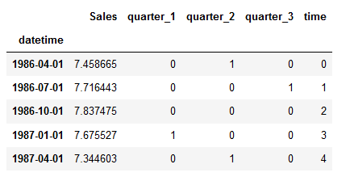

Save the df.["Sales"] column into the variable y

use df.drop(["Sales"], inplace=True, axis=1) to drop the Sales column

Save the df into the X variable

Now instatiate a linear regression, fit it to the train set and use it to predict

using the train_test_split() utility with random_state=42 and shuffling=False, divide the data into 80% train and 20% test data

instantiate a linear regression model, save it in lr

fit the linear regression model using lr.fit() function, save the resulting fitted model into lr_fitted (you can save it back into lr, but you might want to remember that you fitted lr already)

use lr_fitted.predict() function to interpolate, giving it as input X_train, saving the output as predictions_train

use lr_fitted.predict() function to forecast, giving it as input X_test, saving the output as predictions_test

evaluate the model

use the MAD_mean_ratio() function to calculate the MAD/MEAN ratio error of predictions_train

print the error

use the MAD_mean_ratio() function to calculate the MAD/MEAN ratio error of predictions_test

print th error

The errors should be near this (these are percentages, .75% and 2.51%):



use the plotModelResults() function to plot the predictions and the true test values

use the plotCoefficients() function to plot the coefficients of the regression

The outputs should be near this:

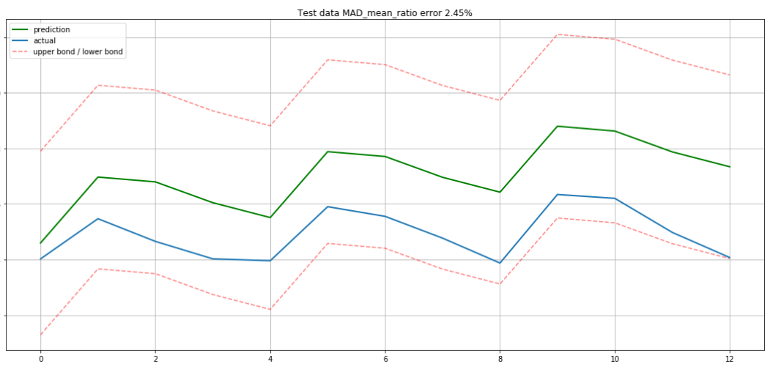

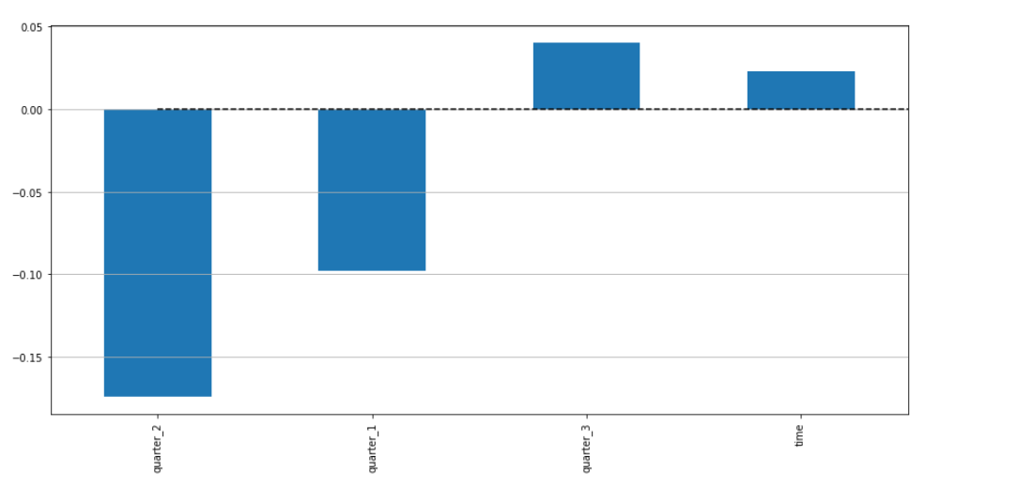

Now let us try to bring down the error in the test predictions by introducing error (bias) into the train predictions, that is, by making the regression fit the train data not so well as before, so that it can predict the test data better. We do this by using a Ridge regression and looking for the regularization value of the alpha parameter. These are the steps:

1. Load and visualize the unscaled data
2. Divide the data into test and train set: 80% train 20% test: train_test_split(X, y, test_size=.2, shuffle=False, random_state=42)
3. Set up a pipeline to scale the data appropriately during grid search: Pipeline([("scaler", StandardScaler()), ("ridge", Ridge())])
4. Separate out a percent of the train set as validation data: 20% (5 folds cv=5): TimeSeriesSplit(n_splits=5)
5. Use the validation data to select the model with best parameters: GridSearchCV(pipe, param_grid, cv=tscv, scoring="neg_mean_absolute_error")
6. Instatiate and train (=fit) a new model with the best parameters on the training data
7. Test (=predict) the model on the testing data
8. Plot the predictions vs true values
9. Evaluate the model using a metric (=MAD/MEAN RATIO score)

The MAD/MEAN ratios should be near:



That is, the Train set error should go up and the Test set error should go down.

The visual output of Ridge should be near:

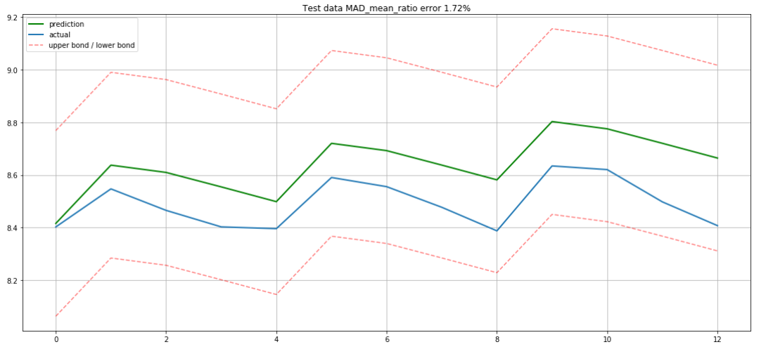

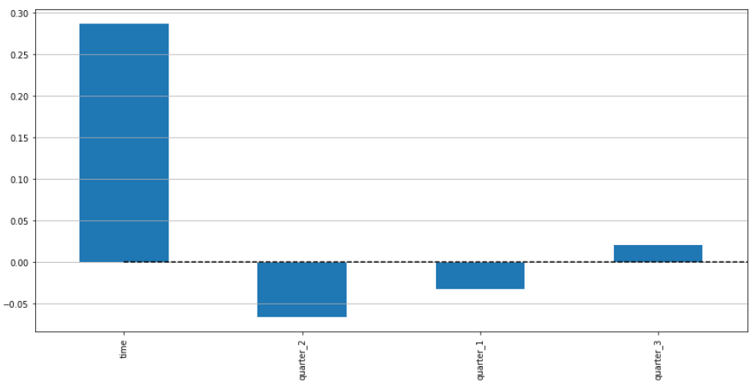

So the ridge beta (slope) coefficients should have shrunk in size when compared to the corresponding plain regression beta (slope) coefficients.

NOTE:

To get the model directly out of the grid search object, use the property: grid_search_object.best_estimator_[1]

(grid_search_object.best_estimator_[0] is the scaler).

Regarding steps 6, 7, 8 and 9 above:

If you do (A):

A: you instantiate a whole new regression object giving it the parameters obtained from the grid search object’s best_params_ property and you predict the test data using that newly instantiated regression object, the results are going to be different than if you do (B):

B: you use the grid search object to predict the test data directly using the grid search object’s predict method**.

Why?

Because the length of the training data is going to be different in the two cases (actually, this used to be the case but this is no longer true. In the latest implementation of GridSearchCV the refit argument defaults to True, so the two cases A and B above should result in the same output). In A, all the training data is being used to train the model, in B, part of the training data is separated out for validation. Try it both ways and see. But in the end, for this assignment select the method that gives a graph that is closest to the one suggested.

**You can do (B) two ways:

You can predict with the grid search object’s predict method or

You can predict by first obtaining the grid search object’s best_estimator_[1] and using it to predict.

Note that the grid search object best estimator is actually a pipeline that includes scaling as the first step.

So the input of the grid search object need not be scaled.