Assignment 4 report

**NLM analysis**

Set 1:

Source result

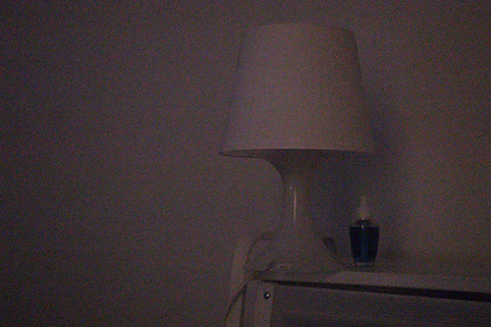

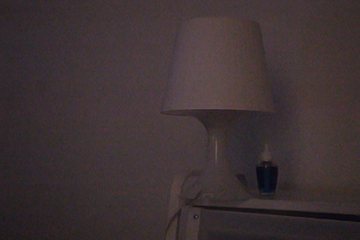

Set 2:

Source result

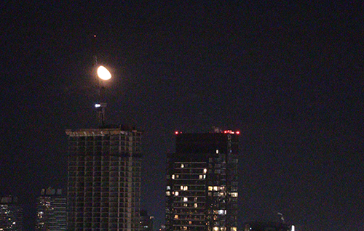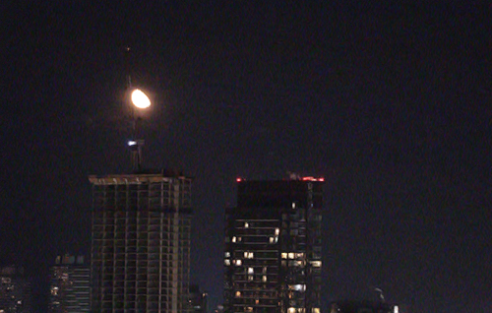

Increase patch size

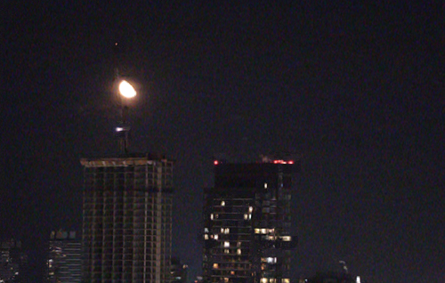

Set 3:

Source Result

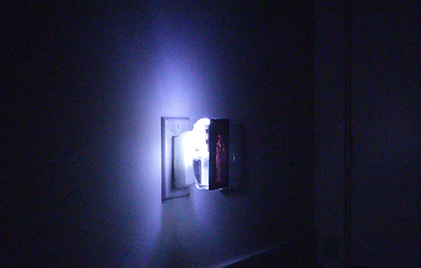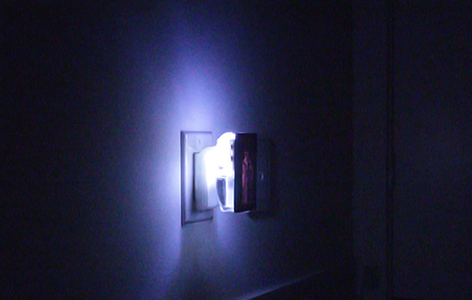

Increase radius Increase patch size

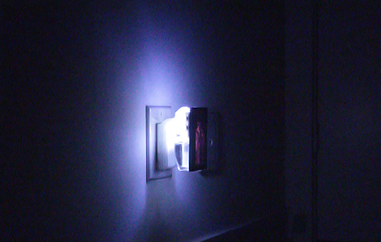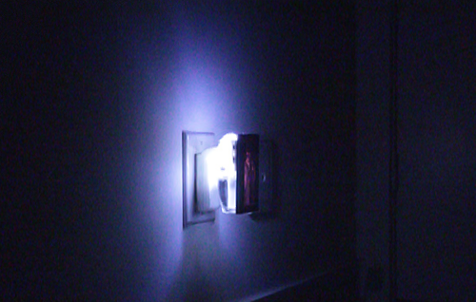

Increase k

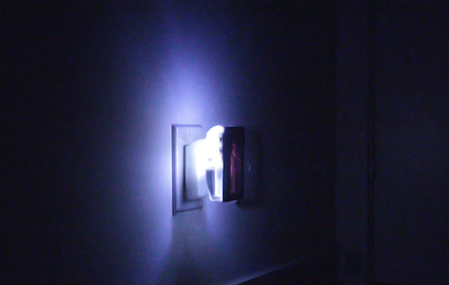

All source photos taken at ISO 128000, resolution changed to 500*300 to reduce running time of the algorithm

From those tests, we can conclude:

* k: By increasing k, the de-noise effect will be enhanced. Noise in the photo are blurred more compare with lower k. However, the detail of picture will be lost. (This can be conclude from set 3)
* Radius: No big difference when change radius. However, theoretically, proper radius will help the algorithm to find better patch similar to the source patch.
* Patch size: By increasing patch size, the de-noise effect will be enhanced. Distortion of details can be fount in the reconstructed image. Wrong details sometimes appear in the reconstructed picture due to the large patch size. (example in set 2, black circle can be found at the right side of the right building)

**Jaguar 2 result**

Patch-match:

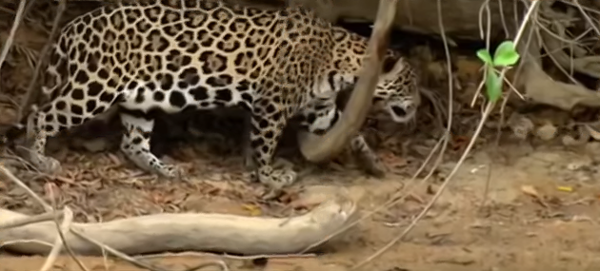

De-noise:

