Zibo Meng

Nov. 5th, 2015

Report to assignment 4 for CS570

1. Introduction

This project implemented and evaluated the k-means clustering algorithm in JAVA and IntelliJ IDEA (IDE). In this program, arff files are required as the data input files, and it can take and handle both numeric and nominal features and classes. Besides, it can take parameters to decide whether the normalization will be used in the program, how much iteration for each clustering process and how many clusters will be generated.

To execute this program, you’d better import this project into IntelliJ IDEA 14.1.5 and use JDK 1.8.0_60. Besides, there is an external .jar library, jcommander-1.27.jar, which is used to handle multiple parameters. Please include it as your external library.



Parameter details as follows:

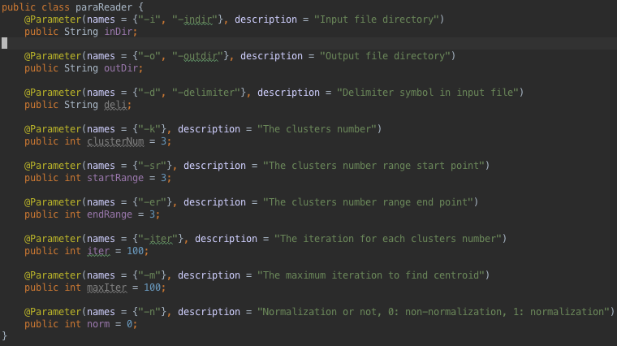

Usage:

Set parameters like

*-i dat/baskball.arff –o output.txt –sr 2 –er 20 –iter 100 –n 0*

Recompile, run and wait for result.

Happy done.

1. Dataset choosing and preprocessing
2. dat/baskball.arff

5 features without class and all these features are numeric

96 instances

1. dat/cloud.arff

7 features without class and part of these features are numeric, others are nominal

108 instances

1. dat/mushroom.arff

22 features with class and all these features are nominal

7423 instances

There is no missing data in all of these datasets above and there is no obvious correlation between features in these datasets. Thus, we don’t need to do the data preprocessing before clustering.

1. Evaluation methods and quality metrics:

For dataset without class (unsupervised):

Calculate and compare their Sum of Squared Error (SSE) and Between cluster Sum of Squares (BSS) value

For dataset with class (supervised):

1. Calculate and compare their SSE and BSS values
2. Calculate their accuracy, precision and recall values
3. Results, comparing and analysis

In this process, *SimpleKMeans* and *EM* in Weka are chosen as the comparator to get the result comparison.

1. Results and compare for unsupervised:

For baskball.arff, non-Normalization, best in 100 iteration for myKMeans, 1 iteration result for KMeans in Weka

|  |  |  |  |  |  |  |  |  |  |  |
| --- | --- | --- | --- | --- | --- | --- | --- | --- | --- | --- |
|  | | K=2 | K=3 | K=4 | K=5 | K=7 | K=10 | K=13 | K=16 | K=19 |
| myKMeans | SSE | 7199 | 5402 | 4182 | 3493 | 2485 | 1806 | 1376 | 1132 | 948 |
| BSS | 230 | 695 | 1557 | 4419 | 8543 | 16210 | 26446 | 41194 | 64378 |
| KMeans  Weka | SSE | 7207 | 5699 | 4185 | 3701 | 2951 | 2139 | 1674 | 1452 | 1128 |
| BSS | N/A | N/A | N/A | N/A | N/A | N/A | N/A | N/A | N/A |

For baskball.arff, Normalization, best in 100 iteration for myKMeans, 1 iteration result for KMeans in Weka

|  |  |  |  |  |  |  |  |  |  |  |
| --- | --- | --- | --- | --- | --- | --- | --- | --- | --- | --- |
|  | | K=2 | K=3 | K=4 | K=5 | K=7 | K=10 | K=13 | K=16 | K=19 |
| myKMeans | SSE | 14.36 | 11.47 | 9.01 | 7.79 | 6.35 | 5.02 | 4.355 | 3.884 | 3.324 |
| BSS | 0.282 | 0.945 | 2.11 | 3.52 | 7.72 | 18.6 | 33.0 | 51.09 | 76.17 |
| KMeans  Weka | SSE | 17.28 | 11.49 | 9.01 | 8.46 | 7.205 | 5.683 | 4.953 | 4.324 | 3.563 |
| BSS | N/A | N/A | N/A | N/A | N/A | N/A | N/A | N/A | N/A |

Analyze:

For the baskball dataset, we can compare the results of myKMeans and SimpleKMeans and generate the conclusion that myResults are very close and a little better than the WekaResults. I think it is because I repeat the KMeans 100 times to find the optimal results, which is close to the global optimal results. However, the Weka only run 1 time and will be easy to get the local optimal results. Then, we can only the normalization results to decide the optimal cluster number, because the non-normalization results and normalization results are similar.

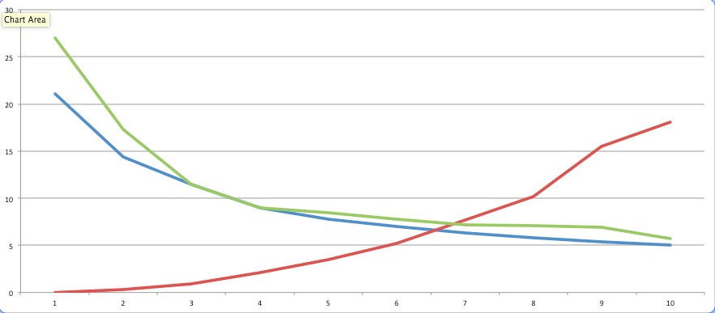

This is the KMeans clustering SSE and BSS trend graph. In this graph, x-axis is the k value, y-axis is the SSE or BSS value. The red line is the BSS value of myKMeans, blue line is the SSE of myKMeans and green line is the SimpleKMeans of Weka. Based on the elbow principle, we can choose k=4 as the most proper cluster number.

For cloud.arff, non-Normalization, best in 100 iteration for myKMeans, 1 iteration result for KMeans in Weka

|  |  |  |  |  |  |  |  |  |  |  |
| --- | --- | --- | --- | --- | --- | --- | --- | --- | --- | --- |
|  | | K=2 | K=3 | K=4 | K=5 | K=7 | K=10 | K=13 | K=16 | K=19 |
| myKMeans | SSE | 102298 | 33731 | 9934.2 | 5289.5 | 3282.3 | 1852.0 | 1205.0 | 1002.6 | 826.20 |
| BSS | 10209 | 31014 | 67621 | 88037 | 138606 | 357712 | 586748 | 984928 | 1056762 |
| KMeans  Weka | SSE | 102298 | 33730 | 29086 | 28215 | 4248.4 | 2805.0 | 2457.0 | 2352.2 | 1314.9 |
| BSS | N/A | N/A | N/A | N/A | N/A | N/A | N/A | N/A | N/A |

For cloud.arff, Normalization, best in 100 iteration for myKMeans, 1 iteration result for KMeans in Weka

|  |  |  |  |  |  |  |  |  |  |  |
| --- | --- | --- | --- | --- | --- | --- | --- | --- | --- | --- |
|  | | K=2 | K=3 | K=4 | K=5 | K=7 | K=10 | K=13 | K=16 | K=19 |
| myKMeans | SSE | 101.6 | 84.86 | 71.05 | 59.17 | 35.30 | 19.25 | 15.88 | 13.19 | 11.64 |
| BSS | 2.005 | 6.301 | 12.70 | 20.99 | 43.00 | 106.9 | 189.6 | 289.3 | 434.3 |
| KMeans  Weka | SSE | 102.3 | 88.48 | 72.68 | 59.13 | 44.36 | 30.50 | 16.71 | 15.79 | 15.45 |
| BSS | N/A | N/A | N/A | N/A | N/A | N/A | N/A | N/A | N/A |

For cloud dataset, it’s very similar to the baskball dataset except the nominal features in dataset. But we still can generate the SSE and BSS value trends and get the most proper cluster number is 7.

1. Results and compare for supervised:

For mushroom.arff, normalization, best in 100 iteration for myKMeans

|  |  |  |  |  |  |  |  |  |  |
| --- | --- | --- | --- | --- | --- | --- | --- | --- | --- |
|  | | K=2 | K=3 | K=4 | K=5 | K=6 | K=7 | K=8 | K=9 |
| myKMeans | SSE/10^4 | 5.72 | 4.98 | 4.56 | 4.27 | 4.17 | 4.08 | 3.89 | 3.73 |
| BSS | 22 | 66 | 132 | 220 | 330 | 462 | 616 | 792 |
| Ave. Precision | 89.5% | 89.7% | 90.2% | 96.8% | 95.2% | 92.5% | 89.9% | 90.7% |
| Ave. Recall | 89.1% | 89.3% | 89.9% | 96.7% | 91.0% | 92.3% | 89.6% | 90.8% |

For mushroom.arff, 1 iteration for EM in Weka.

|  |  |  |  |  |  |  |  |  |
| --- | --- | --- | --- | --- | --- | --- | --- | --- |
| EM | K=2 | K=3 | K=4 | K=5 | K=6 | K=7 | K=8 | K=9 |
| Log Likelihood | -17.76 | -15.59 | -14.40 | -13.03 | -12.42 | -11.74 | -11.98 | -11.28 |

Analyze:

For the mushroom dataset, its features are all nominal and it contains the class. From the results of myKMeans and the EM results from Weka, we can discover the most proper cluster number of mushroom is k = 5, because its average precision and recall are largest when k = 5. To check its correctness, we can get the SSE, BSS and EM Log likelihood value trend graph.

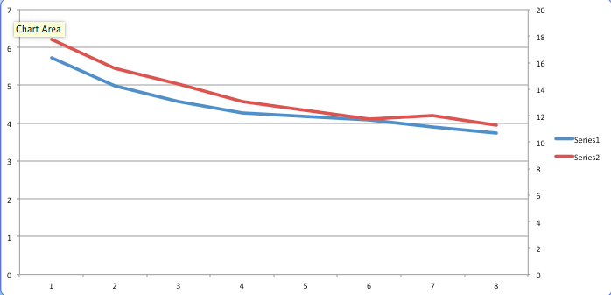

The blue line is the SSE/10^4 value from myKMeans and the red line is the Log Likelihood * (-1) value from the EM in Weka. We can easily find that the most proper cluster number is k = 5 by using the elbow principle.