The Last Starvation Game Design Document (GDD)

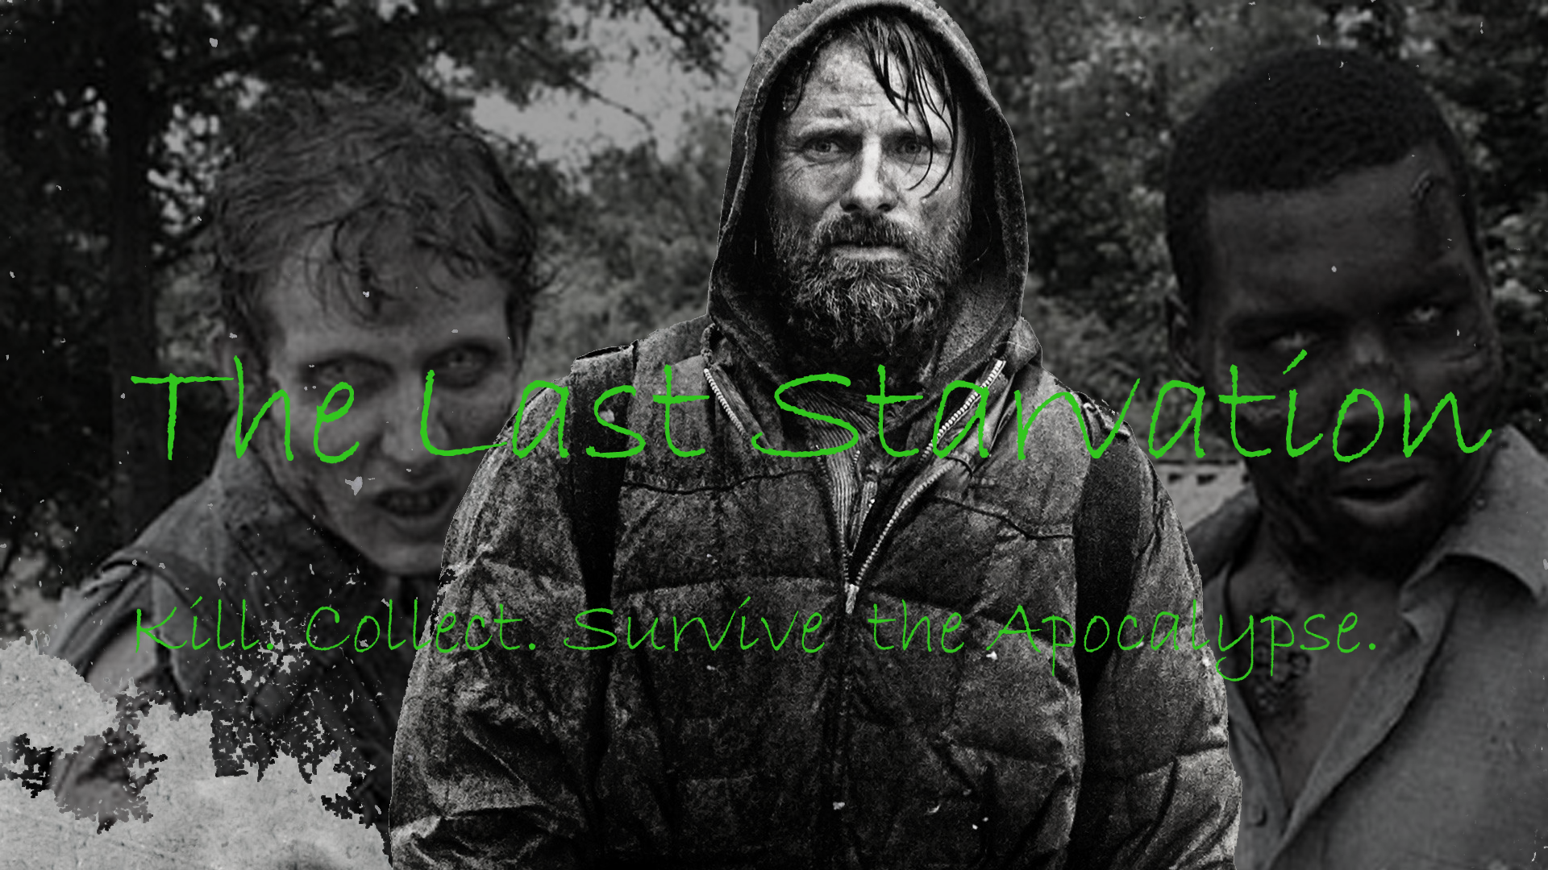

***‘Kill. Collect. Survive the apocalypse.’*** - Josh Robey

|  |  |  |
| --- | --- | --- |
| Table of Contents  1 Game Overview  2 High Concept  3 Platform Minimum Requirements  4 Competence Titles  5 Synopsis  6 Unique Selling Points  7 Game Objectives  8 Game Rules  9 Game Structure  10 Game Play  10.1 Game Controls  10.2 HUD  11 Art  11.1 Setting  11.2 Level Design  11.3 Audio  11.4 What Was Developed   |  | | --- | |  | | Game Development Team Members    PRODUCER  Josh Robey    PRODUCTION MANAGER  Josh Robey    PRODUCTION COORDINATOR  Josh Robey  GAME DESIGNERS  Josh Robey  SYSTEMS/IT COORDINATOR  Josh Robey  PROGRAMMERS  Josh Robey  TECHNICAL ARTISTS  Josh Robey  AUDIO ENGINEERS  Josh Robey  UX TESTERS  Josh Robey |

|  |
| --- |
|  |

# Game Overview

**Title:** The Last Starvation

**Platform:** PC / MAC / Linux standalone

**Genre:** Roguelike Survival

**Rating:** (10+) ESRB

**Target:** Casual gamers (aging from 12 - 30)

Serious gamers

**Release date:** March, 2017

**Publisher:** Noble Axe Gaming

Description: This section describes the high-level overview of your game. Put as much detail into this section as you can. This should contain your elevator pitch and more details to capture the attention and get the reader to want to play your game.

The Last Starvation is an endless roguelike survival game where the player is the last living human on the ruined planet. All around him is the endless remains of human civilization, allowing him to sustain himself a little bit longer. The player is not alone, as the wastes are stalked by hordes of undead who attempt to chase and kill the player in melee combat. The player may collect items such as armor and weapons to increase their survivability and prowess in combat. Consumable items also increases the player's Food meter allowing him to survive longer. If the player's hunger reaches zero the player is killed and the game ends.

# High Concept

The Last Starvation sets the player in a procedurally-generated apocalyptic wasteland where he/she is attacked by zombies, attempting to consume Chips and Soda to prevent starvation. Equipment can be found in chests scattered around the map. Armor and swords made from randomly generated components increase the survivability of the player. Swords allow the player to deal increased damage to terrain and zombies. Gloves and boots increase player's ability to resist damage.

# Platform Minimum Requirements

PC, MAC AND LINUX STANDALONE

OS: Windows XP SP2+, Mac OS X 10.8+, Ubuntu 12.04+, SteamOS+

Graphics card: DX9 (shader model 2.0) capabilities

# Competence Titles

Dwarf Fortress by Bay12 Games

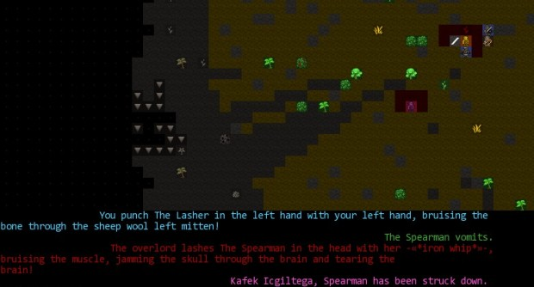

The Binding of Isaac by Edmund McMillen

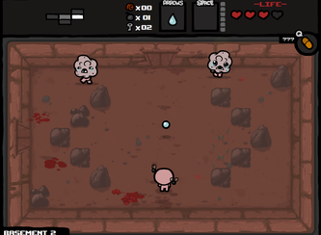

Darkest Dungeon by Red Hook Studios

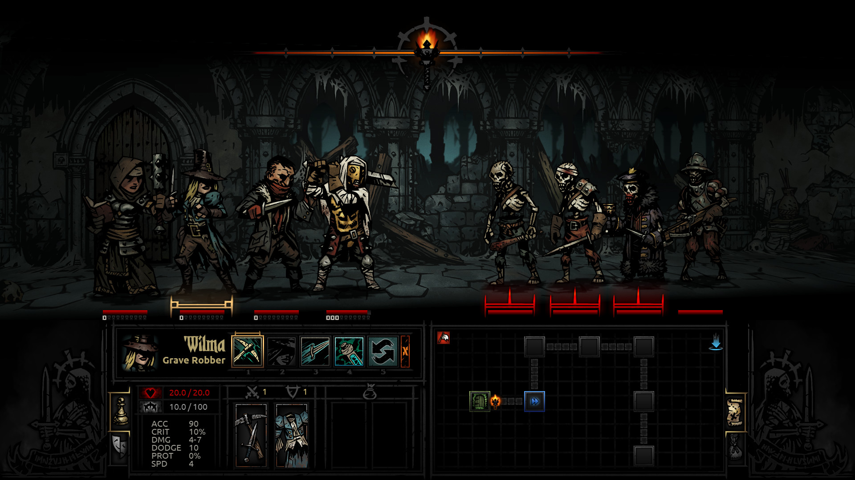

Synopsis

You are the last survivor of the human race...that you know of. All others you come in contact with are the zombified remains of mankind. You must scavenge for food to prevent starvation, and fend off the zombie hordes to survive as long as possible.

# Unique Selling Points

* Multiplatform
* High replayability
* Randomly-generated unique weapon combinations

Game Objectives

The object of the game is to survive for as long as possible, making your way through as many maps as possible.

Game Rules

The game is a procedurally generated infinite environment where the player is attacked by humanoid zombies. The Player can move around in an four cardinal directions and attack the zombies in melee combat or simply avoid them. The player can find equipment in chests to increase their armor and melee damage. The player attempts to move about the map, collecting equipment and food to make it to the next randomly generated Exit sign. The exit sign transports the player to a new procedurally generated map. This process continues until the player dies...or the heat death of the universe.

Game Structure

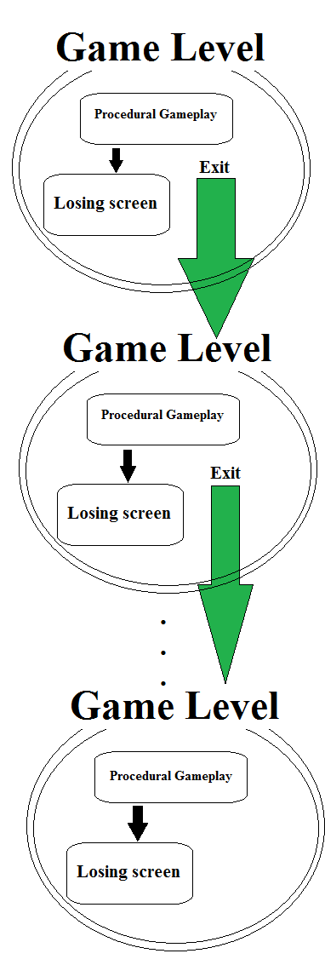

Gameplay

Game Controls (PC/MAC/Linux)

W or Up Arrow: Move character up one tile

A or Left Arrow: Move character left one tile

S or or Down Arrow: Move character down one tile

D or Right Arrow: Move character right one tile

HUD

Health: The player meter displays the amount of life the player has remaining. Hitting zero results in game over.

Items: Items collected by the player such as armor (gloves/boots) and weapons (swords) are displayed as icons to the side of the screen.

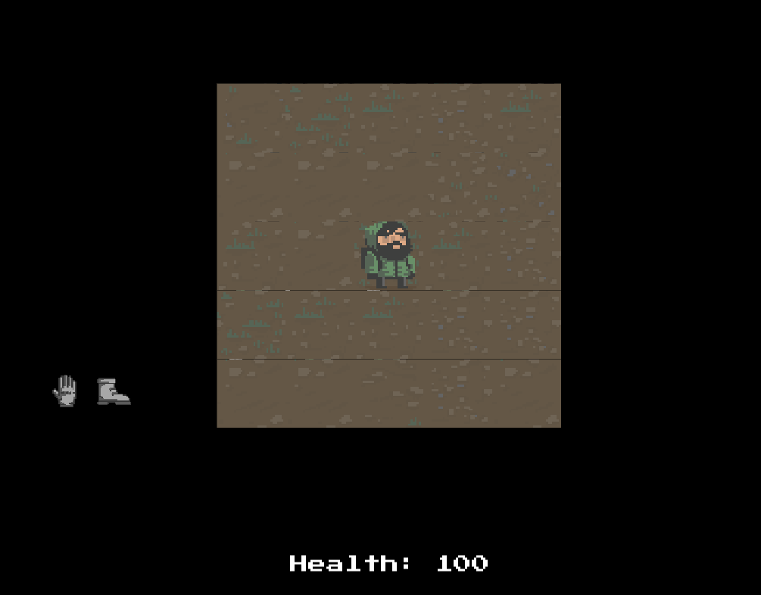

# Art

## Setting

The game takes place in a drab brownish and greyish landscape, in the ruins of human civilization. The surrounding terrain is dirt, littered by the refuse and remnants of civilization which serve as obstacles to the player and zombies.

## Level Design

The levels are generated through the algorithms created in the roguelike tutorial in the instructional book *Procedural Content Generation for Unity Game Development* by Ryan Watkins. The level begins with a 5x5 tile grid with the player starting in the center. As the player moves more terrain is generated and revealed to the player. Zombies, chests, and the Exit sign to the next level are also procedurally generated as the player moves.

## Audio

**Name Category Description**

sound1.wav Background music Procedural music generation piece

sound2. Background music Procedural music generation piece

sound3.wav Background music Procedural music generation piece

What Was Developed

No original art was created as of the writing of this document. Logo was created from a still of the movie *The Road* and a promo image from the TV show *The Walking Dead* as cited below*.*

Logo Design Images

http://4.bp.blogspot.com/-ZF4ftFmLbuM/TqjI5dI70KI/AAAAAAAAHis/qNq0K12T7uM/s1600/Zombies+Walking+Dead.jpg

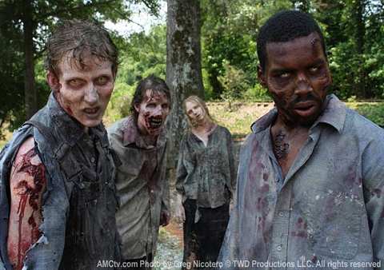

https://24miles.files.wordpress.com/2014/08/czpsjydfnugljagrnwa57wcmljn.jpg

