The Last Starvation Technical Design Document (GDD)

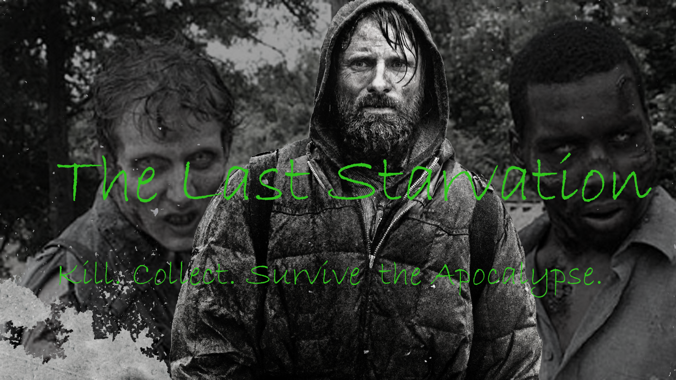

***‘Kill. Collect. Survive the apocalypse.’*** - Josh Robey

|  |  |  |
| --- | --- | --- |
| Table of Contents  1 Executive Summary  1.1 Game Overview  1.2 Technical Summary  2 Equipment  2.1 Hardware  2.2 Software  3 Evaluation  3.1 Game Engine  3.2 Target Platform  4 File Formats & Naming Conventions  5 Levels  5.1 Main Level  5.2 Asset List   |  | | --- | |  | | Game Development Team Members    PRODUCER  Josh Robey    PRODUCTION MANAGER  Josh Robey    PRODUCTION COORDINATOR  Josh Robey  GAME DESIGNERS  Josh Robey  SYSTEMS/IT COORDINATOR  Josh Robey  PROGRAMMERS  Josh Robey  TECHNICAL ARTISTS  Josh Robey  AUDIO ENGINEERS  Josh Robey  UX TESTERS  Josh Robey |

|  |
| --- |
|  |

# Executive Summary

# Game Overview

**Title:** The Last Starvation

**Platform:** PC / MAC / Linux standalone

**Genre:** Roguelike Survival

**Rating:** (10+) ESRB

**Target:** Casual gamers (aging from 12 - 30)

Serious gamers

**Release date:** March, 2017

**Publisher:** Noble Axe Gaming

Description: This section describes the high-level overview of your game. Put as much detail into this section as you can. This should contain your elevator pitch and more details to capture the attention and get the reader to want to play your game.

The Last Starvation is an endless roguelike survival game where the player is the last living human on the ruined planet. All around him is the endless remains of human civilization, allowing him to sustain himself a little bit longer. The player is not alone, as the wastes are stalked by hordes of undead who attempt to chase and kill the player in melee combat. The player may collect items such as armor and weapons to increase their survivability and prowess in combat. Consumable items also increases the player's Food meter allowing him to survive longer. If the player's hunger reaches zero the player is killed and the game ends.

# Technical Summary

The Last Starvation sets the player in a procedurally-generated apocalyptic wasteland where he/she is attacked by zombies, attempting to consume Chips and Soda to prevent starvation. Equipment can be found in chests scattered around the map. Armor and swords made from randomly generated components increase the survivability of the player. Swords allow the player to deal increased damage to terrain and zombies. Gloves and boots increase player's ability to resist damage.

# Equipment

# Hardware

The sole developer will utilize a dual 23" monitor setup connected to a regularly upgraded home gaming PC. It will serve as the primary hardware platform for game development and asset creation. Additional hardware includes an ASUS G73jh Desktop replacement laptop and miscellaneous hardware items owned by the developer.

Product Task Cost* Quantity Total

Gaming PC Game Development $2,000 1 $2,000

ASUS G73 On the road game development $1,000 1 $1,000

TOTAL $3,000

*Values listed are USD approximations

# Software

All software must be licensed for a single seat for the sole developer for the one month of development time required.

Product Cost Quantity Total

Unity 5.5.1 $125/month 1 $125

Adobe Photoshop CS5.1 $19.95/month 1 $19.95

Microsoft Visual Studio 2015 Community Edition $0 1 $0

TOTAL $144.95

# Evaluation

# Game Engine

The game engine utilized for the development of *The Last Starvation* is Unity as it allows for the creation of 2D sprite-based games with incredible ease. The art and all other assets can be swapped and added with ease allowing for a high degree of modification in a short time frame. Deploying across the separate target platforms is as easy as selecting preconfigured settings and running the Build operation once for each platform. Deploying across multiple desktop platforms is made easier using Unity.

# Target Platform

*The Last Starvation* will be deployed to all major PC operating systems. The game could easily be expanded to touch control on mobile devices such as iOS and Android but is not currently configured for the controls. Spreading deployment across multiple operating systems increases brand awareness and market penetration.

# File Formats and Naming Conventions

All Scripts are to be done in C# with the first word in the script name capitalized such as:

* DungeonManager.cs
* GameManager.cs
* Wall.cs
* Player.cs
* etc...

All images can be .jpg's or .png's.

# Levels

Main Level

*The Last Starvation* is build off a single Main level. The level is procedurally generated from C# scripts from Unity prefabs and sprite assets. Asset generation creates emergent gameplay and allows unique experiences each playthrough.

Each successive level after the first uses the same algorithm to create another procedurally generated map for the player to explore, collect loot on, and escape from through the exit.

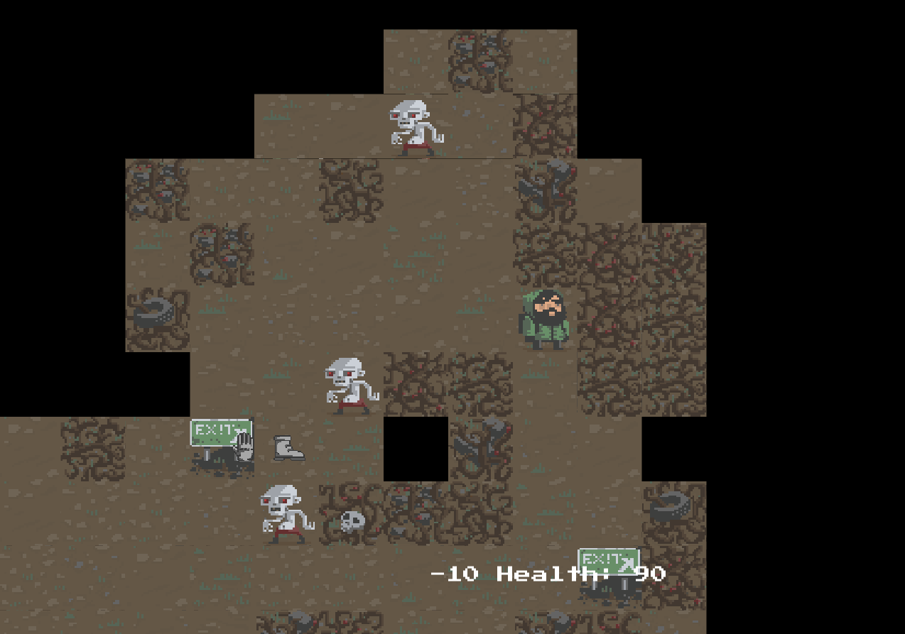

Asset List

All assets are imported assets from the Unity Roguelike Tutorial Package for free from the Unity store.