Jet Set HoloLens

Game Design Document

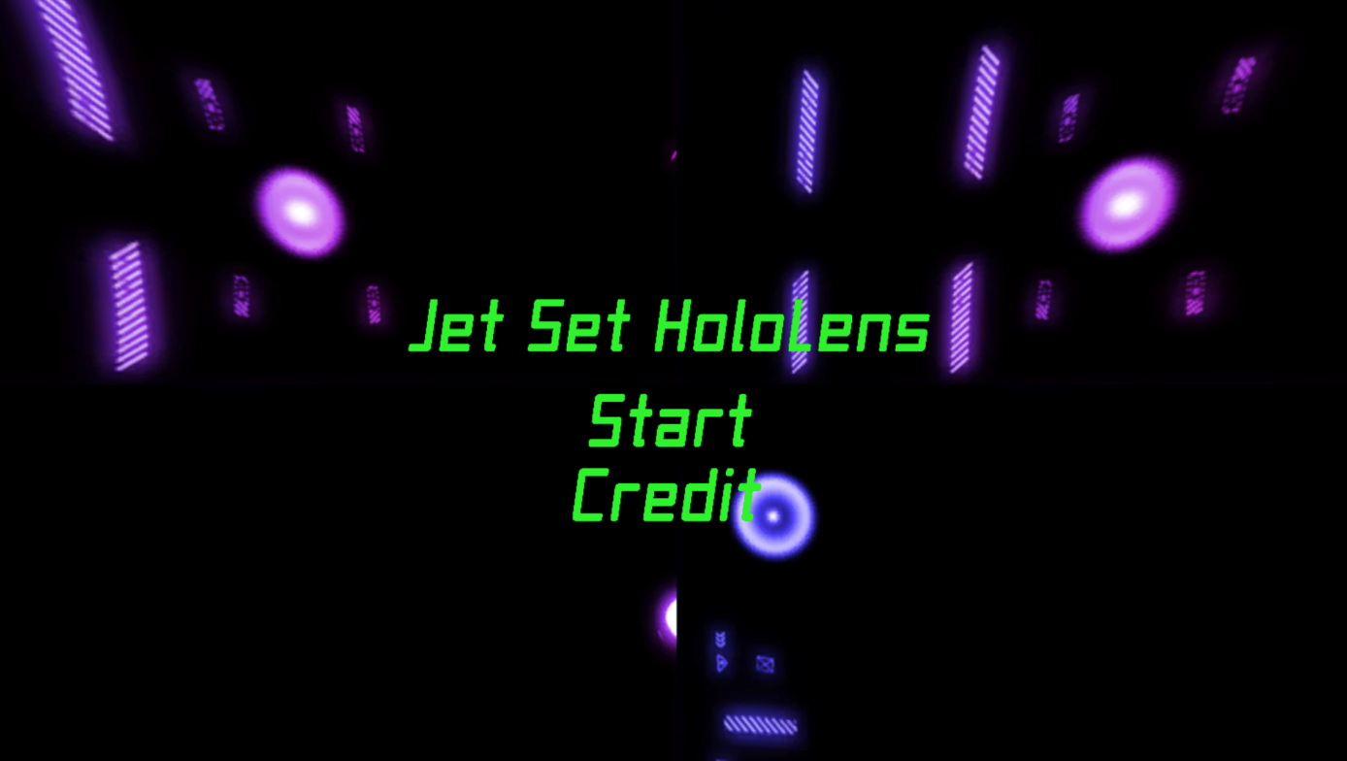

Contents

|  |  |  |
| --- | --- | --- |
| [1 Game Overview](https://n-xovwktmtjsnaxyc2mwes2xu7pohqedmdm6zjw5q-2lu-script.googleusercontent.com/userCodeAppPanel)  [2 High Concept](https://n-xovwktmtjsnaxyc2mwes2xu7pohqedmdm6zjw5q-2lu-script.googleusercontent.com/userCodeAppPanel)  [3 Game Objectives](https://n-xovwktmtjsnaxyc2mwes2xu7pohqedmdm6zjw5q-2lu-script.googleusercontent.com/userCodeAppPanel)  [4 Game Rules](https://n-xovwktmtjsnaxyc2mwes2xu7pohqedmdm6zjw5q-2lu-script.googleusercontent.com/userCodeAppPanel)  [5 Game Structure](https://n-xovwktmtjsnaxyc2mwes2xu7pohqedmdm6zjw5q-2lu-script.googleusercontent.com/userCodeAppPanel)  [6 Game Play](https://n-xovwktmtjsnaxyc2mwes2xu7pohqedmdm6zjw5q-2lu-script.googleusercontent.com/userCodeAppPanel)  [6.1 Game Controls](https://n-xovwktmtjsnaxyc2mwes2xu7pohqedmdm6zjw5q-2lu-script.googleusercontent.com/userCodeAppPanel)  7 Audio  [8 Art](https://n-xovwktmtjsnaxyc2mwes2xu7pohqedmdm6zjw5q-2lu-script.googleusercontent.com/userCodeAppPanel)  [8.1 Setting](https://n-xovwktmtjsnaxyc2mwes2xu7pohqedmdm6zjw5q-2lu-script.googleusercontent.com/userCodeAppPanel)  [8.2 Level Design](https://n-xovwktmtjsnaxyc2mwes2xu7pohqedmdm6zjw5q-2lu-script.googleusercontent.com/userCodeAppPanel)  8.3 What We Developed     |  | | --- | |  | | Game Development Team Members    PRODUCER  Stephen Luu  Yoshitaka Nishikori  Josh Robey  Juan Roman    PRODUCTION MANAGER  Josh Robey  PRODUCTION COORDINATOR  Stephen Luu  Yoshitaka Nishikori  Josh Robey  Juan Roman    GAME DESIGNERS  Stephen Luu  Yoshitaka Nishikori  Josh Robey  Juan Roman    SYSTEMS/IT COORDINATOR  Stephen Luu  Yoshitaka Nishikori  Josh Robey  Juan Roman    PROGRAMMERS  Stephen Luu  Josh Robey  Yoshitaka Nishikori  TECHNICAL ARTISTS  Stephen Luu  Yoshi Nishikori  Josh Robey  Juan Roman  AUDIO ENGINEERS  Stephen Luu  Yoshitaka Nishikori  Josh Robey  Juan Roman  UX TESTERS  Stephen Luu  Yoshitaka Nishikori  Josh Robey  Juan Roman |

|  |
| --- |
|  |

# 1 Game Overview

**Title**: Jet Set HoloLens

**Platform**: Microsoft HoloLens (Windows 10 built)

**Genre**: Action

**Rating**: (10+) ESRB

**Target**: Casual gamer (aging from 7 - 30)

**Release date**: May, 2017

**Publisher**: Group 4

Jet Set HoloLens is an action game that is created for the HoloLens users. In this game, you can pick up a spray can and start painting a real room with it. With a hand gesture, you can either pick up or drop the spray can.

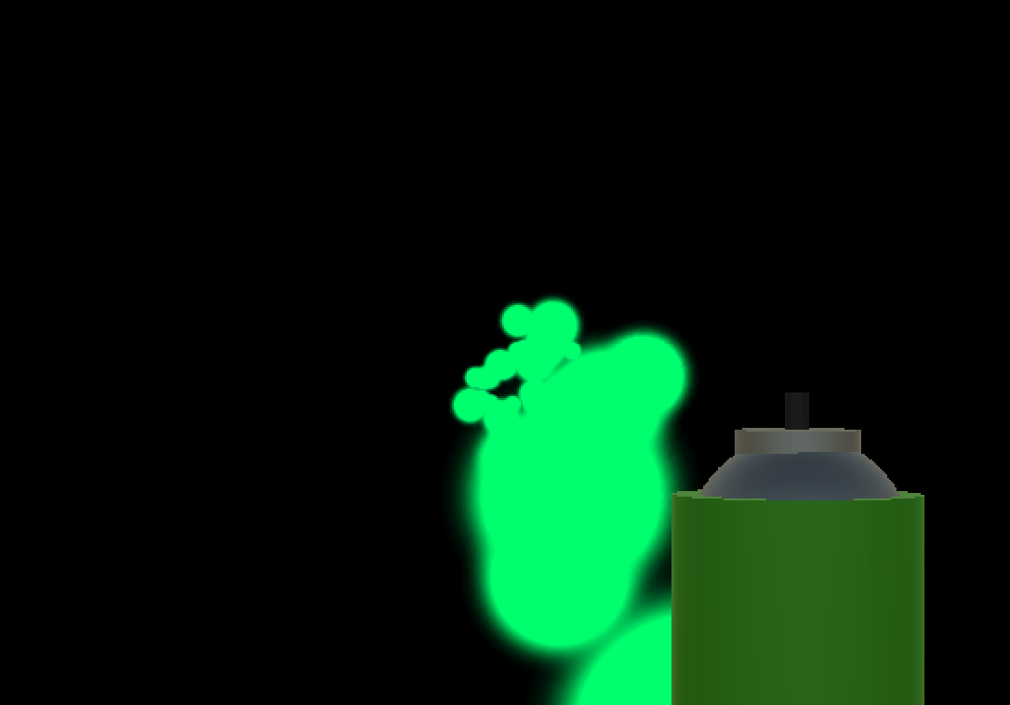

# 2 High Concept

Jet Set HoloLens allows the player to spray some objects or paint the walls through HoloLens. Feel what it is like to spray objects that exist in real life!

# 3 Game Object

You are the First Person Controller, and you can keep moving around to see how you can do some move (spraying, picking up/dropping a spray can) with HoloLens.

# 4 Game Rules

In 60 seconds, spray paint all of the objects that are located in the Game scene. If you can do this in 60 seconds, you will be sent to the Win screen. Otherwise, you will be sent to the Lose screen. After that, you have a choice to go back to the Start Menu to keep continue playing the game.

# 5 Game Structure

# 6 Game Play

## 6.1 Game Controls

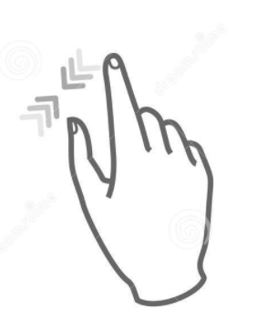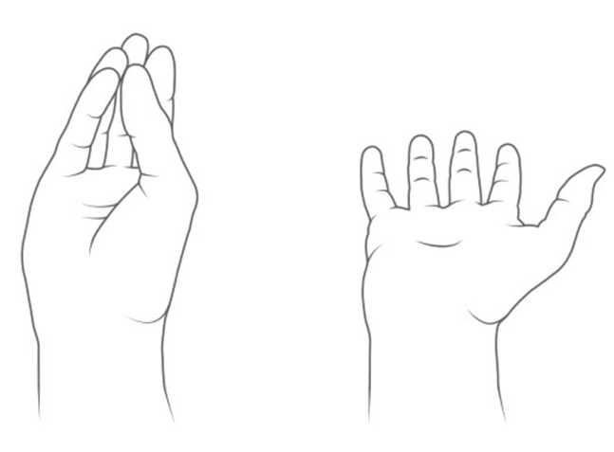

Quit game

Pick up/Drop an object

# 7 Audio

|  |  |  |
| --- | --- | --- |
| Name | Category | Description |
| Strange-Game-Menu | Background Music | Plays on the Menu Scene |
| Noir_Procedural | Background Music | Plays during the game |
| Pelican_Bay | Background Music | Plays on the Winning screen |
| The_Battle_Is_Lost_Music_3 | Background Music | Plays on the Losing screen |

# 8 Art

## 8.1 Setting

Before the game starts, the HoloLens scans the room so that it can know where walls/objects are located. By doing so, it enables the player to do things such as spraying paint the walls and putting an object on a table.

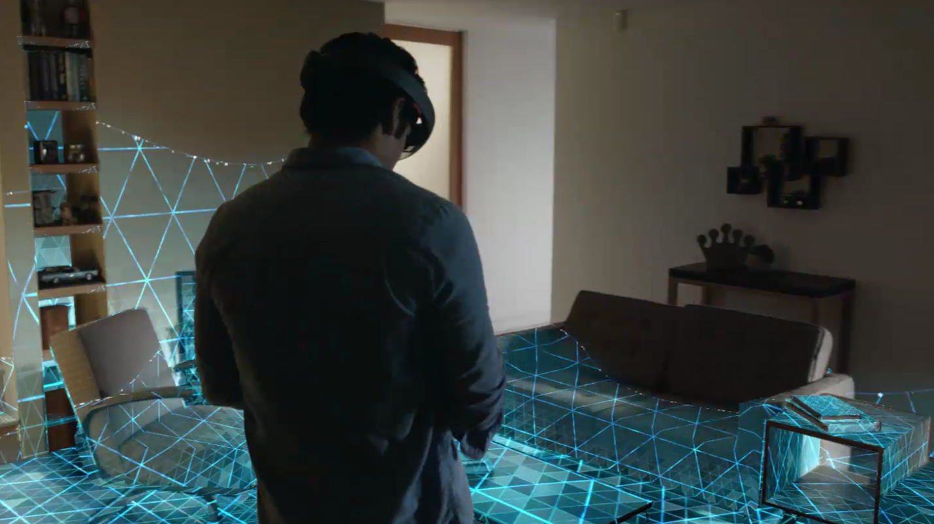

## 8.2 Level Design Jet Set HoloLens consists of Menu, Play and Win/Lose scenes. It only has one level (Play Scene) as a playable scene. This level is based on the location of the player preferably a room with four walls. The reason for this is because the HoloLens will scan the room and create the level the player is set in.

8.3 What We Developed

We implemented codes from HoloLens Tutorial (101 and 230) and created our own prefabs such as a spray can. Enabling/Disabling a spray can to stop spraying is also what we developed.