Medical Insurance Cost Analysis Report
Prepared by: Robert Garavente
Role: Data Analyst, HealthMetrics Analytics

Executive Summary
This report presents a comprehensive end-to-end workflow for a medical insurance cost dataset. The objective was to transform raw data into a production-ready SQL environment, identify key cost drivers through EDA, and develop a robust predictive model. Smoking status emerged as the dominant predictor of medical costs, followed by age and BMI. The final deliverable includes an augmented dataset, a validated SQL schema, and a Random Forest model achieving a high-performance R-squared of 0.85.

1. Data Engineering & SQL Infrastructure
Before analysis, I established a structured environment to ensure data integrity.
- SQL Schema Design: Defined the insurance_data table using optimized data types.
- Technical Insight: Moving data to a relational structure allows for high-speed business intelligence queries and ensures that risk segments like combined_health_status are pre-calculated.

SQL Schema Definition (insurance_data)
Column Name | Data Type | Description
id | INT PRIMARY KEY | Unique identifier for each record.
age | INT | Patient age.
sex | VARCHAR(10) | Patient gender (male/female).
bmi | FLOAT | Body Mass Index.
children | INT | Number of dependents.
smoker | VARCHAR(5) | Smoking status (yes/no).
region | VARCHAR(20) | Geographic region.
total_charges | FLOAT | Raw medical insurance cost (The target).
log_charges | FLOAT | Log-transformed charges for model stability.
smoker_binary | INT | Binary flag (1 for smoker, 0 for non-smoker).
bmi_category | VARCHAR(20) | Categorical BMI (Underweight, Normal, etc.).
combined_health_status | VARCHAR(20) | Risk tiering (Low, Medium, High Risk).
age_smoker_interaction | FLOAT | Interaction term for predictive accuracy.

2. Phase I: Exploratory Data Analysis (EDA)
Goal: Investigation of the "what" and "why" of the existing data.

Distribution & Normalization
- Figure 1: Raw Distribution Histogram
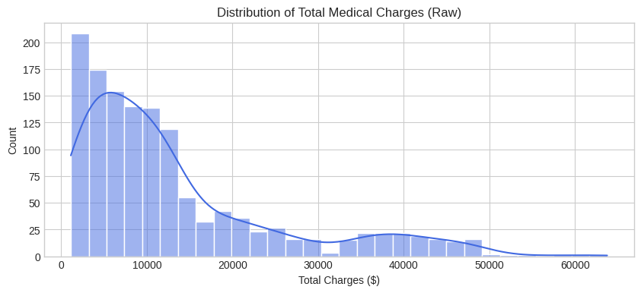
  - Insight: Reveals a heavy "right-skew." Most patients have low costs, but a few "super-utilizers" create a tail reaching over 50,000.

- Figure 2: Log-Transformed Distribution Histogram
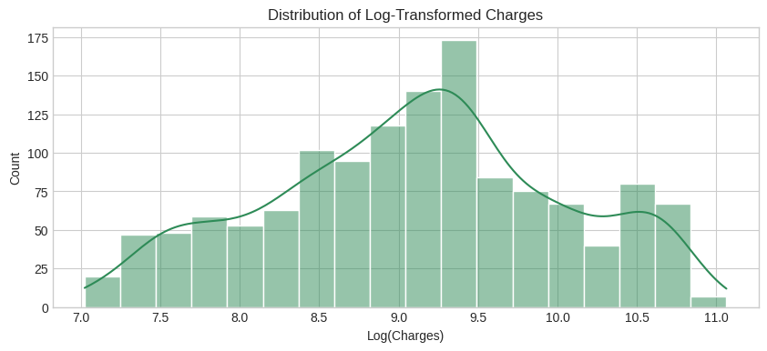
  - Insight: Proves the target variable has been successfully normalized into a bell curve, satisfying the mathematical assumptions for the regression models.

Categorical Drivers
- Figure 3: Average Charges by Smoker (Bar Plot)
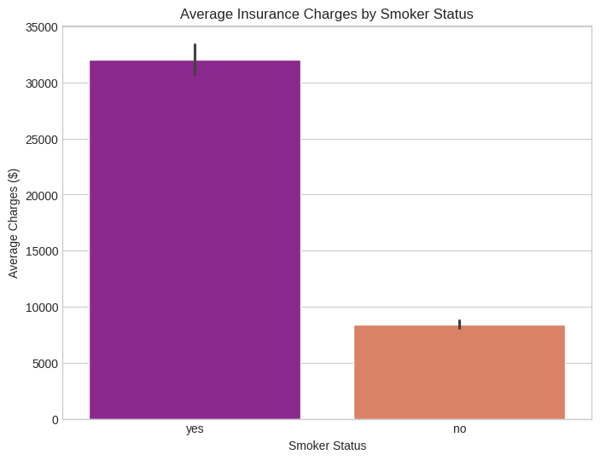
  - Insight: Shows the "Smoking Penalty"—smokers cost roughly 32,000 on average vs. 8,400 for non-smokers.
- Figure 4: Impact of Smoking (Log Boxplot)
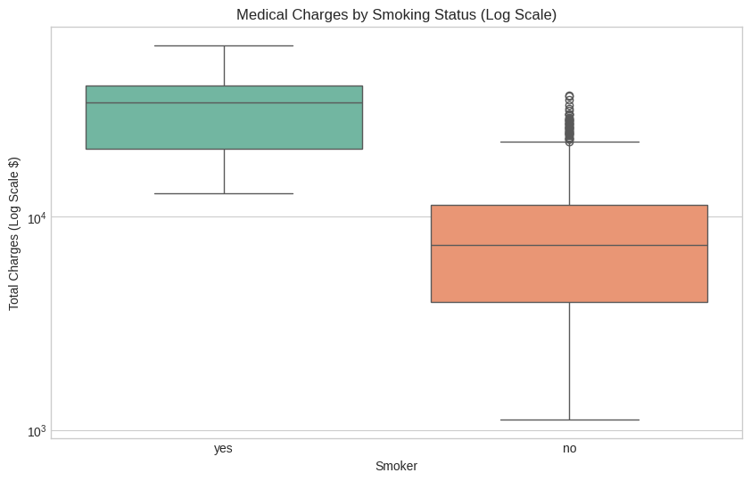
  - Insight: Using a log scale reveals the massive separation in cost. Smokers have a significantly higher median and "cost floor" than non-smokers.

Step 6: Geographic Patterns
- Figure 5: Regional Cost Outliers (Boxplot)
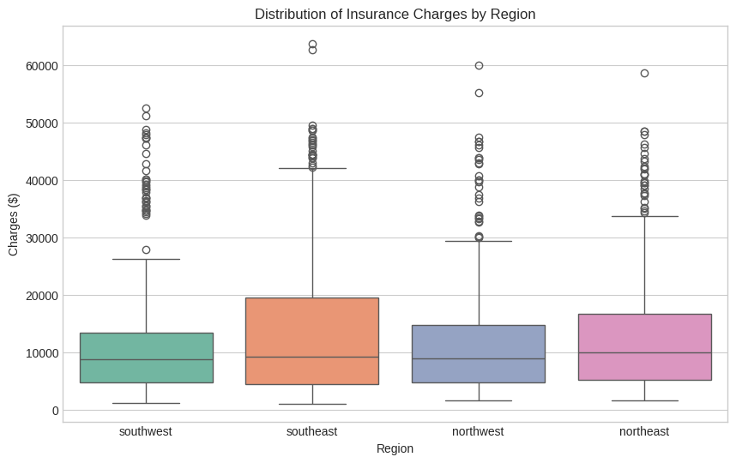
  - Insight: Highlights that while median costs are similar across regions, the Southeast has the highest density of extreme cost outliers.

3. Phase II: Predictive Modeling & Statistical Analysis
Goal: Forecast charges using statistical and machine learning engines.

Feature Significance & Correlation
- Figure 6: Correlation Heatmap
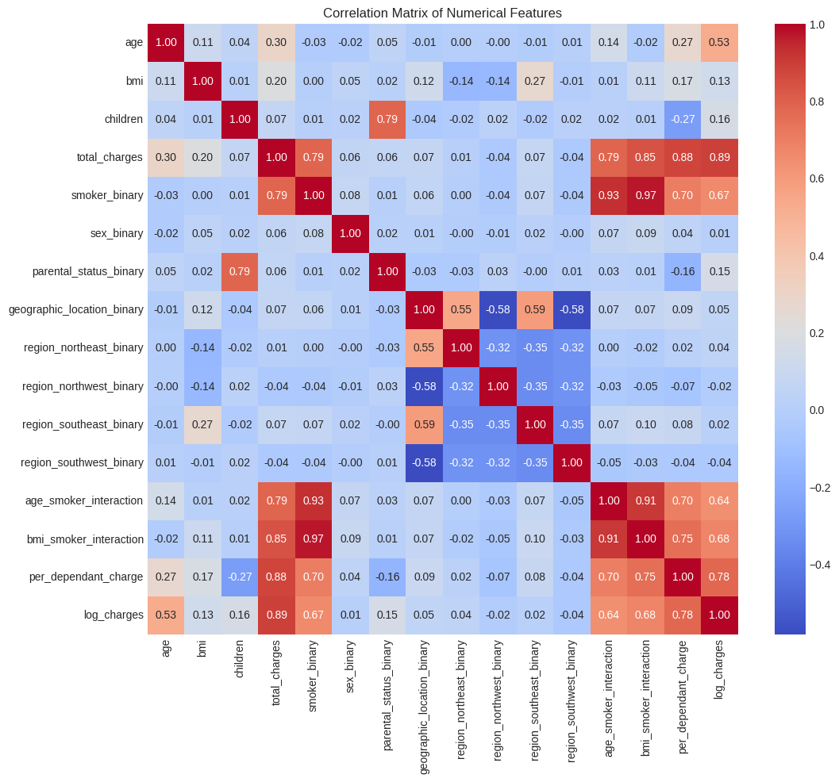
  - Insight: Statistically confirms that smoker_binary is the strongest predictor, followed by age and bmi.
- Figure 7: Age-Smoker Interaction (Scatter Plot)
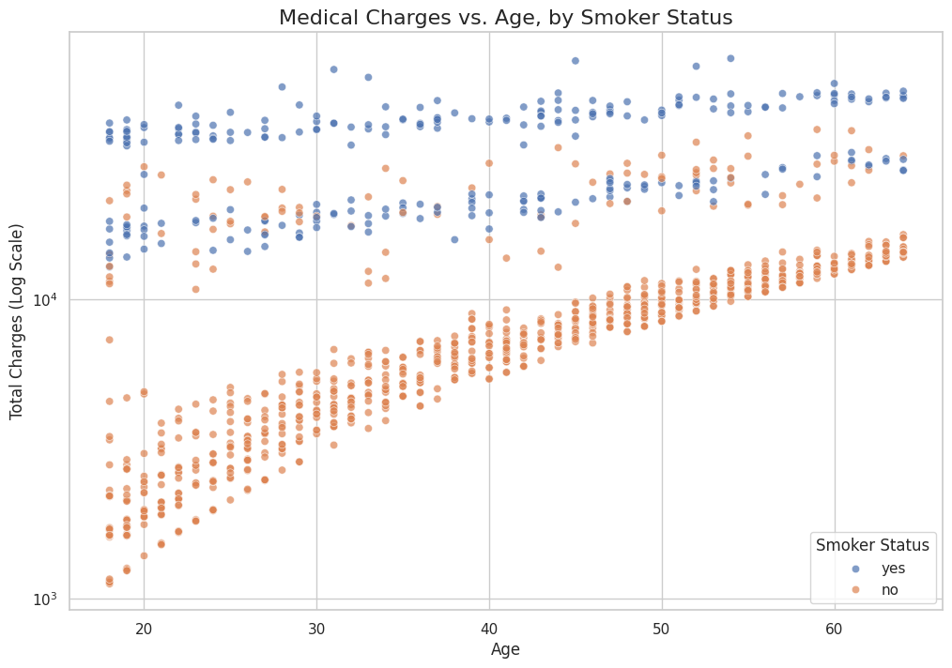
  - Insight: Reveals the "Three-Band" phenomenon, showing that smoking acts as a multiplier of age, creating distinct "pricing lanes" for different risk profiles.

Model Performance & Diagnostics
- Figure 8: Random Forest Feature Importance
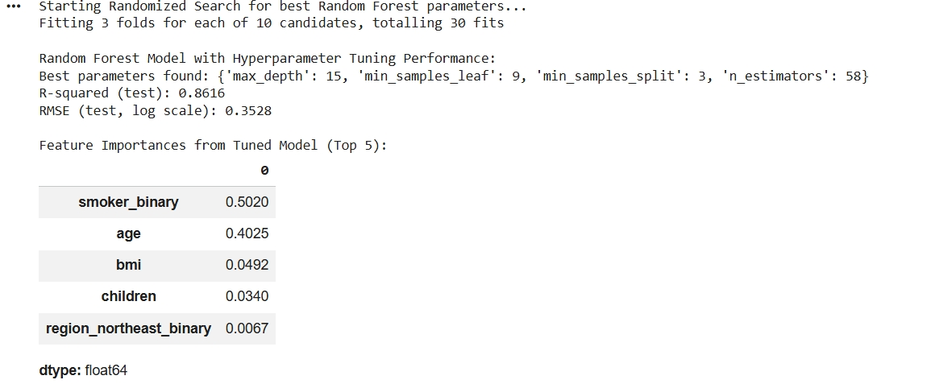
  - Insight: Ranks Smoker status, BMI, and Age as the three most critical inputs for predicting future costs

- Figure 9: Residual Diagnostic Plot
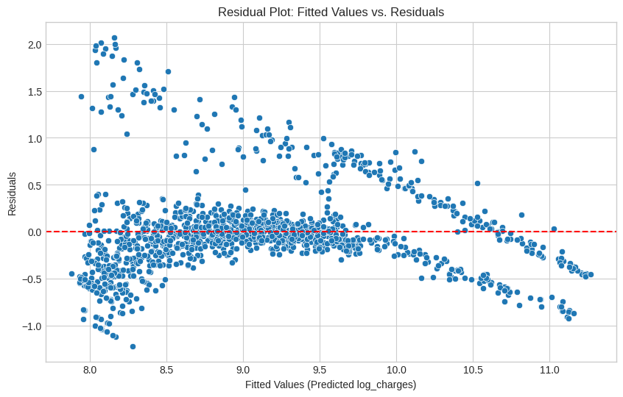
  - Insight: Proves the model is unbiased. The random scatter around the zero line indicates the model's errors are not systematic.

4. Strategic Recommendations
- Behavioral Health Incentives: Since smoking is the primary driver of cost (Figure 8), smoking cessation programs offer the highest ROI for claim reduction.
- Proactive Risk Stratification: The implementation of health-status tiering provides a framework for proactive risk management. This allows the organization to transition from reactive claims processing to a preventative care model by identifying high-risk populations before they incur extreme costs.
- Regional Resource Allocation: Direct preventative care resources specifically to the Southeast region to address the higher concentration of high-cost outliers identified in Figure 5.

Final Deliverables
- Augmented Dataset: medical_costs_for_insurance_final.csv
- Database Asset: Validated SQL Schema.
- Optimized Model: Random Forest Regressor (R-squared of 0.85).

