User Interface Documentation

The main designs are based on the functionality of the project. The usability was considered and the designs are made to be simple and based around the initial prototype design with all functions included. Efficiency and user-friendliness specifications were important while designing these pages as it is made to be clear and easy to use as we target users of all ages with different literate abilities.

There is a common grey box in the header where some relevant information fields are placed. A search bar makes the searching of a topic of a room easier. There is an option for logging in and out next to the search bar. We decided that the “Login” and “Register” would be links instead of buttons. The “Login | Register” will be there before a user register and signs in. After signing in, the links will become “Hello, *username* | Logout”.

Before Logging In
After Logging In
The name of the developer and the SVN revision number are placed in the left and right side of the footer respectively.
All the sections of the projects are grouped and put as tabs. This ensures the website will gives a clear view of the content for it. The tabs included are, “Home”, “Debates”, “Users”, “Search” and “F.A.Q.”. All these tabs makes navigation easy and simple. The colour that we have chosen are light and pleasant. It is not too dark nor too light. The words are all visible and easy to read.
Design Layout
Home
The “Home” section is just a page where the introduction of what our website does.
Nothing too fancy, just a brief explanation with the “Recent Updates” after the main welcoming section.

Debates
The “Debates” page contains a list of titles of the debate rooms. The list of rooms are listed with a grayed box and to the left of each gray box, there will be the count of the number of members joining the debate. There is an extra function where the room will be locked at certain time into the debate. That will be shown as “JOIN” and “LOCK” below the number count of members participating in that particular room. Each room, the creator and when the room was created will be shown on the bottom right of the box, this will allow the users to see who and when it was created.
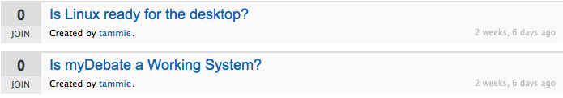
Debate Rooms
The debate room are laid out as such that there is a large region where the all the sent input texts are shown together for every users to read, a small one line text field where the users types in their discussions. Next to the text field is a button for the users to submit their text. This could also be done by entering “return/enter” on one’s keyboard. The title of the room will stay put at the top of the messages displayed.

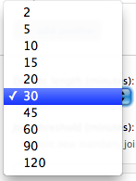
There is a box where all the participants of that room are shown. This will allow the participants to see who and how many people are in that same discussion. Due to the nature for this project, we decided to have it time based. Each room will have a certain amount of time for the users to discuss on their topics. Therefore, there is a count down clock. It is located below the members box. The clock will start from the duration and start counting down as it goes on. A users can decide to leave the debate at any time. There is a link where brings you out of the discussion, but before leaving, there is a warning/confirming window that a user will have to confirm their decision upon leaving.

Start a Debate
Start a Debate is in form style. First, we have got the “Question” field. Below it are the “Choices” field. The Choices by default would have two fields. To have more choices, there is a button “add another”. There is an pull down option for the debate time length. It ranges from 2 minutes to 120 minutes.
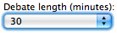

Below setting the time limit for the debate, there is also a time to lock the debate room. It consists of a horizontal sidebar for the user to choose the time. The time is also shown on top of it.
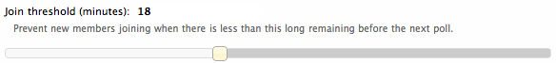

Users
In the “Users” page, the registered users are listed. They might have a picture next to their names depending on if they have an account on Gravatar. If they don’t, they would have a “Gravatar” default picture.
User Profile
Each user will have a profile. On here, information where the users added will be displayed. If the user has an avatar, it will be shown as well. There is an edit profile button for each of the users for editing their profile information.
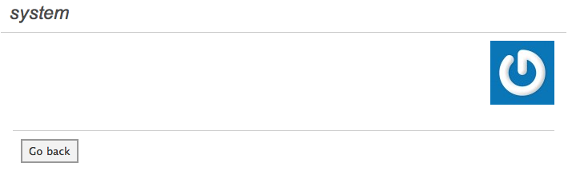
Edit Profile
In the edit profile section, the user will be able to add information into the text box available.
The text box can be dragged to enlarge the field area. There is a submit button where the user can click and save the changes made to their profile. There is also a link where user can click on that and it will bring him/her back to the user profile page without saving the changes made.
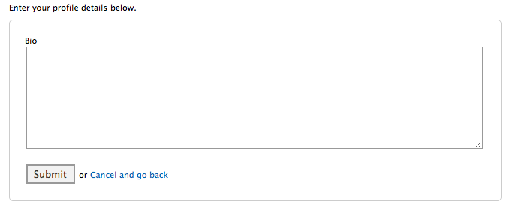
Search
The search page contains a text field where users can enter a keyword for the name of the debate. The list of debates where a word of the name matches the entered word will be shown directly below the search field. This search field will still be present after the list of rooms are listed. This enables a user to change the search entry without having to go back to the previous page.
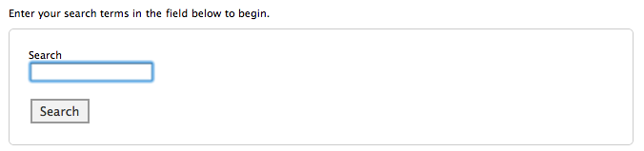
LOGO Design
The idea for this logo for our project came when we were looking for icons that are possibly suitable for our website. The red chat signs had inspired us and we thought it was suitable because our project is about chatrooms. The two squarish conversation signs creates a democratic feel of the nature of the debate. The colour of the speech signs are red because it stands out and it emphasised on the logo. The words “myDebate” is in “American Typewriters” font, because it brings out the professional look of our nature of our software. The blue colour was chosen because it goes well with the colour of the website and it makes the logo stands out. The design is designed to mean to the point and simple.


