**G52GRP**

**Democratic Conferencing Tool**

**Interim Report Appendix – November 2009**

* **To Accompany Main Report -**

**Group:** gp09-sdb

**Supervisor:** Dr. Steven Benford

**Group Members:** Robert Golding, William Redrup**,** Tammie Seo**,** Christopher Lensvelt**,** Henry James**,** Zhongda Zhu

# Market Research - Appendix

## Bantu

<http://www.bantu.com/>

Bantu is a cross-platform Business IM, and is similar to Google wave, but less user-friendly.

## WeMeeting

<http://www.netdive.com/indexwme.htm>

WeMeeting is another Business IM which incorporates video-conferencing into the rooms.

## ZPN Mesh

<http://www.zullotech.com/>

ZPN Mesh is a project collaboration package, with a built-in IM system.

# Technical Research - Appendix

## Django

Here is an example of a simple model in Django source code:

class Poll(models.Model):

question = models.CharField(max_length=200)

pub_date = models.DateTimeField('Date published')

class Choice(models.Model):

poll = models.ForeignKey(Poll)

choice = models.CharField(max_length=200)

votes = models.IntegerField()

Here’s an example of a simple view in Django:

def index(request):

latest_poll_list = Poll.objects.all().order_by('-pub_date')[:5]

data = {'latest_poll_list': latest_poll_list}

return render_to_response('index.html', data)

Here is an example of a template in Django:

{% if latest_poll_list %}

<ul>

{% for poll in latest_poll_list %}

<li>{{ poll.question }}</li>

{% endfor %}

</ul>

{% else %}

<p>No polls are available.</p>

{% endif %}

## Ruby-on-Rails

To create the blog application:

$ rails blog

Here is an example code to configure MySQL Database in Ruby-on-Rails:

development: adapter: mysql encoding:

utf8 database: blog_development pool: 5 username: root password: socket:

/tmp/mysql.sock

An example of Migration in Ruby-on-Rails:

class CreatePosts <

ActiveRecord::Migration def self.up create_table :posts do |t| t.string :name

t.string :title t.text :content t.timestamps end end def self.down drop_table

:posts end end

## SVN

Here is an example displaying the basic structure of the SVN 3D-Tree system.

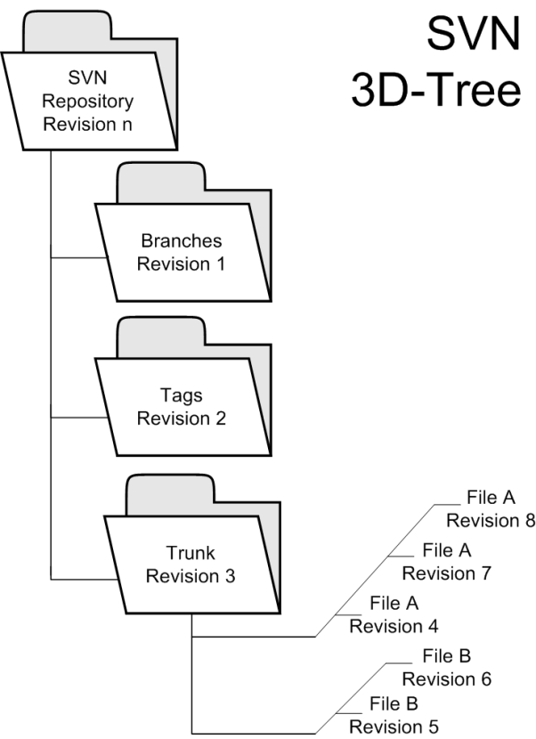

## Mercurial

The hashes in a Mercurial repository look like this:

1:1ef7872431f9c64908c732f0bcd4db5700b4cb70

This means that unlike Subversion, two revision identifiers cannot be easily compared to see which is newer.

# Functional Specification – Appendix

## Flowchart

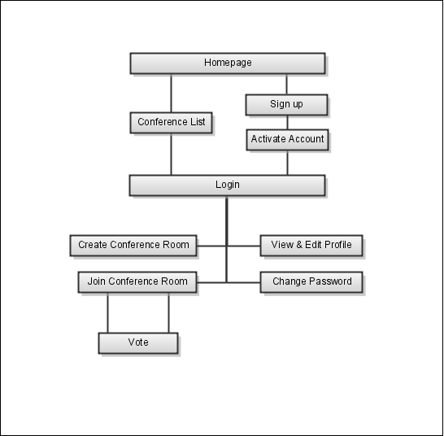

## User Interface

Initial Design #1

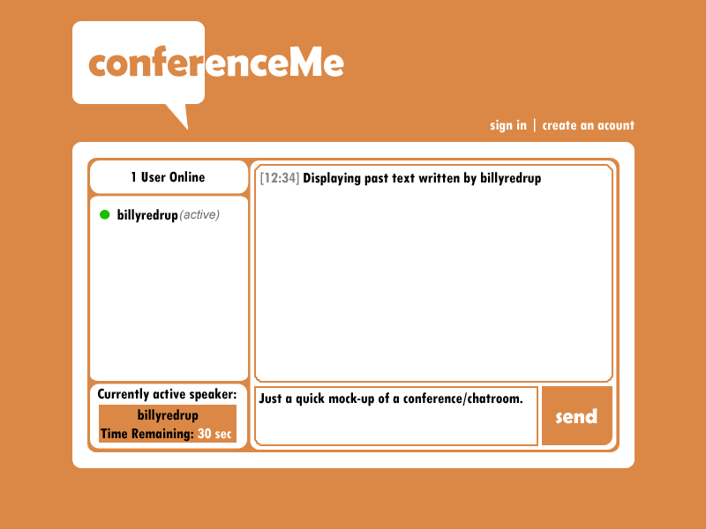

Initial Design #2

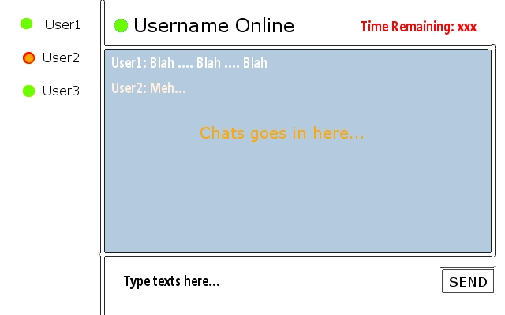

Initial Design #3



Initial Design #4

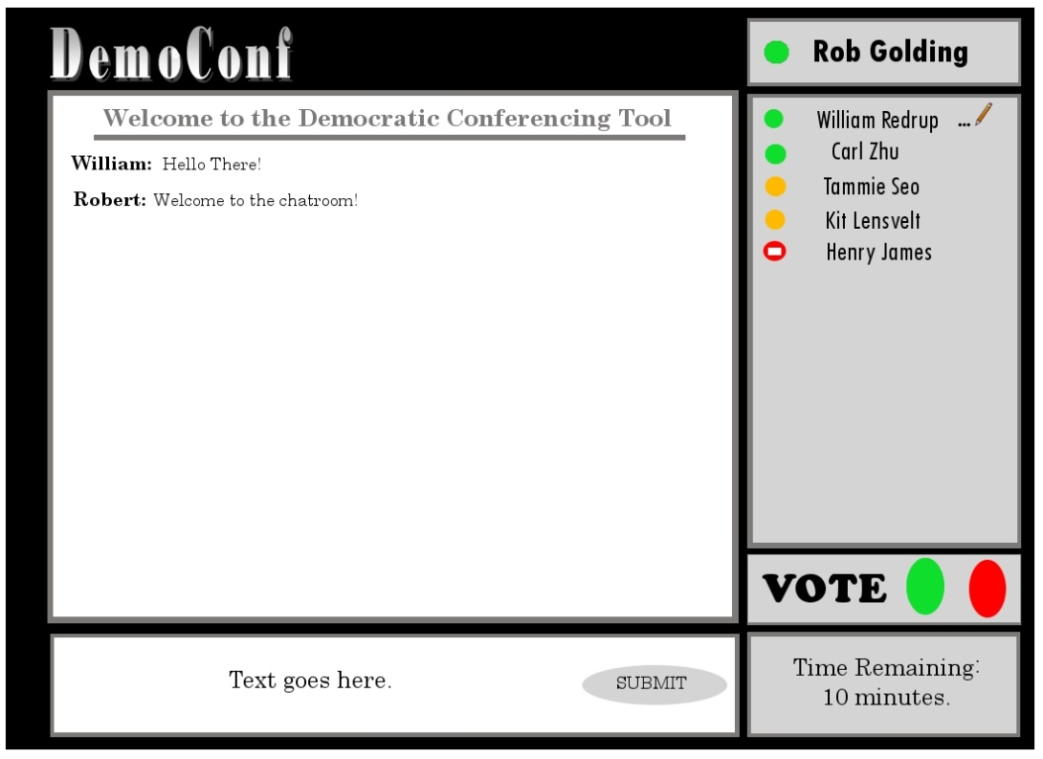

Initial Design #5

