|  |
| --- |
| University of Nottingham |
| **Democratic Conferencing Tool** |
| **G52GRP Final Group Report** |
|  |
| gp09-sdb |
| April 2010 |

**Group:** gp09-sdb

**Supervisor:** Dr. Steven Benford

**Group Contributors:** Robert Golding (rjg08u),

William (Billy) Redrup (wrr08u)**,**

Tammie Seo (tls08u)**,**

Henry James (hej08u)**,**

Zhongda (Carl) Zhu (zxz09u)

Table of Contents

Table of Contents 2

1 Executive Summary 4

2 Introduction 4

3 The Problem 4

4 Research 5

4.1 Summary of Completed Research 5

5 Functional Specification 6

5.1 Overview 6

5.2 User Stories/Scenarios 6

5.2.1 Scenario: Jimmy 6

5.3 System Flowchart 7

5.4 Screen-by-Screen 7

5.4.1 Home Page 7

5.4.2 Login 7

5.4.3 Register 7

5.4.4 Debates List 8

5.4.5 Debate Screen 8

5.4.6 Voting 8

5.4.7 Creating a new Debate 8

5.4.8 Users List 8

5.4.9 User Profile 9

5.4.10 Search 9

5.4.11 FAQ 9

6 Implementation 9

6.1 Database Design 9

6.1.1 Room 10

6.1.2 Question 10

6.1.3 Poll 10

6.1.4 Choice 10

6.1.5 Vote 10

6.1.6 Justification 10

6.2 API Design 10

6.2.1 JSON 10

6.2.2 API Methods 11

6.2.3 jQuery 11

6.3 Django Design 12

6.3.1 Rooms Application 12

6.3.2 Polling Application 12

6.3.3 API Application 12

6.4 Third-Party Applications 14

6.5 Testing 15

7 User Interface 15

7.1 Inspiration for the Design 15

7.2 The Design 15

7.3 Frequent Asked Questions (FAQ) 20

7.3.1 Introduction 20

7.3.2 Research 20

7.3.3 The Questions 20

8 Testing 22

9 System Walkthrough 26

10 Reflective Comments 26

11 Project Objectives Achieved 26

12 Time Plan 26

# Executive Summary

**[To be completed after the report content is finalised]**

# Introduction

The purpose of this report is to describe and explain in detail how our group completed our project; the Democratic Conferencing Tool, and all of the stages leading up to the final system being produced. All documentation completed throughout the project will be present in this report or references made to those included in the interim report.

The initial focus of this report will explain the problem we hoped to solve as a group, and how this had changed from our earlier explanation in the interim report, and then move towards the research and planning stage; with sub-headings for the appropriate research sections. This section will feature a condensed summary of the research we conducted in earlier stages of the project, as the interim report was primary based upon the gathering of information we could potentially use for our own system. The focus will then shift to individual specifications, with particular interest paid to the functional and technical aspects of the system as they are the most important parts of the project in this second semester, when the system is the primary deliverable.

The User Interface is described next, with screenshots and snippets taken to illustrate the various screens and menus within our system. This section will go in-depth, and explain in detail why we designed the interface the way we did, and why we believe it is accessible to potential users of the system. This is followed by a small testing summary, with references made to the full testing table which is featured within the appendix of the report.

Finally, a number of conclusive sections of the report are featured at the end of the document, ranging from the testing of the system to a brief summary of how well the group performed as a cohesive unit. Despite their late appearances within the document, these sections are extremely important as they help explain to the reader how well the group worked together, and the final product that was produced.

# The Problem

Project Description: *“This project is to design, implement and evaluate a new text conferencing tool that aims to support more democratic participation. Each participant is given a "talk budget" which may be refreshed from time to time. When this runs out they can no longer talk, unless another participant donates some of their remaining budget to them.”*

A brief description of the project is included at the top of this section, taken directly from the module webpage. It is worth mentioning at this stage that the idea of using a ‘talk budget’ was scrapped when plans of using a user feedback system changed. Therefore the system is being taken in a new direction from what is described above, whilst maintaining the demographic nature portrayed in the title of the project.

Since the interim report was written, the group has come a long way regarding knowledge of how best to tackle the remaining stages of the project. We have moved on from discussing potential content, and are now focused on how best to approach the design and implementation of the system. With the idea for individual users receiving feedback being discarded for a more general voting system aimed towards a debate, we now had a solid foundation to build upon with our final decisions.

With this newfound knowledge, we should be finished toying with potential ideas, as we now have a real idea of where this system is headed and how it will look upon completion. The new problem ahead of the group is achieving everything that is required before those final deadlines arrive.

Our objective is still the same as before, in that we are hoping to build a democratic, user-friendly, and self-moderating community where opinion-sharing is not only welcome, but encouraged. The direction we are steering the system in has just changed directly slightly, however as a group we feel the general voting system is a better idea than feedback specifically being targeted at individuals.

Research

## Summary of Completed Research

The majority of our research is contained within the interim report, as most of the early focus was upon researching ideas for our system from similar products. This focus has shifted to a more technical aspect as of late; therefore this section will be brief in comparison.

We started with market research into similar web-chat software, in the hope that we could gather ideas that would be suitable for what we wanted to achieve with our system. We looked at a wide range of products, but Google Wave and Effusia Business IM were the most relevant to our plan. We gathered information about how to portray a simple user-friendly interface from these products, Effusia especially, as well as incorporating the idea of leaving short messages to inform other users of your change in status if you were to leave the computer for a certain period of time.

After gathering a small, albeit useful, amount of information from these products, the research shifted onto the technical side of the system, and we began to look into ideas for frameworks that we could utilise as a base for our program. A discussion began about web-frameworks and desktop-based platforms, and a comparison was made in the interim report along with the advantages and disadvantages of each. We then branched further into discussing particular software within each platform and researched a number of products that are both web-based and desktop-based. Having quickly made the decision that we would be using a web-based platform for our software, we had a good idea of which direction we would be heading in regards to the completion of this project.

To allow for ease of communication between group members, we set up on Basecamp; a project management and collaboration tool, which then allowed us to keep in touch with each other far more easily than if we were relying solely on e-mail. At Basecamp, we would all be able to view our progress at the same location, which made things far easier for everyone, as well as having a function for the creation of a ‘To-Do’ list, which allowed us to set tasks for ourselves and one another and keep track of these with the use of deadlines. Once completed, a task can be crossed off the list and you can move onto something else.

Along with the use of this project-management software, we decided to utilise Subversion software (SVN) to create a repository where all of our work could be stored and shared with one another without fear of files conflicting with one another when saved at different locations. This made it possible to keep completely up-to-date with the project on our home computers, as you can access the files at a separate location to where you were working. The idea of using ‘Mercurial’ was also researched; however as this would involve each of the group members having a separate local repository rather than a shared one, it was decided against as the most-important aspect of this decision was to make sharing documentation easier.

Functional Specification

## Overview

myDebate is a service that allows users to participate in a democratic debate or discussion - to achieve a goal of agreement on a particular subject.

The system forces users to vote on a goal at the end of each time period (which is 30 minutes by default). The goal is specified when the debate is created, in the form of a question acting as the room title. If all (or a specified proportion) of the participants agree when the vote is cast, then the goal has been achieved and the debate can be ended. Otherwise, the discussion continues for another period.

## User Stories/Scenarios

The user stories or scenarios specified in this specification will help to define how users interact with the system.

### Scenario: Jimmy

Jimmy is an 18-year-old college student in London, studying the arts, and has a keen interest in computers. Jimmy is a participant in a number of online communities, where he often has heated discussions, supporting his views on his choice of operating system – Mac OS X. Jimmy enjoys making fun of people that use Microsoft Windows or Linux, and often gets himself into arguments in forums or message boards over the subject.

While browsing his usual online forums, Jimmy came across a thread that simply stated: “Which operating system is better, Windows or OSX? Debate now on myDebate!”. He was intrigued, and clicked the link to the myDebate website.

In order to take part in the debate, Jimmy was required to create an account on the site, which he did. He clicked the link that was sent in an email to his account, and logged in immediately. He then joined the debate about OSX and Windows.

He found that there was a timer counting down in the corner of the screen, and people were putting forward points in an attempt to win the vote of the other participants. When the counter reached zero, a screen appeared asking Jimmy to vote – he picked OSX straight away, and then saw a pie chart that changed as the votes from the other participants arrived. He was impressed at the responsiveness of the system, which seemed to react almost instantly to his clicks and keypresses.

After two periods, the vote was starting to show a majority towards OSX, so Jimmy remained in the debate and put forward his own arguments as to why he likes OSX so much. The next time a poll was taken, 68% of the participants voted in favour of OSX, and the debate was declared finished with a majority.

Jimmy enjoyed putting forward his points on myDebate, and bookmarked the list of debates in his browser so that he could keep checking the latest ones.

## System Flowchart

This flow chart gives a high-level overview of how the user interacts with the system, and vice-versa.

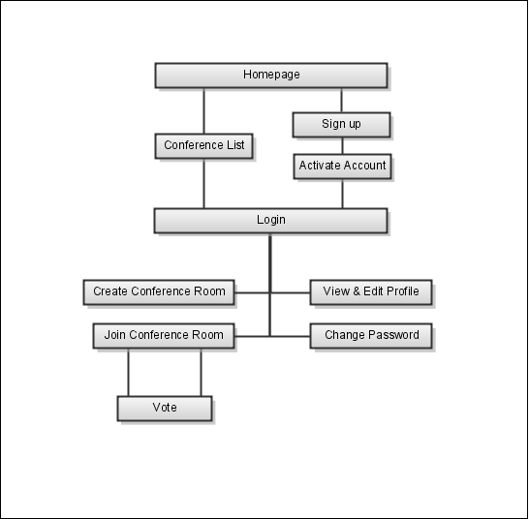

## Screen-by-Screen

### Home Page

The home page should offer an introduction to the user, and briefly explain what the application is about. From here, the user can access each main area of the application using a tab-like menu in the header of the page. The header should be present on every page in the application, to retain a consistent user experience throughout.

The header (and therefore the home page) should also contain a button that allows the user to login. Also, search should be easy to access, with a search input field directly accessible inside the header (ready for the user to input a search query).

### Login

The login page should be simple and to-the-point. An input field for the username and password is all that is required. The password should be obscured using asterisks so that it is not visible when typed.

### Register

The registration page allows a user to sign up for an account on the system. The following information is required for an account:

* First and last names (i.e. the full name of the user)
* A username (that is not already taken)
* A password (must be entered twice to make sure no mistakes were made)
* Email address

The email address must be verified by sending an email to the address containing a link. When the user clicks the link in their email, their new account is activated and they can login. Before this point, the user cannot login (as their account is not yet active).

Again, the passwords should be obscured using asterisks so that they are not visible when typed.

### Debates List

The list of debates should show each debate that is currently open, with the number of users in that debate clearly shown on the left. Also on the left, the list should show whether the room is in join mode or lock mode. Finally, each debate should show who created it, and when (in relative time format, e.g. 3 hours ago).

### Debate Screen

Users can only be present in one debate at a time, so if they attempt to join a debate when they are already in another, they should receive an error that tells them which other debate they are already present in.

When the user is in a debate, the largest portion of the screen should be taken up by the messages that are being exchanged in that debate. On the right, the list of users currently present in the room should be shown, with the countdown timer at the bottom of this panel.

Underneath the messages list, the user should have a box to enter their message, which has a submit button to the right of it. The user should also be able to activate this button with the enter key.

When the user arrives on the debate screen, the message input field should be automatically in focus, so that they can begin typing without having to click in the field.

### Voting

When a debate reaches the end of a period, the voting window should appear in front of the debating window (and the background should be greyed out, as it is unusable). Once the user has cast their vote, the voting window should change to a graph showing the results of the vote in pie-chart form. This graph should automatically update as the votes from the other users are cast.

Once all the users have voted, the person who is in control of the debate has the choice over whether to go to another period, or end the debate.

The person who is in control of the debate is either the person who created it, or the person who has been in the room longest if the creator has left. If the creator re-joins the room again, they ***do not*** become in control again, unless everyone that has been in the room longer than them leaves.

### Creating a new Debate

Users should be able to create new debates as they wish. To create a new debate, the user is required to enter the **question** (i.e. the issue that will be debated) and **at least two** choices (that users can vote on in response to the question). They can then also alter the length of the period and the join threshold (the length of time remaining before the room is locked to new members).

### Users List

Users should be able to browse through the other users on the system, in a list that looks similar to the list of debates. This list of users should show a thumbnail of the user's avatar on the left, and their name should be a link to their profile.

### User Profile

A user's profile should contain their avatar (in larger format) on the top right of the page, with the information they have entered into their profile in the centre.

If the user is looking at his/her **own** profile, there should be an option to edit it, so they can enter, edit or remove information from their own page.

### Search

The search page should contain a prominent search query input field at the top, with the search results listed below. Search should only query the names of debates (and not return anything other than debates), so the list should look the same as the debates list screen.

If no debates are found for a given search query, the results list should not be present, and instead should display the text “No results found”.

### FAQ

The Frequently Asked Questions page should be a one-page section with questions specified in headers, and the answers beneath them. This page should also include images to make the descriptions easier to understand.

Implementation

## Database Design

When designing any application, the first step is usually to define the way that data will be stored. This is most easily done on paper, using rough entity-relationship diagrams to map out the way that different database objects (entities) will interact. In Django, the database layout is known as the *models*.

Our group spent some time discussing the best way to design the database, with most of the effort spent deciding on the polling structure. The way that polls and votes are to be stored is the most complicated part of the application, as we decided that historical data would need to be kept for post-processing and analysis once the conference/debate is finished.

After some revisions, the final entity-relationship diagram was decided on as follows:

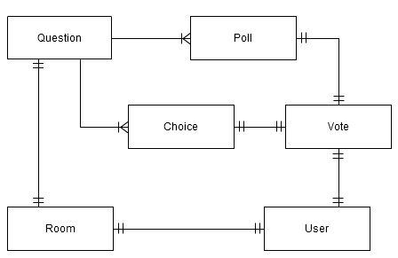

### Room

Central to the application is the **Room** entity. This represents a conference room/debate. The **Room** entity has an owner, which is represented internally in Django using the **User** model.

### Question

The room also has one (and only one) **Question** object. This represents the topic that the room is based around, and stores the question that members vote upon every time a period ends.

### Poll

The question then references many **Poll** objects. These are the “instantiations” of the question for a particular period. This allows each **Poll** to store the votes associated with it, whilst not being deleted once the period has ended.

### Choice

The question object also references many **Choice** objects. These represent the choices that are available for participants to vote on.

### Vote

Once a participant casts a vote, a new **Vote** object is created. This object references both the **Choice** and the **Poll** that was taking place at that particular moment. It also references the user that cast the vote.

### Justification

The above implementation was chosen over a number of alternatives. These alternatives include using an “archive” version of the poll, choice and vote objects in order to keep historical data.

The given ERD was decided upon as being the neatest (and simplest) way of solving the problem, and hinges on the fact that a **Vote** objects stores a reference to both the choice *and* the poll upon which it was cast.

## API Design

The messaging aspect of the application, in particular, relies heavily on JavaScript. Without this, messages would not be delivered to the user until the browser page is refreshed. This was deemed early on to be wholly unacceptable.

Therefore, an easily-consumable API was required, to allow simple acquisition of data, and to also allow data to be posted asynchronously (in the case of sending a message or casting a vote, for example).

### JSON

The group decided to use JSON (JavaScript Object Notation) to serialise the data when communicating between client and server. This is because it is such a simple, human-readable protocol. Also, it is extremely easy to serialise and de-serialise data using built-in Python and JavaScript libraries.

The alternatives to representing the data in JSON, would be to use a format such as XML, which carries its own advantages and disadvantages. For example, XML is less human-readable (and thus it is harder to debug an error in the application), though it is possible to give the data meaning, which is not an option with JSON – the application designer simply has to know which fields represent what. Fortunately, that is an advantage that we have with this project, so JSON offers a much easier format to work with.

### API Methods

To achieve full functionality on the front-end of the system using JavaScript, the following methods were implemented in the API:

#### rooms/get_info

This method returns relevant information pertaining to a particular debate. Includes the following data:

* Number of members
* A list of members
* Messages (all or unread only)
* The current room mode (conferencing or locked for voting)
* The time until the next polling period begins

#### rooms/send_message

This method posts a message to a given debate, which returns the following:

* A list of unread messages for the sending user (including the message posted)

#### rooms/reset

This method resets a given debate, deleting all current poll data and resetting the countdown to the original value (length of the period). Only the person in control of the room or an administrator is able to perform this action.

#### rooms/end

This method ends a given debate, thus removing it from the main list of topics. Again, only the person in control of the room or an administrator is able to perform this action.

#### polling/get_info

This method retrieves the information for the poll that is currently in use for a given room. Returns the following information:

* The number of votes
* Whether the current user has voted on the current poll or not
* Poll results so far (the number of votes for each possible choice)

#### polling/cast_vote

This method is used to cast a vote for a given choice in the current poll for a given room.

### jQuery

In order to implement the complex front-end user interactions, such as asynchronous message receipt and vote casting, a lot of JavaScript was required. Therefore, it made sense to make use of a library in order to make the ‘heavy-lifting’ much simpler. The library that seemed best suited to this task was jQuery, which is free and open source (and licensed under either the MIT license or the GPL).

There are alternatives to jQuery, such as mooTools, Prototype, and others. Rob has experience with jQuery however, and there are no obvious disadvantages to using it over one of the alternatives. In fact, it is the most popular JavaScript framework on the internet[1].

## Django Design

When designing a Django project, the generally accepted method for development is to split the functionality into separate, loosely-coupled *applications*, each of which could feasibly be installed into another Django project, and function correctly (given any dependencies that the app may have are satisfied). For our system, we divided the project up in the following way:

### Rooms Application

The *rooms* application is where the core functionality of the system lies. This application contains the Room, Message and Membership models, and handles all aspects of the low-level chat-based system. Due to the way the *rooms* application works, it depends on the polling application, which is described in detail below. The *rooms* app has the following views:

* conference_room
  + Displays the initial HTML for the conference room/debate screen, at which point the JavaScript takes over to provide the end-user experience (as the page never refreshes)
* leave
  + Allows a user to leave a conference room
  + Removes user from the “current members” of a room instantly
* create_room
  + Allows a user to create a new conference room/debate
  + Presents the HTML form for creating a new room if the request method is GET
  + Parses the form data and returns errors/success redirect if the request method is POST

The *rooms* application depends on the *polling* application.

### Polling Application

The *polling* application handles all aspects of the polling system, including casting votes and getting the results for a given room's poll. Therefore, the *polling* application depends on the *rooms* application. This app contains the *Question*, *Poll*, *Choice* and *Vote* models.

The *polling* application has no views in its app folder. Instead, all functionality is exposed via the API, which is explained in the next section.

### API Application

The project uses a third application to wrap up all the functionality of the JSON API into one neat code structure. This application is laid out slightly differently to the other two, with a folder for the views instead of a single file. This is because the API application is made up **solely** of views, so separation made more sense.

There are two important files inside the views folder – one for rooms and one for polling. The third file, **__init__.py**, is simply an empty file that tells Python that the directory is to be treated as a python module, instead of just a normal folder. This allows the rest of the project to access files inside the views folder.

Also, the views themselves in the API application are written differently. All the views extend from a common class, **APIView**. There is also a class called **APIAuthView**, which acts as a convenience class that does not allow the API view to be used unless the user is logged in.

The API methods for both of the main apps are listed in the API Design section above. This section focuses however, on the way that the applications are laid out.

The APIView class has two methods that are available for overriding: **get()** and **post()**. These are called when the respective request method is made (a GET request or a POST request). The parent class also has a method named __call__. This is used in Python to execute when the object is “called”. This means that an instantiation of the APIView class acts just like a function, which is how a view should act.

The __call__ function then calls the correct request method, and then returns the serialised JSON data to the browser, with the correct mimetype. This also allows the __call__ method to catch any exceptions that may occur in the processing, and return them as an error string in the JSON data, leaving the success variable as False, which signifies to the client that something went wrong – without causing an error 500 (internal server error). This also means that errors that occur deep within the backend system can be propagated to the user, instead of using complex error codes (or ambiguous “general” errors).

The structure of the API application's views can be represented by the following diagram:

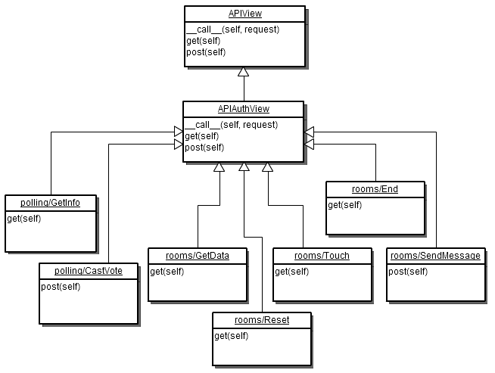

It is clear from the diagram that all of the operations in the API inherit from the APIAuthView class, as all operations require the user to be logged in.

The option of combining the two base classes into one class was considered, but the above solution was deemed to be conceptually sound, and fit for future expansion with API operations that no not require authentication.

The Django design is most easily represented by a diagram. The basic UML diagram below shows the applications in the Django project, with dotted arrows representing dependencies (for example, the API application depends on both the Rooms application and the Polling application).

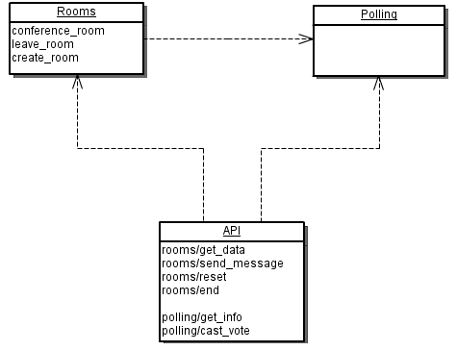

Alternatively, the Django project could have been designed by incorporating the API code into the relevant application to which it belongs. For example, the rooms API views could have been included inside the *rooms* application, and similarly for the *polls* application.

This, however, would mean that the code that is common to the API views (the APIView and APIAuthView base classes) would have to either be rewritten, or placed in a central location, resulting in a similar layout in the end (as rewriting code is obviously not optimal).

## Third-Party Applications

One of the major advantages of Django and the way it’s applications are designed, is the ability to download and use applications that others have written in other projects. In the group project, we used two third-party applications: **registration** and **haystack**.

Registration provides a reusable way of allowing users to register for the site, with e-mail validation. This was an important feature for our project, especially for the Open Day demonstration, which usually takes a long time to code.

Haystack is a front-end for the Python search framework called **whoosh**. It allows Django projects to index the content in their database, and provides an easy-to-use API for querying the search index. This allowed us to quickly implement search, which is also an important part the project.

There also exist applications for voting, but since this is such a core part of the project, the group decided to write the polling application from scratch, including all the functionality that was needed – and none that wasn’t. This gave us greater flexibility over the API that is exposed from the polling application itself, and as a result from the project as a whole.

## Testing

One of the greatest advantages of using an established framework such as Django is that the code that our project is based on has already been extensively tested. This negates the need to test simple cases such as attempting to login with no password, or specifying an input that is too long. Instead, we will focus on testing the *functional* aspects of the system, as it is perceived from a user’s perspective, in a specialised section later in the report.

# User Interface

## Inspiration for the Design

After potential designs for the system were researched, the conclusion the group came to was that to make the system into a user-friendly and professional-looking website, it is important to have a ‘clean’ look; avoiding too much clutter on each of the web pages. This decision enabled the group to keep the design both simple and stylish, whilst avoiding complications when it came to the actual creation of each design. The original prototype served as a basic guideline on how the system should look, however many changes were made to transform a basic web-application into a functional, user-friendly system.

Each debate within the system occurs in a chat window, with a basic message box for entering the text you wish to contribute to the debate, and a simple button used to send each message. This feature is tried-and-tested in many existing applications, including the popular ‘Windows Live Messenger’, and has proven successful, becoming ‘the norm’ for chat window functionality.

It was decided during the development stage that we required a way of displaying the current poll results to each user during the voting period. Fortunately, the student union elections were taking place during this stage in our project. We took inspiration from their polling system, whereby a pie chart is displayed to indicate the number of votes for each option.

## The Design

At the top of each webpage, there are the all-important links for both registering a new account and logging into the system. The image below displays the bar before a user is logged into the system:



Once logged into the system, it displays the username alongside the search bar, as well as a ‘logout’ link, as shown below:



As shown, the search bar remains whether the user is logged-in or not. A term can be searched for if not logged-in; however the debates can only be accessed once the user is signed into the system.

Another feature that is featured on each webpage is the footer; displaying both the project date and company on the left, and the project revision number on the right:



Each section within the system is sorted into individual tabs, as shown below:

tabs.JPG

The tab design allows for an organised overview of the system, with all of the sections clearly labelled; it is easy for the user to identify the purpose of each section. The colour scheme for the tabs and the text fit within the background too, which complements the general design scheme of myDebate.

**Home**

The default tab upon loading the webpage is “Home”; a sparsely-populated page there to provide the existing users of myDebate with status updates, while providing any new registrants with key features of what the system offers.

**Debates**

The “Debates” tab has two purposes; one of which is providing a list of existing debates for both guests and registered users (though only people who are logged-in will be able to access these debates), and the second purpose is for the creation of new debates if a user has a new topic to discuss which isn’t covered by the existing rooms.

The information provided about each debate, once created, is listed as follows:

* The question being asked, serving as the room name.
* A list of users participating in the debate
* The time remaining until the voting process begins
* A message box allowing the user to type messages

The image below contains each of the features listed above:

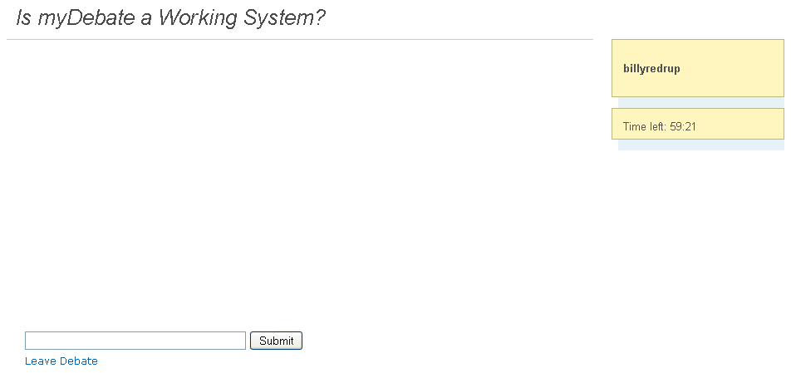

When viewing the ‘Debates’ tab, the user is presented with a list of the currently-active rooms where discussion is taking place. Each debate includes five pieces of information on this tab:

* The name of the room, serving as the debate topic
* The room creator’s username
* When the debate was created by said person
* How many myDebate users are currently in the room
* Whether the room is in ‘JOIN’ or ‘LOCK’ mode

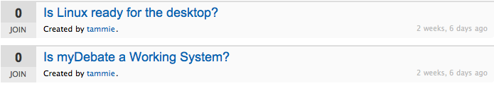

As you can see from the image above, all of the above features are included within the list.

**Starting a Debate**

When starting a new debate, you are required to complete a number of fields based on the topic you wish to discuss and the amount of options you want to include in the voting process. The first step

**[Complete this section with access to the A32 machines]**

Start a Debate

Start a Debate is in form style. First, we have got the “Question” field. Below it are the “Choices” field. The Choices by default would have two fields. To have more choices, there is a button “add another”. There is an pull down option for the debate time length. It ranges from 2 minutes to 120 minutes.

Below setting the time limit for the debate, there is also a time to lock the debate room. It consists of a horizontal sidebar for the user to choose the time. The time is also shown on top of it.

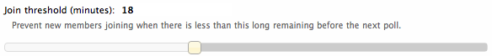

Users

In the “Users” page, the registered users are listed. They might have a picture next to their names depending on if they have an account on Gravatar. If they don’t, they would have a “Gravatar” default picture.

User Profile

Each user will have a profile. On here, information where the users added will be displayed. If the user has an avatar, it will be shown as well. There is an edit profile button for each of the users for editing their profile information.

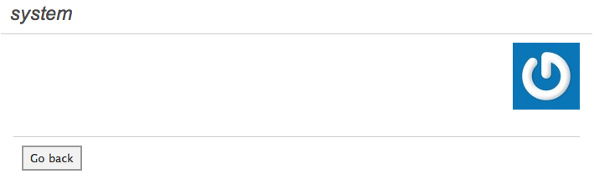Edit Profile

In the edit profile section, the user will be able to add information into the text box available.

The text box can be dragged to enlarge the field area. There is a submit button where the user can click and save the changes made to their profile. There is also a link where user can click on that and it will bring him/her back to the user profile page without saving the changes made.

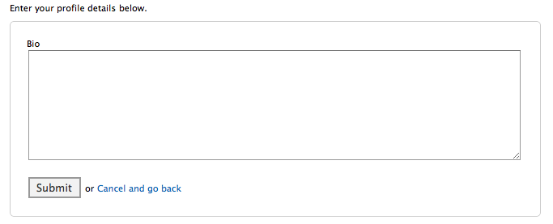Search

The search page contains a text field where users can enter a keyword for the name of the debate. The list of debates where a word of the name matches the entered word will be shown directly below the search field. This search field will still be present after the list of rooms are listed. This enables a user to change the search entry without having to go back to the previous page.

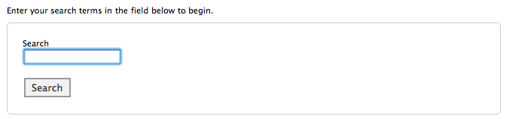

LOGO Design

The idea for this logo for our project came when we were looking for icons that are possibly suitable for our website. The red chat signs had inspired us and we thought it was suitable because our project is about chatrooms. The two squarish conversation signs creates a democratic feel of the nature of the debate. The colour of the speech signs are red because it stands out and it emphasised on the logo. The words “myDebate” is in “American Typewriters” font, because it brings out the professional look of our nature of our software. The blue colour was chosen because it goes well with the colour of the website and it makes the logo stands out. The design is designed to mean to the point and simple.



## Frequent Asked Questions (FAQ)

### Introduction

The “FAQ” page will contain the questions and answers likely to be asked by a user. Therefore the FAQ will cover the whole system.

For the creation of the FAQ section of the project we started out by researching into current help pages of similar systems, some examples being question and answer pages like Stack Overflow, and existing chat rooms like world of chat. These existing systems, when put together, become quite similar to what we were heading to achieve for the overall project which made them useful tools for writing the help section.

### Research

After researching the different systems, we sat down and decided on the most suitable questions from our research, and adapted them to fit our system. This turned out to be a useful way of only using the best questions, as before this we could only think of simple questions like “how do I create an account?”, We decided these types of questions were too broad and unspecific. Along with these questions we decided it would be a good idea to explain to the user what everything in a debate room does by using a screenshot. Apart from being useful to show the user on a picture what we are talking about, it also makes the page more colourful, interesting, and stops to page looking like a big block of text that makes the page less interesting to read.

### The Questions

We chose the question “Do I need to create an account” because it is a basic question that will stop people being confused, but on the other hand it’s not an obvious question like “how do I create an account” which we felt is self explanatory when you are at the registration page and the information on the screen.

Another question we thought was useful to include is “What does the 'Join' and 'Lock' mean next to each room on the debate page”, we decided this was a definite question to include n the FAQ section as it’s not obvious what they mean and will easily confuse people when they can’t enter a debate. We thought it was best to explain in detail what exactly they mean so the user will know exactly what they are saying and stop any further confusion.

The next couple of questions we thought to include were “what kind of debates can I start/not start”, we thought this questions very useful as they give a general idea of what kind of debates to start and what will not be accepted.

A further question we thought to add was “what does everything on the debate page mean” we thought this good as it explains what is going on when on a debate page and stops people being overwhelmed when the page suddenly changes when the timer stops.

The final question we thought to add was “can I change my vote once my vote has been cast”, this we felt was a good question to finish off because it explains how you can’t change your vote but you can change your vote at the next casting session, this stops people from worrying because they pressed the wrong button.

We included a FAQ section in the system as it is an important tool to allow users to understand the system and gives them a place to go to when they are confused or stuck while using the website and its features. We spent a lot of time on this as we thought it was crucial to make this as helpful and well written as possible.

# Testing

|  |  |  |
| --- | --- | --- |
| Requirement | Achieved | Comments |
| The system should have a web-accessible interface | Yes | The system has a modern web interface with a professional design on each page. This allows the user to navigate the system easily without each page being crowded with potentially confusing information. |
| Users should be able to log into and log out of the system | Yes | There is a simple login/logout link located at the top of each webpage. Once logged in, this allows for the users to edit their profile and/or log out of the system after they are finished with myDebate. |
| The system should present users with a list of available debates | Yes | The system’s design features tabs for navigation purposes. One of these tabs, labelled “Debates”, takes the user to an easily-navigated page which allows the user to browse a list of the currently open debates. |
| The amount of people currently participating in each debate should be clear to other users | Yes | This is made clear by the large numbered indicator next to each debate within the appropriate tab. This allows the user to recognise whether a debate is empty, and if not; then how many people are within that particular room at the moment. |
| The system should allow logged-in users to join debates and chat with other users within the room | Yes | If the user clicks an existing debate, the system will take you to the room, provided they are logged into the system. If not logged in, the user is taken to the login page where they must enter their username and password. Once the user has joined a debate, chat messages can be sent by typing into the text box and clicking the ‘Submit’ button alongside it. Empty messages cannot be sent. |
| The system should allow users to see other members within the debate | Yes | When participating in a debate, a list of the active users within that room is listed clearly alongside the chat window. |
| The system should allow users to leave a debate, and return to the list of available debates | Yes | When participating in a debate, there is a “Leave Debate” link, displayed below the chat box. When clicked, this will ask the user to confirm they wish to leave the debate. Clicking the “Yes, I’m sure” will return the user to the list of active debates, whereas clicking the “No, take me back” alternative will allow them to remain within that debate until they choose to leave. |

|  |  |  |
| --- | --- | --- |
| Requirement | Achieved | Comments |
| The system should use an asynchronous method of communication (i.e. the page should not refresh when a new message is available) | Yes | The system uses Ajax to constantly check for new messages every 2 seconds in the background which means the page will not refresh every time it needs to display a message. |
| The system should allow users to sign-up for a user account | Yes | At the top of each page of the system (when not logged into an account), there is a link to take the guest to the registration page to allow them to create a new user account. |
| Users must specify their full name when registering for an account | Yes | There is a box on the registration page for the user’s first name and another box for the user’s last name, with both being required fields to register an account. There is a 30 character maximum length on each box, which prevents the user of unrealistically long names. |
| Users must choose a username and password when registering for an account | Yes | On the registration page there is a box for entering a desired username. This is limited to fewer than 30 characters, to prevent the use of extremely long names. The same applies to the field used for entering a password. Both of these are required fields on the registration page and will not allow the user to continue unless they are complete. |
| Users must enter their email address when registering for an account | Yes | Users must enter an email address on the registration page in the supplied box as it is a required field. This field does not accept regular text and must be completed in the format of an e-mail address. Blank entries are also regarded as invalid by the system. |
| The system should send the user an email, which includes a link that the user must click in order to ‘activate’ their account | Yes | An email containing an activation link is sent to the email address the user supplied at registration. Upon clicking this link, the user is taken to a page on the website confirming their account is activated, and also supplies a link to the login page so the user can log in and start participating in active debates. |
| Before the user has clicked the link in their email, the account should be inactive - so the user cannot login | Yes | The system will not allow the user to access their account until they have clicked the activation link sent to their email address after registering. It tells the user their username or password doesn’t match if they have not yet clicked the activation link. |

|  |  |  |
| --- | --- | --- |
| Requirement | Achieved | Comments |
| Users should have a profile, containing their personal information shared with other users | Yes | Each user has a personal profile page which can be accessed by clicking their username at the top of the system. Other user profiles can be accessed by navigating to the users tab and clicking them. |
| Users should be able to create debates | Yes | Users can create a new debate by going onto the debates tab and clicking “start new debate” link at the bottom of the page or top of the page. This takes them to the relevant page where the user can then complete the fields necessary to start a new debate. |
| Users should be able to edit the information in their profile | Yes | Once on their profile, the user can click a button in the bottom right which says “edit profile”. This will take the user to a page where they can enter some details about themselves in the “About Me” section, which will be displayed on their profile page after they click the submit button. |
| The system should require all users create a poll when starting a debate in the form of a question and potential answers. | Yes | The user must supply a question, which will serve as the debate title. They must then supply a list of choices in the fields provided. The user is also able to supply further choices by pressing the “add another” button which will then add a field for an additional option. |
| Users should be able to choose the length of the ‘period’ when creating a debate (a default value of 30 minutes should be provided) | Yes | Users can choose how long a period in the debate by choosing an amount of time from the drop down box on the start a new debate page, the user cannot change this length after the debate has been created. |
| Users should be able to choose the time at which a room ‘locks’ - so that no new members can join, before a poll is due. | Yes | Users can decide when a room ‘locks’ (in minutes) by moving the slider on the new debate page to the desired time before a vote. This cannot be less than 1 minute before the voting process begins. A suggested time is set by default when the length of a period is chosen by the user. |
| The system should switch to a vote at the end of each specified time period | Yes | When participating in a debate there is a timer showing how long there is before the next voting period. Once the countdown has ended, a pop-up box is displayed over the debate. Each user is then required to pick one of the options available. Once they have voted, a chart is displayed to show the current results of the poll, and is updated dynamically as more votes are counted by the system. |

|  |  |  |
| --- | --- | --- |
| Requirement | Achieved | Comments |
| When in the voting mode, users should not be able to enter messages in the debate. Everyone is required to vote on the poll specified at creation time | Yes | When a debate is in vote mode users are not able to type messages or read messages until vote mode is over and the user ‘admin’ chooses to go to a new period. |
| One the poll has been completed, the person who is unofficially leading the room has the choice over whether to end the debate or go to another period | Yes | Once everyone in a room has voted, a box will pop up for the user who is ‘in charge’, allowing them to choose whether to go to a new period of end the current debate. |
| The person who is in ‘charge’ is decided by who has been participating in the debate for the longest period of time | Yes | If the debate creator leaves the room, then the user who has been in the debate for the longest period then becomes the debate ‘leader’. If they leave, then this occurs again for the next most-active user within the debate. |
| The system should allow users to search for debates quickly and easily, so that sorting through a large amount of debates is not necessary | Yes | There is a search box at the top of every page allowing the user to type what they are interested in debating. It will then return a list of those that meet the criteria. The function will not search for simple words like “a”, “it”, “the”, etc. |
| The system should have a Frequently Asked Questions (FAQ) section | Yes | The website has an FAQ section which can be accessed by clicking the FAQ tab. This contains potentially-useful questions, such as: “What does everything on the debate page mean?” and “What kind of debates can I start?” |
| The web interface should be accessible from any platform, using either of **two** main browsers – Firefox and Google Chrome | Yes | The user can access the webpage from both of the specified browsers easily and with all functionality working correctly. |
| The system should be secure in that unauthenticated users cannot access debates | Yes | The user must login to join any debates. It will not allow them to access a debate without having a valid account logged into the system. |
| The system should be working and available by entering the relevant URL | Yes | You can access the website from any computer that has internet access. |
| The system should respond to requests in a reasonable time period | Yes | The system responds to each request without delay and without any errors. |
| The FAQ should be comprehensive; providing relevant questions that users may ask, and aid people in using the to its full potential | Yes | The FAQ section is made up of questions that reflect the system and does not include any questions that were deemed unnecessary. |

System Walkthrough

Reflective Comments

The purpose of this section is to look back at the way the group performed over the course of the project, and to highlight reasons why certain objectives were achieved, and why others were not, as well as giving us a chance to look back and decide what would be done differently if we could begin anew. The comments in this section will not only focus on how well we performed regarding the technical aspects of the project, but will also be aimed at the group from a different perspective to gather feedback on how well we worked together when producing each of the deliverables.

## Project Objectives Achieved

The primary objective of the project was to create a working system, and to base a number of documents around this objective. Therefore, from a purely technical standpoint, we succeeded in achieving our aim, as a working ‘Democratic Conferencing Tool’ system was created. The basic concept is achieved, as we created an application which allows users to sign up and debate any topic they wished with each other, while maintaining democratic in the approach of allowing the users to moderate themselves. Upon its completion, a new name was given to the system; myDebate.

The features of myDebate include the following:

* A simple registration process which involves a confirmation e-mail being sent to the user
* Easily-creatable debates for new users, or the option to join an existing discussion if the topic interests them
* A full member list, which allows for new users to locate friends within the myDebate community
* Working search function to help highlight specific discussions with key words that interest the user
* A voting system where the user can choose the answer that they agree with regarding the topic being debated

All of the source code for the system is completed, and has undergone thorough testing for any errors that made it through the development stage of the system. Despite a number of errors being found during development, each of them have been fixed and the submitted version of the source code is as bug-free as we could possibly get it during our testing process.

## Project Objectives Not Achieved

Time Plan

**[Detailed time plan will be added upon completion of the other sections in the report]**

**[Testing]**

1. http://trends.builtwith.com/JavaScript/JQuery