Run: #1577 The Shemailman Bitchfest Hash

Hare: Shemailman

Location: A Big Rock Surrounded by Horseshit at Goddard Park, Warwick, RI

Weather: Perfect unless you really like rain, snow and cold weather

The Pack: WHO, OOzing, O'Bone'R, Rusty, Misses Pussy, Sleeping Booty, WIPOS, Wee Balls, Butt Plug, Shemailman, POP, Meat Wallet, others???

Visitors: Just Tom (Lost on Trail?) from Equador H3(?)

Hashit: Wee Balls

Where do I start?? Monday was the day after Father’s day weekend and so we all know Shemailman was going to put no effort into setting trail. So he decides to blaze trail over last week’s trail. My only thought is he wants to upper deck PG and Crotches trail or put little effort in and use there trail to confuse the pack. I vote for the later and success was achieved.

I showed up late and as I was driving to the trail I receive a text from SheMailman stating “There are tit check. Dick check. CB. NB. BN. BVN.”, “I didn’t have time to set trail today going to live hare see you at the beer stop” (see pic belw). So to inform the pack I sent it to O’boner to relay the message. I have no idea if she informed the pack of the marks, but I did see them at the start. I also receive a call from Shemailman asking for me to sweep behind the pack and he gives me details of the trail.

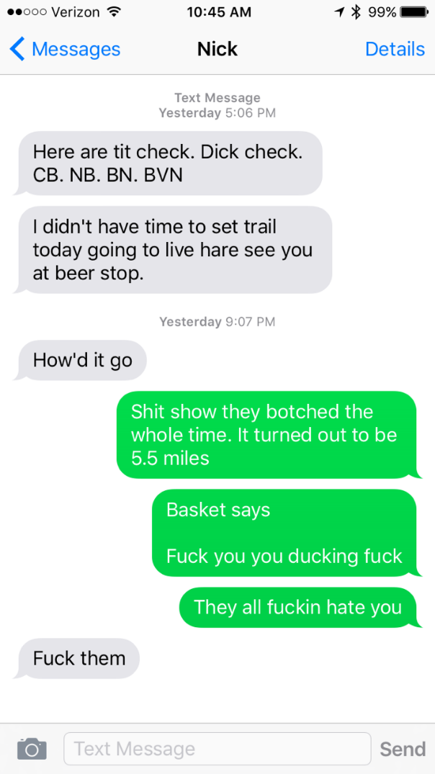

As I enter the park I see pack heading right down the wall. Booty give me an ass shake and it warrants a honk in return. She is the last hasher, so I park and embark out into the general direction of the hash, sweeping as I go. I find marks on the trees near the stone wall and I am ONON. Into the vast open fields I enter, not seeing a single hasher in the distance. Crossing the plains of Goddard park gives you time to think.

Did I lock my car?

Will there be good beer?

Am I going to miss the tit check?

If the square root of 69 = 8 something, then what is the square root of 6969?

Am I lost?

I soon come to and find trail again. I hear a horn in the distance and come across basket, waddling over a check, apparently the first one he has seen. He said the pack is calling on straight, left and right. Makes you think what marks did they come across way in that direction??? With the intel I received from SheMailman, I set the check and the pack, basket, moves on. Crossing another field I hear “Are You?????” deep in the woods. POP calls on the pack and they V line it to the ONON calls. Out of the woods pop out Misses Pussy, O’Boner and Just Tom (that was the last time I saw Just Tom). They cross the field and get abused by locals in the park, but we all know they like that type of action.

From this point to the beer check gets a little fuzzy for me. There was more dick checks, tit checks, and a song/shot/sucking/snatch/shandy check. There was a BN in the woods in the exact location from last week’s trail, maybe it was the same BN, WHO knows. Then I run into Butt Plug and Rusty on the scenic board walk, were I find them complaining about not finding any marks. I look down and right in front of me I see a chalk arrow pointing in a direction. Then comes WHO bitching about the sun in his eyes and not able to see color. He sounds like Basket complaining about his color. Maybe WHO is turning into Basket??? Can you imagine having two Baskets at the hash??? Would you follow WHO? What a shit show it would be.

We continue down the beach and lay flour to assist the hare. I clearly saw a BVN written on log. But the Hare miscalculated the tidal shift in the ocean and set marks and the B on the high tide mark. Beer was found and more complaining occurred. This time it was the beer selection. “It taste like piss” shouts Oozing, “I swear this is Coors Light” complains Booty, “Where the fuck is the Hare??” Wee Balls yells.

At this point I know I have been set up by Shemailman. That prick was not at the beer stop and the interrogation begins. I am getting it from all sides, fending of pricks and ducking allegations. I am not falling on Shemailman sword. I defend “I am not the Hare, he must be at the circle??” But the pack is growing restless wanting answers and to punish the Hare. All this time Rusty is still bitching about the BN not being by the B. Are there rules to Hashing?? Is there an approximate distance a BN needs to be to the B?? If so, please show this in writing, double space, Tacoma 12 font and post it on the website.

Even though they bitched about the beer, the pack still drank it. Except Booty poured some out, alcohol abuse. Future accusation.

We took the coastline back to the circle. High tide made it a little wet, some went high others like going down. Beer was drank. Rating was given to Shemailman doppelganger, a rock, and then was thrown in the water and left. Wee Balls was the only nomination for Hashshit because Shemailman set him up and was nowhere to be found on trail, beer stop or the circle.

On In is at Fat Bellys, not the one in Warwick, the one in East Greenwich, same as last week. Oozing immediately notes a different waitress and complains the service sucks. Then Basket and Rusty complain about the beer tasting bad, which it did. Then everyone complains about the trail and how a BN needs to be by the B, but don’t state how close. All in all I think it was a success!!