Bondo Jovi Reamin’

All the streaks are brown
In his shorts of grey
Bondo said his doc
Said it’s time to pay
The flexible video endoscope
Was chilled way down they say
Bondo Jovi Reamin
Up his ass today

He stopped into a church (stopped into a church)
Passed along the way (passed along the way)
And he got down on his knees (got down on his knees)
Before a preacher to pray (the preacher to pray)
Oh, the preacher he was cold (he was cold))
He knows I’m gonna pay (knows I’m gonna pay)

Bondo Jovi Reamin’ (Bondo Jovi Reamin’)
On such a spring day

Dr WHO was there (Dr. WHO was there)
He heard his nurse Jeanne say (his nurse Jeanne say)
Basket Boom Boom’s ass (Basket Boom Boom’s ass)
Is cuter, I’ll bet my pay (I’ll bet my pay)
I hope Bondo flushed his system (Bondo flushed his system)
We don’t want shit, not way (shit, NO WAY)
Oh, Bondo Jovi Reamin’ (Bondo Jovi Reamin’)
On such a spring day

The Rhody Hash went to visit (went to visit)
In the room where he lay (room where he lay)
He was still knocked out (he was still knocked out)
With a smile on his face (a smile on his face)
Oh, we knew that he would like it (knew he would like it)
To have his ass reamed this way (have his ass reamed this way)

Oh, Bondo Jovi Reamin’ (Bondo Jovi Reamin’)
On such a spring day

All the streaks are brown (all the streaks are brown)
In his shorts of grey (in his shorts of grey)
He won’t walk very straight (he won’t walk too straight)
When he’s finished today (when he’s finished today)
He may not be virgin (may not be virgin)
But he’s never had it this way (never had it this way)

It’s Bondo Jovi Reamin (Bondo Jovi Reamin’)
On such a Spring Day (on such a spring day)
On such a Spring Day (on such a spring day)
On such a Spring Day (on such a spring day)
On such a Spring Day

THE OPERATION

Chili goes in one end and out the other

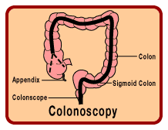

Any beer sucking polyps are snipped off immediately

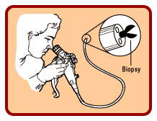

Dr. WHO: “Nurse Jeanne, you may want to close your eyes for this one.

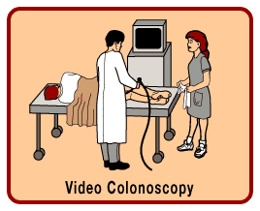

Jeanne: “Whoa, where’d all that gas come from?”

Dr.WHO: “It’s those damn Diverticulosis Pockets. Everybody get back and don’t light any matches!”

Jeanne: “Is that a smile on his face?”

