LOCATION BASED EVENT NOTIFIER

A Project Report
Submitted in partial fulfilment for the award of the degree
of

Master of Technology
in
Information Technology
by
ROBICK. R
15MIN0810

Under the guidance of
Dr. RAJESH KALURI
Assistant Professor (Senior)



School of Information Technology and Engineering
August, 2019

School of Information Technology and Engineering

DECLARATION BY THE CANDIDATE

I hereby declare that the thesis entitled “LOCATION BASED EVENT NOTIFIER” submitted by me to Vellore Institute of Technology, Vellore, in partial fulfillment of the requirement for the award of the degree of Master of Technology in Information Technology is a record of Bonafede project work carried out by me under the supervision of Dr. Rajesh Kaluri, Assistant Professor (Senior). I further declare that the work reported in this project has not been submitted and will not be submitted, either in part or in full, for the award of any other degree or diploma in this institute or any other institute or university.

Place:
Date: Signature of the Candidate
School of Information Technology and Engineering

BONAFIDE CERTIFICATE

This is to certify that the project work entitled “LOCATION BASED EVENT NOTIFIER” by ROBICK (15MIN0810), to Vellore Institute of Technology, Vellore, in partial fulfillment of the requirement for the award of the degree of Master of Technology in Information Technology, is a project Bonafede work carried out by him/her under my supervision. The project fulfills the requirement as per the regulations of this Institute and in my opinion meets the necessary standards for submission. The contents of this report have not been submitted and will not be submitted either in part or in full, for the award of any other degree or diploma in this Institute or any other Institute or University.

Dr. Rajesh Kaluri.
Internal Supervisor,
Assistant Professor (Senior), Vellore Institute of Technology, Vellore.

Internal Examiner(s) External Examiner(s)

Table of Contents
ABSTRACT 6
LIST OF TABLES 7
List of Figures 8
LIST OF Abbreviations 9
1 INTRODUCTION 10
1.1 MOTIVATION 10
1.2 SCOPE 10
2 LITERATURE SURVEY 11
2.1 ASSUMPTION 11
2.2 DEPENDENCIES 12
2.3 RISK 12
3 SYSTEM ARCHITECTURE 13
3.1 ARCHITECTURAL DESIGN 13
3.2 DATAFLOW DESIGN 13
3.3 DECOMPOSITION DESCRIPTION 14
4 DETAILED SYSTEM DESIGN 15
5 GRAPHICAL USER INTERFACE DESIGN 16
5.1 LOGIN: 16
5.2 HOME SCREEN 17
5.3 ADD EVENT 18
5.4 ADOF 19
5.5 SAMPLE CODE - FRONTEND 20
5.6 SAMPLE CODE – BACKEND 35
6 RESULTS 42
6.1 TEST SCHEDULE [REQUIRED] 42
6.2 TEST PLANS [REQUIRED] 42
6.2.1 UTC PLAN [REQUIRED] 42
6.2.2 APPLICATION PRODUCT TEST (APT) PLAN [REQUIRED] 43
6.2.3 USER ACCEPTANCE TEST (UAT) PLAN [REQUIRED] 44
6.3 TEST RESULT 45
6.3.1 UTC 45
6.3.2 APT 45
6.3.3 UAT 45
6.4 TEST DEFECTS 45
7 FUTURE SCOPE 46
8 REFERENCES 47

ABSTRACT

The Location based event notifier is a mobile application developed to provide the end users with the various types of notification’s according to the location he is in. According to the need of user.

Now the users are having issue with tracking multiple tasks for the day like buying groceries while returning from office or to meet someone, while he is on some specific location.

The proposed solution for this is provided by the mobile device of the users by this application. The user will be sharing his location service in his mobile. Then the user can schedule an event notification by the place he is in. Which will remind the user when he is available at the location. The users can share the event with their friends. And plan/schedule events according to the location. The wider scope this project is to provide the user with custom advertisement and offers available at his location.

The application is developed by Java, HTML5, NativeScript, ionic, Angular, Android Studio, Spring-boot, Dedicated Linux server.

LIST OF TABLES
Table No | Title | Page No
1 | Assumptions | 6
2 | Test schedule | 38
3 | UTC Plan | 38
4 | APT Plan | 39
5 | UAT Plan | 40
6 | UTC Result | 41
7 | APT Result | 41
8 | UAT Result | 41
9 | Test defects | 41

LIST OF FIGURES
Figure No | Title | Page No
1 | Architecture of “Location Based Event notifier” | 8
2 | Dataflow of “Location Based Event notifier” | 8
3 | Context diagram Level 0 DFD | 9
4 | Context diagram Level 1 DFD | 9
5 | Login screen of “Location based event notifier” | 11
6 | Home screen of “Location based event notifier” | 12
7 | Add event screen of “Location based event notifier” | 13
8 | ADOF screen of “Location based event notifier” | 14

LIST OF ABBREVIATIONS
ACRONYM | EXPANSION
GPS | Global Positioning System
ADOF | Advertisements and offers
LBEN | Location based event notifier
SDK | Software development kit
DFD | Data flow diagram
APT | Application Planned Test
UAT | User Acceptance Test
UTC | Unit Test Case

INTRODUCTION

MOTIVATION

Nowadays to remember what task to do at what location is very tedious job for everyone because there are so many tasks that everyone must perform in their day to day life [6]. Nowadays android smartphones are everywhere, and it provides Google Map, Google Location services to the smartphones through which we can easily get the location detail, but Google does not provide the facility to add the task reminder on specific location [1][3]. By using their services of Map, GPS and Location we developed the system called as “Location Based Event Notifier”.

This system plays very important role in user’s daily life to set task reminder at several locations through which user can make idea and alert of tasks he will perform on specific location. There are so many applications on smartphones which provide location-based services, but they are allow us to set multiple reminder at multiple location through our implemented system we can add multiple reminders on one location. This will help user to improve their daily important activities such as meeting, conference, wedding, party, exam and many more. For marketing and business-oriented users it is very beneficial system. We implemented this system using Android Programming language on Android operating system as Android provides more flexibility and ease of installing any application developed on it [5]. We included some permission for fetching the location of the user from Android SDK.

SCOPE
Below are the features which are in scope for this project:
1) Provides ease of access to the end user
2) Quick and easy to handle application
3) Providing better reliability
4) Faster access to the location and easily customizable
5) Providing efficient output to the user in terms of reminder of tasks by notifying them on correct location

LITERATURE SURVEY

ASSUMPTION

Assumption ID | Description | Consequence of False Assumption
AS_1 | User will be providing the application a valid set of personal information. | Application won't be able to communicate to the user.
AS_2 | Having a reliable network connection to fetch location services | Location can't be detected.
AS_3 | Turning on the notification option in the application | Notification won't be provided at correct time.
AS_4 | Connectivity and cost of third-party system involved in the overall functioning of application | Failure will lead to miss the reminder

Table: 1. Assumptions

DEPENDENCIES
System needs a network connectivity to make the application run.
Google based application to provide information about the location and other task related objects and offers available for the user’s interest.
Third party system’s like facebook, Instagram, WhatsApp etc to let the friends and family know about the event planned.

RISK
Network disturbance causing connectivity issue with application
Server unavailability for google apps to get location information and other required advertisements.
Maintenance of third-party systems.
Failure of the device or power off.
Manual mistake of turning off the GPS and notification feature.
Security risks of sharing location.

SYSTEM ARCHITECTURE

ARCHITECTURAL DESIGN
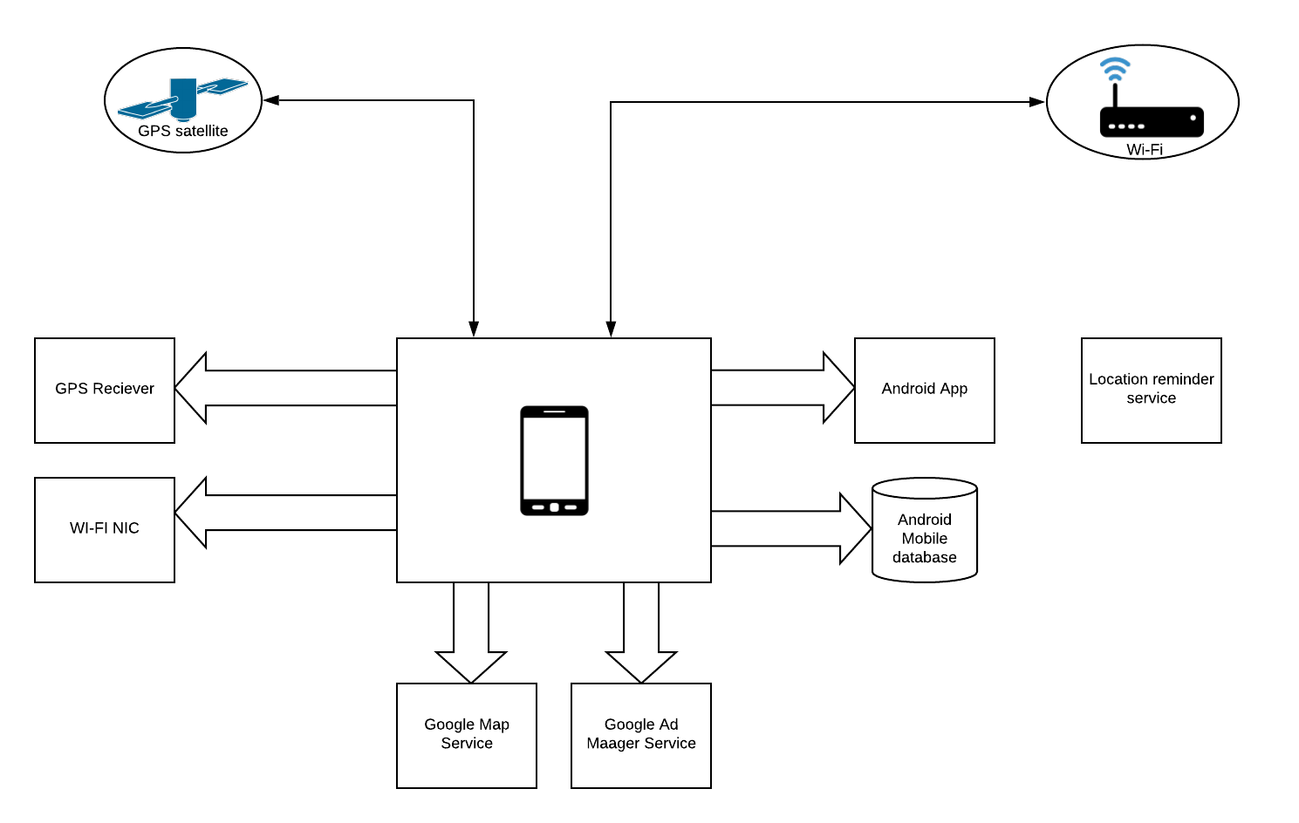

Fig: 1. Architecture of “Location Based Event notifier”

DATAFLOW DESIGN
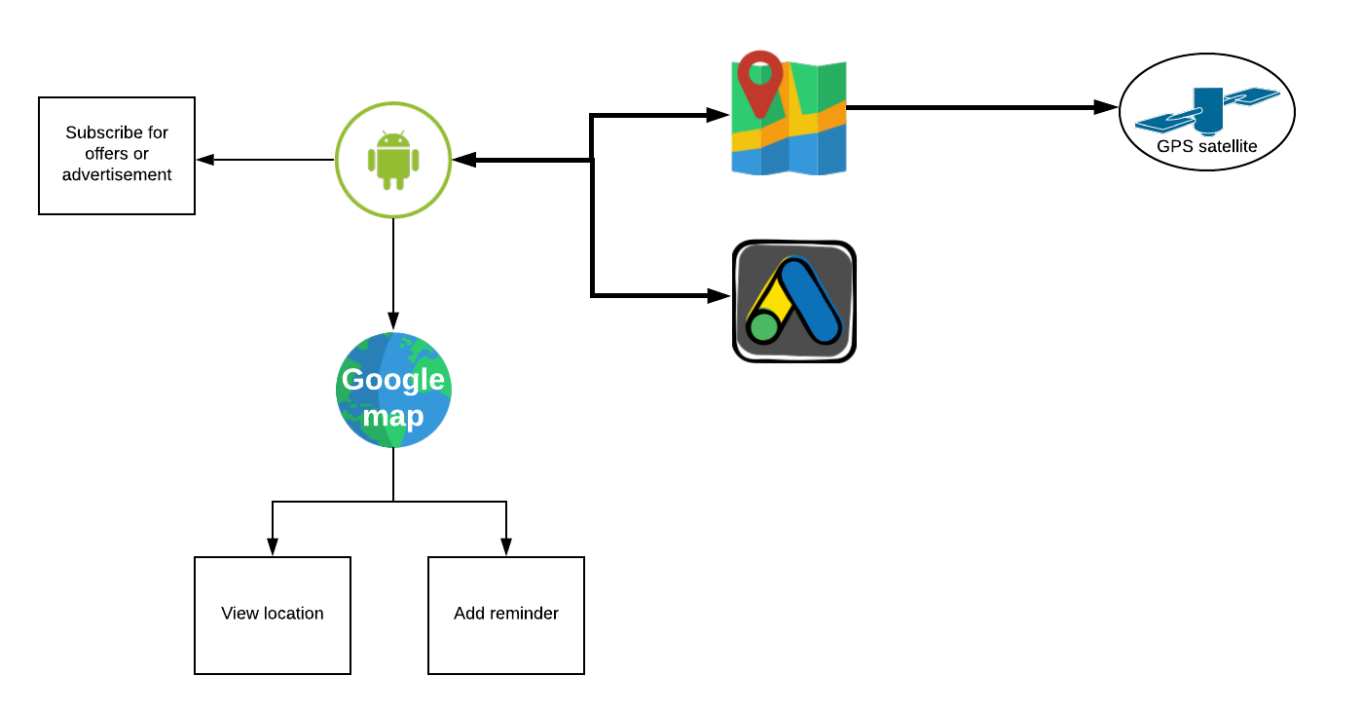

Fig: 2. Dataflow of “Location Based Event notifier”

DECOMPOSITION DESCRIPTION
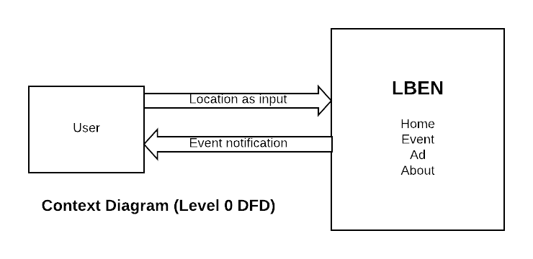

Fig: 3. Context diagram Level 0 DFD
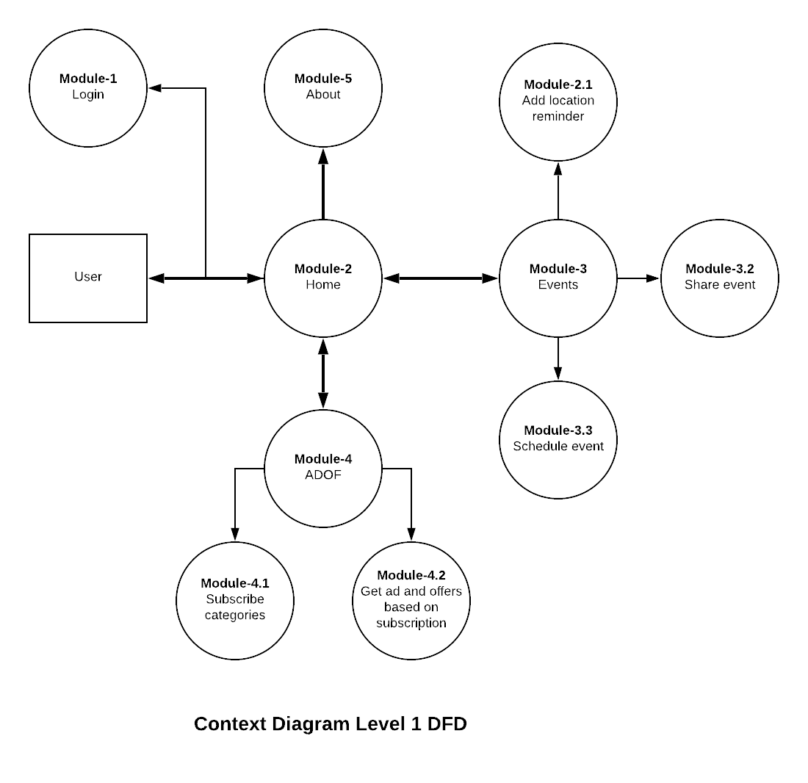

Fig: 4. Context diagram Level 1 DFD

DETAILED SYSTEM DESIGN
Module-1: Login
The module to handle login and authorize users.
Module-2: Home
This module is the landing page of the app. From where user will navigate.
Module-3: Events
The module where the user will add, plan and share events according to location.
Module-3.1: Add location reminder
This module helps in adding reminder when user is back at this location.
Module-3.2: Share event
This module helps in sharing the event when user plans for it.
Module-3.3: Schedule event
This module helps in schedule the event when user plans for it.
Module-4: ADOF
This module helps the user to view the advertisement and offers with users consent.
Module-4.1: Subscribe categories
This module helps the user to subscribe various categories of offers and advertisement.
Module-4.1: Get offers and Ad
This module helps the user to view offers and advertisement which user have subscribed to.
Module-5: About
This module provides information about the mobile application details.

GRAPHICAL USER INTERFACE DESIGN

LOGIN:
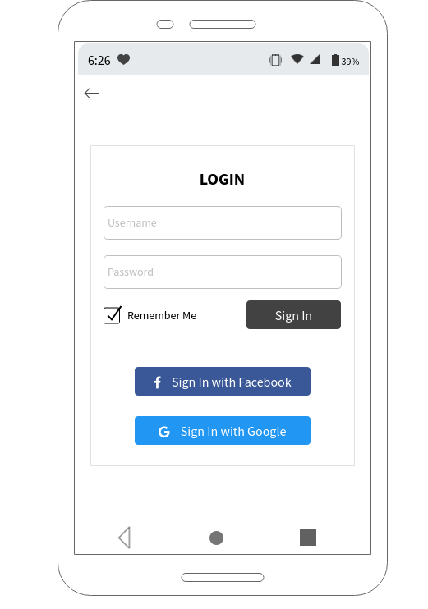

Fig: 5. Login screen of “Location based event notifier”

HOME SCREEN

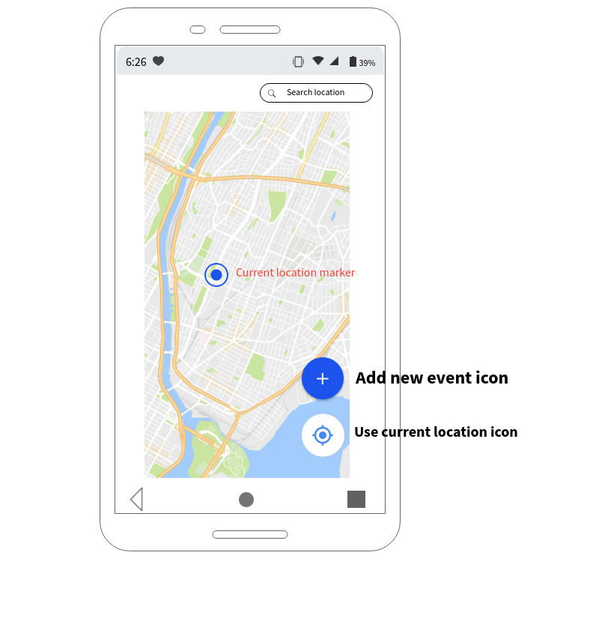

Fig: 6. Home screen of “Location based event notifier”

ADD EVENT
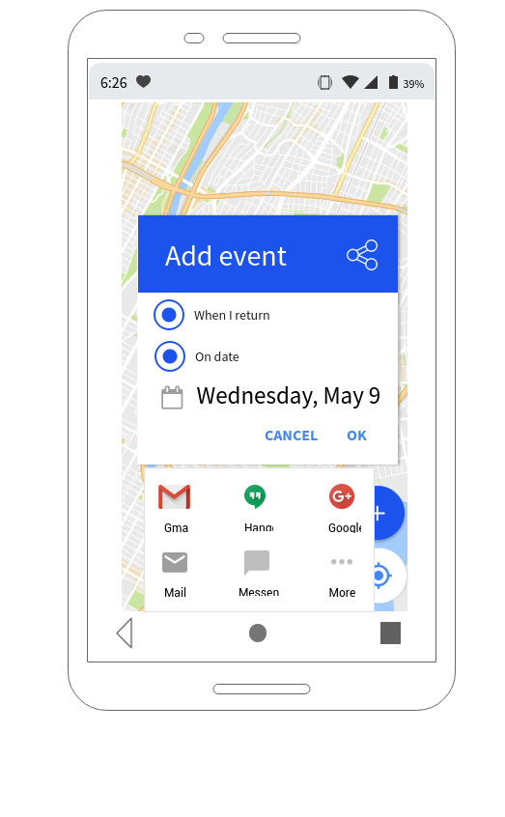

Fig: 7. Add event screen of “Location based event notifier”

ADOF
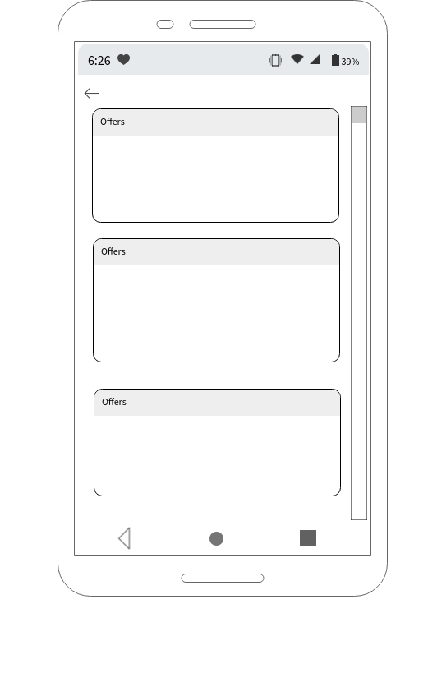

Fig: 8. ADOF screen of “Location based event notifier”

SAMPLE CODE - FRONTEND
    - AndroidManifest.xml
<?xml version="1.0" encoding="utf-8"?>
<manifest xmlns:android="http://schemas.android.com/apk/res/android"
package="__PACKAGE__"
android:versionCode="1"
android:versionName="1.0">
<supports-screens
android:smallScreens="true"
android:normalScreens="true"
android:largeScreens="true"
android:xlargeScreens="true"/>
<uses-permission android:name="android.permission.READ_EXTERNAL_STORAGE"/>
<uses-permission android:name="android.permission.WRITE_EXTERNAL_STORAGE"/>
<uses-permission android:name="android.permission.INTERNET"/>

<application
android:name="com.tns.NativeScriptApplication"
android:allowBackup="true"
android:icon="@drawable/icon"
android:label="@string/app_name"
android:theme="@style/AppTheme">

<activity
android:name="com.tns.NativeScriptActivity"
android:label="@string/title_activity_kimera"
android:configChanges="keyboard|keyboardHidden|orientation|screenSize|smallestScreenSize|screenLayout|locale|uiMode"
android:theme="@style/LaunchScreenTheme">

<meta-data android:name="SET_THEME_ON_LAUNCH" android:resource="@style/AppTheme" />
<meta-data android:name="com.google.android.geo.API_KEY" android:value="@string/nativescript_google_maps_api_key" />

<intent-filter>
<action android:name="android.intent.action.MAIN" />
<category android:name="android.intent.category.LAUNCHER" />
</intent-filter>
</activity>
<activity android:name="com.tns.ErrorReportActivity"/>
</application>
</manifest>

    - Package.json
{
"nativescript": {
"id": "org.nativescript.robickprojectapp",
"tns-android": {
"version": "6.0.0"
},
"tns-ios": {
"version": "6.0.1"
}
},
"description": "NativeScript Application",
"license": "SEE LICENSE IN <your-license-filename>",
"repository": "<fill-your-repository-here>",
"dependencies": {
"@angular/animations": "~8.0.0",
"@angular/common": "~8.0.0",
"@angular/compiler": "~8.0.0",
"@angular/core": "~8.0.0",
"@angular/forms": "~8.0.0",
"@angular/http": "~8.0.0-beta.10",
"@angular/platform-browser": "~8.0.0",
"@angular/platform-browser-dynamic": "~8.0.0",
"@angular/router": "~8.0.0",
"angular-font-awesome": "^3.1.2",
"bootstrap": "^4.3.1",
"bootstrap-material-design": "^4.1.2",
"nativescript-angular": "~8.0.0",
"nativescript-geolocation": "^5.1.0",
"nativescript-google-maps-sdk": "^2.7.0",
"nativescript-theme-core": "~1.0.6",
"reflect-metadata": "~0.1.12",
"rxjs": "^6.5.2",
"tns-core-modules": "~6.0.0",
"zone.js": "~0.9.1"
},
"devDependencies": {
"@angular/compiler-cli": "~8.0.0",
"@ngtools/webpack": "~8.0.0",
"nativescript-dev-webpack": "~1.0.0",
"typescript": "~3.4.0"
},
"gitHead": "f28dbc60d74dd2cef4b645afd8fdd63bbb12c73e",
"readme": "NativeScript Application"
}

    - App.module.ts
import { NgModule, NO_ERRORS_SCHEMA } from "@angular/core";
import { NativeScriptModule } from "nativescript-angular/nativescript.module";

import { AppRoutingModule } from "./app-routing.module";
import { AppComponent } from "./app.component";
import { ItemsComponent } from "./item/items.component";
import { ItemDetailComponent } from "./item/item-detail.component";
import { HomeComponent } from './home/home.component';
import { MainComponent } from './main/main.component';
import { HttpClientModule } from '@angular/common/http';
import { BrowserModule } from '@angular/platform-browser';

//Uncomment and add to NgModule imports if you need to use two-way binding
import { NativeScriptFormsModule } from "nativescript-angular/forms";

// Uncomment and add to NgModule imports if you need to use the HttpClient wrapper
import { NativeScriptHttpClientModule } from "nativescript-angular/http-client";

@NgModule({
bootstrap: [
AppComponent
],
imports: [
NativeScriptModule,
AppRoutingModule,
BrowserModule,
HttpClientModule,
NativeScriptHttpClientModule,
NativeScriptFormsModule

],
declarations: [
AppComponent,
ItemsComponent,
ItemDetailComponent,
HomeComponent,
MainComponent
],
providers: [],
schemas: [
NO_ERRORS_SCHEMA
]
})
/*
Pass your application module to the bootstrapModule function located in main.ts to start your app
*/
export class AppModule { }

    - App-routing.module.ts
import { NgModule } from "@angular/core";
import { NativeScriptRouterModule } from "nativescript-angular/router";
import { Routes } from "@angular/router";

import { ItemsComponent } from "./item/items.component";
import { ItemDetailComponent } from "./item/item-detail.component";
import { HomeComponent } from "./home/home.component";
import { MainComponent } from "./main/main.component";

const routes: Routes = [
{ path: "", redirectTo: "/home", pathMatch: "full" },
{ path: "items", component: ItemsComponent },
{ path: "item/:id", component: ItemDetailComponent },
{ path: "home", component: HomeComponent },
{ path: "main", component: MainComponent },
];

@NgModule({
imports: [NativeScriptRouterModule.forRoot(routes)],
exports: [NativeScriptRouterModule]
})
export class AppRoutingModule { }

    - Main.component.ts
import { Component, OnInit } from '@angular/core';
import { isEnabled, enableLocationRequest, getCurrentLocation, watchLocation, distance, clearWatch, } from "nativescript-geolocation";
import { EventDto } from '../model/eventDto';
import { EventService } from '../event.service';

@Component({
selector: 'ns-main',
templateUrl: './main.component.html',
styleUrls: ['./main.component.css'],
moduleId: module.id,
})
export class MainComponent implements OnInit {
private eventDto:EventDto=new EventDto();
constructor(private eventService:EventService) { }

ngOnInit() {

}
addEvent(){
var location = getCurrentLocation({desiredAccuracy: 3, updateDistance: 10, maximumAge: 20000, timeout: 20000}).
then(function(loc) {
if (loc) {
console.log("Current location is: " + JSON.stringify(loc));
this.eventDto.user="Robick";
this.eventDto.location=loc;
this.eventService.addEvent(this.eventDto).subscribe(resposne => {
console.log("Added event"+JSON.stringify(resposne));
})
}
}, function(e){
console.log("Error: " + e.message);
});
}

    - Main.component.html
<Page
xmlns="http://www.nativescript.org/tns.xsd"
xmlns:maps="nativescript-google-maps-sdk"
>
<StackLayout orientation="vertical" width="90%" height="100%" backgroundColor="lightgray">
<GridLayout width="80%" height="90%">
<maps:mapView latitude="{{ latitude }}" longitude="{{ longitude }}" mapAnimationsEnabled="{{ mapAnimationsEnabled }}"
zoom="{{ zoom }}" bearing="{{ bearing }}"
tilt="{{ tilt }}" padding="{{ padding }}" mapReady="onMapReady"
markerSelect="onMarkerSelect" markerBeginDragging="onMarkerBeginDragging"
markerEndDragging="onMarkerEndDragging" markerDrag="onMarkerDrag"
cameraChanged="onCameraChanged"
cameraMove="onCameraMove" />
</GridLayout>
<Button class="btn btn-primary btn-active" id="button" text="Add event" (tap)="addEvent()" width="40%" height="10%"></Button>
</StackLayout>
</Page>

    - Home.component.html
<ActionBar title=" Yuuuhhuuu" android.icon="res://icon" android.iconVisibility="always" horizontalAlignment="center">
</ActionBar>
<StackLayout orientation="vertical" width="70%" height="30%" backgroundColor="lightblue">
<TextField #username hint="Username" autocorrect="false" (textChange)="onTextChange()"
class="input input-border"></TextField>
<TextField #password hint="Password" autocorrect="false" returnKeyType="done"
class="input input-border"></TextField>
<Button text="Login" (tap)="submit(password.text,username.text)" class="btn btn-primary btn-active" bottom></Button>
</StackLayout>

    - Home.component.ts
import { Component, OnInit } from '@angular/core';
import { Router } from '@angular/router';
import { TextField } from "tns-core-modules/ui/text-field";
@Component({
selector: 'ns-home',
templateUrl: './home.component.html',
styleUrls: ['./home.component.css'],
moduleId: module.id,
})
export class HomeComponent implements OnInit {
public firstTx: string = "";

constructor(private router:Router) { }
ngOnInit() {
}

public onTextChange(args) {
let textField = <TextField>args.object;

console.log("onTextChange");
this.firstTx = textField.text;
}

public onReturn(args) {
let textField = <TextField>args.object;

console.log("onReturn");
this.firstTx = textField.text;
}

public showAlert(result) {
alert("Text: " + result);
}

public submit(username,password) {
console.log("username"+username);
this.router.navigate(['main']);
}
}

    - Items.component.html
<GridLayout class="page">
<ListView [items]="items" class="list-group">
<ng-template let-item="item">
<Label [nsRouterLink]="['/item', item.id]" [text]="item.name"
class="list-group-item"></Label>
</ng-template>
</ListView>
</GridLayout>

    - Items.component.ts
import { Component, OnInit } from "@angular/core";

import { Item } from "./item";
import { ItemService } from "./item.service";

@Component({
selector: "ns-items",
moduleId: module.id,
templateUrl: "./items.component.html"
})
export class ItemsComponent implements OnInit {
items: Array<Item>;

// This pattern makes use of Angular’s dependency injection implementation to
// inject an instance of the ItemService service into this class.
// Angular knows about this service because it is included in your app’s main NgModule,
// defined in app.module.ts.
constructor(private itemService: ItemService) { }

ngOnInit(): void {
this.items = this.itemService.getItems();
}
}

    - Event.service.ts
import { Injectable } from '@angular/core';
import { HttpClient,HttpErrorResponse } from '@angular/common/http';
import { EventDto } from './model/eventDto';
import { Observable, throwError } from 'rxjs';
import { catchError } from 'rxjs/operators';

@Injectable({
providedIn: 'root'
})
export class EventService {
private eventUrl:string="/event";
constructor(private httpClient:HttpClient) { }
addEvent(eventDto:EventDto):Observable<{}>{
return this.httpClient.post<EventDto>(this.eventUrl,eventDto).pipe(
catchError(this.handleError));
}

private handleError(error: HttpErrorResponse) {
if (error.error instanceof ErrorEvent) {
// A client-side or network error occurred. Handle it accordingly.
console.error('An error occurred:', error.error.message);
} else {
// The backend returned an unsuccessful response code.
// The response body may contain clues as to what went wrong,
console.error(
`Backend returned code ${error.status}, ` +
`body was: ${error.error}`);
}
// return an observable with a user-facing error message
return throwError(
'Something bad happened; please try again later.');
};
}

    - Webpack.config.ts
const { join, relative, resolve, sep, dirname } = require("path");

const webpack = require("webpack");
const nsWebpack = require("nativescript-dev-webpack");
const nativescriptTarget = require("nativescript-dev-webpack/nativescript-target");
const { nsReplaceBootstrap } = require("nativescript-dev-webpack/transformers/ns-replace-bootstrap");
const { nsReplaceLazyLoader } = require("nativescript-dev-webpack/transformers/ns-replace-lazy-loader");
const { nsSupportHmrNg } = require("nativescript-dev-webpack/transformers/ns-support-hmr-ng");
const { getMainModulePath } = require("nativescript-dev-webpack/utils/ast-utils");
const CleanWebpackPlugin = require("clean-webpack-plugin");
const CopyWebpackPlugin = require("copy-webpack-plugin");
const { BundleAnalyzerPlugin } = require("webpack-bundle-analyzer");
const { NativeScriptWorkerPlugin } = require("nativescript-worker-loader/NativeScriptWorkerPlugin");
const TerserPlugin = require("terser-webpack-plugin");
const { getAngularCompilerPlugin } = require("nativescript-dev-webpack/plugins/NativeScriptAngularCompilerPlugin");
const hashSalt = Date.now().toString();

module.exports = env => {
// Add your custom Activities, Services and other Android app components here.
const appComponents = [
"tns-core-modules/ui/frame",
"tns-core-modules/ui/frame/activity",
];

const platform = env && (env.android && "android" || env.ios && "ios");
if (!platform) {
throw new Error("You need to provide a target platform!");
}

const AngularCompilerPlugin = getAngularCompilerPlugin(platform);
const projectRoot = __dirname;

// Default destination inside platforms/<platform>/...
const dist = resolve(projectRoot, nsWebpack.getAppPath(platform, projectRoot));

const {
// The 'appPath' and 'appResourcesPath' values are fetched from
// the nsconfig.json configuration file
// when bundling with `tns run android|ios --bundle`.
appPath = "src",
appResourcesPath = "App_Resources",

// You can provide the following flags when running 'tns run android|ios'
aot, // --env.aot
snapshot, // --env.snapshot,
production, // --env.production
uglify, // --env.uglify
report, // --env.report
sourceMap, // --env.sourceMap
hiddenSourceMap, // --env.hiddenSourceMap
hmr, // --env.hmr,
unitTesting, // --env.unitTesting
verbose, // --env.verbose
} = env;

const isAnySourceMapEnabled = !!sourceMap || !!hiddenSourceMap;
const externals = nsWebpack.getConvertedExternals(env.externals);
const appFullPath = resolve(projectRoot, appPath);
const appResourcesFullPath = resolve(projectRoot, appResourcesPath);
const tsConfigName = "tsconfig.tns.json";
const entryModule = `${nsWebpack.getEntryModule(appFullPath, platform)}.ts`;
const entryPath = `.${sep}${entryModule}`;
const entries = { bundle: entryPath };
const areCoreModulesExternal = Array.isArray(env.externals) && env.externals.some(e => e.indexOf("tns-core-modules") > -1);
if (platform === "ios" && !areCoreModulesExternal) {
entries["tns_modules/tns-core-modules/inspector_modules"] = "inspector_modules";
};

const ngCompilerTransformers = [];
const additionalLazyModuleResources = [];
if (aot) {
ngCompilerTransformers.push(nsReplaceBootstrap);
}

if (hmr) {
ngCompilerTransformers.push(nsSupportHmrNg);
}

// when "@angular/core" is external, it's not included in the bundles. In this way, it will be used
// directly from node_modules and the Angular modules loader won't be able to resolve the lazy routes
// fixes https://github.com/NativeScript/nativescript-cli/issues/4024
if (env.externals && env.externals.indexOf("@angular/core") > -1) {
const appModuleRelativePath = getMainModulePath(resolve(appFullPath, entryModule), tsConfigName);
if (appModuleRelativePath) {
const appModuleFolderPath = dirname(resolve(appFullPath, appModuleRelativePath));
// include the lazy loader inside app module
ngCompilerTransformers.push(nsReplaceLazyLoader);
// include the new lazy loader path in the allowed ones
additionalLazyModuleResources.push(appModuleFolderPath);
}
}

const ngCompilerPlugin = new AngularCompilerPlugin({
hostReplacementPaths: nsWebpack.getResolver([platform, "tns"]),
platformTransformers: ngCompilerTransformers.map(t => t(() => ngCompilerPlugin, resolve(appFullPath, entryModule), projectRoot)),
mainPath: join(appFullPath, entryModule),
tsConfigPath: join(__dirname, tsConfigName),
skipCodeGeneration: !aot,
sourceMap: !!isAnySourceMapEnabled,
additionalLazyModuleResources: additionalLazyModuleResources
});

let sourceMapFilename = nsWebpack.getSourceMapFilename(hiddenSourceMap, __dirname, dist);

const itemsToClean = [`${dist}/**/*`];
if (platform === "android") {
itemsToClean.push(`${join(projectRoot, "platforms", "android", "app", "src", "main", "assets", "snapshots")}`);
itemsToClean.push(`${join(projectRoot, "platforms", "android", "app", "build", "configurations", "nativescript-android-snapshot")}`);
}

nsWebpack.processAppComponents(appComponents, platform);
const config = {
mode: production ? "production" : "development",
context: appFullPath,
externals,
watchOptions: {
ignored: [
appResourcesFullPath,
// Don't watch hidden files
"**/.*",
]
},
target: nativescriptTarget,
entry: entries,
output: {
pathinfo: false,
path: dist,
sourceMapFilename,
libraryTarget: "commonjs2",
filename: "[name].js",
globalObject: "global",
hashSalt
},
resolve: {
extensions: [".ts", ".js", ".scss", ".css"],
// Resolve {N} system modules from tns-core-modules
modules: [
resolve(__dirname, "node_modules/tns-core-modules"),
resolve(__dirname, "node_modules"),
"node_modules/tns-core-modules",
"node_modules",
],
alias: {
'~': appFullPath
},
symlinks: true
},
resolveLoader: {
symlinks: false
},
node: {
// Disable node shims that conflict with NativeScript
"http": false,
"timers": false,
"setImmediate": false,
"fs": "empty",
"__dirname": false,
},
devtool: hiddenSourceMap ? "hidden-source-map" : (sourceMap ? "inline-source-map" : "none"),
optimization: {
runtimeChunk: "single",
splitChunks: {
cacheGroups: {
vendor: {
name: "vendor",
chunks: "all",
test: (module, chunks) => {
const moduleName = module.nameForCondition ? module.nameForCondition() : '';
return /[\\/]node_modules[\\/]/.test(moduleName) ||
appComponents.some(comp => comp === moduleName);
},
enforce: true,
},
}
},
minimize: !!uglify,
minimizer: [
new TerserPlugin({
parallel: true,
cache: true,
sourceMap: isAnySourceMapEnabled,
terserOptions: {
output: {
comments: false,
semicolons: !isAnySourceMapEnabled
},
compress: {
// The Android SBG has problems parsing the output
// when these options are enabled
'collapse_vars': platform !== "android",
sequences: platform !== "android",
}
}
})
],
},
module: {
rules: [
{
include: join(appFullPath, entryPath),
use: [
// Require all Android app components
platform === "android" && {
loader: "nativescript-dev-webpack/android-app-components-loader",
options: { modules: appComponents }
},

{
loader: "nativescript-dev-webpack/bundle-config-loader",
options: {
angular: true,
loadCss: !snapshot, // load the application css if in debug mode
unitTesting,
appFullPath,
projectRoot,
ignoredFiles: nsWebpack.getUserDefinedEntries(entries, platform)
}
},
].filter(loader => !!loader)
},

{ test: /\.html$|\.xml$/, use: "raw-loader" },

// tns-core-modules reads the app.css and its imports using css-loader
{
test: /[\/|\\]app\.css$/,
use: [
"nativescript-dev-webpack/style-hot-loader",
{ loader: "css-loader", options: { url: false } }
]
},
{
test: /[\/|\\]app\.scss$/,
use: [
"nativescript-dev-webpack/style-hot-loader",
{ loader: "css-loader", options: { url: false } },
"sass-loader"
]
},

// Angular components reference css files and their imports using raw-loader
{ test: /\.css$/, exclude: /[\/|\\]app\.css$/, use: "raw-loader" },
{ test: /\.scss$/, exclude: /[\/|\\]app\.scss$/, use: ["raw-loader", "resolve-url-loader", "sass-loader"] },

{
test: /(?:\.ngfactory\.js|\.ngstyle\.js|\.ts)$/,
use: [
"nativescript-dev-webpack/moduleid-compat-loader",
"nativescript-dev-webpack/lazy-ngmodule-hot-loader",
"@ngtools/webpack",
]
},

// Mark files inside `@angular/core` as using SystemJS style dynamic imports.
// Removing this will cause deprecation warnings to appear.
{
test: /[\/\\]@angular[\/\\]core[\/\\].+\.js$/,
parser: { system: true },
},
],
},
plugins: [
// Define useful constants like TNS_WEBPACK
new webpack.DefinePlugin({
"global.TNS_WEBPACK": "true",
"process": "global.process",
}),
// Remove all files from the out dir.
new CleanWebpackPlugin(itemsToClean, { verbose: !!verbose }),
// Copy assets to out dir. Add your own globs as needed.
new CopyWebpackPlugin([
{ from: { glob: "fonts/**" } },
{ from: { glob: "**/*.jpg" } },
{ from: { glob: "**/*.png" } },
], { ignore: [`${relative(appPath, appResourcesFullPath)}/**`] }),
new nsWebpack.GenerateNativeScriptEntryPointsPlugin("bundle"),
// For instructions on how to set up workers with webpack
// check out https://github.com/nativescript/worker-loader
new NativeScriptWorkerPlugin(),
ngCompilerPlugin,
// Does IPC communication with the {N} CLI to notify events when running in watch mode.
new nsWebpack.WatchStateLoggerPlugin(),
],
};

if (report) {
// Generate report files for bundles content
config.plugins.push(new BundleAnalyzerPlugin({
analyzerMode: "static",
openAnalyzer: false,
generateStatsFile: true,
reportFilename: resolve(projectRoot, "report", `report.html`),
statsFilename: resolve(projectRoot, "report", `stats.json`),
}));
}

if (snapshot) {
config.plugins.push(new nsWebpack.NativeScriptSnapshotPlugin({
chunk: "vendor",
angular: true,
requireModules: [
"reflect-metadata",
"@angular/platform-browser",
"@angular/core",
"@angular/common",
"@angular/router",
"nativescript-angular/platform-static",
"nativescript-angular/router",
],
projectRoot,
webpackConfig: config,
}));
}

if (hmr) {
config.plugins.push(new webpack.HotModuleReplacementPlugin());
}

return config;
};

SAMPLE CODE – BACKEND
    - Pom.xml
<?xml version="1.0" encoding="UTF-8"?>
<project xmlns="http://maven.apache.org/POM/4.0.0" xmlns:xsi="http://www.w3.org/2001/XMLSchema-instance"
xsi:schemaLocation="http://maven.apache.org/POM/4.0.0 http://maven.apache.org/xsd/maven-4.0.0.xsd">
<modelVersion>4.0.0</modelVersion>
<parent>
<groupId>org.springframework.boot</groupId>
<artifactId>spring-boot-starter-parent</artifactId>
<version>2.1.6.RELEASE</version>
<relativePath/> <!-- lookup parent from repository -->
</parent>
<groupId>com.robick.sem8</groupId>
<artifactId>project</artifactId>
<version>0.0.1-SNAPSHOT</version>
<name>project</name>
<description>Demo project for Spring Boot</description>

<properties>
<java.version>1.8</java.version>
</properties>

<dependencies>
<dependency>
<groupId>org.springframework.boot</groupId>
<artifactId>spring-boot-starter-data-mongodb</artifactId>
</dependency>
<dependency>
<groupId>org.springframework.boot</groupId>
<artifactId>spring-boot-starter-web</artifactId>
</dependency>

<dependency>
<groupId>org.springframework.boot</groupId>
<artifactId>spring-boot-devtools</artifactId>
<scope>runtime</scope>
<optional>true</optional>
</dependency>
<dependency>
<groupId>org.projectlombok</groupId>
<artifactId>lombok</artifactId>
<optional>true</optional>
</dependency>
<dependency>
<groupId>org.springframework.boot</groupId>
<artifactId>spring-boot-starter-test</artifactId>
<scope>test</scope>
</dependency>
<!-- https://mvnrepository.com/artifact/org.quartz-scheduler/quartz -->
<dependency>
<groupId>org.quartz-scheduler</groupId>
<arifactId>quartz</artifactId>
<version>2.3.1</version>
</dependency>
<dependency>
<groupId>org.springframework</groupId>
<artifactId>spring-tx</artifactId>
</dependency>
<dependency>
<groupId>org.springframework</groupId>
<artifactId>spring-context-support</artifactId>
</dependency>
</dependencies>

<build>
<plugins>
<plugin>
<groupId>org.springframework.boot</groupId>
<artifactId>spring-boot-maven-plugin</artifactId>
</plugin>
</plugins>
</build>

</project>

    - Bootstrap.properties
spring.cloud.config.uri=http://localhost:8888
spring.application.name=lbenProjectApp

    - Application.properties
server.port=9190
eureka.client.service-url.defaultZone=http://localhost:8889/eureka
eureka.client.register-with-eureka=true
security.basic.enable=false
spring.data.mongodb.authentication-database=${mongodb_authentication-database}
spring.data.mongodb.username=${mongodb_username}
spring.data.mongodb.password=${mongodb_password}
spring.data.mongodb.database=${mongodb_database}
spring.data.mongodb.port=${mongodb_port}
spring.data.mongodb.host=${mongodb_host}

    - ProjectApplication.java
package com.robick.sem8.project;

import org.springframework.boot.SpringApplication;
import org.springframework.boot.autoconfigure.SpringBootApplication;
import org.springframework.cloud.client.discovery.EnableDiscoveryClient;
import org.springframework.cloud.netflix.zuul.EnableZuulProxy;
import org.springframework.context.annotation.ComponentScan;
import org.springframework.data.mongodb.repository.config.EnableMongoRepositories;

@SpringBootApplication
@EnableDiscoveryClient
@ComponentScan({"com.robick.sem8.project*"})
@EnableMongoRepositories("com.robick.sem8.project.repository")
@EnableZuulProxy
public class ProjectApplication {

public static void main(String[] args) {
SpringApplication.run(ProjectApplication.class, args);
}
}

    - SchedulerConfig.java
package com.robick.sem8.project.config;

import java.io.IOException;
import java.util.Properties;

import org.quartz.JobDetail;
import org.quartz.SimpleTrigger;
import org.quartz.spi.JobFactory;
import org.quartz.Trigger;
import org.springframework.beans.factory.annotation.Qualifier;
import org.springframework.beans.factory.annotation.Value;
import org.springframework.beans.factory.config.PropertiesFactoryBean;
import org.springframework.context.ApplicationContext;
import org.springframework.context.annotation.Bean;
import org.springframework.context.annotation.Configuration;
import org.springframework.core.io.ClassPathResource;

import org.springframework.scheduling.quartz.JobDetailFactoryBean;
import org.springframework.scheduling.quartz.SchedulerFactoryBean;
import org.springframework.scheduling.quartz.SimpleTriggerFactoryBean;

import com.robick.sem8.project.scheduler.EventMonitor;

@Configuration
public class SchedulerConfig {
@Bean
public JobFactory jobFactory(ApplicationContext applicationContext) {
SpringJobFactory jobFactory = new SpringJobFactory();
jobFactory.setApplicationContext(applicationContext);
return jobFactory;
}

@Bean
public SchedulerFactoryBean schedulerFactoryBean(JobFactory jobFactory,
Trigger simpleJobTrigger) throws IOException {
SchedulerFactoryBean factory = new SchedulerFactoryBean();
factory.setJobFactory(jobFactory);
factory.setQuartzProperties(quartzProperties());
Trigger rt=simpleJobTrigger;
factory.setTriggers(rt);
System.out.println("starting jobs....");
return factory;
}

@Bean
public SimpleTriggerFactoryBean simpleJobTrigger(
@Qualifier("simpleJobDetail") JobDetail jobDetail,
@Value("${eventJob.frequency}") long frequency) {
System.out.println("simpleJobTrigger");

SimpleTriggerFactoryBean factoryBean = new SimpleTriggerFactoryBean();
factoryBean.setJobDetail(jobDetail);
factoryBean.setStartDelay(0L);
factoryBean.setRepeatInterval(frequency);
factoryBean.setRepeatCount(SimpleTrigger.REPEAT_INDEFINITELY);
return factoryBean;
}

@Bean
public Properties quartzProperties() throws IOException {
PropertiesFactoryBean propertiesFactoryBean = new PropertiesFactoryBean();
propertiesFactoryBean.setLocation(new ClassPathResource(
"/quartz.properties"));
propertiesFactoryBean.afterPropertiesSet();
return propertiesFactoryBean.getObject();
}

@Bean
public JobDetailFactoryBean simpleJobDetail() {
JobDetailFactoryBean factoryBean = new JobDetailFactoryBean();
factoryBean.setJobClass(EventMonitor.class);
factoryBean.setDurability(true);
return factoryBean;
}
}

    - SpringJobFactory.java
package com.robick.sem8.project.config;

import org.quartz.spi.TriggerFiredBundle;
import org.springframework.beans.factory.config.AutowireCapableBeanFactory;
import org.springframework.context.ApplicationContext;
import org.springframework.context.ApplicationContextAware;
import org.springframework.scheduling.quartz.SpringBeanJobFactory;

public final class SpringJobFactory extends SpringBeanJobFactory implements ApplicationContextAware {

private transient AutowireCapableBeanFactory beanFactory;
@Override
public void setApplicationContext(final ApplicationContext context) {
beanFactory = context.getAutowireCapableBeanFactory();
}

@Override
protected Object createJobInstance(final TriggerFiredBundle bundle) throws Exception {
final Object job = super.createJobInstance(bundle);
System.out.println("create job instance");
beanFactory.autowireBean(job);
return job;
}
}

    - ProjectController.java
package com.robick.sem8.project.controller;

import java.util.ArrayList;
import java.util.List;

import org.springframework.http.HttpStatus;
import org.springframework.http.ResponseEntity;
import org.springframework.web.bind.annotation.GetMapping;
import org.springframework.web.bind.annotation.PostMapping;
import org.springframework.web.bind.annotation.RequestBody;
import org.springframework.web.bind.annotation.RequestMapping;
import org.springframework.web.bind.annotation.RestController;

import com.robick.sem8.project.dto.AddEventDto;
import com.robick.sem8.project.dto.ResponseDto;
import com.robick.sem8.project.model.Event;

@RestController
@RequestMapping("/lben")
public class projectController{
@PostMapping(value="/addEvent")
public ResponseEntity<ResponseDto> addEvent(@RequestBody AddEventDto addEventDto){
ResponseDto responseDto=new ResponseDto();
return new ResponseEntity<>(responseDto,HttpStatus.OK) ;
}

@GetMapping(value="/getEvents")
public ResponseEntity<List<Event>> getAllEvent(){
List<Event> events=new ArrayList<>();
return new ResponseEntity<>(events,HttpStatus.OK) ;
}

@GetMapping(value="/getEventById")
public ResponseEntity<List<Event>> getEventById(){
List<Event> events=new ArrayList<>();
return new ResponseEntity<>(events,HttpStatus.OK) ;
}
}

    - EventController.java
package com.robick.sem8.project.controller;

import java.util.List;

import org.springframework.beans.factory.annotation.Autowired;
import org.springframework.cloud.client.loadbalancer.LoadBalanced;
import org.springframework.context.annotation.Bean;
import org.springframework.http.HttpStatus;
import org.springframework.http.ResponseEntity;
import org.springframework.web.bind.annotation.DeleteMapping;
import org.springframework.web.bind.annotation.GetMapping;
import org.springframework.web.bind.annotation.PathVariable;
import org.springframework.web.bind.annotation.PostMapping;
import org.springframework.web.bind.annotation.RequestBody;
import org.springframework.web.bind.annotation.RequestMapping;
import org.springframework.web.bind.annotation.RequestParam;
import org.springframework.web.bind.annotation.RestController;
import org.springframework.web.client.RestTemplate;

import com.robick.sem8.project.model.Event;
import com.robick.sem8.project.service.EventService;

@RestController
@RequestMapping("/event")
public class EventController {

@Autowired
EventService eventService;

@GetMapping("/")
public List<Event> getAll() {
List<Event> event=eventService.getAllEvents();
return event;
}

@GetMapping("/event/{eventId}")
public Event getSku(@PathVariable String eventId) {
System.out.println("Inside getSku");
Event event=eventService.getEventBySku(eventId);
return event;
}

@PostMapping("/add/")
public ResponseEntity<Event> addEvent(@RequestBody Event event){
System.out.println("Event"+event.getEventCde());
Event added=eventService.addEvent(event);
if(added!=null) {
return new ResponseEntity<Event>(added,HttpStatus.CREATED);
}else {
return new ResponseEntity<Event>(added,HttpStatus.EXPECTATION_FAILED);
}

}

@DeleteMapping("/delete/{eventId}")
public ResponseEntity<String> deleteEvent(@PathVariable String eventId){
System.out.println("eventId"+eventId+" Message");
String status=eventService.deleteEvent(eventId);
if(status=="SUCCESS") {
return new ResponseEntity<String>(status,HttpStatus.CREATED);
}else {
return new ResponseEntity<String>(status,HttpStatus.EXPECTATION_FAILED);
}

}
@Autowired
RestTemplate restTemplate;

@Bean
@LoadBalanced
RestTemplate restTemplate() {
return new RestTemplate();
}

@GetMapping("/eventDetails")
public String getEventDtls(@RequestParam(value="eventId") String eventId) {
String response=this.restTemplate.getForObject("http://event-service-app/message", String.class);
return response;
}

}

RESULTS

TEST SCHEDULE
Here the planning is done for the overall system check through different phases of testing, where APT, IPT, performance test, security test schedule planning is done.
Phase of test | Start date | End date
APT | 04/07/2019 | 08/07/2019
IPT | 11/07/2019 | 14/07/2019
Performance | 18/07/2019 | 20/07/2019
Security | 21/07/2019 | 25/07/2019

TEST PLANS
[Describe in the following test plan sections the entrance criteria, test activities for each plan, and exit criteria. Include all testing environments needed, types of data required during each phase, key departments or resources required for each component, anticipated duration, how to execute, how to summarize results of each testing component, pass/fail ratios, etc.]

UTC PLAN
[Testing each part of the application is working]

Test Case ID | Description | Result | Status
LBEN_UTC_01 | To validate the application is opening on android device | With a click application is opening in android device | PASS
LBEN_UTC_02 | To validate the login | Login is working fine post entering ID and Password | PASS
LBEN_UTC_03 | To validate the location navigator is working | Location navigator is showing the locations as per google map | PASS
LBEN_UTC_04 | To validate the navigation to different features is working fine | Once any feature is clicked the navigation is moving to another page/screen | PASS
LBEN_UTC_05 | To validate post event insertion notification is triggered | Notification is getting triggered | PASS

APPLICATION PRODUCT TEST (APT) PLAN
[The Application Product Test (APT) validates the functional requirements of an application or system under test]
[APT’s objective is verification – making sure the system is built right]
Test Case ID | Description | Result | Status
LBEN_APT_01 | To validate while writing in password box values are encrypted, to make sure the security of the application | Password is visible in encrypted format making sure about the security | PASS
LBEN_APT_02 | To validate if user entering wrong password error message is showed. | Post entering wrong password, error message is visible as 'Incorrect Password!' | PASS
LBEN_APT_03 | To validate once remember me option is checked, while logging second time user's ID is coming automatically | User is recognized by the system and asked for only password | PASS
LBEN_APT_04 | To validate post entering in the application location navigation is working with all the below features:  --> Connection with google maps  --> Current location identification  --> Search option to check for any location in the map | Location navigation is working fine as per google maps to search location and identify current location | PASS
LBEN_APT_05 | To validate if any mid-way store location is added for scheduling the reminder, offers available in that store is fetched and sent to the user | Available offers are showed before reaching to the place | PASS
LBEN_APT_06 | To validate if the place for a particular event is about to come, notification is getting triggered with correct reminder mentioned | Correct notification is triggered while nearing the place of event | PASS
LBEN_APT_07 | To validate if an event involves multiple people the reminder will get sent to them through social media (like Facebook, Instagram, WhatsApp) | Reminder sent to multiple people through social media included in the event | PASS

USER ACCEPTANCE TEST (UAT) PLAN
[The User Acceptance Test (UAT) validates the functional requirements of an application or system under test (SUT) by the actual software users to validate the application or system can handle required tasks in real-world scenarios.]
Test Case ID | Description | Result | Status
LBEN_UAT_01 | User should be able to login to the application | Login worked | PASS
LBEN_UAT_02 | User should be able to schedule the below details:  Location  Event  Participants | Event scheduled | PASS
LBEN_UAT_03 | User should get notification and related advertisements of his event | Notification triggered | PASS
LBEN_UAT_04 | Multiple users involved in the event should get notified for the event with relevant information | Notification triggered to multiple users | PASS

TEST RESULT
The results are checked and capture while each phase of test to insure the quality of the product

UTC
Total | Executed | Pass | Fail | Blocked or Not Run | % Pass per Executed | % | Defects | Defects
Scripts |  |  |  |  |  | Executed | Discovered | Resolved
5 | 5 | 5 | 0 | 0 | 100 | 100 | 1 | 1

APT
Total | Executed | Pass | Fail | Blocked or Not Run | % Pass per Executed | % | Defects | Defects
Scripts |  |  |  |  |  | Executed | Discovered | Resolved
7 | 7 | 7 | 0 | 0 | 100 | 100 | 3 | 3

UAT
Total | Executed | Pass | Fail | Blocked or Not Run | % Pass per Executed | % | Defects | Defects
Scripts |  |  |  |  |  | Executed | Discovered | Resolved
4 | 4 | 4 | 0 | 0 | 100 | 100 | 0 | 0

TEST DEFECTS
Defect ID | Description | Stage found | Owner | Status
D-0001 | Connectivity to google applications is not established | UTC | Robick | Resolved
D-0002 | Password is not encrypted while logging in | APT | Robick | Resolved
D-0003 | Connectivity to social media for multiple users event triggering is not working | APT | Robick | Resolved
D-0004 | Advertisement related to the event place is not getting showed up | APT | Robick | Resolved

FUTURE SCOPE
The application is planned to provide several other features according to the needs of user. The other feature includes the user to subscribe for offer’s and advertisement’s according to their favourite categories. Once they have subscribed, then the application will be able to get the offer’s and advertisement available within certain radius of the user’s location and they can view that in the application in a different tab.

REFERENCES
[1] Mohammad Salah Uddin, S. M. Allayear, N. C. Das, and F. A. Talukder “A Location Based Time and Attendance System”.

[2] T. Sohn, et al., "Place-Its: A Study of Location- Based Reminders," in UbiComp, 2005, p. 19.

[3] U. Government. (1999), Global Positioning System. [Online]. www.gps.gov.

[4] Reto Mier, “Professional Android Application Development”.

[5] Ruchika Gupta and BVR Reddy GPS and GPRS Based Cost Effective Human Tracking System Using Mobile Phones.

[6] Location Based Services by Valerie Bennett

[7] Amit Kushwaha, Vineet Kushwaha “Location Based Services using Android Mobile Operating System” International Journal of Advances in Engineering &
Technology, Mar 2011. ISSN: 2231-1963.

[8] Mark Dexter version 1.1 (2008),‟Eclipse and Java : Using the Debugger version Companion Tutorial Guide‟ Licensed under the Educational Community License.

[9] http://developers.android.com/index.html

