LOCATION BASED EVENT NOTIFIER

A Project Report
Submitted in partial fulfilment for the award of the degree
of

Master of Technology
in
Information Technology
by
ROBICK. R
15MIN0810

Under the guidance of
Dr. RAJESH KALURI
Assistant Professor (Senior)



School of Information Technology and Engineering
Month, 2019
School of Information Technology and Engineering

DECLARATION BY THE CANDIDATE

I hereby declare that the thesis entitled “LOCATION BASED EVENT NOTIFIER” submitted by me to Vellore Institute of Technology, Vellore, in partial fulfillment of the requirement for the award of the degree of Master of Technology in Information Technology is a record of Bonafede project work carried out by me under the supervision of Dr. Rajesh Kaluri, Assistant Professor (Senior). I further declare that the work reported in this project has not been submitted and will not be submitted, either in part or in full, for the award of any other degree or diploma in this institute or any other institute or university.

Place:
Date: Signature of the Candidate
School of Information Technology and Engineering

BONAFIDE CERTIFICATE

This is to certify that the project work entitled “LOCATION BASED EVENT NOTIFIER” by ROBICK (15MIN0810), to Vellore Institute of Technology, Vellore, in partial fulfillment of the requirement for the award of the degree of Master of Technology in Information Technology, is a project Bonafede work carried out by him/her under my supervision. The project fulfills the requirement as per the regulations of this Institute and in my opinion meets the necessary standards for submission. The contents of this report have not been submitted and will not be submitted either in part or in full, for the award of any other degree or diploma in this Institute or any other Institute or University.

Dr. Rajesh Kaluri.
Internal Supervisor,
Assistant Professor (Senior),
VIT University.

Internal Examiner(s) External Examiner(s)

TABLE OF CONTENTS
CHAPTER NO. | TITLE | PAGE NO.
 | ABSTRACT | 6
 | LIST OF TABLES | 7
 | LIST OF FIGURES | 7
 | LIST OF SYMBOLS | 7
1. | INTRODUCTION | 8
 | 1.1 Motivation | 8
 | 1.2 Scope | 8
2. | Literature Survey | 9
 | 2.1 Assumptions | 9
 | 2.2 Dependencies | 9
 | 2.2 Risks | 10
3 | FEATURES REQUIREMENTS OF THE SYSTEM | 10
 | 3.1 Software Requirements | 10
 | 3.2 Hardware Requirements | 10
 | 3.2 Business Requirements | 10
4 | SYSTEM ARCHITECTURE | 11
 | 4.1 Architectural Design | 11
 | 4.2 Dataflow Design | 11
 | 4.3 Decomposition Description | 12
5 | DETAILED SYSTEM DESIGN | 13
6 | GRAPHICAL USER INTERFACE DESIGN | 14
 | 6.1 Login | 14
 | 6.2 Home screen | 15
 | 6.3 Add Event | 16
 | - ADOF | 17
 | 6.5 Sample AndroidManifest.xml | 18
7 | REFERENCES | 19

ABSTRACT

The Location based event notifier is a mobile application developed to provide the end users with the various types of notification’s according to the location he is in. According to the need of user.

Now the users are having issue with tracking multiple tasks for the day like buying groceries while returning from office or to meet someone, while he is on some specific location.

The proposed solution for this is provided by the mobile device of the users by this application. The user will be sharing his location service in his mobile. Then the user can schedule an event notification by the place he is in. Which will remind the user when he is available at the location. The users can share the event with their friends. And plan/schedule events according to the location. The wider scope this project is to provide the user with custom advertisement and offers available at his location.

The application is developed by Java, HTML5, Angular, Android Studio, Spring-boot, Dedicated Linux server.

LIST OF TABLES
Table No | Title | Page No
1 | Assumptions | 10

List of Figures
Figure No | Title | Page No
1 | Architecture of “Location Based Event notifier” | 11
2 | Dataflow of “Location Based Event notifier” | 11
3 | Context diagram Level 0 DFD | 12
4 | Context diagram Level 1 DFD | 12
5 | Login screen of “Location based event notifier” | 14
6 | Home screen of “Location based event notifier” | 15
7 | Add event screen of “Location based event notifier” | 16
8 | ADOF screen of “Location based event notifier” | 17

LIST OF Abbreviations
ACRONYM | EXPANSION
GPS | Global Positioning System
ADOF | Advertisements and offers
LBEN | Location based event notifier
SDK | Software development kit
DFD | Data flow diagram

- INTRODUCTION
  - Motivation

Nowadays to remember what task to do at what location is very tedious job for everyone because there are so many tasks that everyone must perform in their day to day life [6]. Nowadays android smartphones are everywhere, and it provides Google Map, Google Location services to the smartphones through which we can easily get the location detail, but Google does not provide the facility to add the task reminder on specific location [1][3]. By using their services of Map, GPS and Location we developed the system called as “Location Based Event Notifier”.

This system plays very important role in user’s daily life to set task reminder at several locations through which user can make idea and alert of tasks he will perform on specific location. There are so many applications on smartphones which provide location-based services, but they are allow us to set multiple reminder at multiple location through our implemented system we can add multiple reminders on one location. This will help user to improve their daily important activities such as meeting, conference, wedding, party, exam and many more. For marketing and business-oriented users it is very beneficial system. We implemented this system using Android Programming language on Android operating system as Android provides more flexibility and ease of installing any application developed on it [5]. We included some permission for fetching the location of the user from Android SDK.

  - Scope
Below are the features which are in scope for this project:
1) Provides ease of access to the end user
2) Quick and easy to handle application
3) Providing better reliability
4) Faster access to the location and easily customizable
5) Providing efficient output to the user in terms of reminder of tasks by notifying them on correct location

- LITERATURE SURVEY
  - Assumption

Assumption ID | Description | Consequence of False Assumption
AS_1 | User will be providing the application a valid set of personal information. | Application won't be able to communicate to the user.
AS_2 | Having a reliable network connection to fetch location services | Location can't be detected.
AS_3 | Turning on the notification option in the application | Notification won't be provided at correct time.
AS_4 | Connectivity and cost of third-party system involved in the overall functioning of application | Failure will lead to miss the reminder

Table: 1. Assumptions

  - Dependencies
System needs a network connectivity to make the application run.
Google based application to provide information about the location and other task related objects and offers available for the user’s interest.
Third party system’s like facebook, Instagram, WhatsApp etc to let the friends and family know about the event planned.
  - Risk
Network disturbance causing connectivity issue with application
Server unavailability for google apps to get location information and other required advertisements.
Maintenance of third-party systems.
Failure of the device or power off.
Manual mistake of turning off the GPS and notification feature.

- FEATURES REQUIREMENTS OF THE SYSTEM
  - Software Requirements:
JAVA, Android SDK, Android Operating System (Minimum Android 2.3), Eclipse, Maven, Spring-boot, Angular 8 and HTML-5.

  - Hardware Requirements:
1GB of RAM, 2GB of storage space and Android device.

  - Business Requirement:
To receive proper personal details to configure the application, which will result into sending notification to the correct user.
To get the handy location and relative task information which a user needs to be reminded about.
To provide user with their specific advertisement or offers available near his location.

- SYSTEM ARCHITECTURE
  - Architectural Design:
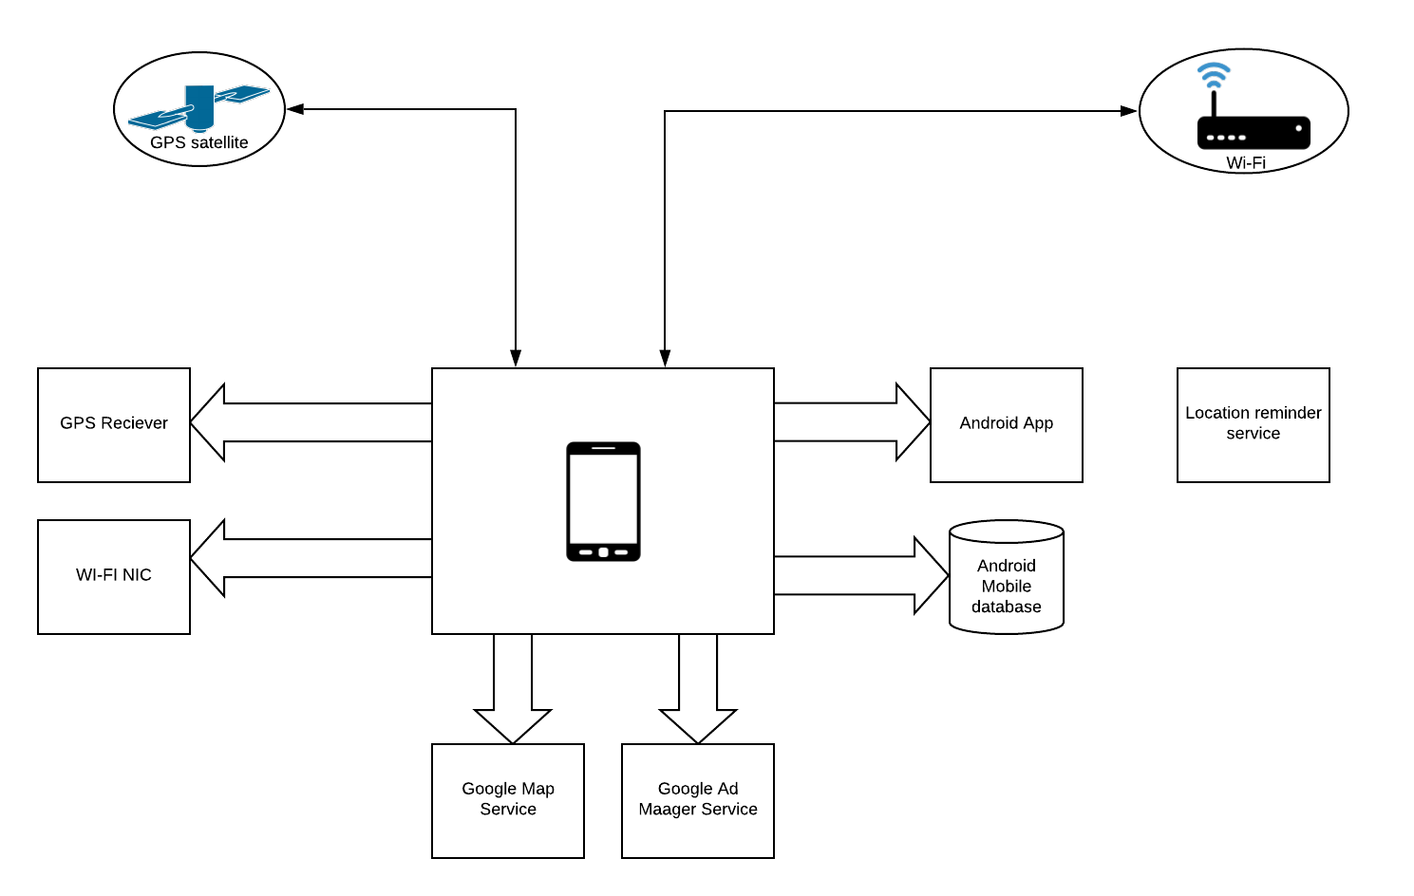
Fig: 1. Architecture of “Location Based Event notifier”

  - Dataflow Design:
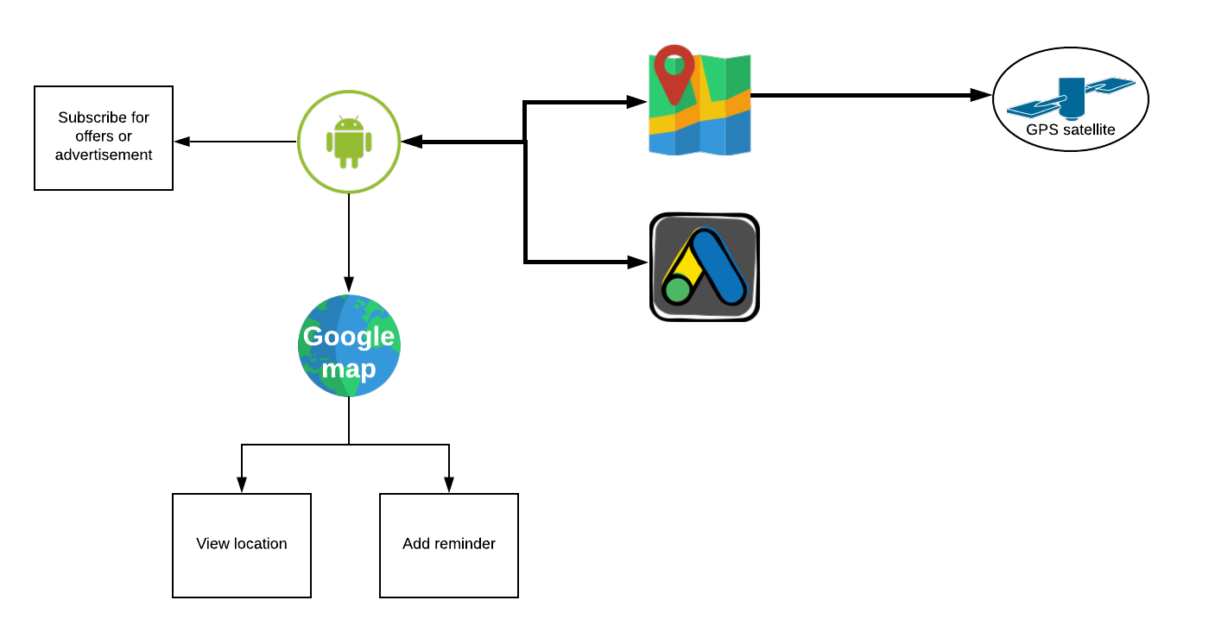
Fig: 2. Dataflow of “Location Based Event notifier”
  - Decomposition Description:
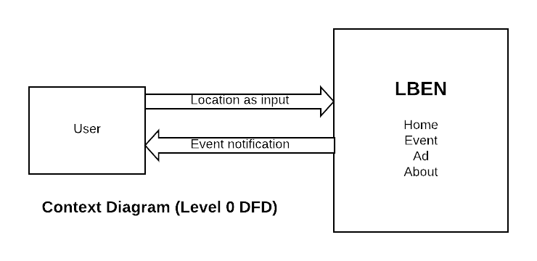
Fig: 3. Context diagram Level 0 DFD
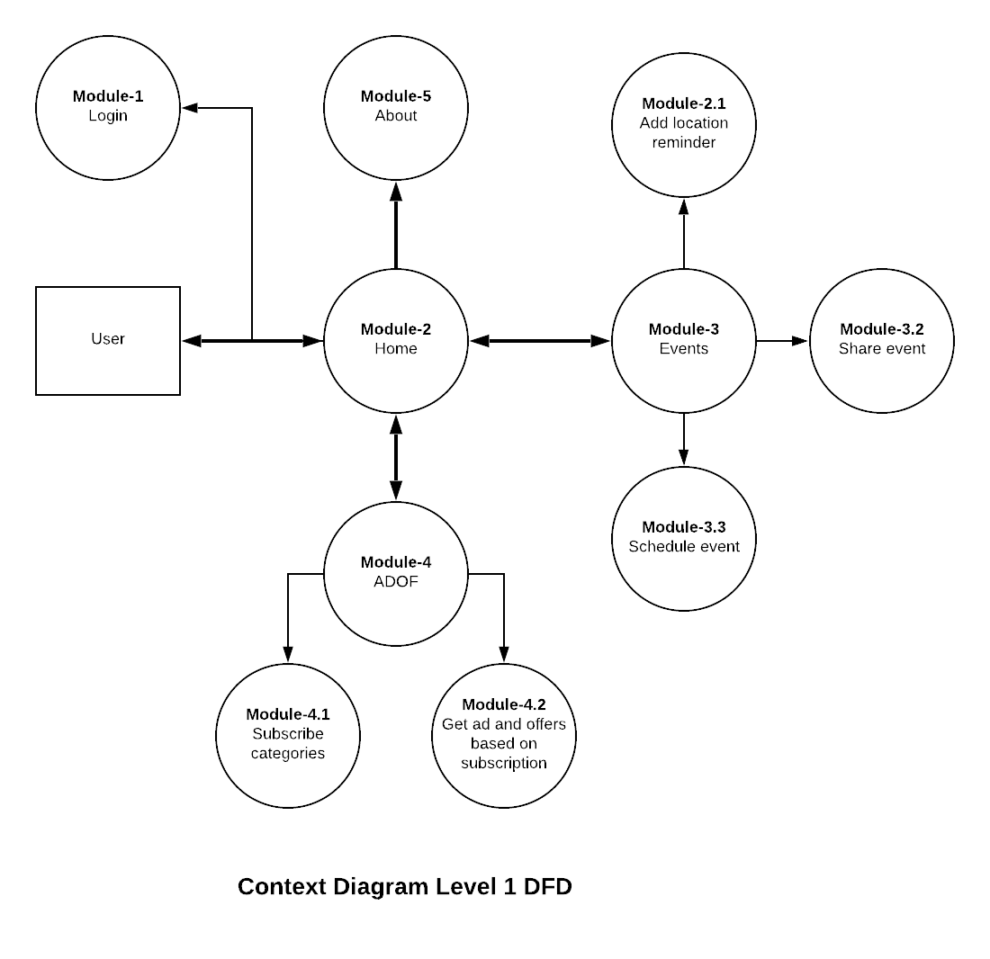
Fig: 4. Context diagram Level 1 DFD
- DETAILED SYSTEM DESIGN
Module-1: Login
The module to handle login and authorize users.
Module-2: Home
This module is the landing page of the app. From where user will navigate.
Module-3: Events
The module where the user will add, plan and share events according to location.
Module-3.1: Add location reminder
This module helps in adding reminder when user is back at this location.
Module-3.2: Share event
This module helps in sharing the event when user plans for it.
Module-3.3: Schedule event
This module helps in schedule the event when user plans for it.
Module-4: ADOF
This module helps the user to view the advertisement and offers with users consent.
Module-4.1: Subscribe categories
This module helps the user to subscribe various categories of offers and advertisement.
Module-4.1: Get offers and Ad
This module helps the user to view offers and advertisement which user have subscribed to.
Module-5: About
This module provides information about the mobile application details.

- GRAPHICAL USER INTERFACE DESIGN
  - Login:
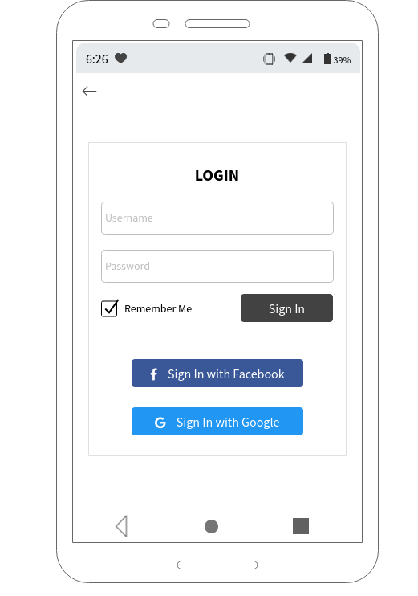
Fig: 5. Login screen of “Location based event notifier”

  - Home screen:

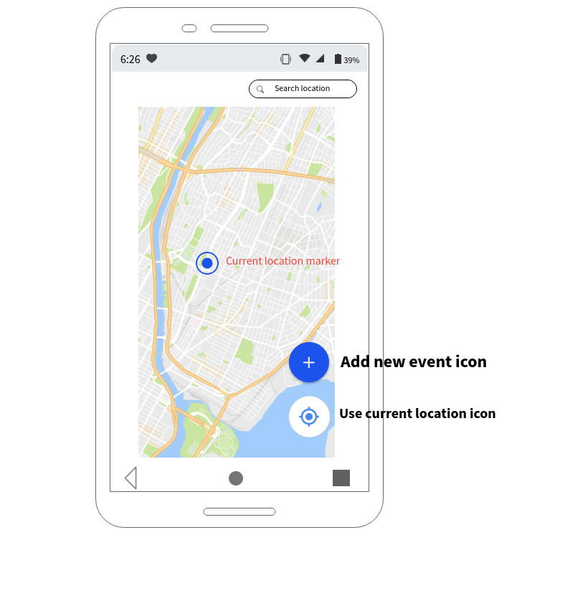
Fig: 6. Home screen of “Location based event notifier”

  - Add event:
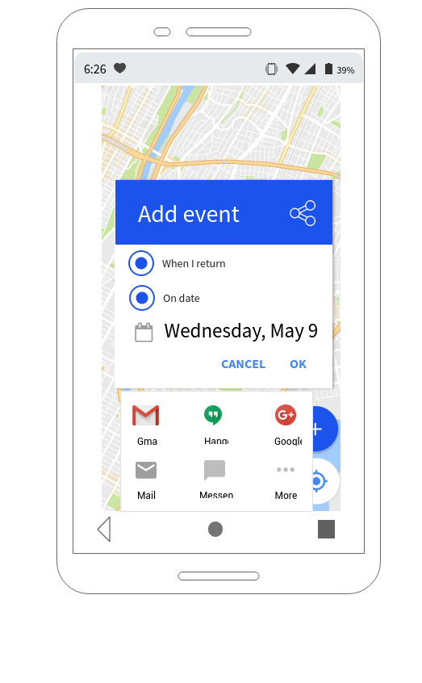
Fig: 7. Add event screen of “Location based event notifier”

  - ADOF:
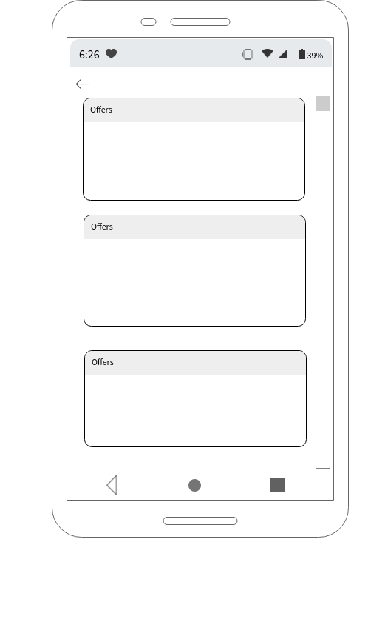
Fig: 8. ADOF screen of “Location based event notifier”

  - Sample AndroidManifest.xml
<?xml version="1.0" encoding="utf-8"?>
<manifest
xmlns:android="http://schemas.android.com/apk/res/android"
android:versionCode="1"
android:versionName="1.0"
package="com.robick.lben.raeven">
<uses-sdk android:minSdkVersion="15" android:targetSdkVersion="26" />
<uses-permission android:name="android.permission.ACCESS_FINE_LOCATION"/>
<uses-permission android:name="android.permission.INTERNET"/>
<uses-permission android:name="android.permission.ACCESS_NETWORK_STATE"/>
<application
android:allowBackup="true"
android:icon="@mipmap/ic_launcher"
android:roundIcon="@mipmap/ic_launcher_round"
android:label="@string/app_name"
android:supportsRtl="true"
android:theme="@style/AppTheme">
<activity android:name=".MainActivity">
<intent-filter>
<action android:name="android.intent.action.MAIN" />
<category android:name="android.intent.category.LAUNCHER" />
</intent-filter>
</activity>
<activity
android:name=".DisplayMessageActivity"
android:parentActivityName=".MainActivity" />
</application>
</manifest>

- REFERENCES
[1] Mohammad Salah Uddin, S. M. Allayear, N. C. Das, and F. A. Talukder “A Location Based Time and Attendance System”.

[2] T. Sohn, et al., "Place-Its: A Study of Location- Based Reminders," in UbiComp, 2005, p. 19.

[3] U. Government. (1999), Global Positioning System. [Online]. www.gps.gov.

[4] Reto Mier, “Professional Android Application Development”.

[5] Ruchika Gupta and BVR Reddy GPS and GPRS Based Cost Effective Human Tracking System Using Mobile Phones.

[6] Location Based Services by Valerie Bennett

[7] Amit Kushwaha, Vineet Kushwaha “Location Based Services using Android Mobile Operating System” International Journal of Advances in Engineering &
Technology, Mar 2011. ISSN: 2231-1963.

[8] Mark Dexter version 1.1 (2008),‟Eclipse and Java : Using the Debugger version Companion Tutorial Guide‟ Licensed under the Educational Community License.

[9] http://developers.android.com/index.html

