IEC 61850 Combined IED
Graphical User Interface — User Manual

Platform: Raspberry Pi | Display: Graphic LCD with Touchscreen (320×480 px)
Protocol: IEC 61850 | Communication: GOOSE & Unix Socket API
IED Types: Feed (×2) • Busbar (×2) • Transformer (×2)
Version: 1.0 | 2026

1. System Overview
This document describes the graphical user interface (UI) for a Raspberry Pi-based IEC 61850 Intelligent Electronic Device (IED) system. The UI service connects via Unix domain sockets to a set of IEC 61850 servers, each of which in turn interfaces with a dedicated hardware service for its physical I/O.

The system models a medium-voltage substation with two busbars and six IED instances, providing protection, measurement, and switching control for every circuit position.

1.1 Hardware Platform
Component | Detail
Processing unit | Raspberry Pi
Display | Graphic LCD with touchscreen, 320 × 480 pixels, portrait orientation
IED LCD area | 248 × 322 px sub-surface rendered inside the relay interface screen
Frame rate | 30 fps
Sockets | 6 × Unix domain sockets at /run/iec61850_ui/iec61850_relay_N.sock
Hardware sockets | 6 × /tmp/api_sockN (hardware service health monitoring)
Update interval | 300 ms (background thread per IED)

1.2 IED Configuration
Six IED instances are arranged in two groups of three. Each group covers one busbar (Busbar 1 and Busbar 2).

# | Name | Type | Protection | Primary equipment
1 | Feed 1 | Feed | PTOC | Circuit breaker, disconnector, 2 busbar selectors, CT, VT ×2
2 | Feed 2 | Feed | PTOC | Circuit breaker, disconnector, 2 busbar selectors, CT, VT ×2
3 | Busbar 1 | Bus | PDIF (GOOSE) | 4 × CT (one per connected feeder/TR), VT, GOOSE supervision
4 | Busbar 2 | Bus | PDIF (GOOSE) | 4 × CT (one per connected feeder/TR), VT, GOOSE supervision
5 | TR 1 | Transformer | PTOC | Circuit breaker, 2 busbar selectors, CT, power transformer, VT ×2
6 | TR 2 | Transformer | PTOC | Circuit breaker, 2 busbar selectors, CT, power transformer, VT ×2

1.3 Architecture
The UI service is a single Python/Pygame application that manages all six IEDs simultaneously. Each IED has a dedicated background thread that communicates with its corresponding IEC 61850 server. The main thread handles rendering and touch/input events at 30 fps.

UI Service (Raspberry Pi) | ⇄ | IEC 61850 Server (×6) | ⇄ | Hardware Service (×6) | ⇄ | Physical I/O (Switches, CTs, VTs)

Communication between UI Service and IEC 61850 Server uses newline-delimited JSON over Unix domain sockets. The UI polls every 300 ms with a get_values command and receives all element states in a single response.

2. Start Screen (IED Selection)
When the application starts, the Start Screen is displayed. It shows a 2-column × 3-row grid of six relay buttons, one per IED. Each button is colour-coded to indicate the connection status of that IED.

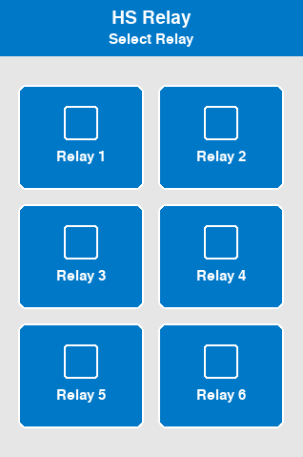
Figure 1 — Start Screen (Main Relay Selection)

2.1 Button Colour Coding
Colour | Meaning
Blue | Fully operational: UI Service connected to IEC 61850 server AND hardware service is active.
Yellow | Partial: Hardware service is running, but UI Service has lost its socket connection to the IEC 61850 server.
Red | Partial: UI Service is connected to the IEC 61850 server, but the hardware service socket is inactive (hardware may be disconnected).
Grey | Offline: No connection to either the IEC 61850 server or the hardware service. IED is not operational.

Status is refreshed once per second by checking both the socket connection state and the /proc/net/unix hardware socket count. Touching a grey button still opens the relay interface, but no live data will be shown until the connection is restored.

2.2 Selecting an IED
Tap any relay button to open the Relay Interface for that IED. The title bar of the Start Screen shows "HS Relay" and the subtitle "Select Relay". Touch the desired relay button to proceed.

To return to the Start Screen from any Relay Interface, tap the ← Back button at the top-left of the screen, or press the hardware Escape key if available.

3. Relay Interface
Tapping a relay button on the Start Screen opens its dedicated Relay Interface. This screen is divided into several zones:

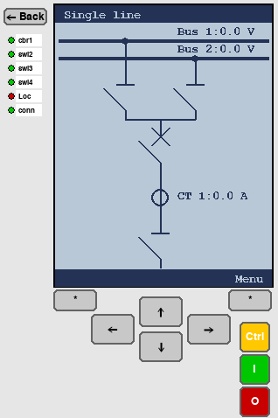
Figure 2 — Relay Interface (Feed IED shown)

3.1 Screen Layout
Zone | Description
← Back button (top-left) | Returns to the Start Screen. Equivalent to pressing the hardware Escape key while at the top-level diagram.
Status LED panel (left strip) | Vertical strip of coloured indicator LEDs showing live breaker/switch positions and connection state for the selected IED.
IED LCD area (centre) | 248×322 px area showing the active page: Single-line diagram, Measurements, Control, Phasor, Settings, or a popup.
Navigation pad (lower-centre) | ↑ ↓ ← → directional buttons for cursor movement within the active page.
* buttons (lower flanks) | Left * = Cancel/Back action. Right * = Enter/Confirm action. Equivalent to left/right soft-key on the page footer.
Ctrl / I / O buttons (right strip) | Ctrl: jump directly to the Control page. I (green): close/operate-in selected switch. O (red): open/operate-out selected switch.

3.2 Status LED Panel
The LED strip on the left side of the Relay Interface shows live status indicators. The indicators shown depend on the IED type:

3.2.1 Feed IEDs (IED 1 & 2)
LED label | Source element | Colour logic
cbr1 | cbr1 (circuit breaker) | Red = Closed (ON). Green = Open (OFF). Yellow = Intermediate/moving.
swi2 | swi2 (disconnector) | Red = Closed. Green = Open. Yellow = Intermediate.
swi3 | swi3 (bus selector 1) | Red = Closed (connected to Bus 1). Green = Open.
swi4 | swi4 (bus selector 2) | Red = Closed (connected to Bus 2). Green = Open.
Loc | loc (Local/Remote) | Green = Local control enabled. Red = Remote control only.
conn | connected (socket) | Green = Socket to IEC 61850 server is active. Red = Disconnected.

3.2.2 Bus IEDs (IED 3 & 4)
LED label | Source element | Meaning
Loc | loc | Green = Local. Red = Remote.
conn | connected | Green = IEC 61850 server reachable. Red = Disconnected.

3.2.3 Transformer IEDs (IED 5 & 6)
LED label | Source element | Colour logic
cbr1 | cbr1 (circuit breaker) | Red = Closed. Green = Open. Yellow = Intermediate.
swi2 | swi2 (bus selector 1) | Red = Closed (Bus 1 selected). Green = Open.
swi3 | swi3 (bus selector 2) | Red = Closed (Bus 2 selected). Green = Open.
Loc | loc | Green = Local. Red = Remote.
conn | connected | Green = IEC 61850 server reachable. Red = Disconnected.

3.3 IED LCD Header and Footer
Every page inside the IED LCD area has a consistent header and footer bar rendered in the foreground (FG) colour on a blue-grey background (BG).
- Header: Shows the full breadcrumb navigation path, e.g. Single line > Main menu > Measurements. If longer than 29 characters, it is truncated from the left.
- Footer: Shows the left soft-key label (e.g. Back or Cancel) and the right soft-key label (e.g. Select, Menu, next). These correspond to the * Cancel and * Enter buttons on-screen.

4. Single-Line Diagram Page
The Single-line diagram page is the default (home) page for every IED. It is displayed immediately upon entering a Relay Interface and shows a live schematic of the primary equipment connected to that IED.

  Figure 3a — Single-line diagram (Feed IED) | 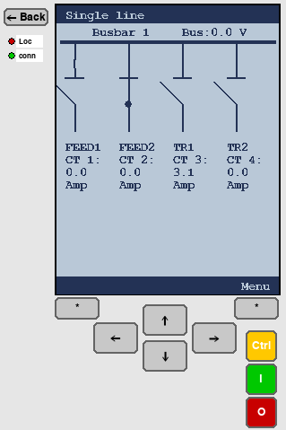  Figure 3b — Single-line diagram (Bus IED)

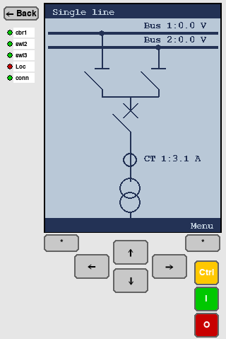
Figure 3c — Single-line diagram (Transformer IED)

4.1 Feed IED Single-Line Diagram
The Feed IED diagram shows, from top to bottom:
- Two busbars (Busbar 1 upper, Busbar 2 lower) with live voltage readings (Bus 1: x.x V, Bus 2: x.x V).
- Two busbar selector disconnectors (swi3 → Busbar 1, swi4 → Busbar 2). A filled circle indicates the live connection point.
- A tie bus connecting the two selector branches.
- The circuit breaker (cbr1), displayed open or closed.
- A current transformer symbol with the live CT reading (CT 1: x.x A).
- The feeder disconnector (swi2) at the bottom, connecting to the external cable.

The circuit breaker and disconnectors are drawn with IEC standard symbols:
- Open: blade shown at an angle away from the contact.
- Closed: filled circle at the contact, blade vertical.
- Intermediate (moving): dashed angled blade indicating transitional state.

4.2 Busbar IED Single-Line Diagram
The Bus IED diagram shows the busbar it protects, with four vertical feeder branches hanging below it (one per connected circuit). Each branch shows:
- A stub line from the busbar downward.
- A disconnector symbol (read-only, non-selectable) showing the GOOSE-received connection state of the feeder’s busbar selector (s_cilo1 through s_cilo4).
- Below each disconnector: a text block showing the feeder identity (FEED1, FEED2, TR1, TR2) and its live CT average reading.

The busbar voltage (Bus: x.x V) is shown at the top-right of the diagram. The Bus IED has no locally operable switches; all interlock states are received via GOOSE from the connected Feed and Transformer IEDs.

4.3 Transformer IED Single-Line Diagram
The Transformer IED diagram is structurally similar to the Feed IED diagram, with the following difference at the bottom: instead of a feeder disconnector, the diagram terminates in a power transformer symbol (two overlapping circles representing the primary and secondary windings). The transformer primary connects to the CT, then the circuit breaker, then the two busbar selectors.

All diagram symbols update live at 300 ms intervals. The footer shows “ Menu” on the right. Press the right * (Enter) button or tap “Menu” to open the Main Menu.

5. Main Menu
The Main Menu is reached by pressing the Enter (*) button while on the Single-line diagram page, or by pressing the right soft-key labelled “ Menu”. It provides access to all functional pages.

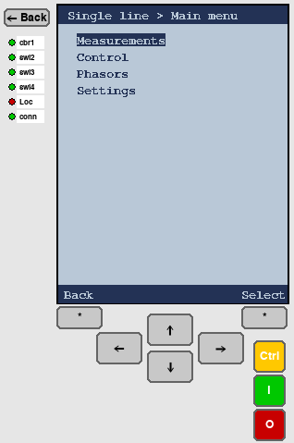
Figure 4 — Main Menu

Menu item | Description
Measurements | Tabular display of all live current and voltage measurements for the IED.
Control | Interactive single-line diagram for selecting and operating switches.
Phasors | Phasor diagram showing amplitude and phase angle of measured quantities.
Settings | Read and write protection and control settings for the IED.

Navigation within the menu:
- Press ↑ / ↓ to move the selection highlight up or down.
- Press Enter (*) or the right soft-key to open the highlighted item.
- Press Cancel (*) or the left soft-key (Back) to return to the Single-line diagram.

6. Measurements Page
The Measurements page shows all live electrical measurements for the selected IED in a scrollable table format. Measurements are polled every 300 ms from the IEC 61850 server.

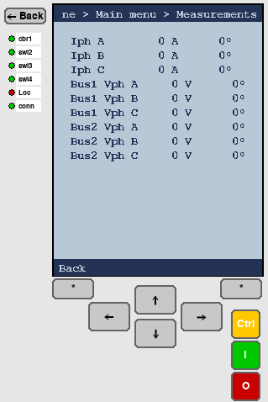
Figure 5 — Measurements page (Feed IED shown)

6.1 Feed IED Measurements
Label | Source | Format
Iph A | m_ctr1_phsA / phsAngA | Iph A xxx.x A xxx.x°
Iph B | m_ctr1_phsB / phsAngB | Iph B xxx.x A xxx.x°
Iph C | m_ctr1_phsC / phsAngC | Iph C xxx.x A xxx.x°
Bus1 Vph A | m_v1_pA / m_v1_aA | Bus1 Vph A xxx.x V xxx.x°
Bus1 Vph B | m_v1_pB / m_v1_aB | Bus1 Vph B xxx.x V xxx.x°
Bus1 Vph C | m_v1_pC / m_v1_aC | Bus1 Vph C xxx.x V xxx.x°
Bus2 Vph A | m_v2_pA / m_v2_aA | Bus2 Vph A xxx.x V xxx.x°
Bus2 Vph B | m_v2_pB / m_v2_aB | Bus2 Vph B xxx.x V xxx.x°
Bus2 Vph C | m_v2_pC / m_v2_aC | Bus2 Vph C xxx.x V xxx.x°

6.2 Busbar IED Measurements
The Bus IED shows measurements from all four connected CTs (one per feeder: FEED1, FEED2, TR1, TR2) plus the busbar VT:
Labels | Source | Note
Iph 1A/B/C | m_ctr1_phsA/B/C + angle | CT on Feed 1 branch
Iph 2A/B/C | m_ctr2_phsA/B/C + angle | CT on Feed 2 branch
Iph 3A/B/C | m_ctr3_phsA/B/C + angle | CT on TR 1 branch
Iph 4A/B/C | m_ctr4_phsA/B/C + angle | CT on TR 2 branch
Bus Vph A/B/C | m_v1_pA/B/C + m_v1_aA/B/C | Busbar VT (single busbar)

6.3 Transformer IED Measurements
The Transformer IED measurement set is identical to the Feed IED: three phase currents from the CT on the transformer HV side, plus three-phase voltages from both busbar VTs (Bus1 and Bus2).

All magnitudes are displayed with one decimal place. Phase angles are displayed in degrees with one decimal place. The page does not scroll; all rows are visible simultaneously.

7. Control Page
The Control page allows the operator to select and operate individual switches within the IED. It displays the same single-line diagram as the diagram page, but with a movable cursor that highlights each selectable switch in sequence.

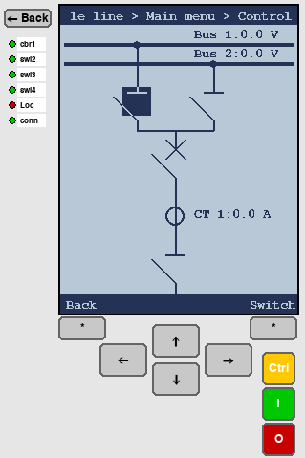
Figure 6 — Control page with cursor on circuit breaker

7.1 Selectable Elements
Only switches and circuit breakers marked as selectable in the configuration can be operated. Read-only elements (such as the GOOSE-derived disconnectors on the Bus IED) are displayed but cannot be selected.

7.1.1 Feed IED selectable elements
- swi3 — Busbar 1 selector disconnector
- swi4 — Busbar 2 selector disconnector
- cbr1 — Circuit breaker
- swi2 — Feeder disconnector

7.1.2 Bus IED selectable elements
None. All four disconnectors (s_cilo1 through s_cilo4) are read-only GOOSE status indicators.

7.1.3 Transformer IED selectable elements
- swi2 — Busbar 1 selector disconnector
- swi3 — Busbar 2 selector disconnector
- cbr1 — Circuit breaker

7.2 Operating a Switch
- Enter the Control page from the Main Menu, or press the Ctrl button on the right of the Relay Interface screen.
- Use ↑ / ↓ to move the cursor through the selectable elements. The currently selected element is highlighted on the diagram.
- To open the highlighted element: press the red O button, or press the keyboard key ‘o’. A confirmation popup appears.
- To close the highlighted element: press the green I button, or press the keyboard key ‘i’. A confirmation popup appears.
- In the confirmation popup: press Enter (*) / OK to confirm, or Cancel (*) / CANCEL to abort.

Pressing Enter directly on the Control page (without O/I) shows a reminder popup: “Press the red (O) button to open or green (I) button to close the selected switch.”

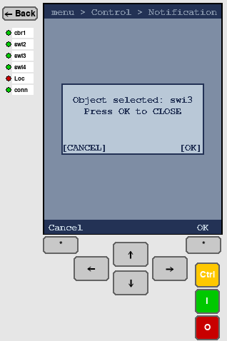
Figure 7 — Control page with switch selected for operation

7.3 Interlocking
Before executing an open or close command, the software checks the relevant interlock status flags from the IEC 61850 server:
- BlkOpn (block open) — if true, the OPEN command is rejected.
- BlkCls (block close) — if true, the CLOSE command is rejected.

Interlock elements per switch:
Switch | BlkOpn element | BlkCls element
swi2 | s_swi2_blkopn | s_swi2_blkcls
swi3 | s_swi3_blkopn | s_swi3_blkcls
swi4 | s_swi4_blkopn | s_swi4_blkcls
cbr1 | (none) | (none)

If an interlock condition is active, an error popup is shown: “[element name] blocked by interlocking”. The operation is cancelled. Do not attempt to bypass interlocking.

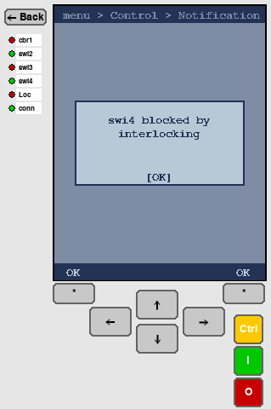
Figure 8 — Control page with interlock error message

7.4 Control from the Diagram Page
Pressing the I or O buttons while the Single-line diagram page (not the Control page) is active displays an informational popup:
"Open the control menu to select elements to operate" — This is a reminder that switch control requires switching to the Control page first. Tap OK to dismiss.

8. Phasor Diagram Page
The Phasor page renders a polar vector diagram of the measured electrical quantities. Phasors are displayed on a circular reference grid. Three phasors are shown per page, cycling through all available measurements.

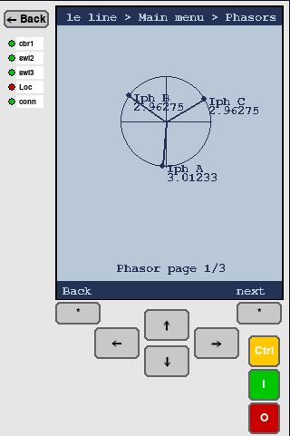
Figure 9 — Phasor diagram (phase currents Iph A, B, C)

8.1 Phasor Display
A reference circle is drawn in the foreground colour. Horizontal and vertical centre lines are overlaid as axes. Each phasor vector is drawn from the centre of the circle as an arrow to a point on or inside the circle.

Phasors are normalised: the largest magnitude in the current page’s set is mapped to the full circle radius. Other phasors are scaled proportionally. This means that the display shows relative phase relationships correctly even if absolute magnitudes differ.

Each vector is labelled with the channel name (e.g. Iph A) and its absolute magnitude (e.g. 120.5). The label is placed near the arrowhead.

8.2 Paging Through Measurements
The total number of pages depends on the IED type:
- Feed IED: 9 measurements ÷ 3 per page = 3 pages.
- Bus IED: 15 measurements ÷ 3 per page = 5 pages.
- Transformer IED: 9 measurements ÷ 3 per page = 3 pages.

Press Enter (*) or the right soft-key (labelled “next”) to advance to the next page. The footer shows the current page number, e.g. “Phasor page 2/3”. Advancing past the last page wraps back to page 1.

Press Cancel (*) or the left soft-key to return to the Main Menu.

8.3 Measurement-to-Page Mapping (Feed / Transformer IED)
Page | Phasors shown
1 | Iph A, Iph B, Iph C (phase currents from CT1)
2 | Bus1 Vph A, Bus1 Vph B, Bus1 Vph C (Busbar 1 phase voltages)
3 | Bus2 Vph A, Bus2 Vph B, Bus2 Vph C (Busbar 2 phase voltages)

9. Settings Page
The Settings page allows the operator to read and write protection and control parameters for the selected IED. Settings are read from the IEC 61850 server when the page is first opened, and written back to the server immediately upon confirmation.

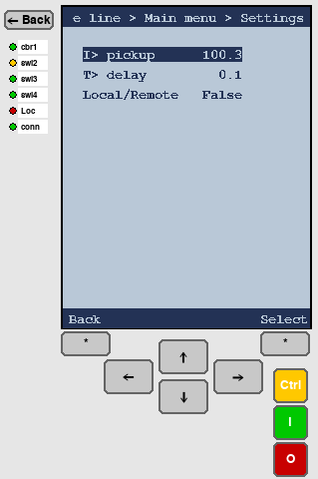
Figure 10 — Settings page (Feed IED)

9.1 Available Settings by IED Type

9.1.1 Feed IEDs (IED 1 & 2)
Setting name | IEC element | Description
I> pickup | s_Ilarge | Overcurrent (PTOC) pickup threshold in Amperes (float).
T> delay | s_Tm | Time multiplier setting for the PTOC function (float, typically 0.10–1.00).
Local/Remote | loc | Control authority: True = Local control from panel. False = Remote via IEC 61850.

9.1.2 Bus IEDs (IED 3 & 4)
Setting name | IEC element | Description
Lo setting | s_LoSet | Low differential current threshold for PDIF low-set operate (float).
Hi setting | s_HiSet | High differential current threshold for PDIF high-set operate (float).
Min. delay | s_MinOpTmms | Minimum operate time in milliseconds for the PDIF function (integer).
Local/Remote | loc | Control authority toggle.

9.1.3 Transformer IEDs (IED 5 & 6)
The Transformer IED uses the same settings as the Feed IED: I> pickup (s_Ilarge), T> delay (s_Tm), and Local/Remote (loc).

9.2 Editing a Setting
- Navigate to the desired setting using ↑ / ↓. The selected row is shown inverted (dark background, light text).
- Press Enter (*) to enter edit mode. A cursor underline appears under the current digit or character.
- For numeric settings (float / int):
  - Press ← / → to move the cursor left/right through the digits.
  - Press ↑ / ↓ to increment or decrement the digit under the cursor (wraps 0–9).
  - The decimal point cannot be changed; only digit positions are editable.
- For boolean settings (Local/Remote):
  - Press ↑ or ↓ to toggle between True and False.
- Press Enter (*) to confirm and write the new value to the IEC 61850 server.
- Press Cancel (*) to discard changes and exit edit mode without writing.

Settings are written to the IEC 61850 server immediately on confirmation. Verify the value before pressing Enter. Incorrect protection settings may cause protection misoperation.

The Local/Remote setting is written via a dedicated write_loc command rather than the generic write_setting command, allowing the server to handle it as a control authority change.

10. Popup Notifications
Popup notifications appear as modal overlays on top of the current page. They block all navigation until dismissed. Three popup types are used:

Type | Buttons shown | When it appears
info | [ OK ] | Informational message (e.g. reminder to use Control page for switch operations).
confirm | [CANCEL] and [OK] | Before any switch open or close operation is sent to the server.
error | [ OK ] | When an interlock blocks the requested operation.

Dismissing popups:
- Press Cancel (*) or the left soft-key to dismiss an info or error popup, or to cancel a confirm popup.
- Press Enter (*) or the right soft-key to confirm a confirm popup (proceeds with the operation).

11. Protection Functions
Protection functions run inside the IEC 61850 server processes, not in the UI service. The UI provides visibility into protection settings and status but does not execute protection logic itself.

11.1 PTOC — Time-Overcurrent (Feed & Transformer IEDs)
Each Feed and Transformer IED implements a PTOC (Definite Time Overcurrent) protection function. The function monitors the CT current and trips the circuit breaker via the hardware service if a threshold is exceeded for a defined time.

Parameter | Description
I> pickup (s_Ilarge) | Phase current threshold. If any phase current exceeds this value, the operate timer starts.
T> delay (s_Tm) | Operate delay (time multiplier). The breaker trips after the current has continuously exceeded the pickup for this duration.
Trip output | Open command sent to cbr1 (circuit breaker) via the hardware service.

11.2 PDIF — Differential Protection (Busbar IEDs)
Each Bus IED implements a PDIF (Differential Current) protection function using GOOSE messaging. The bus protection operates as follows:
- The Bus IED subscribes to GOOSE publications from all connected Feed and Transformer IEDs. It receives the busbar selector switch states to determine which circuits are connected to its busbar.
- The Bus IED compares the sum of currents flowing into the busbar (from the connected feeders) against its differential thresholds (Lo setting, Hi setting).
- If the differential current exceeds the operate threshold for longer than the minimum operate time, the Bus IED publishes a GOOSE trip signal.
- Each connected Feed and Transformer IED subscribes to the bus GOOSE trip and opens its circuit breaker upon receipt.

Parameter | Description
Lo setting (s_LoSet) | Low differential current threshold. Sensitive setting, may require longer Min. delay to avoid transient trips.
Hi setting (s_HiSet) | High differential current threshold. High-set trips faster, providing faster fault clearance for internal faults.
Min. delay (s_MinOpTmms) | Minimum operate time in ms. Prevents trip on current measurement transients during switching operations.
Trip output | GOOSE trip publication to all connected circuits. Each circuit opens its own cbr1 independently.

The c_iloN status elements (s_cilo1 through s_cilo4) received via GOOSE are shown as read-only disconnectors in the Bus IED single-line diagram. They indicate which feeders the bus protection currently considers as connected.

12. IEC 61850 Communication Interface
The UI service communicates with each IEC 61850 server via a private JSON-over-Unix-socket protocol. This section documents the API for integration and troubleshooting purposes.

12.1 Socket Paths
IED # | UI → Server socket | Hardware health socket
1 | /run/iec61850_ui/iec61850_relay_1.sock | /tmp/api_sock1
2 | /run/iec61850_ui/iec61850_relay_2.sock | /tmp/api_sock2
3 | /run/iec61850_ui/iec61850_relay_3.sock | /tmp/api_sock3
4 | /run/iec61850_ui/iec61850_relay_4.sock | /tmp/api_sock4
5 | /run/iec61850_ui/iec61850_relay_5.sock | /tmp/api_sock5
6 | /run/iec61850_ui/iec61850_relay_6.sock | /tmp/api_sock6

The hardware health sockets (/tmp/api_sockN) are not used for data exchange. Their presence in /proc/net/unix is checked: more than one listener entry indicates the hardware service is running.

12.2 Commands Sent by the UI Service
Command | Parameters | Description
get_values | measurements: "True"/"False" diagram: "True"/"False" | Poll all element states. Flags control whether measurement data and diagram element data are included in the response.
open_switch | switch: element name (e.g. "cbr1") | Send an OPEN command to the named switch or circuit breaker.
close_switch | switch: element name | Send a CLOSE command to the named switch or circuit breaker.
write_loc | value: "True" or "False" | Set Local (True) or Remote (False) control authority.
write_setting | element: setting name value: new value as string | Write a protection setting value (I> pickup, T> delay, Lo/Hi/MinOp time).

12.3 Response Format
Responses are newline-delimited JSON objects. A typical get_values response includes all element keys defined in the IED’s ELEMENTS configuration. Key examples:
JSON key | Type | Content
cbr1 | int (DBPOS) | 0 = intermediate, 1 = closed (ON), 2 = open (OFF), 3 = error
swi2/3/4 | int (DBPOS) | Same DBPOS encoding as cbr1.
s_swi2_blkopn | bool | True = OPEN command is blocked by interlocking.
m_ctr1_phsA | float | Phase A current magnitude in Amperes.
m_ctr1_phsAngA | float | Phase A current angle in degrees.
m_v1_aA | float | Busbar 1 phase A voltage amplitude in Volts.
m_v1_pA | float | Busbar 1 phase A voltage angle in degrees.
s_Ilarge | float | Current I> pickup setting value.
loc | bool | True = Local. False = Remote.

13. Step-by-Step Operating Procedures

13.1 Start-up
- Power on the Raspberry Pi. The UI service starts automatically.
- The Start Screen appears showing six relay buttons.
- Check button colours: blue indicates the IED and its hardware service are both reachable. Yellow or red indicates partial connectivity. Grey indicates no connectivity.
- If any IED shows yellow or grey, verify that the IEC 61850 server process and hardware service are running on the host.

13.2 Monitoring an IED
- Tap the relay button for the IED to monitor.
- The Single-line diagram page is shown by default. Observe switch positions and measurement values.
- Tap Enter (*) to open the Main Menu.
- Select Measurements to view all phase currents and voltages in tabular form.
- Select Phasors to view phase relationships visually. Press Enter to cycle through pages.
- Press Cancel (*) or Back to return to the diagram at any time.

13.3 Operating a Switch (Local Mode)
- Confirm the IED is in Local mode: the Loc LED should be green, or check Settings > Local/Remote = True.
- Tap the Ctrl button (right strip) or navigate Main Menu > Control.
- Use ↑ / ↓ to move the cursor to the desired switch.
- Press I (green, close) or O (red, open). A confirmation popup appears.
- Verify the operation shown in the popup, then press Enter (*) to confirm. The command is sent via the Unix socket to the IEC 61850 server.
- Observe the single-line diagram and LED indicators for the new switch position. The display updates within 300 ms.

13.4 Changing a Protection Setting
- Navigate Main Menu > Settings.
- Use ↑ / ↓ to select the setting to change (e.g. I> pickup).
- Press Enter (*) to enter edit mode.
- Use ← / → to position the cursor on the digit to change.
- Use ↑ / ↓ to increment or decrement the digit.
- Press Enter (*) to write the new value to the server. The setting is applied immediately.
Verify the new value carefully before confirming. An incorrect I> pickup or T> delay setting may prevent the protection from operating, or may cause unnecessary trips.

13.5 Switching to Remote Mode
- Navigate Main Menu > Settings.
- Select Local/Remote.
- Press Enter (*) to enter edit mode.
- Press ↑ or ↓ to toggle to False (Remote).
- Press Enter (*) to confirm. The loc element is written via the write_loc command.
- The Loc LED turns red, indicating Remote control is now active.
In Remote mode, switch control commands from the local Control page are still shown in the UI, but the IEC 61850 server may reject them depending on its Local/Remote enforcement logic. Settings can still be read and edited from the panel regardless of control mode.

14. Troubleshooting

Symptom | Likely cause & remedy
IED button shows grey | Both IEC 61850 server and hardware service are unreachable. Check that iec61850_relay_N.sock exists in /run/iec61850_ui/ and that the server process is running.
IED button shows yellow | Hardware service is up (/tmp/api_sockN present) but the IEC 61850 server socket is missing or the UI failed to connect. Restart the IEC 61850 server; the UI reconnects automatically every 2 seconds.
IED button shows red | UI is connected to the IEC 61850 server but the hardware service socket is not found. Check that the hardware service is started.
Measurements show 0 or stale values | The IED connection may have dropped mid-session. Check the conn LED (green = connected). The background thread retries every 2 seconds automatically.
Switch shows intermediate (yellow) for a long time | The switch/breaker mechanism has not completed its travel. Check the physical hardware. If the hardware is stuck, the IEC 61850 server should report DBPOS_INTERMEDIATE (0) until travel is complete.
"blocked by interlocking" popup | The relevant BlkOpn or BlkCls flag is true. Do not bypass interlocking. Resolve the interlocking condition (e.g. open or close the required upstream switch) before retrying.
Settings page shows 0.0 for all values | Settings could not be read from the IEC 61850 server (response contained no setting values). Check server connectivity and that the server supports the relevant setting elements.
Touch input not responding | The Pygame display may have lost focus. Tap the display surface. If the touchscreen driver is not loaded, ensure the relevant device tree overlay is enabled in /boot/config.txt.

15. Technical Specifications

Parameter | Value
Display resolution | 320 × 480 pixels (portrait)
IED LCD sub-surface | 248 × 322 pixels
Frame rate | 30 fps
Data update interval | 300 ms (background thread)
Connection retry interval | 2 seconds
Status refresh (Start Screen) | 1 second
Number of IEDs | 6 (2 Feed, 2 Bus, 2 Transformer)
Socket type | AF_UNIX SOCK_STREAM (newline-delimited JSON)
Socket buffer | 4096 bytes per recv() call
Socket timeout | 2.0 seconds
DBPOS encoding | 0=Intermediate, 1=Closed/ON, 2=Open/OFF, 3=Bad/Error
Phasors per page | 3
UI colour scheme | BG (185,200,215) slate-blue / FG (35,50,85) dark navy
Protection: Feed/TR | PTOC (Time-Overcurrent) — settings: I> pickup, T> delay
Protection: Bus | PDIF (Differential) via GOOSE — settings: Lo set, Hi set, Min. delay

