Report for use case of bank application and Class Diagram on Online Shopping

Subject : **System Analysis and Design**

Subject Code : **CSE325**

Presented for

**Supta Richard Philip**

Senior Lecturer  
Department of CSE   
City University

|  |  |  |
| --- | --- | --- |
| Presented by |  |  |
| Name | : | Md.Robin |
| Roll | **:** | 171442640 |
| Dept | **:** | BSc in CSE |
| Batch | **:** | 44th |

Date: 27-05-2019

What is bank application?

**Mobile banking** is a service provided by a [bank](https://en.wikipedia.org/wiki/Bank) or other [financial institution](https://en.wikipedia.org/wiki/Financial_institution) that allows its customers to conduct [financial transactions](https://en.wikipedia.org/wiki/Financial_transaction) remotely using a [mobile device](https://en.wikipedia.org/wiki/Mobile_device) such as a [smartphone](https://en.wikipedia.org/wiki/Smartphone) or [tablet](https://en.wikipedia.org/wiki/Tablet_computer). Unlike the related [internet banking](https://en.wikipedia.org/wiki/Internet_banking) it uses software, usually called an [app](https://en.wikipedia.org/wiki/Mobile_app), provided by the financial institution for the purpose. Mobile banking is usually available on a 24-hour basis. Some financial institutions have restrictions on which accounts may be accessed through mobile banking, as well as a limit on the amount that can be transacted. Mobile banking is dependent on the availability of an internet or data connection to the mobile device.

Transactions through mobile banking depend on the features of the mobile banking app provided and typically includes obtaining account balances and lists of latest transactions, [electronic bill payments](https://en.wikipedia.org/wiki/Electronic_bill_payment), remote check deposits, [P2P payments](https://en.wikipedia.org/wiki/Peer-to-peer_banking), and [funds transfers](https://en.wikipedia.org/wiki/Giro) between a customer's or another's [accounts](https://en.wikipedia.org/wiki/Deposit_account). Some apps also enable copies of statements to be downloaded and sometimes printed at the customer's premises.

From the bank's point of view, mobile banking reduces the cost of handling transactions by reducing the need for customers to visit a [bank branch](https://en.wikipedia.org/wiki/Branch_(banking)) for non-cash withdrawal and deposit transactions. Mobile banking does not handle transactions involving cash, and a customer needs to visit an [ATM](https://en.wikipedia.org/wiki/Automated_teller_machine) or bank branch for cash withdrawals or deposits. Many apps now have a [remote deposit](https://en.wikipedia.org/wiki/Remote_deposit) option; using the device's [camera](https://en.wikipedia.org/wiki/Camera_phone) to digitally transmit cheques to their financial institution.

**Functional requirement of bank apps**

* Open account
* Login
* Withdraw cash
* Diposit cash
* Clear checks
* Loan application
* Statement
* Check balance

**Use case Diagram of bank apps**

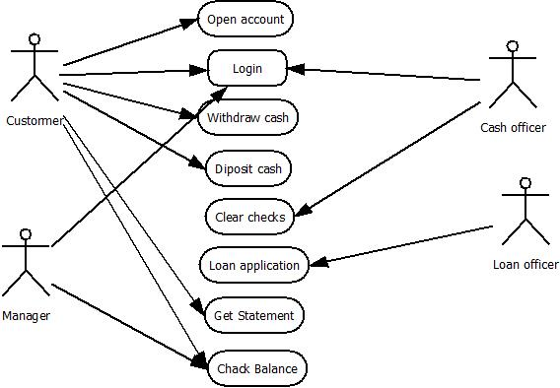

**What is online shopping?**

**Online shopping** is the activity or action of buying products or services over the Internet. It means going online, landing on a seller’s website, selecting something, and arranging for its delivery. The buyer either pays for the good or service online with a credit or debit card or upon delivery.

The term does not only include buying things online but also searching for them online. In other words, I may have been engaged in online shopping but did not buy anything.

Online shopping has been around for about twenty-five years. It has grown in popularity significantly.

Today, we can purchase nearly anything online. In fact, retail experts say that online shopping will soon overtake traditional shopping in monetary terms.

**Attributes of online shopping**

* Customer
* Order
* Order Details
* Shopping Cart
* User
* Products
* Payment

**Class Diagram for online shopping**

