JAPAN-INDONESIA
JOINT CALL FOR PROPOSALS on “Bioenergy”
Joint Application Form
(To be jointly submitted by Japan and Indonesia applicants to JST and BRIN respectively)

Part I. General Information

1. Title of Research Project
Proton-Selective Fluorine-Free Composite Membranes for Microbial Electrolysis Cells: Converting Organic Waste into High-Purity Biohydrogen

2. Subtopics
☒ Bioenergy production using biology-based methods
☒ Bioenergy production using hybrid and advanced methods

3. Project Principal Investigators
Japan-based Principal Investigator
Last Name | [To be completed by the Japan-based partner] | First Name | [To be completed by the Japan-based partner]
Date of Birth | [To be completed by the Japan-based partner]
Organization/Department/ Position | [To be completed by the Japan-based partner]
Address | [To be completed by the Japan-based partner]
Tel | [To be completed by the Japan-based partner]
E-mail | [To be completed by the Japan-based partner]

Indonesia-based Principal Investigator
Note: the Indonesia-based PI uses a single (mononymic) name; please confirm with BRIN how this should be entered in the First/Last Name fields.
First Name | Nasruddin | Last Name | Nasruddin
Date of Birth | [date of birth]
Organization/Department/ Title | Universitas Indonesia / Department of Mechanical Engineering, Faculty of Engineering / Professor
Address | Kampus UI Depok, Depok 16424, West Java, Indonesia
Tel | [telephone]
E-mail | [e-mail]

Part II. Abstract
1. Objectives
This project develops a fluorine-free, proton-selective composite membrane that makes microbial electrolysis cells (MECs) a practical route for converting organic waste into high-purity biohydrogen. Three objectives are pursued jointly. First, to fabricate and optimise a sulfonated poly(arylene ether sulfone)/polyimide nanofibre (SPAES/PIN) composite membrane in which the degree of sulfonation, composite ratio and thickness are controlled, and to map how these variables govern membrane properties. Second, to establish the quantitative relationship between microphase-separated morphology and proton selectivity - the ability to pass protons while rejecting the Na⁺, Mg²⁺ and Ca²⁺ that coexist in MEC anolyte at up to 10⁵ times the proton concentration. Third, to verify performance in MECs fed with real Indonesian wastewater, benchmarked against Nafion-211.
2. Methodology
SPAES is synthesised by polymerisation followed by post-sulfonation at predetermined hydrophilic sites; polyimide nanofibres (≈200 nm) are produced by electrospinning and embedded within the SPAES layer, so that the polymer carries protons while the nanofibre web carries mechanical load. Membranes are characterised by SEM/EDX, AFM (microphase separation), tensile testing in the hydrated state, water uptake, swelling ratio and ion exchange capacity by titration. Proton transport number is measured in a two-chamber cell with Ag/AgCl electrodes, and conductivity by electrochemical impedance spectroscopy. Selectivity is quantified in a three-chamber cell that tracks the diffusion of Na⁺, Mg²⁺ and Ca²⁺ by ion chromatography, together with gas (H₂, CH₄, CO₂) and substrate crossover. Finally, membranes are operated in two-chamber MECs (180 mL) in fed-batch mode at an applied voltage of 0.5 V, monitoring hydrogen yield, gas purity and the pH gradient across the membrane. Volatile fatty acids (VFA) obtained from dark fermentation of organic waste serve as the anodic substrate.
3. Expected scientific results of the joint research
The project will deliver a validated design rule linking sulfonation degree and ionic-channel morphology to proton selectivity, which at present does not exist and forces membrane optimisation to proceed by trial and error. It will produce a fluorine-free membrane that combines high ion exchange capacity (≈2.3 meq/g) with tensile strength above 40 MPa, together with the first dataset on such membranes operating on real tropical agro-industrial wastewater rather than synthetic acetate. Long-term durability and biofouling behaviour, so far unreported for this membrane class in MECs, will be characterised, and a multiscale ion-transport model will be developed and validated against the experimental dataset.
4. Mode of cooperation including the exchange of people
The two teams are complementary rather than overlapping. The Japan side contributes ionomer design, advanced morphological analysis and durability methodology; the Indonesia side contributes membrane fabrication, access to tropical waste feedstocks, and MEC operation and validation. Cooperation runs through annual joint workshops alternating between the two countries, reciprocal laboratory visits, shared samples and cross-validated measurements, and jointly supervised graduate students. Young researchers are central: doctoral and master's students from both sides undertake research stays with the partner laboratory, and early-career researchers lead designated work packages and present at international conferences.
5. Expected economic and social impact of the joint research
Indonesia currently imports all of its proton exchange membranes, and Nafion cost is a significant barrier to deploying bioelectrochemical systems. A fluorine-free membrane based on hydrocarbon polymers can be produced from domestically accessible chemistry, reducing both cost and import dependence, and avoiding the environmental persistence associated with fluorinated materials. Coupling the technology to palm oil mill effluent, tofu and tapioca wastewater addresses a pollution burden while producing clean hydrogen, supporting Indonesia's Net Zero Emission 2060 target and the national hydrogen strategy. For Japan, the collaboration provides field validation of advanced membrane chemistry under tropical, real-feedstock conditions that cannot be reproduced domestically, and access to a growing regional market for bioenergy technology.
6. Graphical abstract
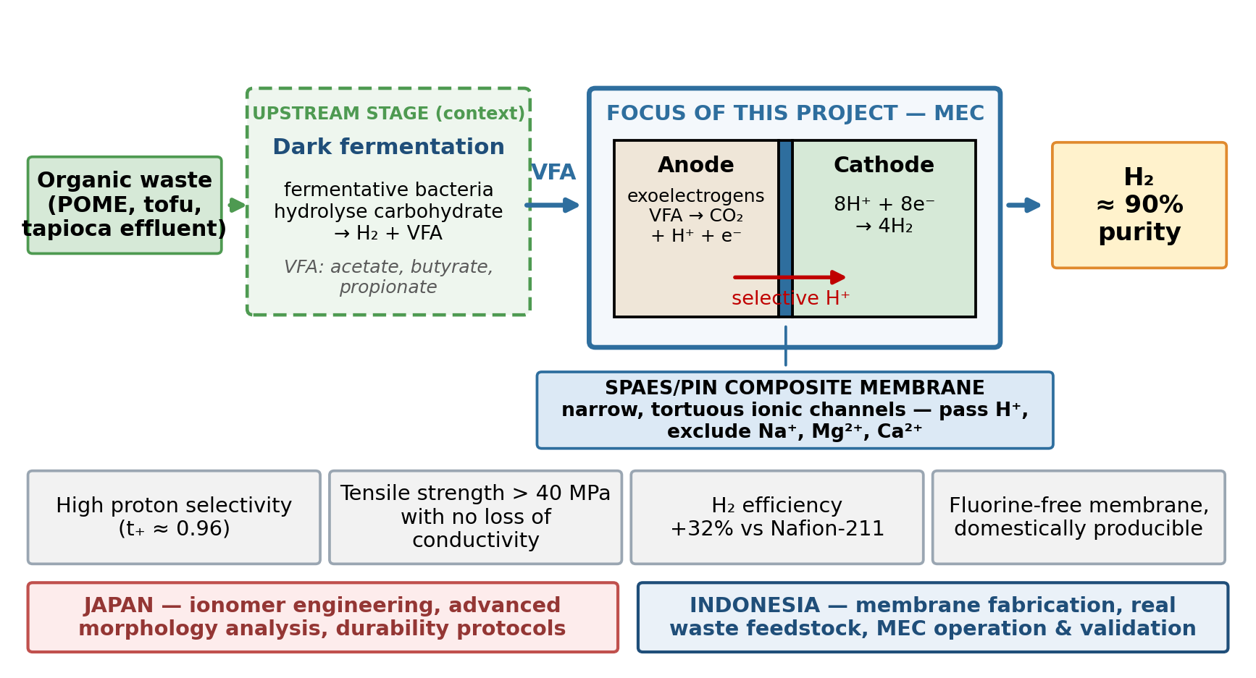
Figure 1. Concept of the proposed research. Dark fermentation of organic waste supplies VFA to the MEC anode; the SPAES/PIN composite membrane selectively transports protons to the cathode, where high-purity hydrogen is produced.

Part III. Research Topic and Work Plan

1. Detailed Description of the Joint Project

1) Problem statement:
Indonesia's transition to clean energy places hydrogen at the centre of its long-term strategy, but the way hydrogen is produced determines whether it is genuinely clean. Conventional water electrolysis requires a cell voltage of roughly 1.8-2.0 V and is therefore energy-intensive, while hydrogen from natural gas reforming still carries a substantial carbon burden. Microbial electrolysis cells offer a third route: exoelectrogenic bacteria at the anode oxidise organic matter into protons, electrons and CO₂, and hydrogen is formed at the cathode with an applied voltage of only about 0.2-0.8 V [2, 5]. Because the feedstock can be agro-industrial wastewater that Indonesia produces in very large volumes, MECs address waste treatment and energy production simultaneously.
It is worth noting where the substrate comes from. Dark fermentation is the established upstream process in this chain: fermentative bacteria hydrolyse carbohydrate-rich waste to produce biohydrogen directly, and in doing so leave an effluent rich in volatile fatty acids - chiefly acetate, butyrate and propionate. Dark fermentation for biohydrogen production has been investigated extensively, and the recurring conclusion is that only a fraction of the substrate energy is recovered as hydrogen, with most of the remainder retained in those VFAs. That leftover VFA stream is precisely what an MEC can convert, which is why the two processes are usually considered in series. This project takes the VFA-rich stream as its starting point and concentrates on the MEC stage, where the decisive bottleneck lies.
That bottleneck is the membrane. In an MEC the proton exchange membrane separates anode from cathode, transports protons, and prevents anodic gases (CO₂, CH₄) from contaminating the cathodic hydrogen. The difficulty is structural: to keep anodic bacteria alive the anolyte must contain mineral nutrients, so Na⁺, K⁺, Mg²⁺ and Ca²⁺ are present at concentrations typically 10⁵ times higher than protons [1, 7]. These cations have a strong affinity for the negatively charged sulfonate groups that form the proton-conducting channels, and they occupy those channels in preference to protons. Protons accumulate at the anode, the anodic pH falls and the cathodic pH rises, and since each unit of pH change corresponds to a 0.06 V potential loss, a pH gradient of 3 units consumes 0.18 V of an applied 0.5 V. The acidified anode also suppresses the exoelectrogens themselves.
Nafion, the default membrane, was never designed for this situation. It was developed for hydrogen fuel cells operating on pure protons, so the literature has optimised proton conductivity rather than proton selectivity. Its highly hydrophobic fluorocarbon backbone produces sharp phase separation with wide, comparatively straight ionic channels [8]; channels that wide pass protons well but also pass competing cations, gases and substrate. Added to high cost and complete import dependence, the case for an alternative is strong.
Sulfonated hydrocarbon polymers such as SPAES offer that alternative. Their aromatic backbones are less hydrophobic, so hydrophilic and hydrophobic domains distribute more evenly and the resulting ionic channels are narrower, more branched and more tortuous [9]. Such channels act as a molecular sieve: small protons still pass by the Grotthuss mechanism, while larger hydrated cations are impeded, and gas and substrate crossover fall at the same time. The penalty is mechanical. Achieving Nafion-comparable conductivity requires extensive sulfonation, which raises water uptake to the point where the membrane swells, softens and delaminates in service. Embedding electrospun polyimide nanofibres inside the polymer resolves this by separating the two roles - SPAES conducts, the nanofibre web reinforces - and polyimide is chosen because it adheres well to SPAES, unlike hydrophobic PTFE supports.
If successful, the project contributes a membrane design principle for environments where protons must be selected out of a competing cation background, an application-validated fluorine-free alternative to Nafion, and a practical route for Indonesia to produce membranes domestically rather than import them.

2) Expected Outcomes:
Scientifically, the project will establish the quantitative link between degree of sulfonation, microphase-separated morphology and proton selectivity. This relationship is currently qualitative, which is why membrane optimisation remains empirical. Combining AFM and scattering-based morphology with transport-number and crossover measurements on a systematic membrane series will convert it into a design rule, supported by a validated multiscale ion-transport model.
Technologically, the outcome is a fabrication protocol for a fluorine-free composite membrane with a defined performance envelope: ion exchange capacity of roughly 2.3 meq/g and water uptake near 35% while retaining tensile strength above 40 MPa and an area swelling ratio about three times lower than Nafion-211; proton transport number of about 0.96; competing-cation crossover 3-10 fold lower and gas permeability 2-2.5 fold lower than Nafion-211 [8, 9]. In MEC operation these translate into roughly 32% higher hydrogen production efficiency and cathodic hydrogen purity near 90%, against about 62% for Nafion-211.
The project will also deliver the first performance and durability dataset for this membrane class on real tropical agro-industrial wastewater, including biofouling behaviour over extended operation, plus a scale-up route from laboratory coupons to continuously cast sheet. Expected deliverables are joint publications in high-impact journals, a jointly filed patent application on the fabrication process, an open dataset, and trained early-career researchers in both countries.

3) Scientific and technological challenges and the means and methods to overcome them:
Four challenges stand between the current state of the art and the objectives, and each is addressed by a specific method.
Challenge 1 - The conductivity/stability trade-off is not resolved by chemistry alone.
Raising the degree of sulfonation improves conductivity but degrades mechanical integrity through excessive swelling; this is the standard limitation of sulfonated hydrocarbon membranes and remains unresolved in purely chemical approaches such as blending or doping [9]. The means to overcome it is structural decoupling: electrospun polyimide nanofibres are embedded inside the SPAES layer so that mechanical load is carried by the fibre web rather than by the ionomer, allowing sulfonation to be pushed higher than a free-standing film would tolerate. Fibre diameter, web porosity and impregnation quality are the variables to be optimised, and prior work with SPEEK/nanofibre composites [3] shows the principle transfers without sacrificing conductivity.
Challenge 2 - Proton selectivity cannot yet be predicted from structure.
No accepted model relates ionic-channel geometry to the ability to discriminate protons from competing cations; existing explanations remain descriptive [8, 9]. The means to overcome it is to build the relationship empirically and then model it: a systematic membrane series spanning sulfonation degrees and composite ratios is characterised by AFM in tapping mode and by scattering methods on the Japan side, and each morphology is paired with directly measured transport number and Na⁺/Mg²⁺/Ca²⁺ crossover from the three-chamber cell. The Japan side then develops a multiscale transport model fitted to the paired dataset, turning correlation into predictive capability.
Challenge 3 - Real feedstock behaviour is unknown.
Published MEC membrane studies operate almost exclusively on synthetic acetate. Real dark-fermentation effluent contains mixed VFAs, suspended solids, phenolic inhibitors and a diverse microbial community, and how a high-IEC hydrocarbon membrane behaves under those conditions - particularly with respect to biofouling - has not been established [3, 4]. The means to overcome it is staged escalation: membranes are first validated on acetate to reproduce the reference performance, then transferred to characterised real effluent with periodic surface analysis and cleaning-protocol trials, so that fouling mechanisms can be separated from intrinsic membrane degradation.
Challenge 4 - Laboratory coupons are not sheets.
Solution casting onto a nanofibre substrate at coupon scale does not guarantee uniform impregnation over a continuous sheet, and thickness variation directly affects both selectivity and mechanical reliability. The means to overcome it is a controlled scale-up study on the Japan side using continuous casting, with thickness uniformity, defect density and property retention measured against the laboratory baseline.

4) Future Prospect of Research:
The economic argument rests on substitution. Proton exchange membranes are a significant share of bioelectrochemical system cost, and Indonesia imports them in full. A membrane built from hydrocarbon chemistry that can be synthesised domestically changes the cost structure of any future deployment and creates a basis for local manufacture; the fabrication route developed here is deliberately kept compatible with equipment available in Indonesian laboratories and industry.
The social and environmental contribution follows from the feedstock. Palm oil mill effluent, tofu processing wastewater and tapioca wastewater are produced in very large volumes and are a recognised pollution burden. Treating them in a process that yields hydrogen converts a disposal cost into an energy asset, with benefits concentrated in the agro-industrial regions that generate the waste. Avoiding fluorinated polymers additionally sidesteps the environmental persistence increasingly under regulatory scrutiny.
The added value of doing this bilaterally is genuine rather than administrative. Japan has deep capability in polymer electrolyte chemistry, advanced morphological characterisation and durability methodology, but cannot access tropical agro-industrial feedstocks or the ambient conditions under which such systems would actually operate. Indonesia has the feedstock, the operating environment and the bioprocess expertise, but limited access to the advanced characterisation and modelling infrastructure that explains why a membrane behaves as it does. Neither side can complete the chain from molecular design to field validation alone; together the chain closes.
Beyond the project term, the membrane platform extends naturally to microbial fuel cells, reverse electrodialysis and water treatment, and the collaboration is intended to continue through joint supervision of doctoral students and follow-on proposals. Engagement with other ASEAN partners facing the same agro-industrial waste profile is a deliberate longer-term aim.

5) Exchange Plan for Young Researchers:
Young researchers are treated as project leaders in training rather than assistants. Each year, designated work packages are led by doctoral students or early-career researchers who report at the joint workshops, so that responsibility and visibility accrue to them directly.
Reciprocal research stays. Each year, two Indonesian graduate students or early-career researchers undertake a research stay of one to three months in the Japanese partner laboratory, working on advanced morphological characterisation and modelling. In return, Japanese students visit Indonesia to work on MEC operation and real-feedstock experiments - experience unavailable in Japan.
Annual joint workshops. A two-day workshop is held each year, alternating between Indonesia and Japan, with the technical programme presented primarily by students and early-career researchers. Workshops are opened to the wider national community so that benefit extends beyond the two teams.
Joint supervision. At least two doctoral students are co-supervised across the two institutions, with membrane characterisation forming part of their theses. Where eligible, Indonesian early-career researcher candidates may be nominated for doctoral study in Japan under the JST capacity-building scheme.
International presentation. Every young researcher involved is supported to present at least once at an international conference during the project, with joint publications co-authored by students of both sides.
Regional engagement. In the final year the workshop is opened to researchers from other ASEAN Member States working on bioenergy and membrane technology, to seed a wider regional network.

6) Bibliography:
Action required: the call asks for up to 5 publications or patent applications of the joint project from the past 5 years, or - if none exists - the principal publications of each PI from the past 5 years. The list below gives the key references underpinning the proposal; the PIs' own recent publications must be inserted here before submission, since they are not available to the drafter.
[1] K.-J. Chae, M. Choi, F. F. Ajayi, W. Park, I. S. Chang, I. S. Kim, Mass transport through a proton exchange membrane (Nafion) in microbial fuel cells, Energy & Fuels 22 (2008) 169-176.
[2] R. A. Rozendal, H. V. M. Hamelers, G. J. W. Euverink, S. J. Metz, C. J. N. Buisman, Principle and perspectives of hydrogen production through biocatalyzed electrolysis, Int. J. Hydrogen Energy 31 (2006) 1632-1640.
[3] K.-J. Chae, K.-Y. Kim, M.-J. Choi, E. Yang, I. S. Kim, X. Ren, M. Lee, Sulfonated polyether ether ketone (SPEEK)-based composite proton exchange membrane reinforced with nanofibers for microbial electrolysis cells, Chem. Eng. J. 254 (2014) 393-398.
[4] A. Kadier, Y. Simayi, P. Abdeshahian, N. F. Azman, K. Chandrasekhar, M. S. Kalil, A comprehensive review of microbial electrolysis cells (MEC) reactor designs and configurations for sustainable hydrogen gas production, Alex. Eng. J. 55 (2016) 427-443.
[5] S.-G. Park, K.-J. Chae, M. Lee, A sulfonated poly(arylene ether sulfone)/polyimide nanofiber composite proton exchange membrane for microbial electrolysis cell application under the coexistence of diverse competitive cations and protons, J. Membr. Sci. 540 (2017) 165-173.
Additional works cited in the text: [7] K. J. Chae et al., Energy Fuels 22 (2008) 169-176; [8] K. A. Mauritz, R. B. Moore, State of understanding of Nafion, Chem. Rev. 104 (2004) 4535-4585; [9] D. W. Shin, M. D. Guiver, Y. M. Lee, Hydrocarbon-based polymer electrolyte membranes: importance of morphology on ion transport and membrane stability, Chem. Rev. 117 (2017) 4759-4805.

2. Time Schedule and Research Plan
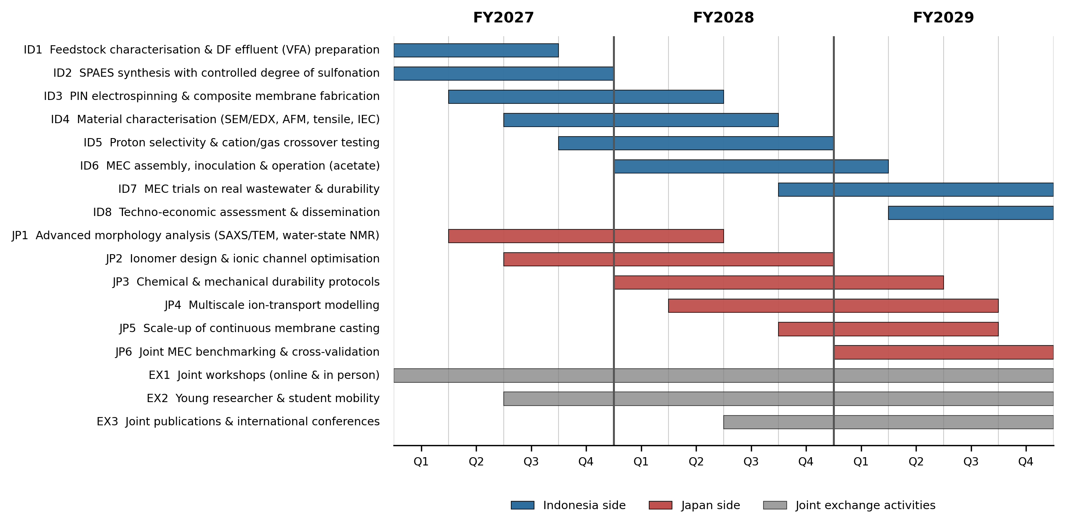
Figure 2. Three-year work plan showing Indonesian and Japanese work packages and joint exchange activities across FY2027-FY2029.

1st Year
Research Work Plan:
1) Japan side
JP1. Establish advanced morphology protocols for SPAES/PIN composites: AFM tapping-mode imaging, small-angle X-ray scattering and water-state NMR on the first membrane series supplied by the Indonesia side.
JP2. Begin ionomer design work: define the sulfonation-degree window and candidate side-chain modifications expected to narrow and interconnect the ionic channels.
JP3. Define standard operating procedures for hydrated tensile testing, conductivity and accelerated chemical stress, so that both laboratories generate comparable data from the outset.

2) Indonesia side
ID1. Collect and characterise candidate feedstocks (palm oil mill effluent, tofu and tapioca wastewater) and prepare VFA-rich dark-fermentation effluent; determine VFA profile, COD, suspended solids and inhibitor content.
ID2. Synthesise SPAES with controlled degree of sulfonation; verify sulfonation by NMR and titration.
ID3. Electrospin polyimide nanofibre webs (≈200 nm) and fabricate the first SPAES/PIN composite membrane series, varying sulfonation degree and composite ratio.
ID4. In-house characterisation: SEM/EDX cross-sections, hydrated tensile strength, water uptake, swelling ratio and ion exchange capacity.
ID5. Commission the three-chamber crossover cell and begin proton transport number measurements.

Research Exchange Plan:
1) Japan side
Host the kick-off joint workshop (2 days) in Japan covering shared protocols and data formats; expected outcome is a common measurement protocol document.
Receive two Indonesian graduate students for a one- to three-month research stay on advanced morphological characterisation.

2) Indonesia side
Send two graduate students to the Japanese partner laboratory; on return they transfer the characterisation protocols to the home laboratory.
Host an online monthly project seminar series led by early-career researchers from both sides.

2nd Year
Research Work Plan:
1) Japan side
JP2. Deliver optimised ionomer chemistry and feed the resulting design parameters back to the Indonesian fabrication team.
JP3. Execute chemical and mechanical durability testing on the second membrane series, including accelerated ageing.
JP4. Build the multiscale ion-transport model and fit it to the paired morphology/selectivity dataset from Year 1.
JP5. Begin scale-up trials of continuous membrane casting; assess thickness uniformity and defect density.

2) Indonesia side
ID3/ID4. Fabricate and characterise the second, optimised membrane series using the design parameters received from the Japan side.
ID5. Complete competing-cation crossover measurements (Na⁺, Mg²⁺, Ca²⁺) and extend to gas (H₂, CH₄, CO₂) and substrate crossover.
ID6. Assemble two-chamber MECs, enrich exoelectrogens and operate in fed-batch mode on acetate at 0.5 V; benchmark against Nafion-211 for hydrogen yield, gas purity and pH gradient.
ID7. Begin MEC trials on real dark-fermentation effluent.

Research Exchange Plan:
1) Japan side
Send two Japanese students to Indonesia for MEC operation and real-feedstock experiments; expected outcome is hands-on bioelectrochemical experience not available domestically.
Co-supervise at least two doctoral students jointly with the Indonesian team.

2) Indonesia side
Host the second joint workshop (2 days) in Indonesia, including a site visit to an agro-industrial wastewater facility; open to the wider national community.
Support young researchers from both sides to co-present the first joint results at an international conference.

3rd Year
Research Work Plan:
1) Japan side
JP4. Validate and publish the ion-transport model against the full experimental dataset, delivering the structure-selectivity design rule.
JP5. Complete scale-up assessment and report property retention from coupon to continuously cast sheet.
JP6. Cross-validate MEC benchmarking data with the Indonesian team and co-author the principal joint publications.

2) Indonesia side
ID7. Complete extended MEC operation on real wastewater; quantify biofouling, cleaning-protocol effectiveness and long-term durability.
ID6/ID7. Final benchmarking of the optimised membrane against Nafion-211 under real-feedstock conditions.
ID8. Techno-economic assessment of domestic membrane production and MEC deployment; prepare the joint patent application and dissemination materials.

Research Exchange Plan:
1) Japan side
Host the closing joint workshop in Japan and agree the follow-on research agenda and joint proposal.
Support nomination of eligible Indonesian early-career researchers for doctoral study in Japan under the JST capacity-building scheme.

2) Indonesia side
Open the final-year workshop to researchers from other ASEAN Member States working on bioenergy and membranes, seeding a regional network.
Ensure every young researcher involved has presented at least once at an international conference and co-authored at least one joint output.

Part IV. Budget Description (for Japan side)

Budget Summary in Japanese Yen
Figures are indicative and must be confirmed by the Japan-based partner. Direct expenses total 24,000 thousand JPY over 36 months; the exchange-plan allocation (b) is 7,200 thousand JPY, i.e. 30% of direct expenses, covering reciprocal research stays, student mobility and the annual joint workshops.

Amount（1,000 JPY） | Fiscal year 2027 | Fiscal year 2028 | Fiscal year 2029 | TOTAL (a)
 |  |  |  |  | Exchange plan (b)
Facilities and equipment | 4,000 | 1,500 | 500 | 6,000 | -
Consumables | 2,200 | 2,200 | 2,200 | 6,600 | -
Travel | 1,700 | 1,800 | 1,900 | 5,400 | 5,400
Personnel | 1,400 | 1,400 | 1,400 | 4,200 | -
Others | 600 | 600 | 600 | 1,800 | 1,800
Total amount | 9,900 | 7,500 | 6,600 | 24,000 | 7,200

Part V. Budget Description (for Indonesia side)

1. Budget Summary in Indonesian Rupiahs
Amounts are in thousand Rupiah. The request is Rp 1,000,000 thousand (Rp 1 billion) per year for three years, the BRIN ceiling. Within each year, personnel is 24% (cap 25%), capital expenditure is at or below 10%, and indirect cost is 5% - all within the RIIM Kolaborasi limits. FY2030 is left blank because BRIN funding runs for a maximum of three years.

Amount（1,000 Indonesian Rupiah） | Fiscal year 2027 | Fiscal year 2028 | Fiscal year 2029 | Fiscal year 2030 | TOTAL
Direct Expenses | 950,000 | 950,000 | 950,000 | - | 2,850,000
Personnel | 240,000 | 240,000 | 240,000 | - | 720,000
Consumables | 435,000 | 455,000 | 405,000 | - | 1,295,000
Travel | 120,000 | 130,000 | 140,000 | - | 390,000
Capital (if any) | 95,000 | 75,000 | 55,000 | - | 225,000
Others | 60,000 | 50,000 | 110,000 | - | 220,000
Indirect Expenses | 50,000 | 50,000 | 50,000 | - | 150,000
TOTAL Budget Requested | 1,000,000 | 1,000,000 | 1,000,000 | - | 3,000,000

2. Expenditure on exchange plan
The exchange expenditure below is drawn from the Travel line of the summary above and stays within the Rp 100,000 thousand per year ceiling on international travel. Note that the researcher mobility scheme is available to BRIN researchers only; the mobility line is therefore budgeted against the BRIN team member.
Amount（1,000 Indonesian Rupiah） | Fiscal year 2027 | Fiscal year 2028 | Fiscal year 2029 | Fiscal year 2030 | TOTAL
Researcher Mobility | 35,000 | 40,000 | 40,000 | - | 115,000
Visiting researcher | 20,000 | 20,000 | 25,000 | - | 65,000
Joint research visit | 35,000 | 35,000 | 35,000 | - | 105,000
TOTAL Budget Requested | 90,000 | 95,000 | 100,000 | - | 285,000

Part VI. Research Participants

1. Japan side
Role | Name (last, first) | Institution/  Department | Position | Role in Project
PI | [To be completed by the Japan-based partner] | [To be completed by the Japan-based partner] | [To be completed by the Japan-based partner] | [Role to be agreed with the Japan-based partner]
Co-PI  *Please delete if not applicable | [To be completed by the Japan-based partner] | [To be completed by the Japan-based partner] | [To be completed by the Japan-based partner] | [Role to be agreed with the Japan-based partner]
Researcher | [To be completed by the Japan-based partner] | [To be completed by the Japan-based partner] | [To be completed by the Japan-based partner] | [Role to be agreed with the Japan-based partner]

2. Indonesia side
Positions and institutional affiliations must be verified against each team member's CV before submission.
Role | Name (last, first) | Institution/  Department | Position | Role in Project
PI | Nasruddin | Universitas Indonesia / Dept. of Mechanical Engineering | Professor | Leading the Indonesian team; membrane fabrication and MEC integration; overall coordination with the Japan side; reporting to BRIN.
Co-PI | Farobie, Obie | IPB University / Dept. of Mechanical and Biosystem Engineering | Associate Professor / Researcher | Feedstock selection and characterisation; preparation of VFA-rich dark-fermentation effluent; exoelectrogen enrichment and MEC operation on real wastewater.
Researcher | Munandar, Erdi | Badan Riset dan Inovasi Nasional (BRIN) | Researcher | Membrane morphology and microstructure analysis (SEM/EDX, AFM); linking microphase separation to ion selectivity; counterpart for the Japanese characterisation work; researcher mobility scheme.

Part VII. Personal Background Information

1. Japan side
To be completed by the Japan-based partner: PI name, organisation and position; education and professional background; five most important publications from the last 5 years; up to five notable awards and honours; and past international personnel exchange achievements.
- Principal Investigator: Name (Organization: Position)

- Co-Principal Investigator: Name (Organization: Position) Please delete if not applicable

- Past international personnel exchange achievements

2. Indonesia side
Principal Investigator: Nasruddin (Universitas Indonesia: Professor, Department of Mechanical Engineering)
The Indonesian PI is a Professor in the Department of Mechanical Engineering, Faculty of Engineering, Universitas Indonesia, with a Dr.-Ing. obtained in Germany. His research covers energy system optimisation, refrigeration engineering and thermodynamics, with sustained work on sustainable energy conversion technologies, adsorption systems and thermoeconomic analysis. He leads the Indonesian team and is responsible for membrane fabrication, MEC integration and overall project coordination.
Insert: education and professional background in date order; the five most important publications from the last 5 years; up to five notable awards and honours; SINTA/Scopus identifiers.
Co-Principal Investigator: Obie Farobie (IPB University: Associate Professor / Researcher)
The Co-PI works on biomass conversion and renewable energy technology, including thermochemical and biochemical routes for converting organic residues into fuels, and feasibility assessment of renewable fuel production systems. Within this project he leads feedstock selection and characterisation, preparation of VFA-rich dark-fermentation effluent, and MEC operation on real wastewater.
Insert: education and professional background; five most important publications from the last 5 years; notable awards and honours.
Researcher: Erdi Munandar (BRIN: Researcher)
The BRIN team member specialises in advanced material characterisation and polymer structure analysis, with access to national characterisation facilities. He leads morphology and microstructure analysis and acts as the direct counterpart to the Japanese characterisation and modelling work.
Insert: education and professional background; five most important publications from the last 5 years; notable awards and honours.
Past international personnel exchange achievements
Insert: previous international joint research and researcher exchange activities of the Indonesian PI - dispatching young researchers, hosting researchers from other countries, symposia organised, and any existing collaboration with Japanese institutions. This is scored by the reviewers and cannot be drafted without the PI's records.
- Principal Investigator: Name (Organization: Position)

- Co-Principal Investigator: Name (Organization: Position) Please delete if not applicable

- Past international personnel exchange achievements

