Funding per project (direct): Rp1M
Number of projects: maximum 5
Research field: bioenergy
Researcher eligibility
- Two identical copies of the proposals must be submitted to JST and BRIN
- Proposal must demonstrate equivalence in effort from the Japanese and Indonesian partners
- Submit through both JST and BRIN.
- Advised to start submitting atleast one week before the deadline
Eligible researchers for BRIN support
- Affiliated with BRIN or other Indonesian research institution (legal registration), for example universities, industry, and or private organization.
- Other registered research institution, excluding BRIN, are encouraged to register with the Sistem Informasi Registrasi Lembaga Riset (SEBARIS).
- Principal investigator (PI) submitting proposal to BRIN: must hold at least a Master degree with active enrollment in a Doctroal degree program.
- The PI and team members must have a:
- Research track record and expertise relevant to the proposed research/project, or
- Clearly defined roles in the research project of where their skill sets provide added value, as clearly stated in their Curriculum Vitae, with their research track record detailed in the research experience section.
- The proposed document requires legal approval from an authorized official of the institution.
- Indonesian applicants shall comply with the research ethical clearance from the Ethics Committee before the project started, including research permit for the foreign researchers involved in research project, by submitting an application to the Ethics Committee Authorized institution.
Proposal for BRIN
- A joint proposal in English
- Complying with
- The Joint Application Form instructions and
- RIIM Kolaborasi guidelines
- Identical copies of the proposal must be submitted to BRIN and JST
- Supporting document required by BRIN
- Signed approval sheet from an authorized official of the institution
- CV of the Indonesian PI and all team members
- Proposed budget details (RAB)
Amount of Funding by JST
- International joint research
JST will support each Japan-based team to JPY 24M (Rp.2.675.000.000,- dua miliar empat ratus juta ribu rupiah)
- Research capacity building
If included, JST will provide additional support for the Japan-based team for the purpose of researchers capacity building
JST will support Indonesian ECR candidates, who would attain a doctoral degree in a Domestic Japanese research institution (JPY 3.9M/year and a total of JPY 11.7 M/year) atau
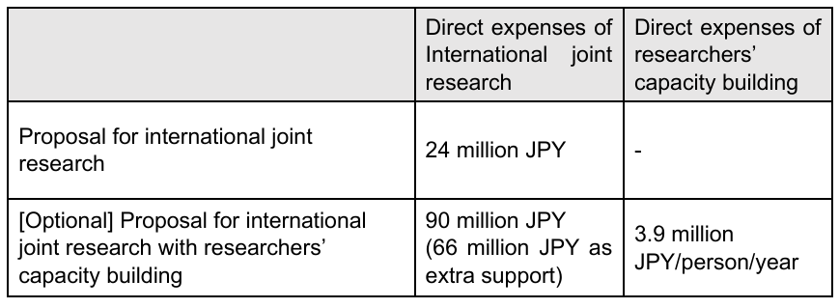
Amount of Funding by BRIN
- BRIN supports up to Rp 1M per project/year
- Funded by the investment gains of the Research Endowment Fund managed by LPDP under the Ministry of Finance
- Research funding can be implemented for a maximum of three years
- The budget may differ each year, depending on:
- The content of activities
- The results of annual reviews
Eligibile costs for BRIN
- Personnel costs
Personnel cost for team members shall not exceed 25% (< Rp250.000.000,00- dua ratus lima puluh juta ribu rupiah)
- Direct costs
Direct costs are expenses directly used for research purposes at the awarded research institution:
- Purchase/procurement of chemicals/consumables for research
- Honorarium to compensate field workers for their contributions
- Honorarium for expert fee
- All expenses arising from the convening of meetings
- Article Processing Charge (APC) for publishing research articles in a reputable high impact (Q1) international journal
- Capital expenditure shall not exceed 10% of the entire amount funded (< Rp100.000.000,- seratus juta ribu rupiah)
- Cost for land and livestock rental
- Domestic travel
- International travel (obtaining research data) shall not exceed (< Rp100.000.000,- seratus juta ribu rupiah)
- International travel (Visiting Professor or joint research visit) will covered only if researcher applies for the researcher mobility scheme.
- Researcher mobility scheme is exclusively for BRIN researchers only.
- Indirect costs
All expenses arising from monitoring or evaluation of activities conducted by beneficiary institutions shall no exceed 5% (< Rp50.000.000,- lima puluh juta ribu rupiah)
Indonesian grants cannot cover these following: Institution/management fee
- Software purchases
- Patent registration fee for BRIN researchers
- Capital expenditure for land purchase, building purchase, or asset acquisition
- Indirect/overhead expenses including but not limited to communication cost
- Other expenses that are not approved.

Submission
- The PI from Japan submit to JST
- The PI from Indonesia submit to BRIN,
(https://pendanaan-risnov.brin.go.id/).
Identical copies of the proposal must be submitted to JST and BRIN.
Timeline
- Deadline: July 22, 2026 at 12PM (WIB)
- Selection results announcement: January 2027
- Start of granted projects: April 2027
Criteria for evaluating proposals
- Consistency with the research field
- Capability of research leaders
- Expected scientific results
- Synergy effects of Indo-Japan collaboration
- Validity of research plan
- Validity of exchange plan
- Expected economic and social impact
- Feasibility of implementation
For proposal including researchers capacity building, an interview will be conducted in the Japan side, these aspects:
- Appropriateness of the number of individuals targeted
- Clarity of the development plan
- Clarity of entry/exit strategies
- Anticipated outcomes and impacts
will be considered in an interview review conducted in the Japan side

