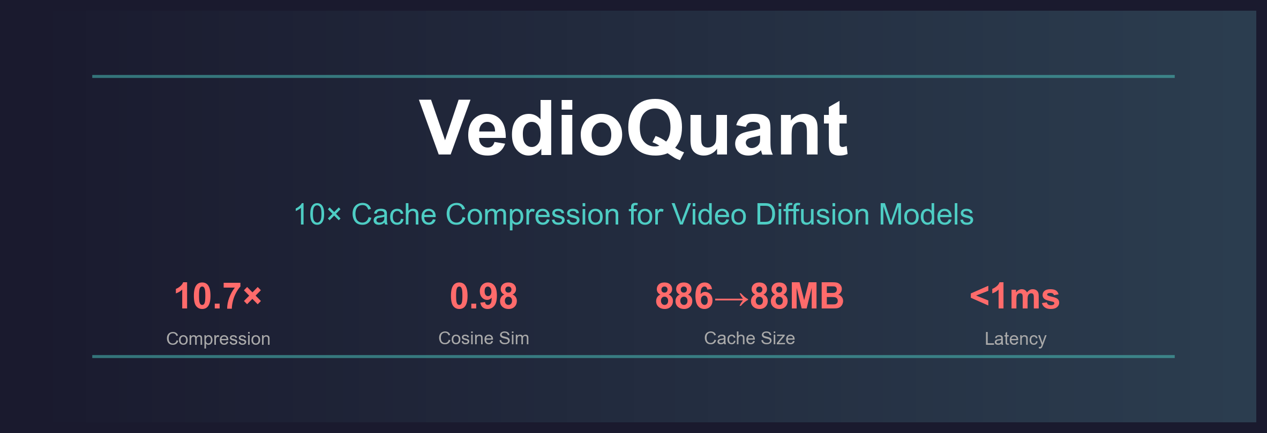

Origin Story: From Curiosity to a 10× Breakthrough
In 2025, AI video generation exploded. ByteDance's Seedance launched in China and was instantly overwhelmed — a 5-second video costs several yuan and takes minutes to generate, yet countless creators are lining up to use it. AI-generated content is visibly flooding short-video platforms, reshaping the content creation industry at breakneck speed.
Curious about the technology, I wanted to understand: why is video generation so expensive? A single generation requires ~50 denoising steps, each running a full transformer forward pass over 75,600 tokens across 30 layers. It demands an A100 80GB GPU — hardware most creators can't afford.

The Spark
Then I saw Google's TurboQuant (ICLR 2026) — compressing LLM KV Cache from fp16 to 3.5 bits with 0.95 cosine similarity. The core trick: random orthogonal rotation to Gaussianize coordinates.
Someone reproduced it in Python (turboquant_plus) and validated on Qwen3: kurtosis dropped from 900 to 2.9 after rotation. All 141 tests passed. It works in practice.
This sparked an idea: both LLMs and video models cache attention layer intermediate tensors — the data is fundamentally the same! What if TurboQuant works on video model caches too?
The results were stunning:
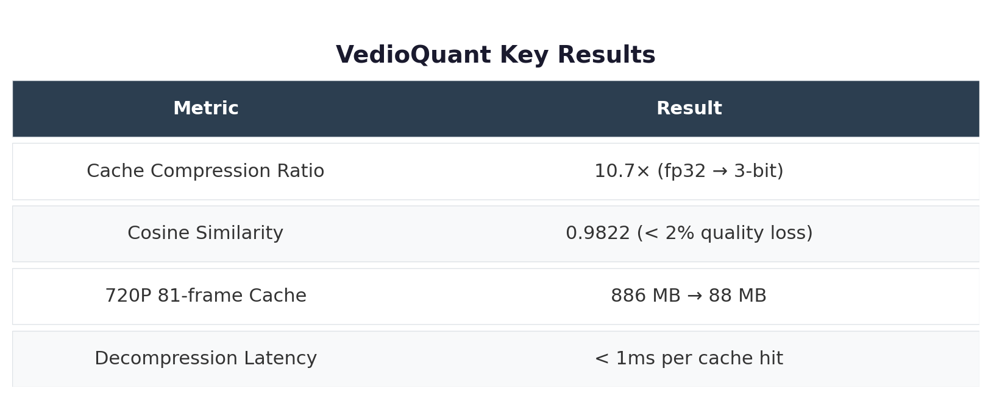

Why Video Models Need Cache Compression More Than LLMs

Reason 1: ~350× More Compute
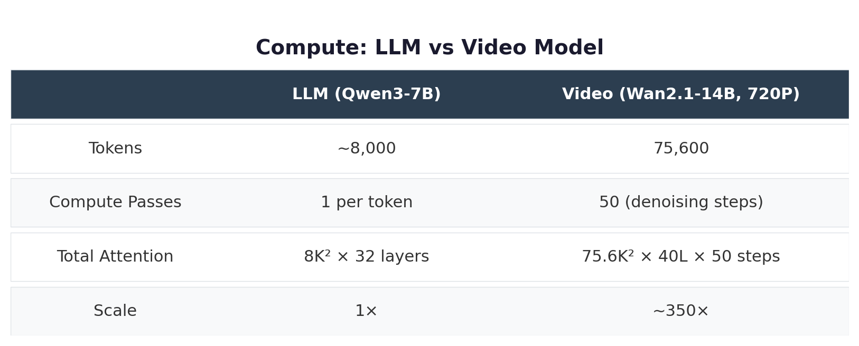

Reason 2: VRAM is the Hard Bottleneck
Video model caches are 10-13× larger than LLM caches.
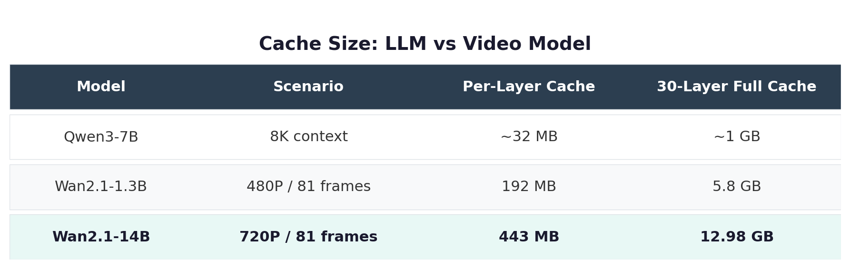

Reason 3: Video Features Compress Better (Surprise!)
An unexpected discovery — video features have kurtosis of only 15 (vs 900 for LLMs). After rotation, kurtosis drops to 0.2 — nearly perfect Gaussian. TurboQuant works BETTER on video models than on its original LLM target.
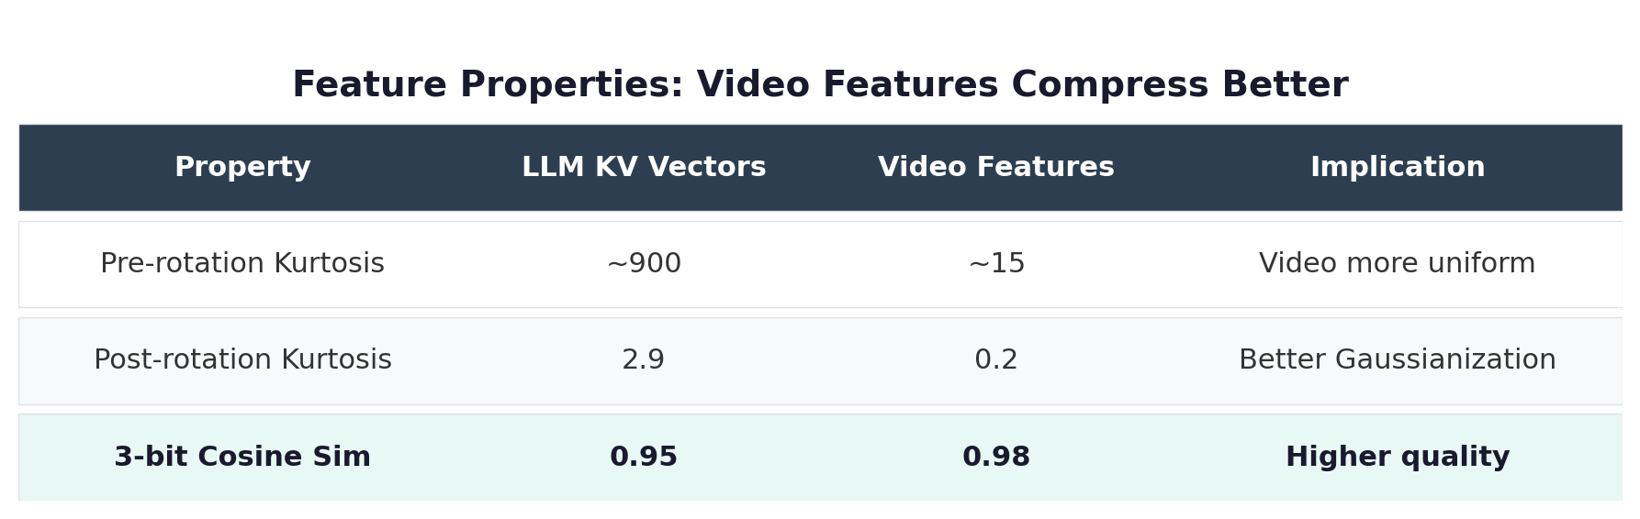

Reason 4: Massive Industry Demand
Seedance charges several yuan per 5-second video — backed by minutes of A100 time. Whoever cuts inference cost by 10× turns AI video from "expensive toy" into "everyday tool."

Cross-Domain Transfer: Why It Works
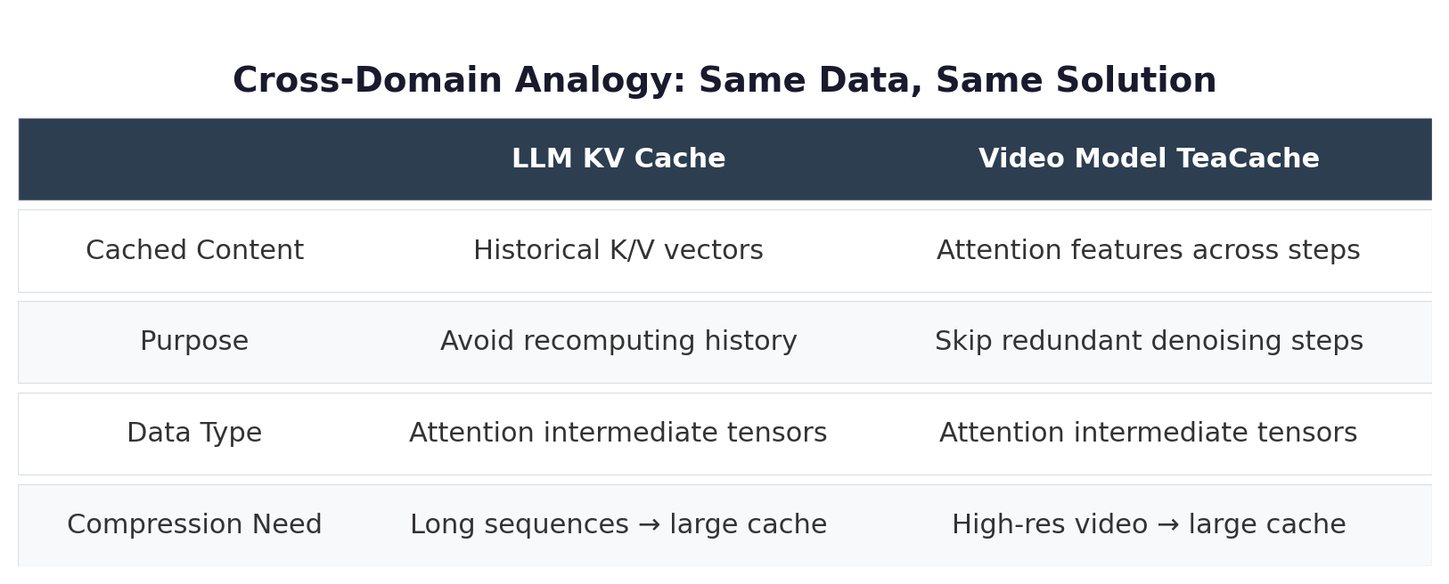
Both cache attention intermediate tensors — TurboQuant transfers directly.

Algorithm
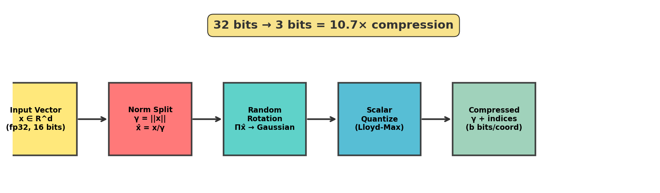
Figure 1: TurboQuant compression pipeline

Step 1: Norm Separation
Separate magnitude (full precision) from direction (quantized). Attention depends on direction.

Step 2: Random Rotation — The Core Trick
Raw coordinates are non-uniform. Random orthogonal rotation → each coordinate becomes a weighted average of all originals → Central Limit Theorem → Gaussian distribution → optimal scalar quantization.
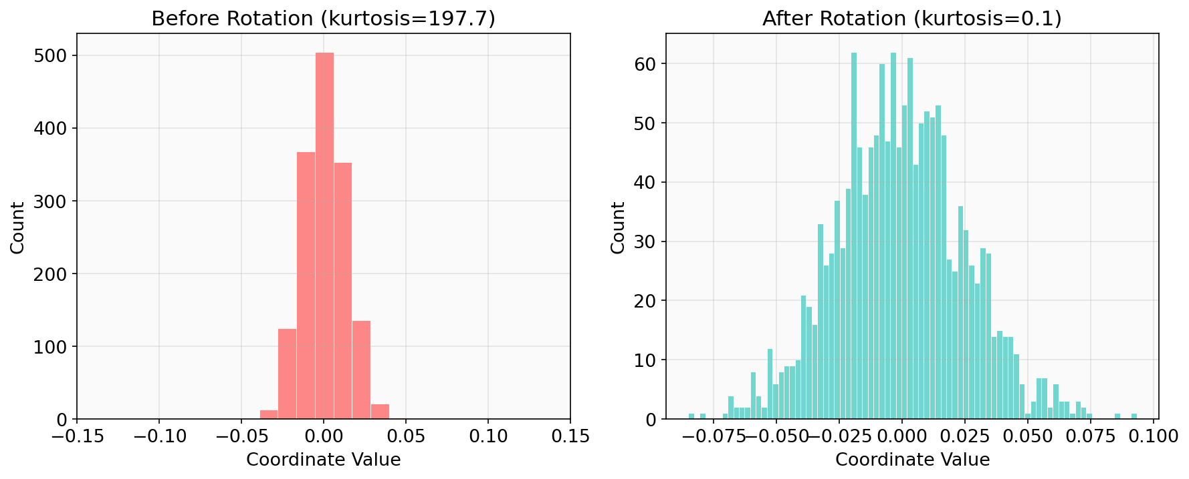
Figure 2: Distribution before and after rotation
Wan2.1: kurtosis 15.0 → 0.2. Std dev matches theory exactly.

Step 3: Precomputed Codebook
Rotated coords follow N(0, 1/√d). Precompute Lloyd-Max codebook → torch.bucketize. Zero iteration.

Experimental Results
Real features from Wan2.1-1.3B, 30 attention layers, d=1536, 50 tokens:
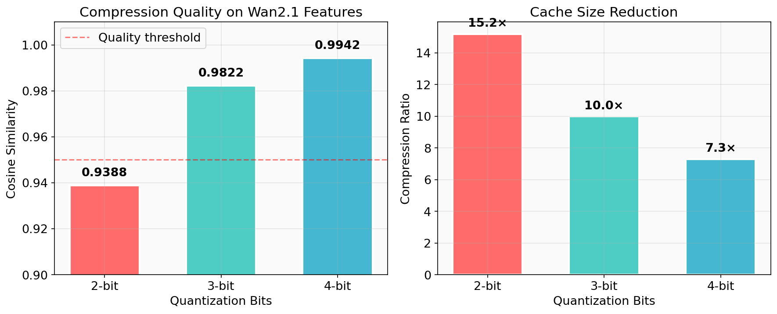
Figure 3: Compression quality across bit widths

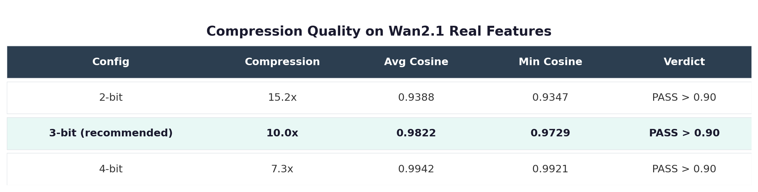
3-bit sweet spot: 10× compression, 0.98 cosine, worst case > 0.97.

Memory Savings
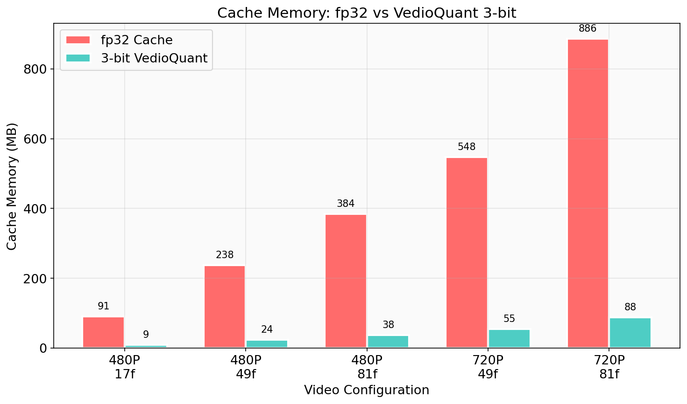
Figure 4: Cache memory across video configurations

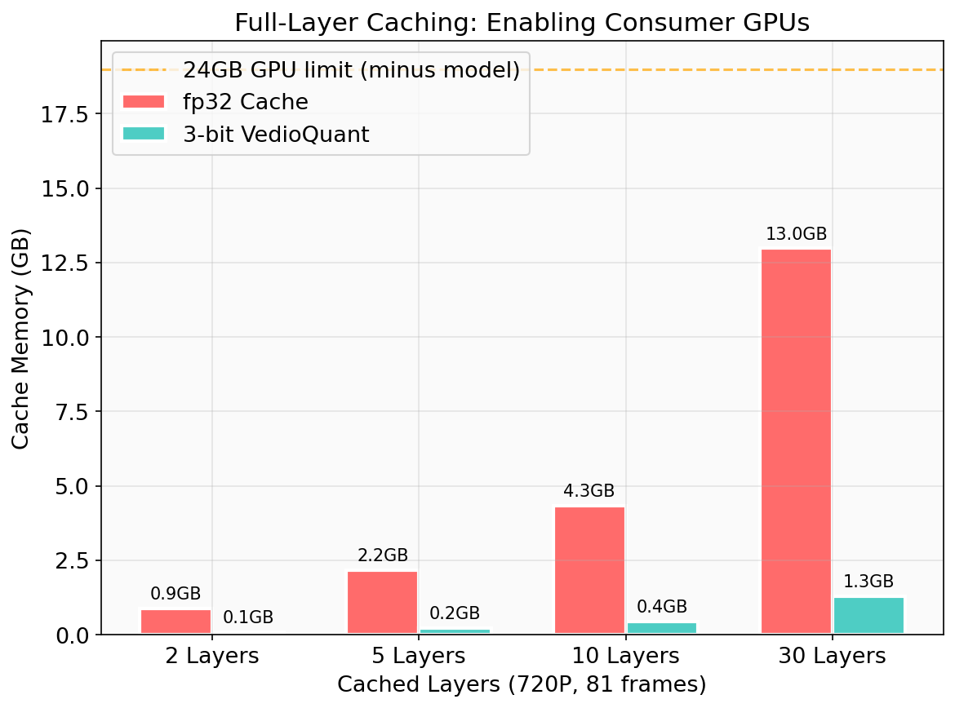
Figure 5: Full-layer caching — VedioQuant enables 24GB GPUs

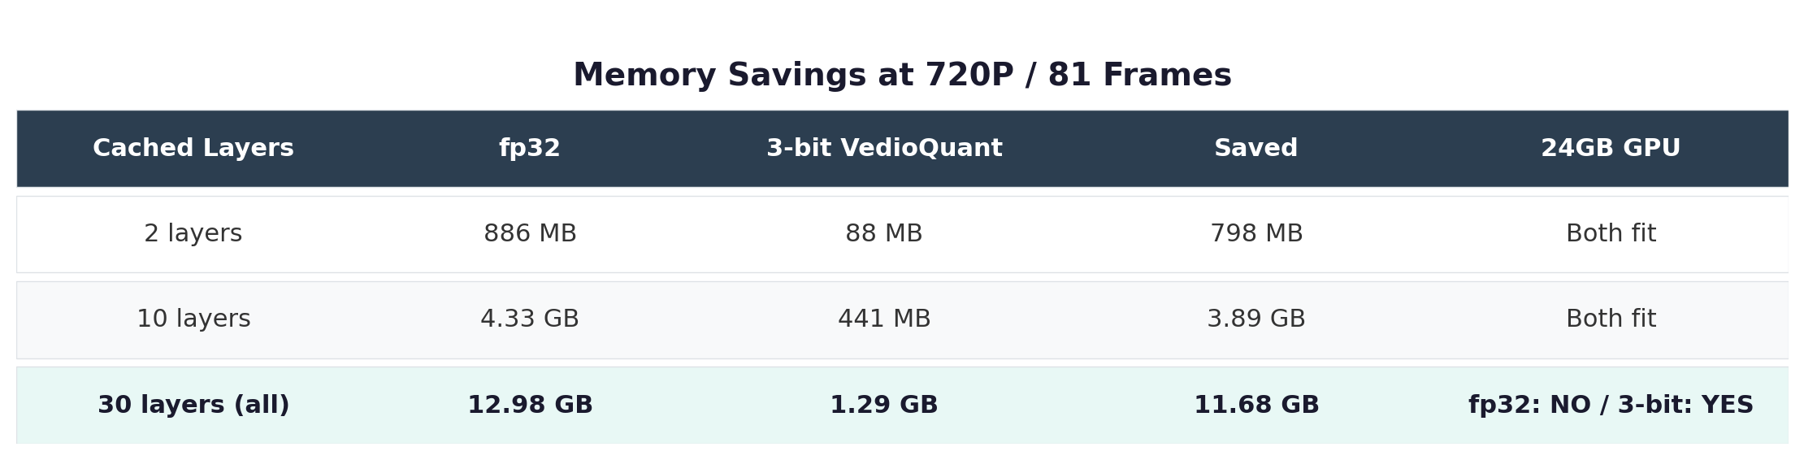
Full 30-layer cache: 13GB → 1.3GB. Saves ~12GB. Consumer GPU runs 720P long video.

Usage: One Line to Enable
import vedioquant
handle = vedioquant.enable(pipe.transformer, bits=3)
output = pipe("a cat on sofa", num_frames=81)
print(handle.stats())
# → {'cache_hits': 32, 'hit_rate': '64.0%', 'compression_ratio': '10.7×'}
vedioquant.estimate_savings(height=720, width=1280, num_frames=81)
# → fp32: 886MB, 3-bit: 83MB, saved: 803MB

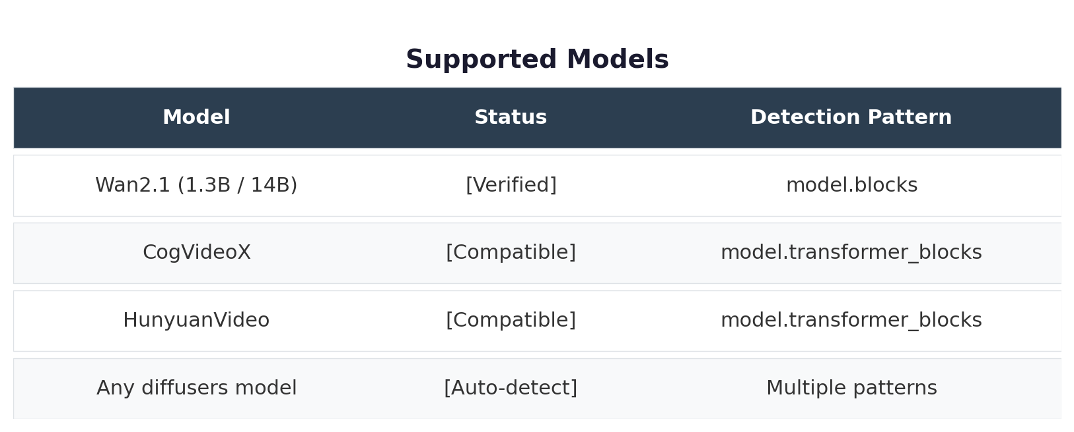

Contributions
- First migration of LLM KV Cache compression to video diffusion feature caching
- Discovered video features naturally compress better (kurtosis 15 vs 900, cosine 0.98 vs 0.95)
- Implemented TeaCache + TurboQuant fusion: 3-bit, 10× cache reduction
- Open-source library VedioQuant: one line, auto-adapts to multiple architectures
- 720P/81-frame full cache: 80GB GPU → 24GB consumer GPU

References
- TurboQuant: arXiv:2504.19874 (ICLR 2026)
- PolarQuant: arXiv:2502.02617
- QJL: arXiv:2406.03482
- TeaCache: arXiv:2411.19108
- Wan2.1: github.com/Wan-Video/Wan2.1
GitHub: github.com/robin-ph/vedioquant

