Practical 6: Install Selenium WebDriver and Configure Environment (Java/Python)

Aim
To install Selenium WebDriver and configure the development environment using Java and Python for browser automation.

Introduction
Selenium is an open-source automation framework used to automate web browsers. Before writing automation scripts, the programming language, IDE, Selenium library, browser, and browser driver must be configured.

Software Requirements
- Windows 10/11
- Java JDK
- Eclipse IDE
- Apache Maven
- Google Chrome
- Python 3.
- Visual Studio Code
- Internet connection

Step 1: Verify Java Installation
- Open Command Prompt.
- Run: java -version
- Run: javac -version
- If both commands work, Java is installed correctly.
- If not, configure JAVA_HOME and PATH.

Step 2: Launch Eclipse IDE
- Open Eclipse.
- Choose a workspace.
- Click Launch.
- Explore Project Explorer, Editor, Console and Problems views.

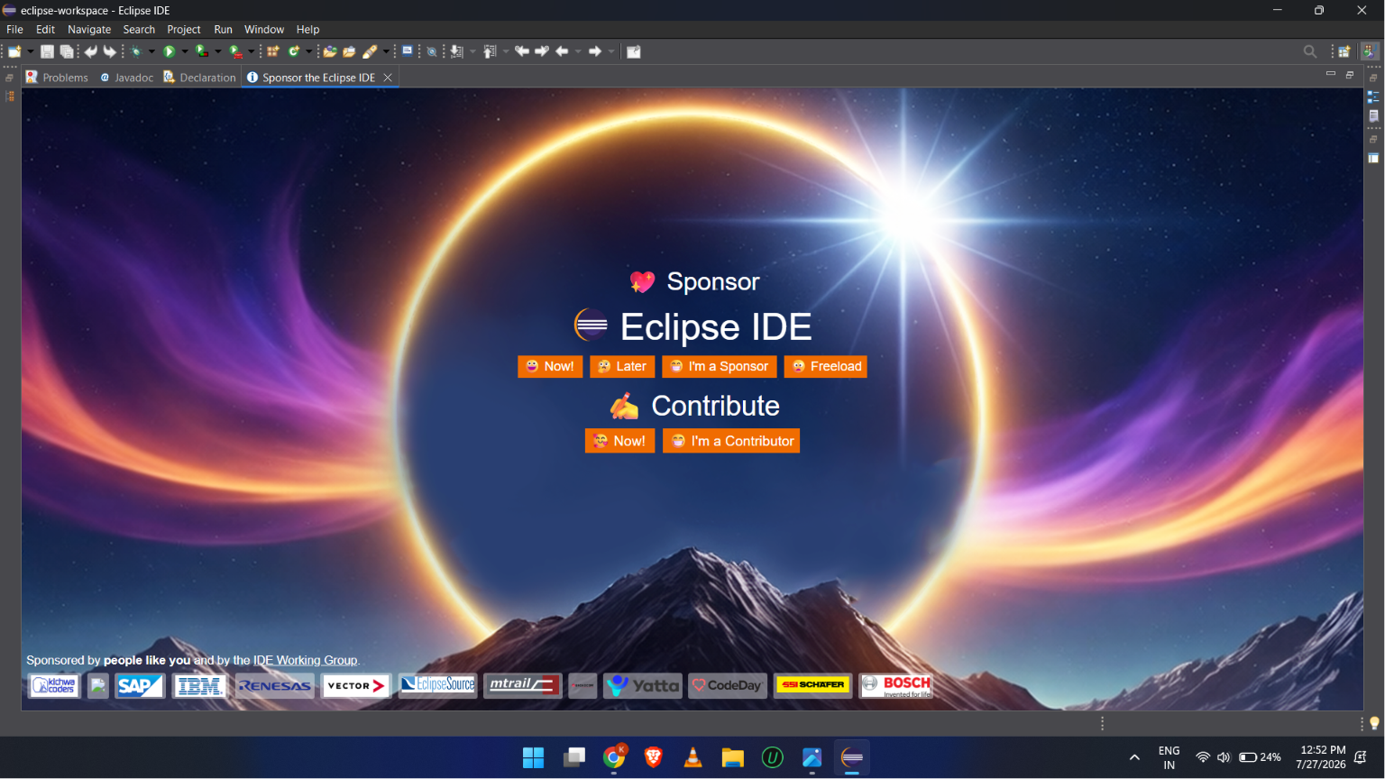

Step 3: Create Java Project
- File → New → Java Project.
- Enter project name.
- Choose installed JDK.
- Click Finish.

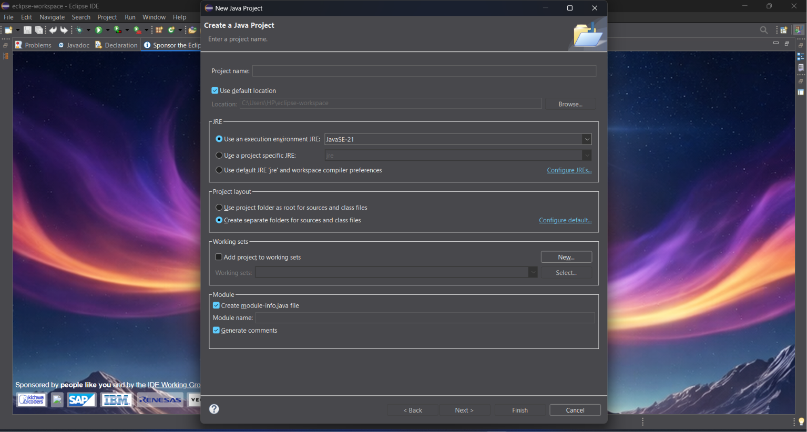Step 4: Create Java Class
- Right-click src.
- New → Class.
- Enter class name.
- Tick public static void main().
- Click Finish.

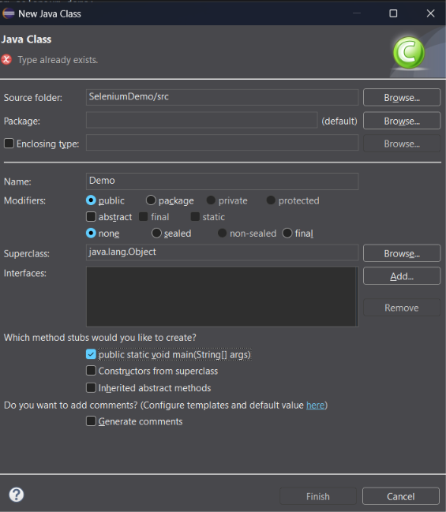

Step 5: Run Hello World
- Write a simple Java program.
- Run as Java Application.
- Verify console output.

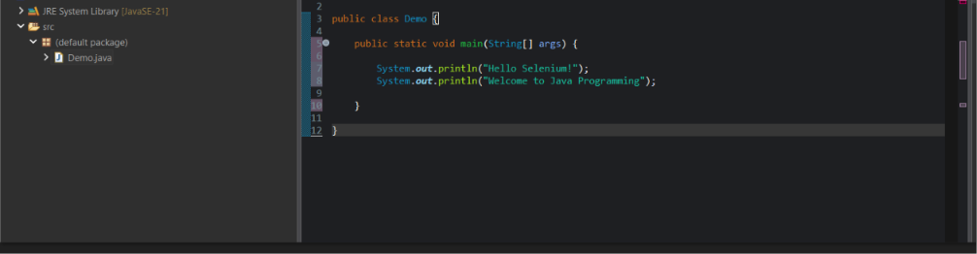

Step 6: Create Maven Project
- File → New → Maven Project.
- Choose maven-archetype-quickstart.
- Click Next.
- Enter Group Id, Artifact Id and Package.
- Click Finish.

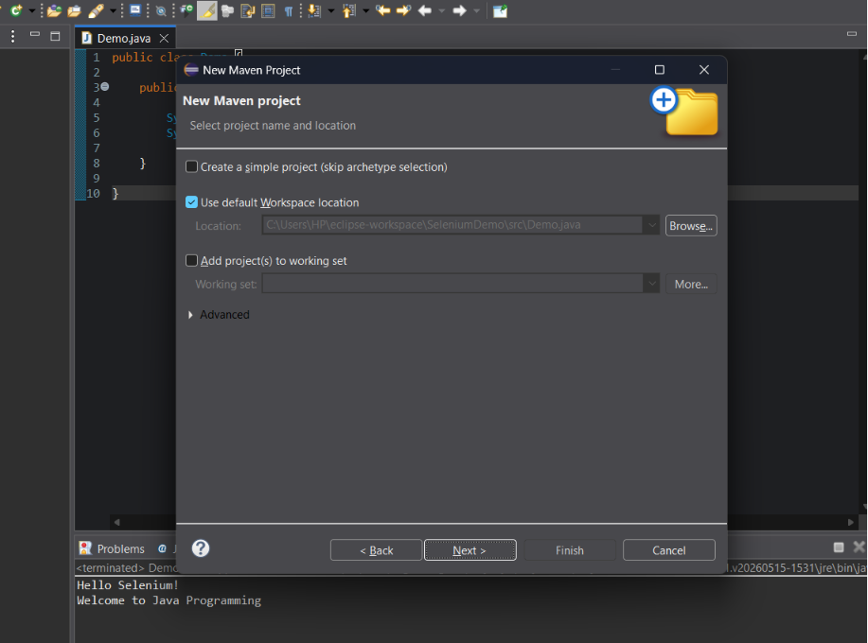

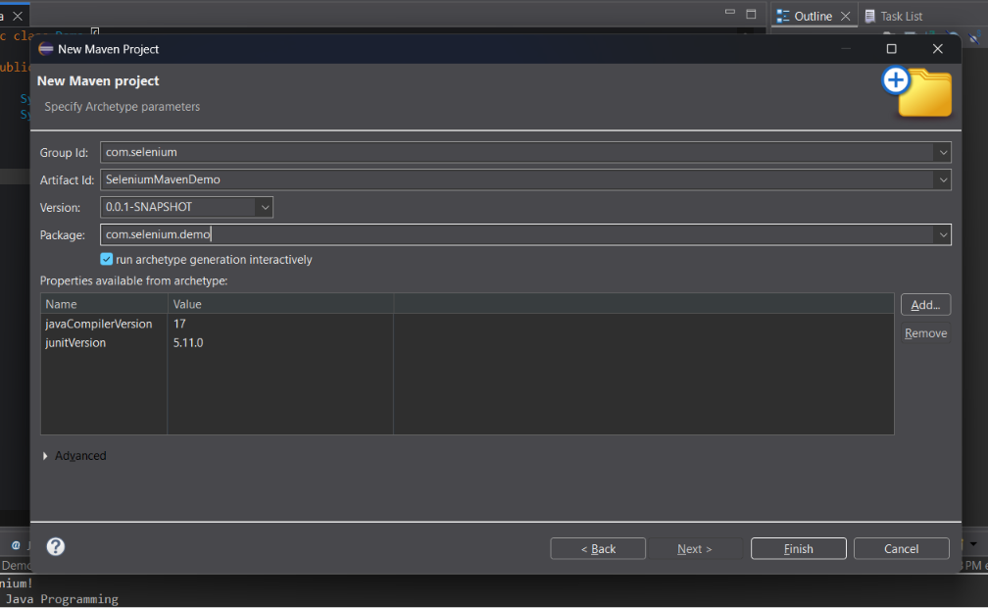
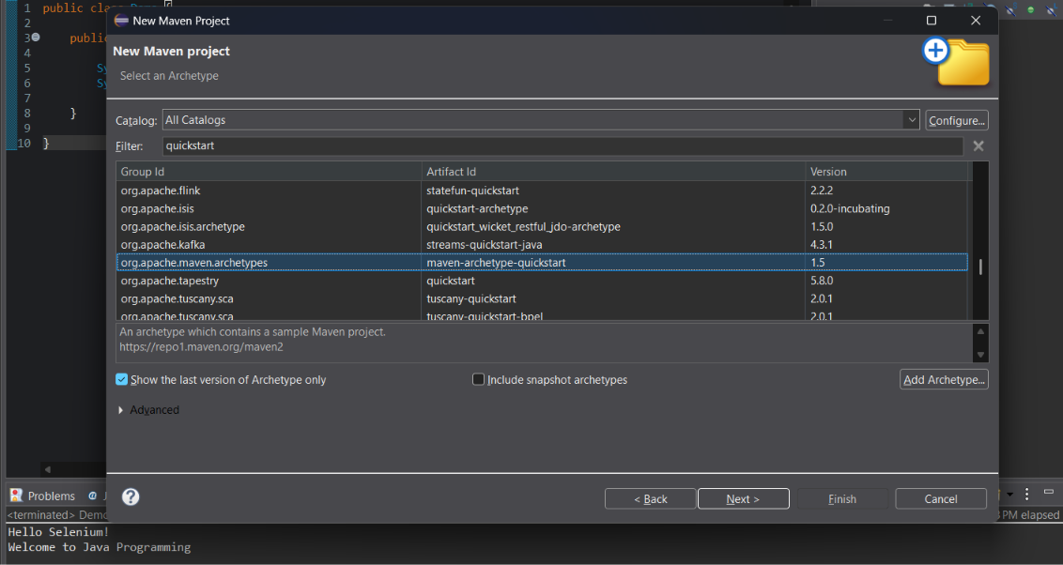

Step 7: Understand Maven
- Observe src/main/java.
- Observe src/test/java.
- Open pom.xml.
- Expand Maven Dependencies.

Step 8: Add Selenium Dependency
- Open pom.xml.
- Add selenium-java dependency.
- Save the file.
- Wait for Maven to download dependencies.

<!-- Selenium WebDriver -->
<dependency>
<groupId>org.seleniumhq.selenium</groupId>
<artifactId>selenium-java</artifactId>
<version>4.35.0</version>
</dependency>

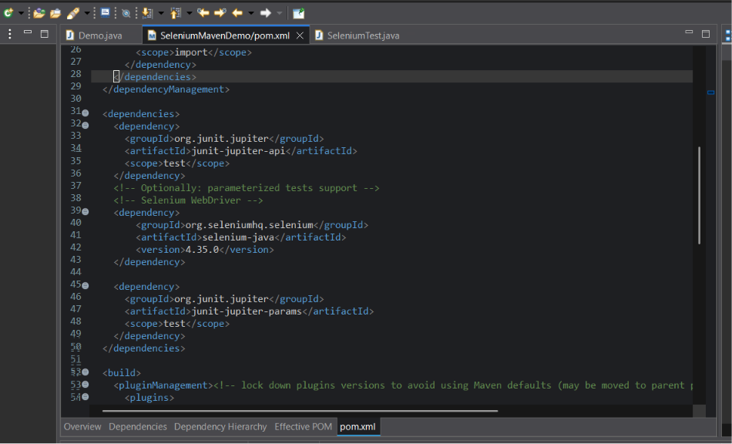

Step 9: Create Selenium Class
- Create SeleniumTest.java.
- Import WebDriver and ChromeDriver.
- Write the automation code.

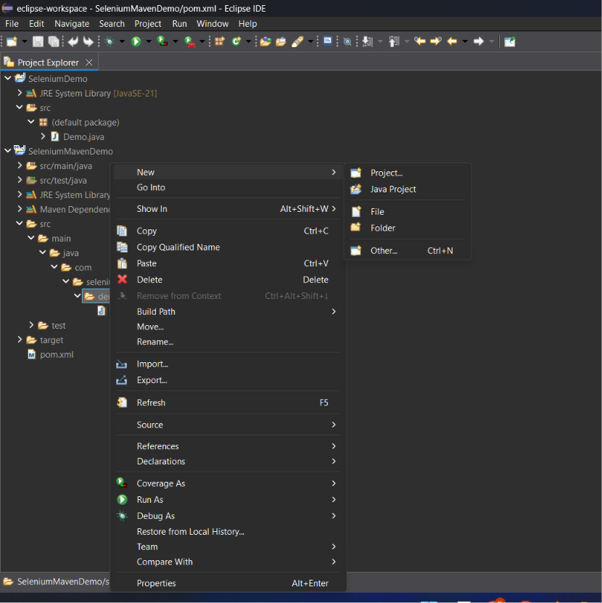

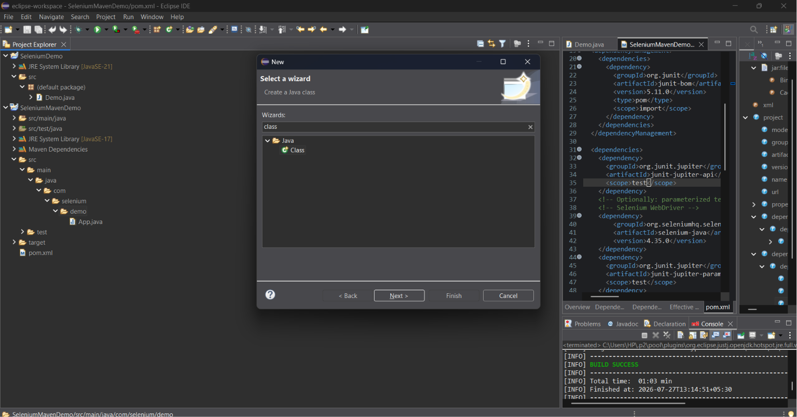

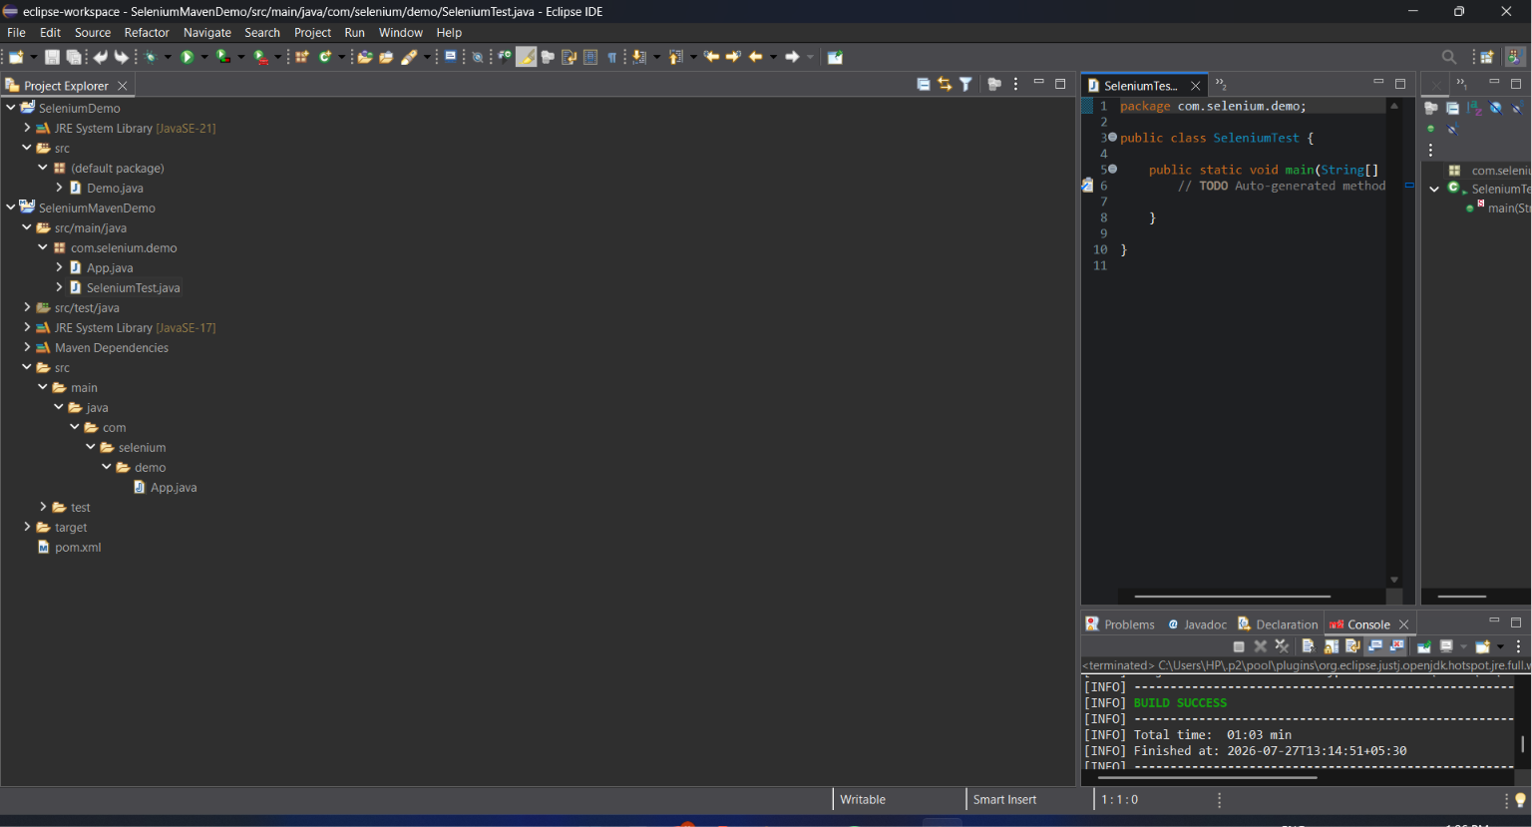

package com.selenium.demo;

import org.openqa.selenium.WebDriver;
import org.openqa.selenium.chrome.ChromeDriver;

public class SeleniumTest {

public static void main(String[] args) {

// Launch Chrome browser
WebDriver driver = new ChromeDriver();

// Open Google
driver.get("https://www.google.com");

// Print page title
System.out.println("Page Title: " + driver.getTitle());

// Close browser
driver.quit();
}
}

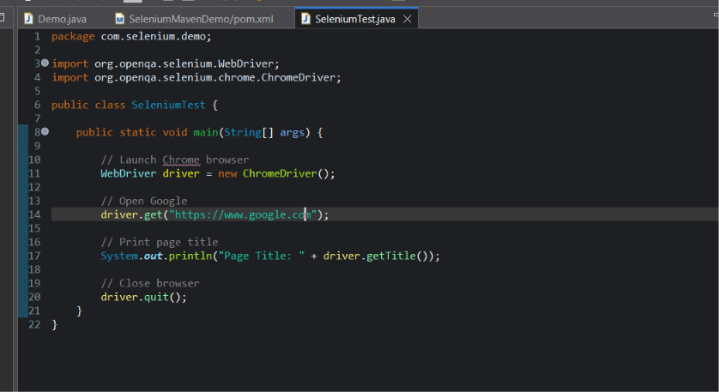

Step 10: Execute Selenium
- Run as Java Application.
- Chrome opens automatically.
- Google homepage loads.
- Console prints page title.
- Browser closes using driver.quit().

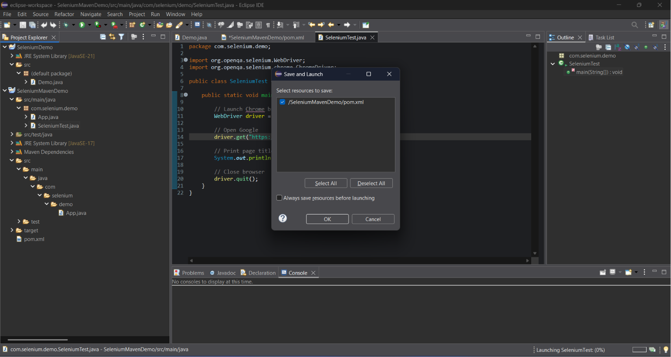
Sample Java Selenium Code
import org.openqa.selenium.WebDriver;
import org.openqa.selenium.chrome.ChromeDriver;
public class SeleniumTest{
public static void main(String[] args){
WebDriver driver=new ChromeDriver();
driver.get("https://www.google.com");
System.out.println(driver.getTitle());
driver.quit();
}
}

Viva Questions
- What is Selenium WebDriver?
- What is Maven?
- What is pom.xml?
- What is ChromeDriver?
- What is the difference between close() and quit()?
- What is pip?
- What is JAVA_HOME?

Conclusion
The Selenium environment for both Java and Python was configured successfully. The browser launched, executed the automation script, displayed the page title, and closed successfully.

