MovieLand

## About

MovieLand is a dynamic website CRUD application and movie database. It is develeped and designed using Symfony PHP framework and third-party library called Doctrine.The Front-end interface uses Bootstrap template emphasized with CSS.

Application allows user to insert, edit, view and delete movie and appropriate cast and crew.

## Database structure

Database called MovieLand is divided into 4 tables. Each table is responsible for describing the one term. Therefore, there are tables labeled Movies, People and Roles.

The forth table, labeled Combined ,as name says, combines other tables in order to connent them.

Each row in combined table contains info about one movie, one member of cast and his/her's role.

This way, it is possible for the same people to participate in other movies without the data being duplicated.

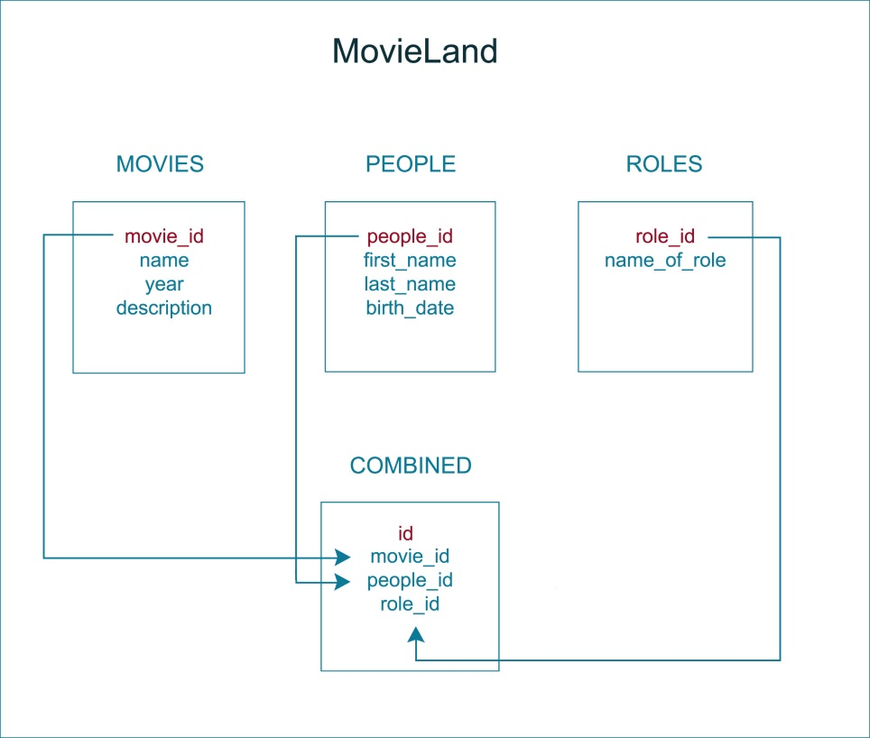

## Run application

Requiremensts:

* + - * Symfony
      * mysql wampserver/xampp
      * Apache PHP web server

Steps:

1. Copy MovieLand folder to server *www* folder(wamp) or *htdocs* folder(xampp).
2. Import the file movieland.sql. into mysql server.
3. C:\wamp\bin\apache\apache2.4.9q\conf\extra\httpd-vhosts

Insert the next lines

<VirtualHost *:80>

DocumentRoot "c:/wamp/www/movieland/web/app_dev.php"

ServerName movieland

</VirtualHost>

1. C:\Windows\System32\drivers\etc\hosts open as administrator

Add 127.0.0.1 movieland in new line.

1. Write movieland/ in your browser address.

You should see the window express like picture below.

