**Birla institute of technology Mesra,Ranchi**

**Numerical method**



Prepared by : Robin

ROLL NO : BTECH/15138/19

Faculty in charge

Dr. Prakash Chandra srivastava

Patna off campus

2021

**Simpson’s 1/3rd rule**

**Algorithm:**

1. Start.

2. Define an equation for f(x).

3. Define a method by the name of simpsonsRule().

4. Take the values of lower and upper limits of integration as well as the number of sub-intervals as inputs from the user.

5. Initialize a variable ifx with 0.

6. Find the value of h. [h = (b-a)/n]

7. Add the values of f(a) and f(b) to ifx.

8. Set the value of i = a+h.

9. Multiply the value of f(i) by 4 and add the result to ifx.

10. Add (2*h) to the existing value of i.

11. Repeat steps 8, 9 and 10 till the value of i is less than b.

12. Set the value of j = a+(2*h).

13. Multiply the value of f(j) by 2 and add the result to ifx.

14. Add (2*h) to the existing value of j.

15. Repeat steps 12, 13 and 14 till the value of j is less than b.

16. Multiply the final value of ifx with h and divide the result by 3 and store it back in ifx.

17. Print the value of integration ifx.

18. Stop.

**Program:**

//1/1+x^2

#include<stdio.h>

#include<conio.h>

float y(float x)

{

return x*x/(1+x*x*x);

}

void main()

{

float x0,xn,h,s,sum;

int i,n;

puts("\n Enter number of subdivision i.e n");

scanf("%d",&n);

puts("\n Enter lower limit of integrals i.e x0");

scanf("%f",&x0);

puts("\n Enter upper limit of integral i.e xn");

scanf("%f",&xn);

h = (xn-x0)/n;

s = y(x0)+ y(xn)+ 4*y(x0+h);

for(i=3;i<=n-1;i+=2)

s+=4*y(x0+i*h)+2*y(x0+(i-1)*h);

sum=s*(h/3);

printf("\n Value of integral is %0.31f \n",sum);

}

**Output:**

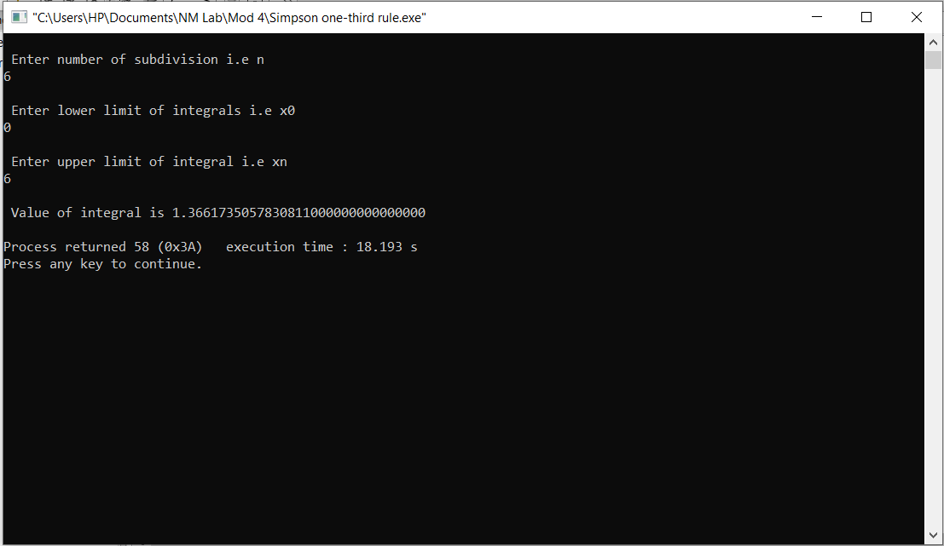

**Trapezoidal rule**

**Algorithm:**

1. Start

2. Input Lower limit a

3. Input Upper Limit b

4. Input number of sub intervals n

5. h=(b-a)/n

6.sum=0

7.sum=fun(a)+fun(b)

8.fori=1; i<n; i++

9.sum +=2*fun(a+i)

10. End Loop i

11.result =sum*h/2;

12. Print Output result

13. End of Program

14. Start of Section fun

15.temp = 1/(1+(x*x))

16. Return temp

17. Stop

**code:**

#include<math.h>

#define f(x) 1/(1+pow(x,2))

int main()

{

float lower, upper, integration=0.0, stepSize, k;

int i, subInterval;

printf("Enter lower limit of integration: ");

scanf("%f", &lower);

printf("Enter upper limit of integration: ");

scanf("%f", &upper);

printf("Enter number of sub intervals: ");

scanf("%d", &subInterval);

stepSize = (upper - lower)/subInterval;

integration = f(lower) + f(upper);

for(i=1; i<= subInterval-1; i++)

{

k = lower + i*stepSize;

integration = integration + 2 * f(k);

printf("%f\t %f\n",k,integration);

}

integration = integration * stepSize/2;

printf("\nRequired value of integration is: %.3f", integration);

getch();

return 0;

}

**Output:**

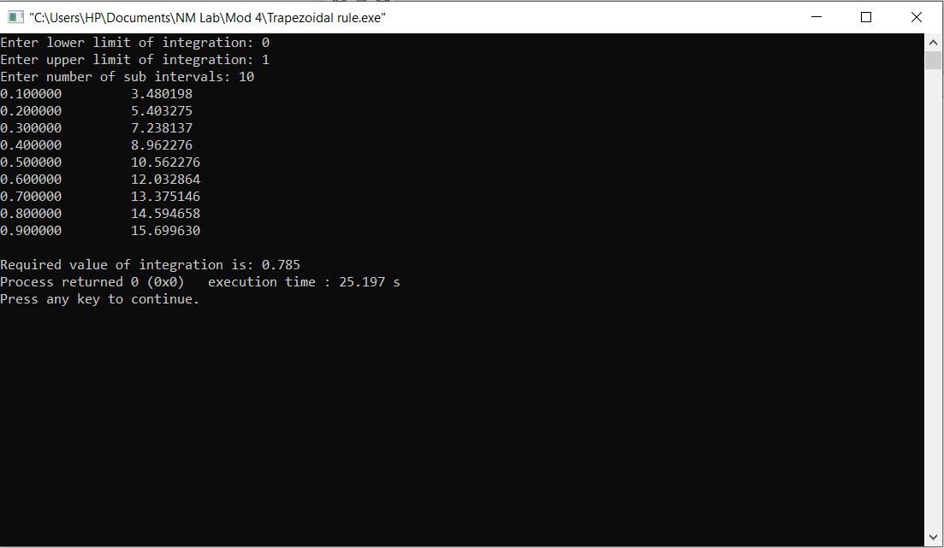

**Numerical Differentiation**

**Code:**

#include<stdio.h>

#include<stdlib.h>

#include<math.h>

#include<conio.h>

int main()

{

float x[20], y[20][20], xp, h, sum=0.0, term, first_derivative;

int i,j, n, index, flag = 0, sign=1;

printf("Enter number of data: ");

scanf("%d", &n);

printf("Enter data:\n");

for(i = 0; i < n ; i++)

{

printf("x[%d] = ", i);

scanf("%f", &x[i]);

printf("y[%d] = ", i);

scanf("%f", &y[i][0]);

}

printf("Enter at what value of x you want to calculate derivative: ");

scanf("%f", &xp);

for(i=0;i< n;i++)

{

if (fabs(xp - x[i])< 0.0001)

{

index = i;

flag = 1;

break;

}

}

if (flag==0)

{

printf("Invalid calculation point. Program exiting...");

exit(0);

}

for(i = 1; i < n; i++)

{

for(j = 0; j < n-i; j++)

{

y[j][i] = y[j+1][i-1] - y[j][i-1];

}

}

h = x[1] - x[0];

for(i=1; i< n-index; i++)

{

term = pow(y[index][i], i)/i;

sum = sum + sign*term;

sign = -sign;

}

first_derivative = sum/h;

printf("First derivative at x = %0.2f is %0.2f", xp, first_derivative);

getch();

return 0;

}

**Output:**

