**Birla Institute of Technology, Mesra**



NUMERICAL METHOD LAB

**Robin**

**ROLL NO: BTECH/15138/19**

Faculty in charge Dr. Prakash Chandra srivastava

Patna off campus

2021

**Euler’s Method**

**Algorithm:**

Step 1. Start;

Step 2. Input function f(x, y);

Step 3. Read x0, y0, xn, h;

/* x0, y0 are initial values and xn is the last value of x

where the process will terminate, h is the step size */

Step 4. for x = x0 to xn step h do

y = y0 + h * f(x, y0);

Print x, y;

y0 = y;

end for loop;

Step 5. Stop;

**Code:**

include<stdio.h>

#include<conio.h>

float fun(float x,float y)

{

float f;

f=y*y-x*x;

return f;

}

main()

{

float a,b,x,y,h,t,k;

clrscr();

printf("\nEnter x0,y0,h,xn: ");

scanf("%f%f%f%f",&a,&b,&h,&t);

x=a;

y=b;

printf("\n x\t y\n");

while(x<=t)

{

k=h*fun(x,y);

y=y+k;

x=x+h;

printf("%0.3f\t%0.3f\n",x,y);

}

getch();

return 0;

}

**Output:**

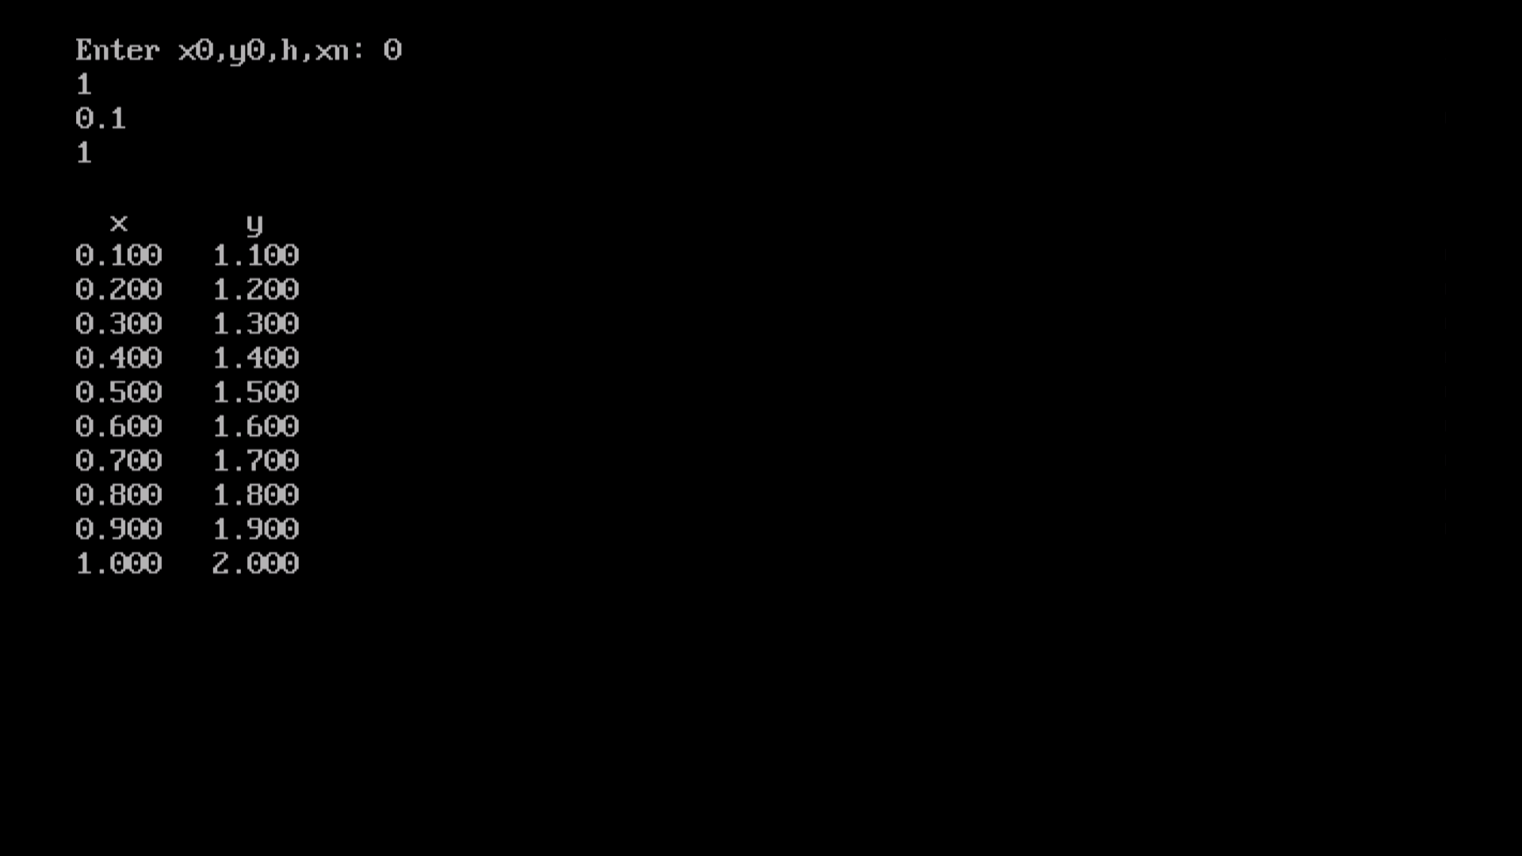

**Runge-Kutta 4th order method**

**Algorithm:**

1. Start

2. Define function f(x,y)

3. Read values of initial condition(x0 and y0),

number of steps (n) and calculation point (xn)

4. Calculate step size (h) = (xn - x0)/n

5. Set i=0

6. Loop

k1 = h * f(x0, y0)

k2 = h * f(x0+h/2, y0+k1/2)

k3 = h * f(x0+h/2, y0+k2/2)

k4 = h * f(x0+h, y0+k3)

k = (k1+2*k2+2*k3+k4)/6

yn = y0 + k

i = i + 1

x0 = x0 + h

y0 = yn

While i < n

7. Display yn as result

8. Stop

**Code:**

#include<stdio.h>

#include <math.h>

#include<conio.h>

#define F(x,y) y-x

void main()

{

double y0,x0,y1,n,h,f,k1,k2,k3,k4;

clrscr();

printf("\nEnter the value of x0: ");

scanf("%lf",&x0);

printf("\nEnter the value of y0: ");

scanf("%lf",&y0);

printf("\nEnter the value of h: ");

scanf("%lf",&h);

printf("\nEnter the value of last point: ");

scanf("%lf",&n);

for(; x0<n; x0=x0+h)

{

f=F(x0,y0);

k1 = h * f;

f = F(x0+h/2,y0+k1/2);

k2 = h * f;

f = F(x0+h/2,y0+k2/2);

k3 = h * f;

f = F(x0+h/2,y0+k2/2);

k4 = h * f;

y1 = y0 + ( k1 + 2*k2 + 2*k3 + k4)/6;

printf("\n\n k1 = %.4lf ",k1);

printf("\n\n k2 = %.4lf ",k2);

printf("\n\n k3 = %.4lf ",k3);

printf("\n\n k4 = %.4lf ",k4);

printf("\n\n y(%.4lf) = %.3lf ",x0+h,y1);

y0=y1;

}

getch();

}

**Output