Mobile devices are fast emerging as an important consideration to be made when designing and building email.

For a long time iphone was the dominant market force. Android had not yet emerged from its comfy Silicon Valley research lab onto the global stage and BlackBerry’s reputation was that of business types drafting emails to co-workers in an effort to stem the boredom of the daily commute.

The waters of late have become decidedly muddied as Android’s open source OS has been embraced by such brands as Samsung and HTC making Android a serious player in the mobile device market. BlackBerry has also lost the stigma of straight-cut business types thanks, in no small part, to the innovation of BBM, allowing BlackBerry users to message other BlackBerry users free of charge.

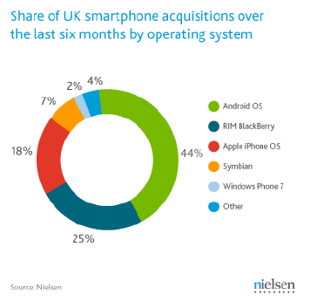This chart shows the ever changing landscape of mobile device popularity. Don’t be fooled, this does not show total market share in the UK from March 2011 to September 2011.  
  
What it does show is the acquisition of smartphones over the 6 months. This period fits neatly between two important release dates. 24th June 2010 saw the release of iphone 4 and 14 Oct 2011, the release of iphone 4s.

It is little wonder that the acquisition rate of iphone slipped between these 2 dates as it is widely acknowledged that Apple products create such a furore that in the immediate aftermath of the grand launch of one of their products, stocks fly off the shelves. But of course, once everyone in the Apple faithful has their latest upgrade they return to their homes and await the next launch date.

Iphone remains the single most popular device but the advances other brands have made, have made a strong impact and must be taken into consideration.

Market research (Feb 2012- own research) reveals the following;

The sample may only be 40 smartphone users but it mirrors other smartphone market share analysis.

We can say with some certainty that current smartphone trends put iphone and Android level pegging and BlackBerry a distant third.

Another issue that needs to be considered is the targeting of emails. BlackBerry may have expanded into the youth market in recent years but their core consumer remains firmly rooted in the business sector. Further research into the demographical breakdown of smartphone usage will be needed but the age, gender, profession and income must all be key considerations when broaching the subject of targeting email for all/certain mobile devices.

The development of Android as rival to iphone and BlackBerry users profile presents varying degrees of difficulty when designing, building and testing email on mobile platforms.

The most important difference between all 3 is the screen size and resolution.

* Iphone 4/4s has a 3.5” screen with a resolution of 640x960px

Apple boasts one advantage over the other 2 as they only have one mobile phone. The iphone 4/4s is the latest Apple phone and comfortably most popular. Android and BlackBerry have numerous devices which may increase their diversity and in doing so, their market share, but from our point-of-view it makes things far more difficult.

The 4 most popular Android devices are;

* HTC Desire/Desire HD
* Samsung Galaxy S/S II

All 4 are slightly different as the upgrade of each (Desire HD and Galaxy S II) features a larger screen but from an HTML point of view the important thing is the resolutions are the same at 480x800px. From this perspective, only one of the phones is required for testing purposes. The pie chart below confirms the market share of what is known as a *Normal/hdpi* screen.

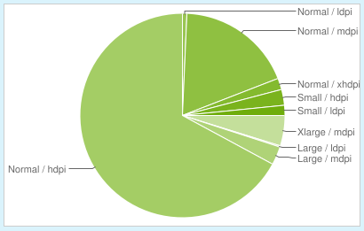

[www.developer.android.com](http://www.developer.android.com) is a website designed to aid app developers with up-to-date information on everything from how to code to current data on the popular OS. The most recent OS breakdown from 1st May 2012 is below.

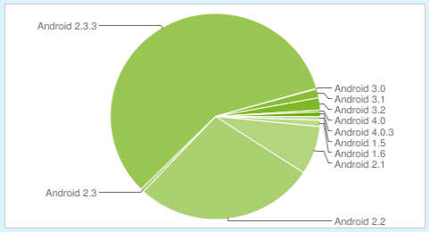

BlackBerry presents problems as their recent foray into touchscreen phones such as the Torch as a rival to iphone/Android devices means guaranteeing email quality for all BlackBerry’s is nigh on impossible. There is a light at the end of BlackBerry tunnel however as their touchscreen devices have not been a huge success.

If the BlackBerry approach is to be watertight then guaranteeing email for one set of specifications is the key.

With a screen size of 2.44”, resolution of 480x360px and density of 246ppi the Curve, Torch and Bold in most of their various 4-digit guises is the clear choice for an approach to BlackBerry that will cover a lot of devices. The second most popular resolution is 320x240px; this must also be taken into account when deciding on the approach although the popularity of the devices with that resolution is waning as upgrades increasingly feature the larger resolution.

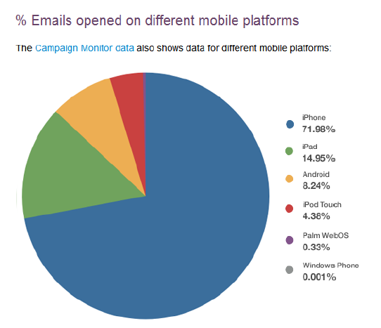

This data from campaign monitor (October 2011) shows a commanding lead for all Apple products when we look at open rates of email on mobiles. The problem of trusting this evidence is all too real as recent examinations of Litmus and Campaign Monitor results have shown.

What we can perhaps take as red however is the total market dominance of ipad in the tablet market. Apple essentially invented the tablet computer but their dominance, although still significant is being eaten into. BBC research shows that “Android accounted for 39% of the [global] market in the final three months of last year, up from 29% a year earlier, Strategy Analytics said. Apple's share fell to 58% from 68%”. Despite this slip in Apple dominance, a Return Path study states there was “an increase of 73% in email views on ipad devices between April and September 2011”. This study, coupled with the huge diversity in size and resolution of tablet devices makes the ipad a shoe-in to be *the* tablet approach.