**Guide to add a client/Employees user to share file**

1. First login into share file, press manage users and add client. Input the e-mail of the Client into the page below that comes up and press next step.

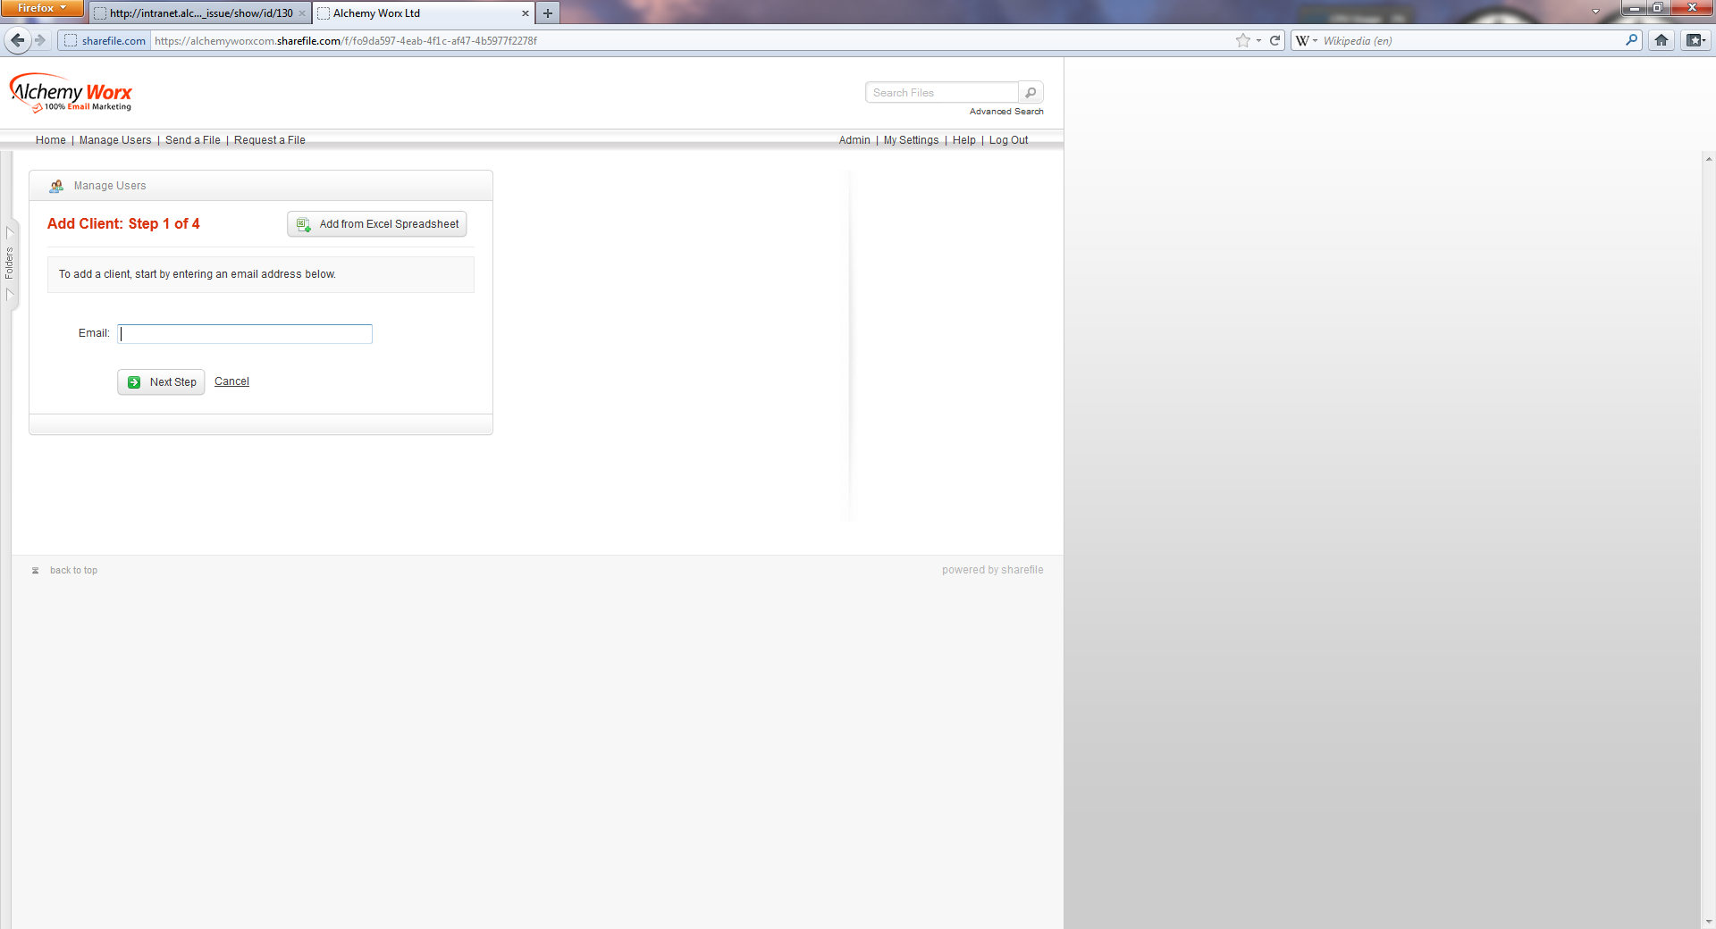

1. Add first name and last name and company if available (there should be one).

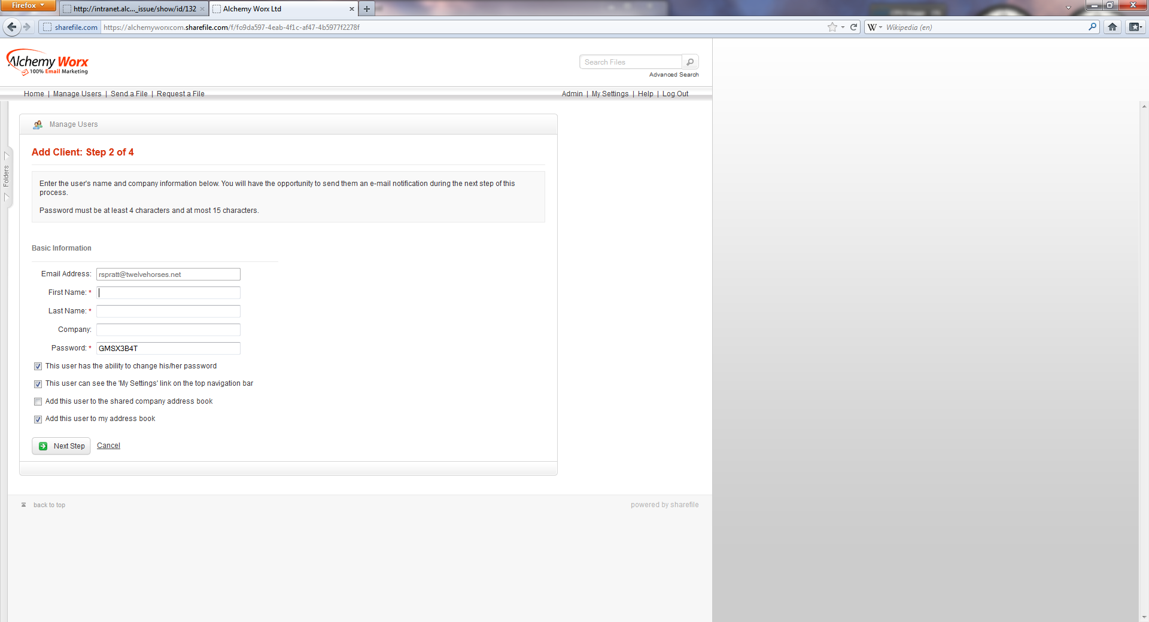

1. Add the required folders and, if needed, Groups by click the “add to groups tab”. Adding to some groups automatically makes many folders available.

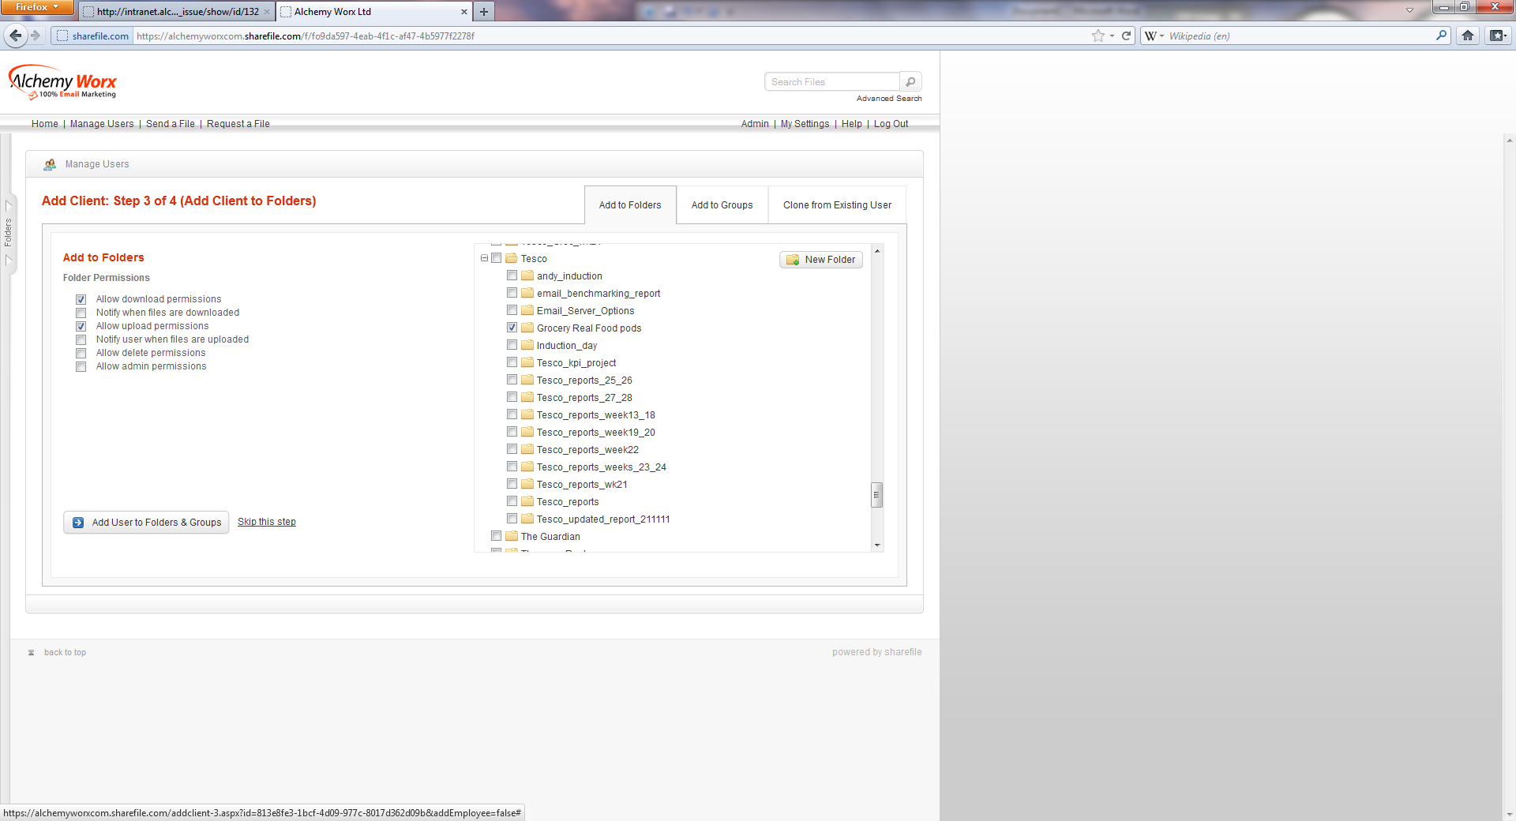

1. Once you press the add button in the previous page the below will appear. Make a record of the Login URL, Username and password and press finish without sending. Do not press send notification e-mail, this does not work.

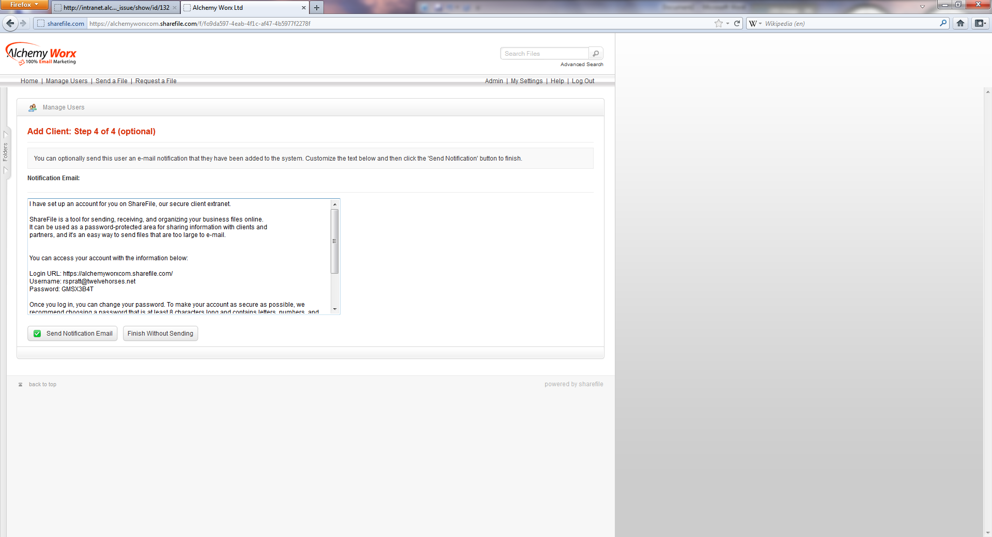

After pressing “finishing without sending” the task is complete.