**Guide To Back Up E-Mail**

Backing up e-mail is useful in-case there are problem with your e-mail storage (it gets corrupted or becomes inaccessible) or there is problems with your machine and you are no longer able to access your e-mail.

First go, on outlook 2010: File / Info / Account Settings or on outlook 2007: Tools / Account Settings. In the window that follows select the data files tab, you should see the below:

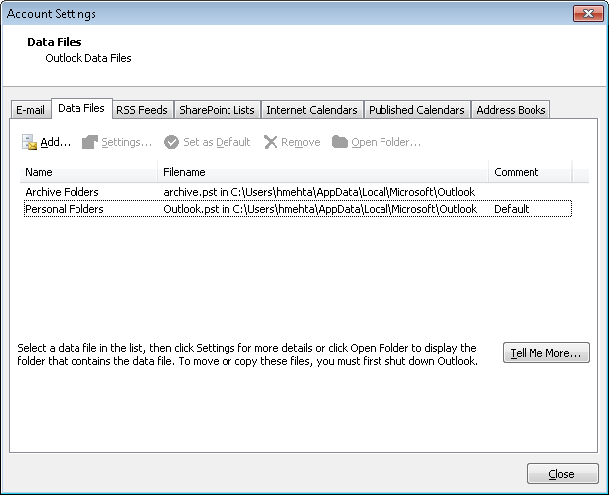

You will see all the mail storages you have. The personal folder is your main folder and any other storage is an archive. Select the personal folder and press the open folder button. You will see the below:

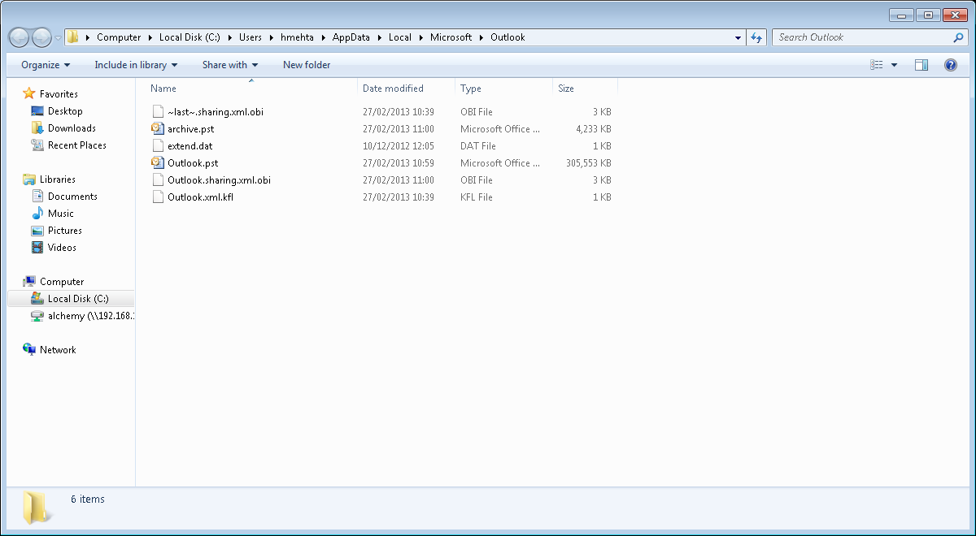

A windows explorer will open showing your mail storages. The outlook.pst is your main mail folder. Copy this file to back up your mail, it is suggested to put backups in this directory: \\192.168.1.4\alchemy\employee under a folder named after you (username i.e. \\192.168.1.4\alchemy\employee\yourusername). You can store the other archive.pst files here as well.

Please note when backing up e-mail **you will not be able to access your outlook.** Also note dependant on size it could take quite a while to back up e-mail so it is suggested to do it over night.