FTP Access Guide
This guide will describe ftp access via winscp. We will use silverpop CPW access as an example.
For Silverpop Ftp Access for CPW start Winscp. Press new (if required) and enter in the details as below:
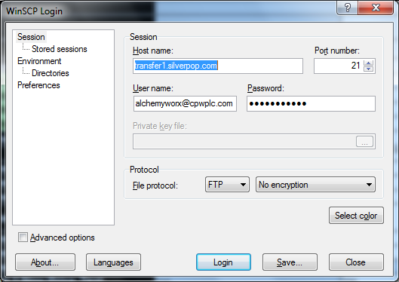
The password will be stored in the FTP keypass database. If you have a newer version of winscp it may look different from above, but the hostname, username, port number and password are all the same. This would be the same for any other ftp access as well.
Once all Details are entered press the save button. If given permission please tick the box for winscp to save the password. Then press ok.
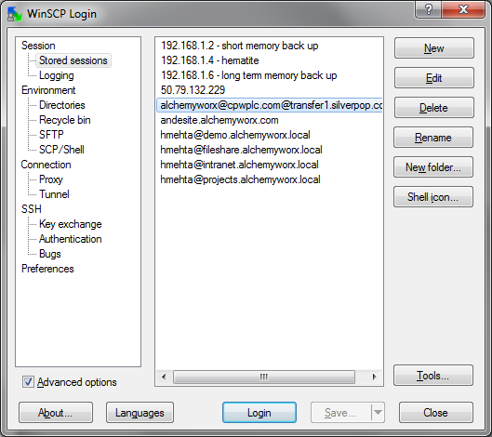
Then press Login (selecting the correct one) to enter that ftp service. Contact your manager if there are any login issues.

