ABSTRACT

**Online Detective Agency (ODA)**

My project is entitled “**Online Detective Agency (ODA)**”. The aim to create the computerized coordination of an Detective agencies**.**

The computer plays a very big role in everyday life. It makes our study easier than our expectations. I just want to extend the use of computer in a detective agency. It makes easy to control and manipulate the working of detective agencies . We like to do such things making something that makes things easy. We feel this little challenging and interesting. That is the motivation behind this project.

**Online Detective Agency** is a web based application. Any number of clients can connect to the server .This software provide facility for reporting any person’s complaints, background check, shows matrimonial investigation details via mail or chat. My project is designed to get all services under one web site.

The Online Detective Agency is an web application developed using ASP.net as front end and SQL Server as back end. The proposed system consists of three modules such as Administrator, Detective agency and registered users. Each of these modules can perform some tasks.

1. Administration

Administrator can view and reply to a user’s complaint and the complaints are passes to the corresponding agencies. The administrator can view and reply to a user’s crimes, add and delete latest hot news, view and delete user’s feedback, add and view the investigation report. It also felicitates email and chat felicitates along with other log in controls.

1. Detective Agency Management

Detective Agency’s add the good investigator for checking different complaints; investigator details and feedback manage the detective agencies.

1. Customer Management

Users can file a checking complaints, uploads the details of checking person, view all further updates by other users. They also can edit complaints, chat or mail people, get uploads on investigation report or the complaints filed by them.

**DATA FLOW DIAGRAM**

**CONTEXT LEVEL:**

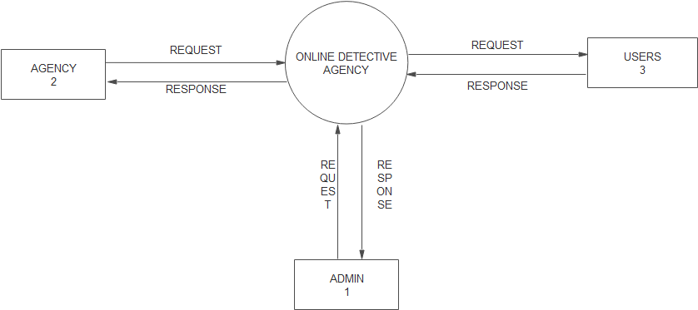

**LEVEL 1: ADMIN**

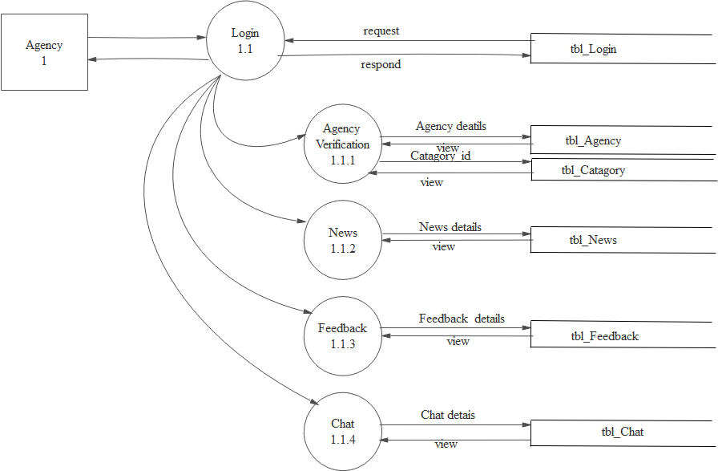

**LEVEL 1: AGENCY**

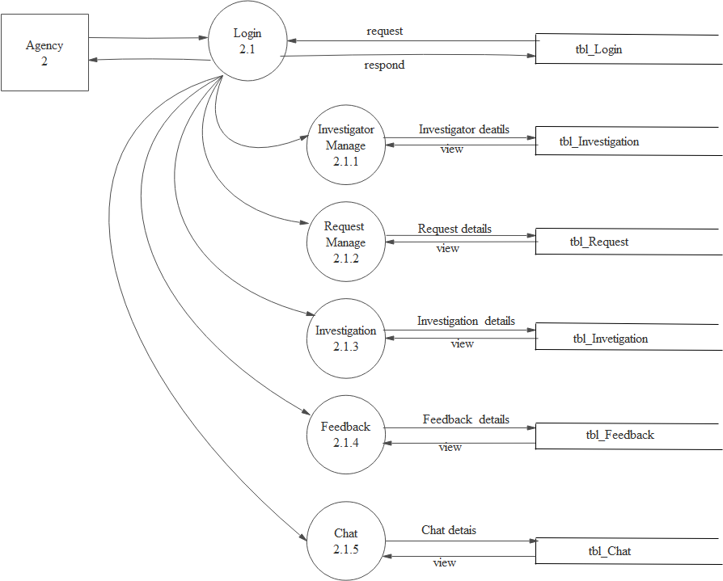

**LEVEL 1: USER**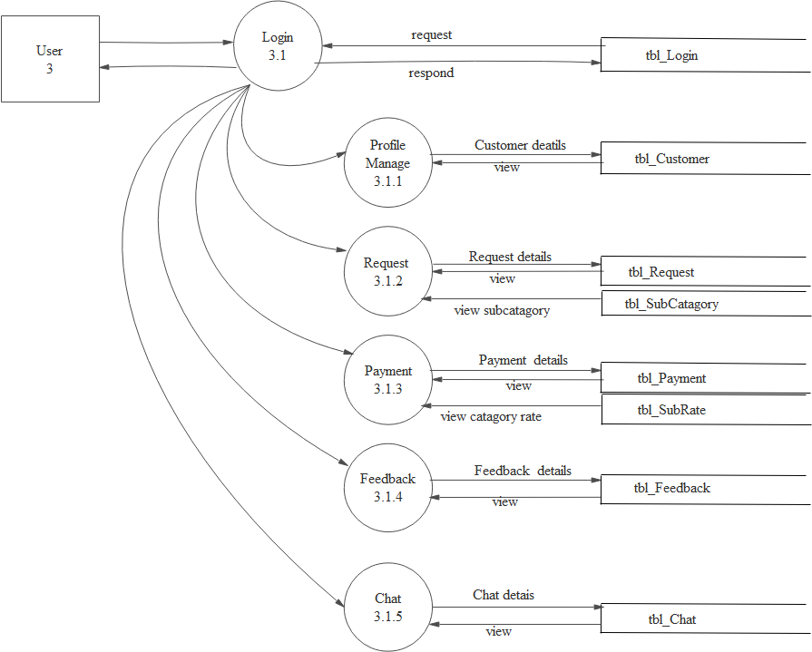

**Table:1**

**Table Name:tbl_login**

**Primary Key:login_id**

**Table Description:Contains details of login**

|  |  |  |  |  |
| --- | --- | --- | --- | --- |
| Field Name | Datatype | Size | Description | Constraints |
| login_username | nvarchar | 50 | Stores the login_username | Not Null |
| login_password | nvarchar | 50 | Stores thelogin_password | Not Null |
| Login_Squstion | nvarchar | 50 | Stores thelogin_question | Not Null |
| Login_Sanswer | nvarchar | 50 | Stores thelogin_answer | Not Null |
| Login_usertype | nvarchar | 50 | Stores thelogin_usertype | Not Null |

**Table:2**

**Table Name:tbl_Agency**

**Primary Key:Agency_code**

**Table Description:Contains Agency details**

|  |  |  |  |  |
| --- | --- | --- | --- | --- |
| Field Name | Datatype | Size | Description | Constraints |
| Agency_CODE | int | 2 | Used to identify agency | PRIMARY KEY |
| Agency_Name | nvarchar | 50 | Stores the agency’s name | Not Null |
| Agency_RegistrationNumber | nvarchar | 50 | Stores the Registration number | Not Null |
| Catagory_ID | int | 5 | Stores the catagory id | FOREIGN KEY |
| Agency_LonginDate | date | 8 | Stores the longin date | Not Null |
| Agency_MobileNo | nvarchar | 10 | Stores the Mobile No | Not Null |
| Agency_Certificate | nvarchar | 50 | Stores the certificate | Not Null |
| Agency_Photo | nvarchar | 50 | Stores the photo | Not Null |
| Agency_Email | nvarchar | 50 | Stores the Email | Not Null |

**Table:3**

**Table Name:tbl_Catagory**

**Primary Key:Catagory_ID**

**Table Description:Contains Catagory details**

|  |  |  |  |  |
| --- | --- | --- | --- | --- |
| Field Name | Datatype | Size | Description | Constraints |
| Catagory_ID | int | 2 | Used to identify Catagory | PRIMARY KEY |
| Catagory_name | nvarchar | 50 | Stores the Catagory name | Not Null |

**Table:4**

**Table Name:tbl_SubCatagory**

**Primary Key:SubCatagory_ID**

**Table Description:Contains details of SubCatagory**

|  |  |  |  |  |
| --- | --- | --- | --- | --- |
| Field Name | Datatype | Size | Description | Constraints |
| SubCatagory_ID | int | 2 | Used to identify SubCatagory | PRIMARY KEY |
| Catagory_ID | int | 2 | Stores the catagory name | FORGIN KEY |
| SubCatagory_Name | nvarchar | 50 | Stores the SubCatagory name | Not Null |

**Table:5**

**Table Name:tbl_SubCatagoryRate**

**Primary Key:SubCatagoryRate_ID**

**Table Description:Contains details of SubCatagoryRate**

|  |  |  |  |  |
| --- | --- | --- | --- | --- |
| Field Name | Datatype | Size | Description | Constraints |
| SubCatagoryRate_ID | int | 2 | Used to identify SubCatagoryRate | PRIMARY KEY |
| SubCatagoryRate_Name | nvarchar | 50 | Stores the SubCatagoryRate name | Not Null |
| Catagory_ID | int | 2 | Stores the Catagory | FORGIN KEY |

**Table:6**

**Table Name:tbl_Customer**

**Primary Key:Customer_CODE**

**Table Description:Contains details of Customer**

|  |  |  |  |  |
| --- | --- | --- | --- | --- |
| Field Name | Datatype | Size | Description | Constraints |
| Customer_CODE | int | 2 | Used to identify Customer | PRIMARY KEY |
| Customer_Name | nvarchar | 50 | Stores the Customer name | Not Null |
| Customer_HouseName | nvarchar | 50 | Stores the House Name | Not Null |
| Customer_Country | nvarchar | 50 | Stores the Country | Not Null |
| Customer_State | nvarchar | 50 | Stores the State | Not Null |
| Customer_MobilNO | nvarchar | 10 | Stores the Mobile No | Not Null |
| Customer_PinCode | nvarchar | 6 | Stores thePinCode | Not Null |
| Customer_AdtherNo | nvarchar | 12 | Stores the adthar no | Not Null |
| Customer_Photo | nvarchar | 12 | Stores the photo | Not Null |
| Customer_Gender | nvarchar | 12 | Stores the gender | Not Null |
| Customer_DOB | date | 12 | Stores the DOB | Not Null |

**Table:7**

**Table Name:tbl_Request**

**Primary Key:Request_*ID***

**Table Description:Contains the details of customer request**

|  |  |  |  |  |
| --- | --- | --- | --- | --- |
| Field Name | Datatype | Size | Description | Constraints |
| Request_ID | int | 2 | Used to identify request | PRIMARY KEY |
| Customer_CODE | int | 2 | Stores the customer name | FOREIGN KEY |
| SubCatagory_ID | int | 2 | Stores the sub catagory | FOREIGN KEY |
| Agency_CODE | int | 2 | Stores the Agency | FOREIGN KEY |
| Catagory_ID | int | 2 | Stores the Catagory | FOREIGN KEY |
| Request_Subject | nvarchar | 50 | Stores the Subject | Not Null |
| Request_Details | nvarchar | 50 | Stores the Details | Not Null |
| Request_DateIn | date | 8 | Stores the DateIn | Not Null |
| Request_DateOut | date | 8 | Stores the Date Out | Not Null |
| Request_Status | nvarchar | 50 | Stores the Status | Not Null |

**Table:8**

**Table Name:tbl_Investigator**

**Primary Key:Investigator_Code**

**Table Description:Contains details of Investigator**

|  |  |  |  |  |
| --- | --- | --- | --- | --- |
| Field Name | Datatype | Size | Description | Constraints |
| Investigator_Code | int | 2 | Used to identify investigator | PRIMARY KEY |
| Agency_Code | int | 2 | Stores the agency name | FOREIGN KEY |
| Investigator_Name | nvarchar | 50 | Stores the Name | Not Null |
| Investigator_HouseName | nvarchar | 50 | Stores the House Name | Not Null |
| Investigator_Place | nvarchar | 50 | Stores the Place | Not Null |
| Investigator_Country | nvarchar | 50 | Stores the Country | Not Null |
| Investigator_State | nvarchar | 20 | Stores the State | Not Null |
| Investigator_Pincode | nvarchar | 6 | Stores the Pincode | Not Null |
| Investigator_MobilNo | nvarchar | 10 | Stores the MobileNo | Not Null |
| Investigator_Email | nvarchar | 20 | Stores the Email | Not Null |
| Investigator_AdtherNo | nvarchar | 12 | Stores the AdtherNo | Not Null |
| Investigator_DOJ | date | 8 | Stores the Date of Join | Not Null |
| Investigator_Position | nvarchar | 20 | Stores the Position | Not Null |
| Investigator_Experience | nvarchar | 20 | Stores the Experience | Not Null |
| Investigator_Photo | nvarchar | 20 | Stores the photo | Not Null |
| Investigator_Qualification | nvarchar | 20 | Stores the Qualification | Not Null |
| Investigator_District | nvarchar | 20 | Stores the District | Not Null |
| Investigator_Gender | nvarchar | 5 | Stores the Gender | Not Null |

**Table:9**

**Table Name:tbl_Investigation**

**Primary Key:Investigation_CODE**

**Table Description:Contains details of Investigation**

|  |  |  |  |  |
| --- | --- | --- | --- | --- |
| Field Name | Datatype | Size | Description | Constraints |
| Investigation_CODE | int | 2 | Used to identify investigation | PRIMARY KEY |
| Investigator_CODE | int | 2 | Stores the investigator | FOREIGN KEY |
| Request_ID | int | 2 | Stores the request id | FOREIGN KEY |
| Investigation_StartingDate | date | 8 | Stores the date | Not Null |
| Investigation_Status | nvarchar | 18 | Stores the Status | Not Null |
| Investigation_Report | nvarchar | 18 | Stores the report | Not Null |

**Table:10**

**Table Name:tbl_FeedBack**

**Primary Key:FeedBack_ID**

**Table Description:Contains FeedBack details**

|  |  |  |  |  |
| --- | --- | --- | --- | --- |
| Field Name | Datatype | Size | Description | Constraints |
| FeedBack_ID | int | 2 | Used to identify feedback | PRIMARY KEY |
| FeedBack_Header | nvarchar | 50 | Stores the Header | Not Null |
| FeedBack_Things | nvarchar | 50 | Stores the Things | Not Null |
| FeedBack_UserType | nvarchar | 50 | Stores the Usertype | Not Null |

**Table:11**

**Table Name:tbl_Chat**

**Primary Key:Chat_ID**

**Table Description:Contains chat details**

|  |  |  |  |  |
| --- | --- | --- | --- | --- |
| Field Name | Datatype | Size | Description | Constraints |
| Chat_ID | int | 2 | Used to identify chat | PRIMARY KEY |
| Chat_Subject | nvarchar | 50 | Stores the subject | Not Null |
| Chat_Message | nvarchar | 50 | Stores the message | Not Null |
| Chat_UserType | nvarchar | 50 | Stores the user type | Not Null |
| Chat_Date | date | 8 | Stores the date | Not Null |
| Chat_Time | time | 10 | Stores the time | Not Null |

**Table:12**

**Table Name:tbl_Payment**

**Primary Key:Payment_ID**

**Table Description:Contains payment details of customer**

|  |  |  |  |  |
| --- | --- | --- | --- | --- |
| Field Name | Datatype | Size | Description | Constraints |
| Payment_ID | int | 2 | Used to identify payment | PRIMARY KEY |
| Customer_CODE | int | 2 | Stores the customer name | FOREIGN KEY |
| SubCatagoryRate_ID | int | 2 | Stores the sub rate | FOREIGEN KEY |
| Payment_Date | date | 8 | Stores the date | Not Null |
| Payment_Amount | nvarchar | 50 | Stores the amount | Not Null |
| Payment_Balance | nvarchar | 50 | Stores the Balance | Not Null |

**Table:13**

**Table Name:tbl_News**

**Primary Key:News_ID**

**Table Description:Contains details of news**

|  |  |  |  |  |
| --- | --- | --- | --- | --- |
| Field Name | Datatype | Size | Description | Constraints |
| News_ID | int | 2 | Used to identify news | PRIMARY KEY |
| News_Heading | nvarchar | 50 | Stores the heading | Not Null |
| News_Photo | nvarchar | 50 | Stores the photo | Not Null |
| News_Subject | nvarchar | 50 | Stores the subject | Not Null |
| News_Date | date | 8 | Stores the date | Not Null |
| News_Time | nvarchar | 50 | Stores the time | Not Null |
| News_LimitedPeroid | nvarchar | 50 | Stores the peroid | Not Null |
| News_Storage | nvarchar | 50 | Stores the news storage | Not Null |