**预先条件:**

1. 下载软件
   1. 下载Oracle 或者OpenJDK 1.7.0版本以上。(本次使用oracle JDK)
2. For windows

<https://download.oracle.com/java/21/latest/jdk-21_windows-x64_bin.msi>

1. For Linux

<https://download.oracle.com/java/21/latest/jdk-21_linux-x64_bin.rpm>

1.2 下载vdbench5.04版本

For Windows/Linux/Unix

<https://download.oracle.com/otn/utilities_drivers/vdbench/vdbench50407.zip>

1. 设置环境变量

JDK下载完后,会自动设置window环境变量,将上述vdbench解压到c:\下,然后系统级别的环境变量

测试vdbench执行环境

./vdbench -t (for a raw I/O workload)

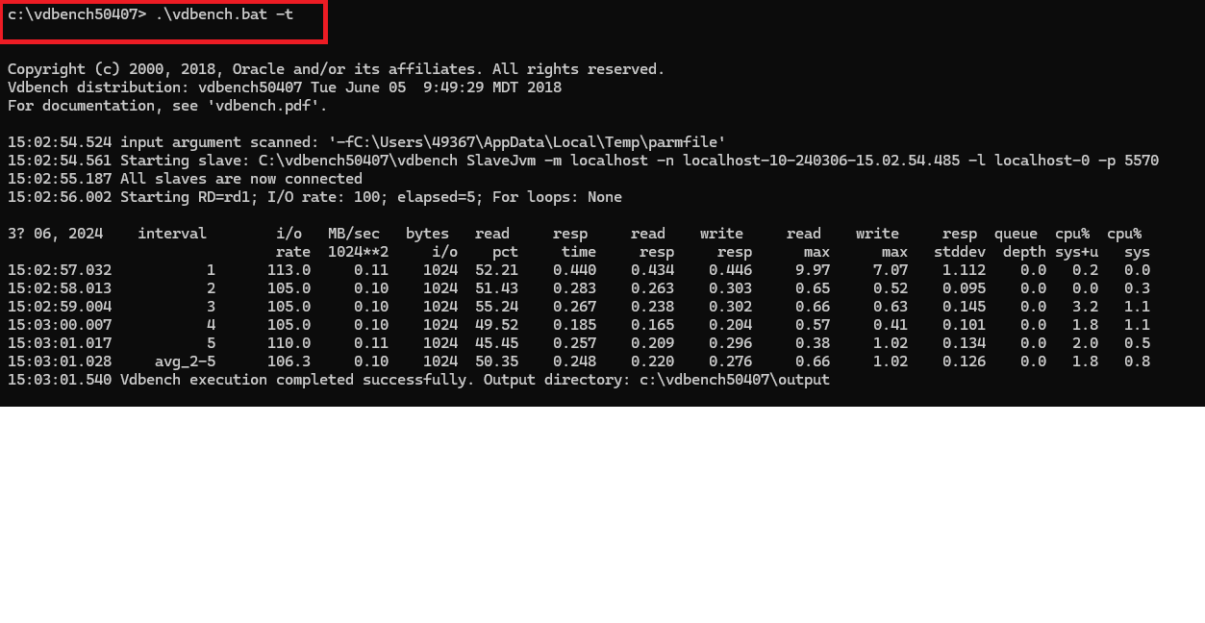

.\vdbench.bat -tf (for a file system workload)

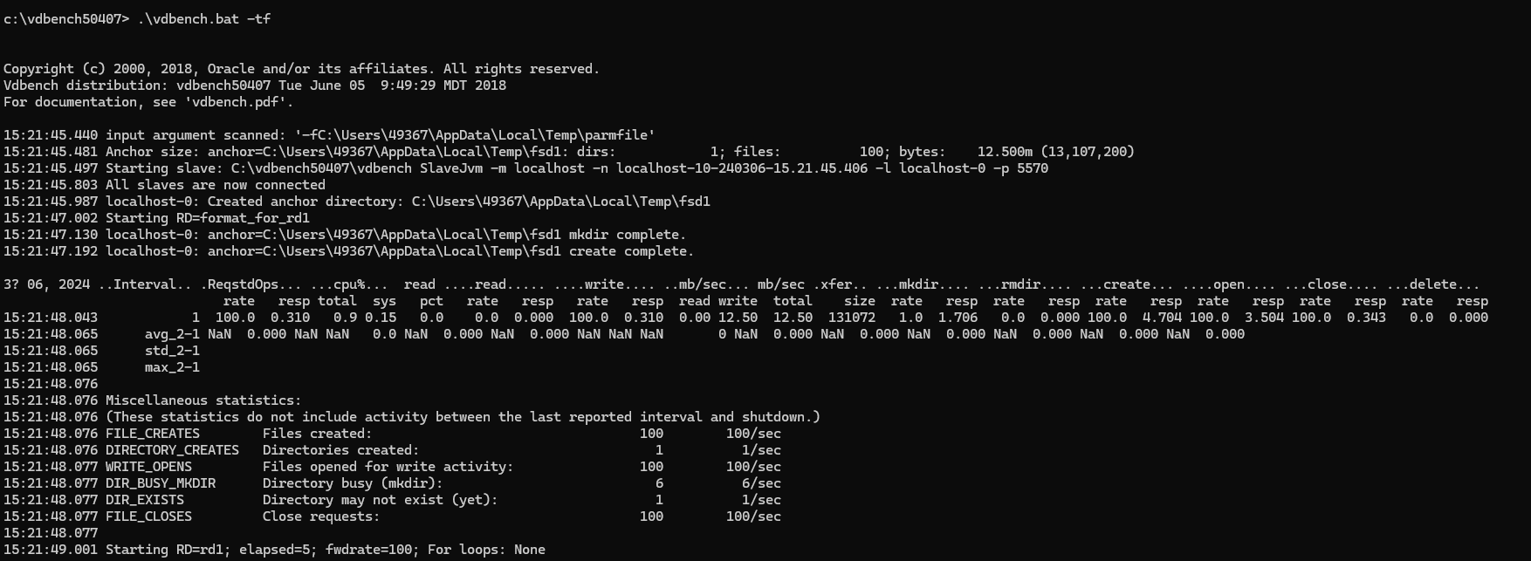

**Terminology**

RAW I/O workload(存储级别,直接对存储本身进行测试,绕过文件系统缓存)

参数如下:

Storage Definition (SD)

Workload Definition (WD)

Run Definition (RD)

File System workload(文件系统级别)

参数如下

File System Definition (FSD)

File system Workload Definition (FWD)

Run Definition (RD)

通用参数

General,

Group (RG)

Host Definition (HD)

Replay

JVM Master

JVM Slave

vdbench测试语法:

Linux/Unix: vdbench -f parmfile

Windows: vdbench.bat -f parmfile

样例文件:

C:\vdbench50407\examples

Openflags

Directio /dev/xxx volumes

[Vdbench performance test on filesystem | FlamingBytes](https://www.flamingbytes.com/blog/vdbench-performance-test-on-filesystem/)

[VDBench - Lustre Wiki](https://wiki.lustre.org/VDBench)

[【ceph】vdbench的使用教程——裸盘测试和文件系统测试vdbanch - bdy - 博客园 (cnblogs.com)](https://www.cnblogs.com/bandaoyu/p/16752095.html)