Programming GPIO on Raspberry Pi 3 using C language and WiringPi library
(by Robin Brämer – https://github.com/robinbraemer)

Steps:

First open a new “Geany”...


...make a new “main.c” file…

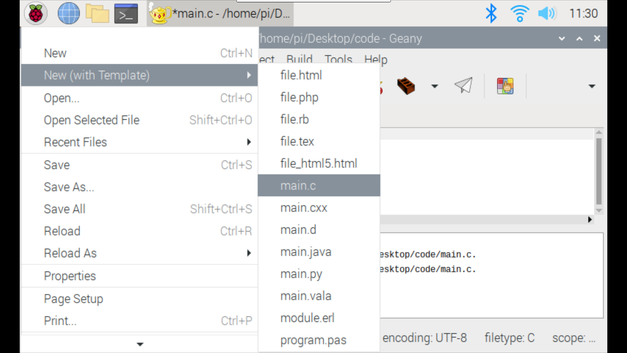
...and copy-paste the following code.

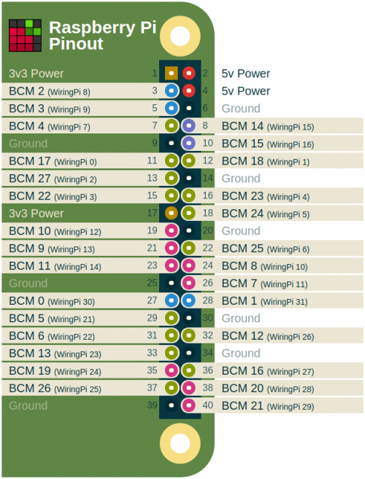
Code sample:
#include <stdio.h>
#include <wiringPi.h>

#define LED 29

int main(void) {
printf("Raspberry Pi blink\n");

wiringPiSetup();
pinMode(LED, OUTPUT);

for (;;) {
digitalWrite(LED, HIGH); // On
delay(500); // mS
digitalWrite(LED, LOW); // Off
delay(500);
}

return 0;
}

Before you can build & run the program you need to link the included wiringPi library!
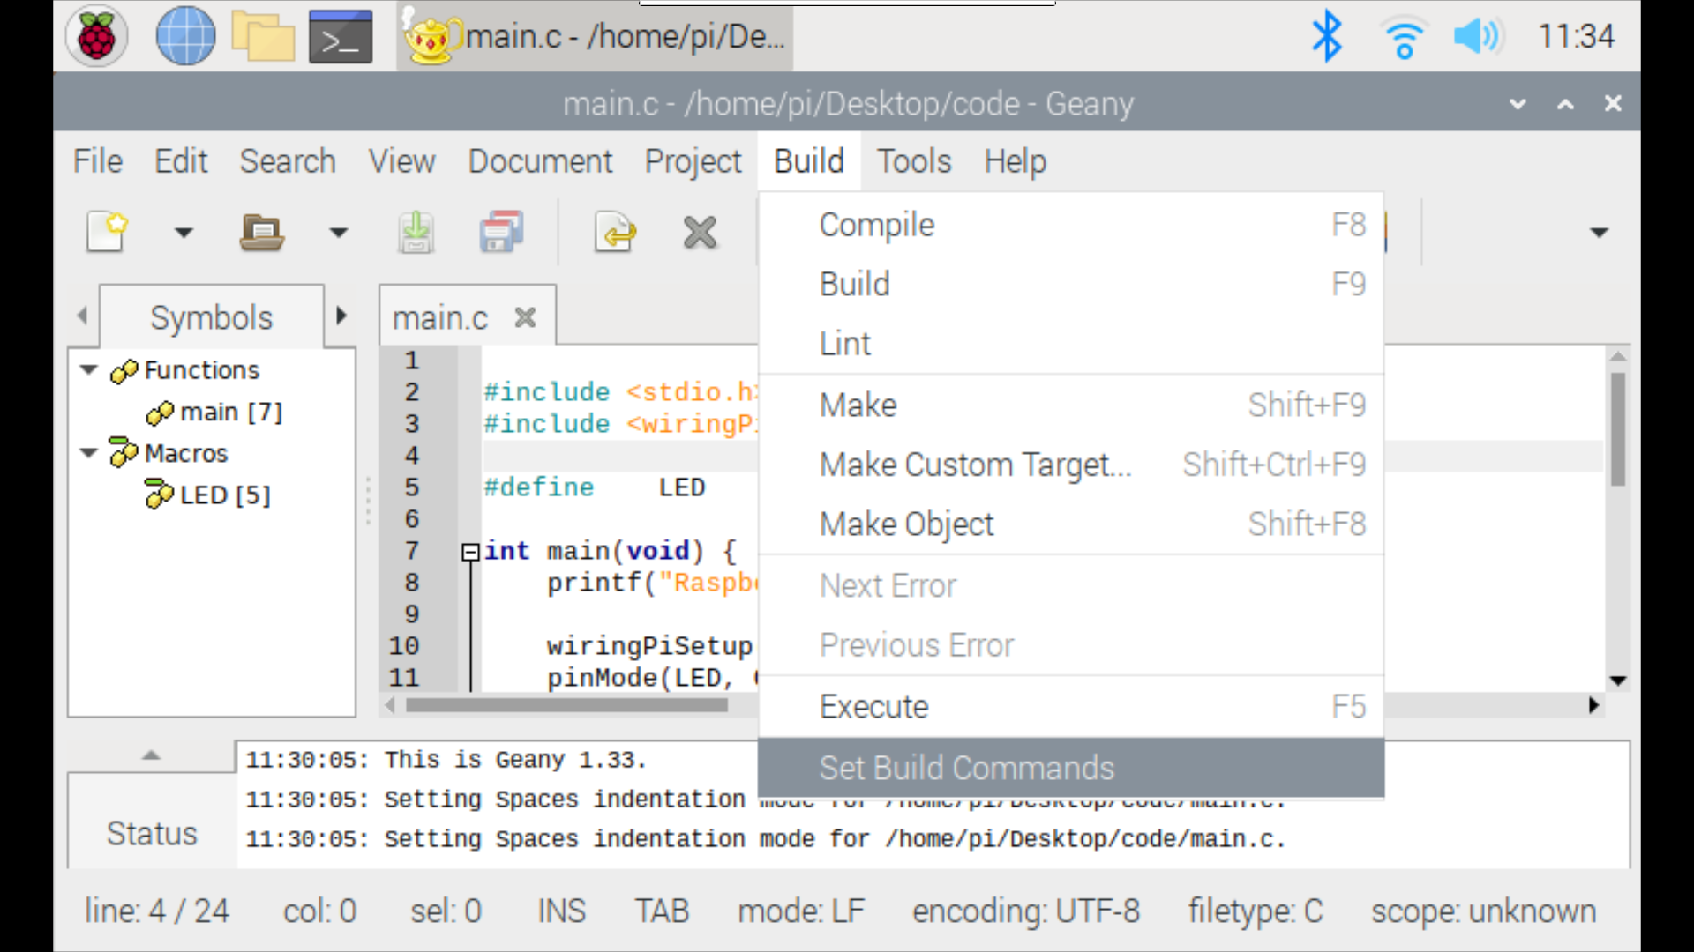

Add the two “-l wiringPi” link flags and save.
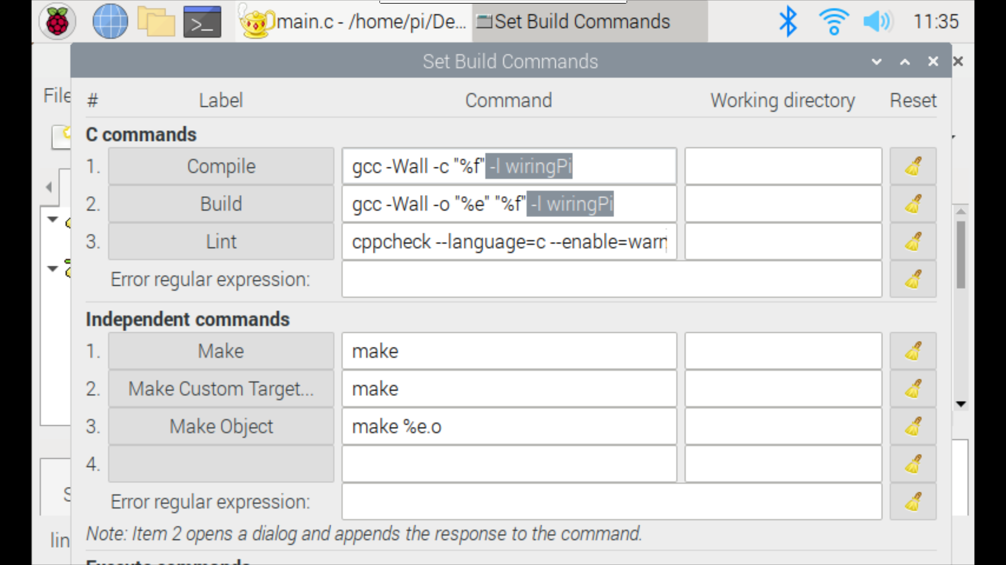
Now you can click Build and Run the program!

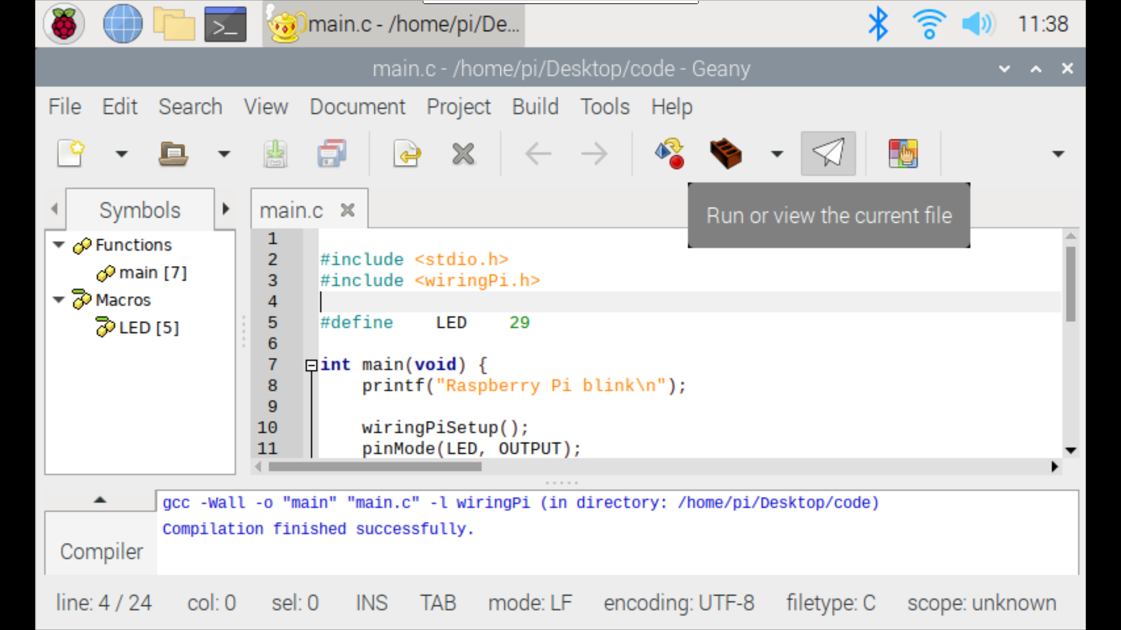
Sources:
- https://wiki.odroid.com/_media/odroid-xu4/application_note/gpio/screenshot_from_2018-03-29_11-33-26.png?w=500&tok=6ae58c

