**Final Database**

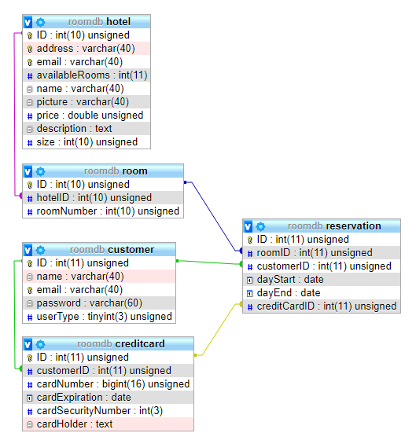

**Summary**

This website is a very basic website reservation hotel. The point of this website is to provide a place to view multiple options for hotels and then reserve a stay in whichever one you want. The Index page provides links to create and log into accounts, it also lists all the available hotels along with a small picture. If a user is logged in the index page will allow them to log out or access the specifics of their own account, if the user is an admin it will also provide a link to access the admin zone. Clicking on a hotel entry will filter it off the page.

Once a user is logged on they can view their reservations and register a credit card to their account. Each reservation can be viewed in more detail. Clicking on the “visit profile” link on the index page will bring you to the profile of whichever hotel you selected where you can see how much a room costs per night, how many guests are fit into each room, a description of the hotel, a larger picture of a hotel room, and a button to reserve a room or return to the index page. If you choose to reserve a room at a hotel it will bring you to a form where you will set the day you would like to start and end your visit, and which credit card on your account you would like to use to pay for the reservation, and also allows the user to cancel the reservation if they so choose.

The admin zone allows an administrator to create, edit, and delete hotels, rooms, and users. I did not add the functionality to add, edit, or delete reservations as the regular user has sufficient ability to do these things and I feel that only the user should have these abilities. The only time that an admin will delete a reservation is if the room (or entire hotel) related to the reservation is deleted.

**Index when not logged in**

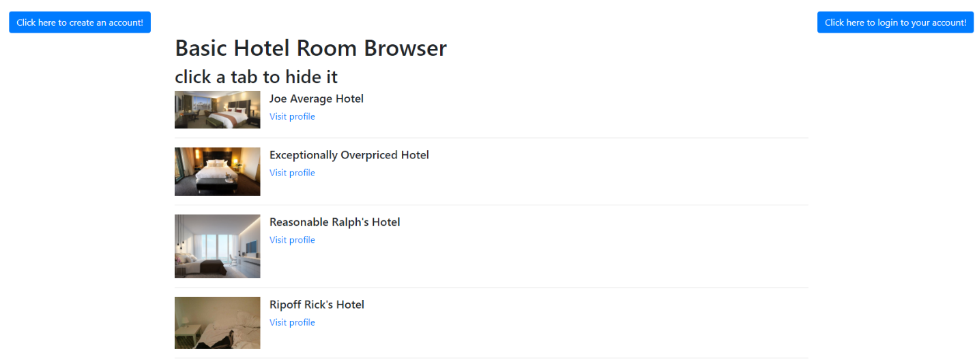

**Index when logged in as regular user**

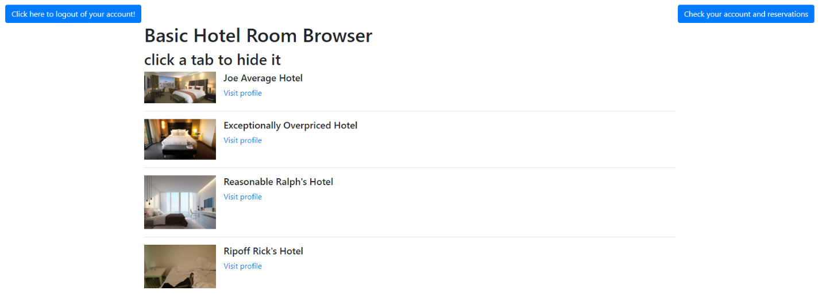

**Index when logged in as admin**

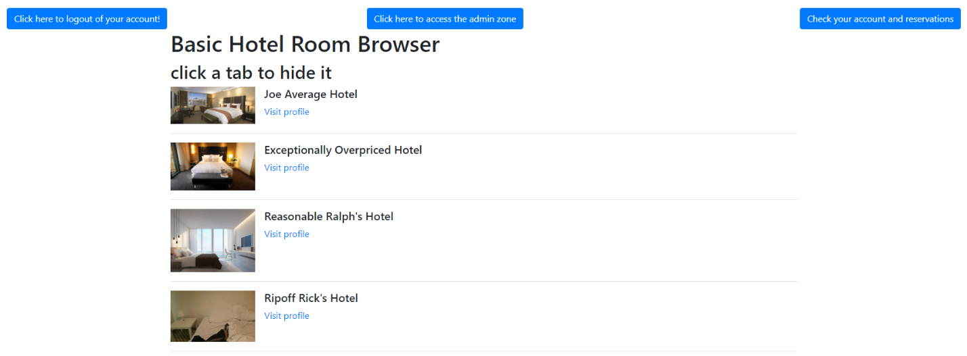

**User account page**

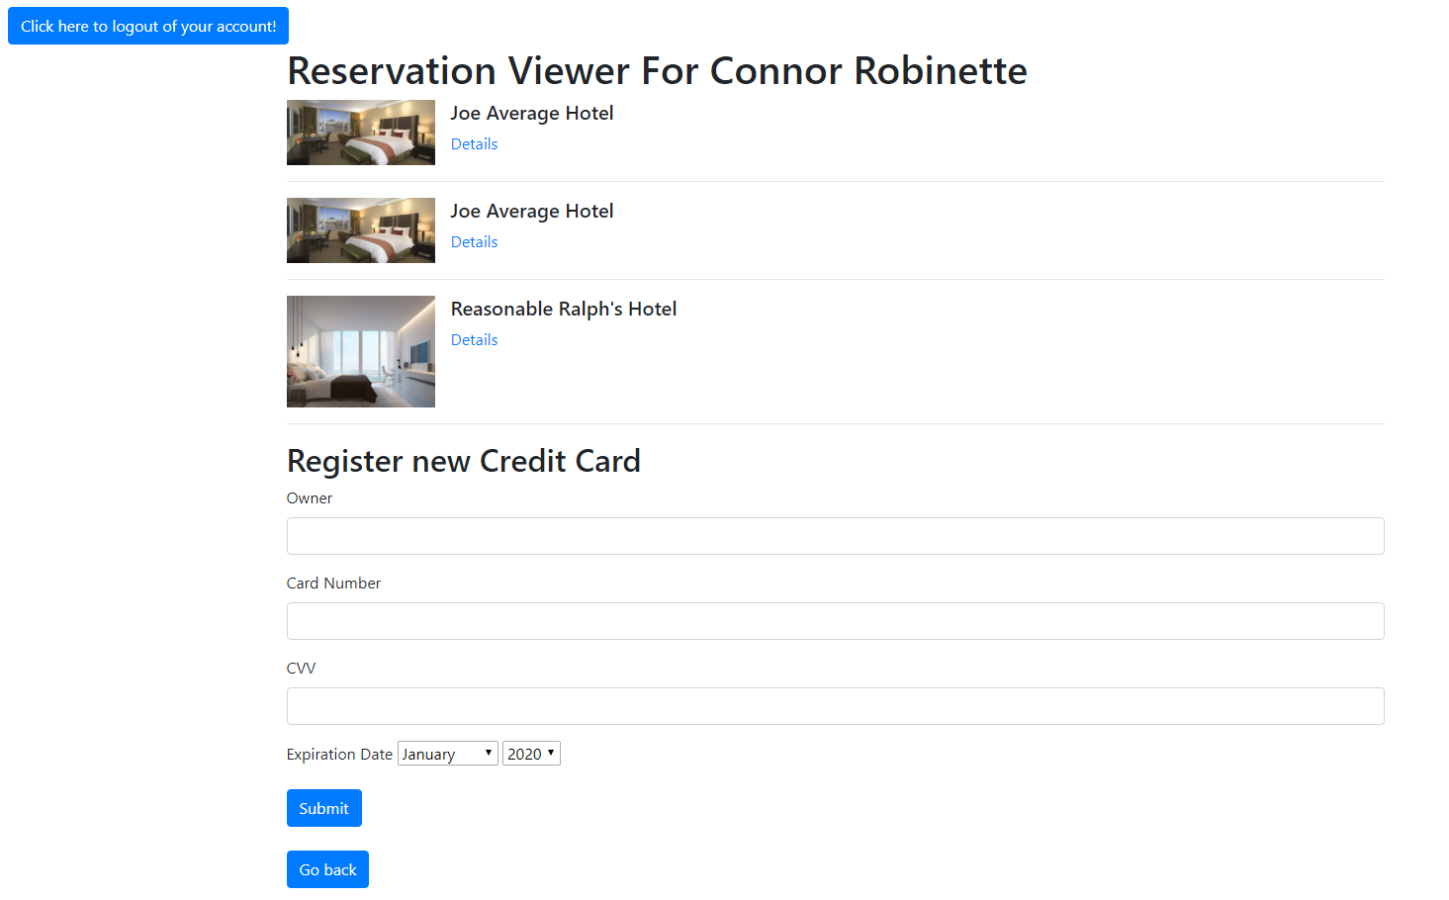

**Reservation detail page**

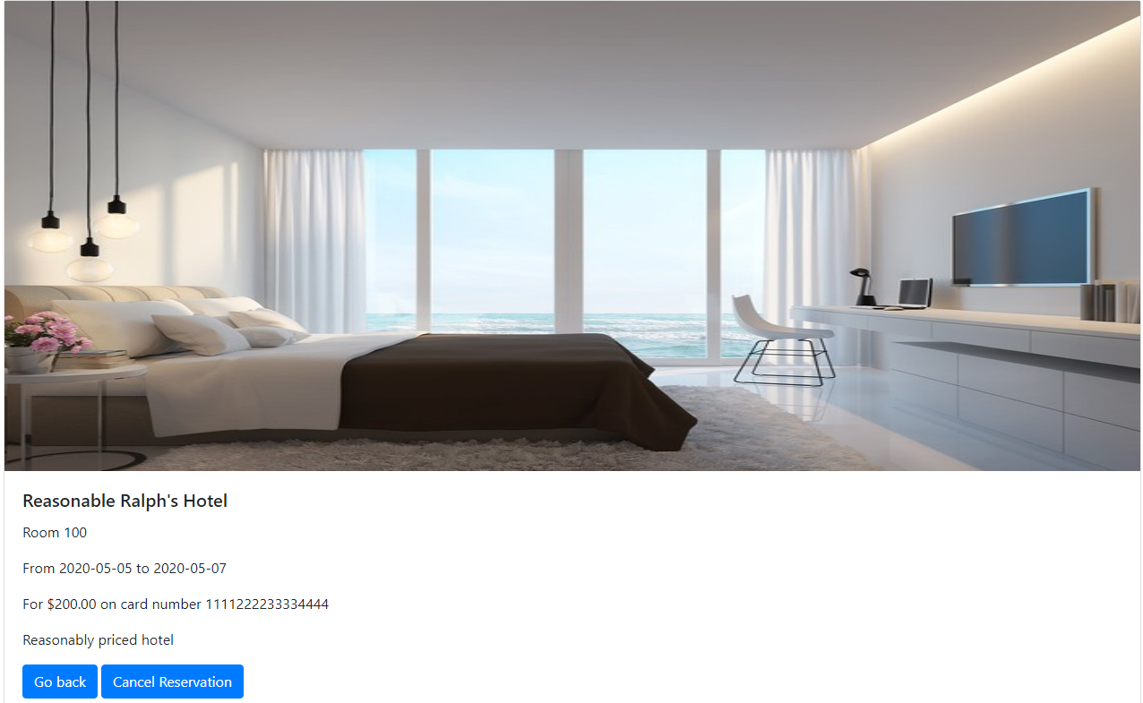

**Hotel profile page**

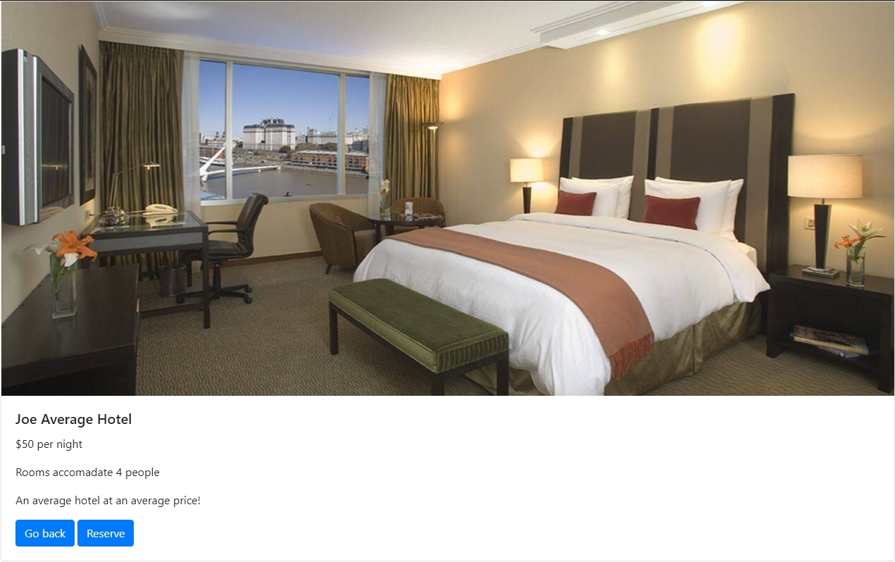

**Reservation page**

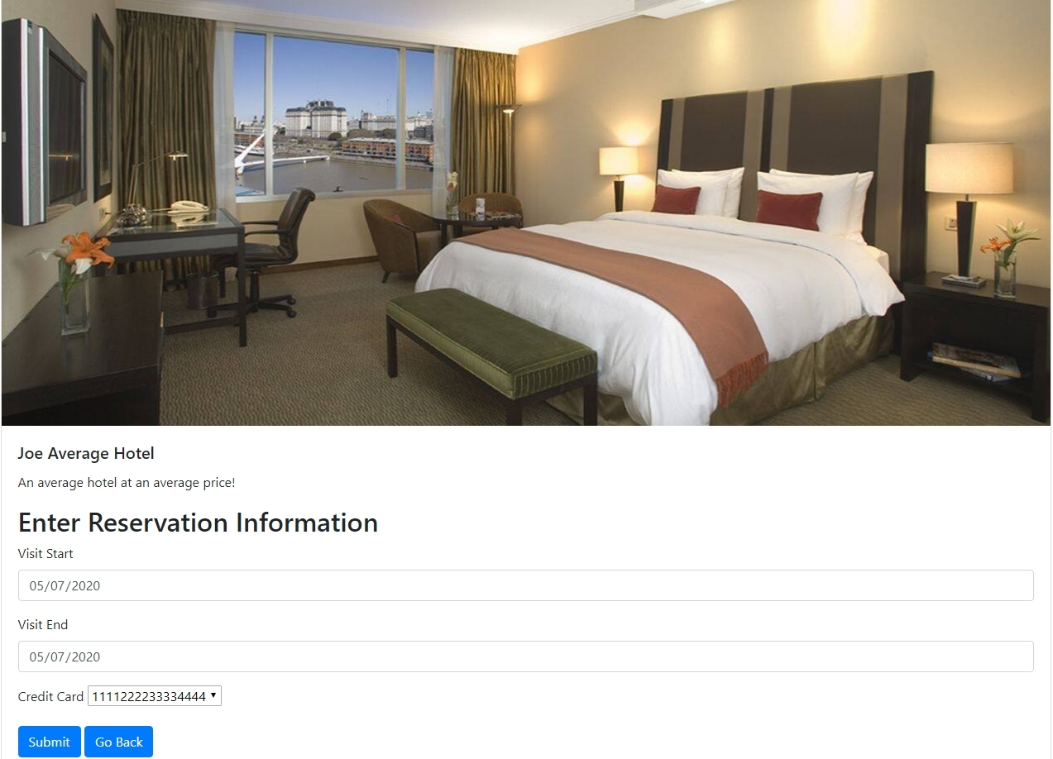

Reservations are not accepted if

* The start date is before the current date
* The end date is before the start date
* The start date and end date are the same
* No credit card is selected
* There are no rooms available in the hotel for the selected date range

When a reservation is requested the room and reservation table are searched for the first room in the hotel that is available during the date range

**Admin zone**

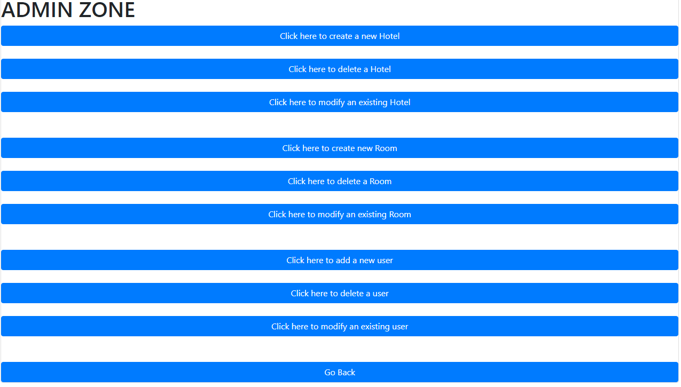

**Create new hotel page**

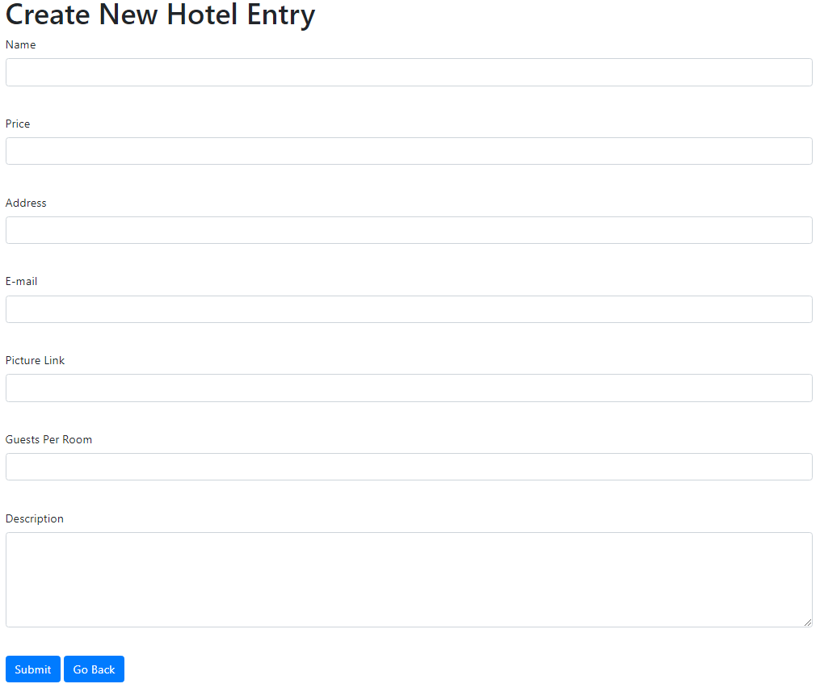

**Modify hotel page**

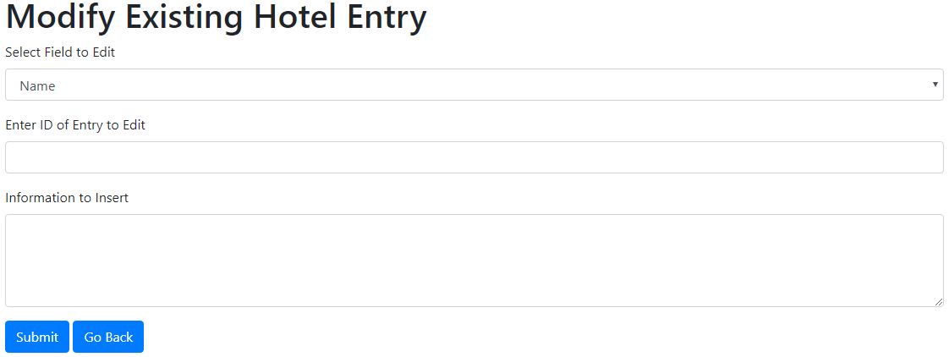

**Delete hotel page**

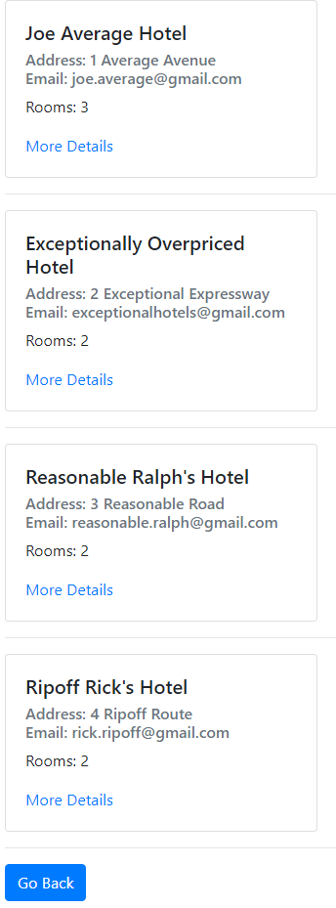

**Delete confirmation page**

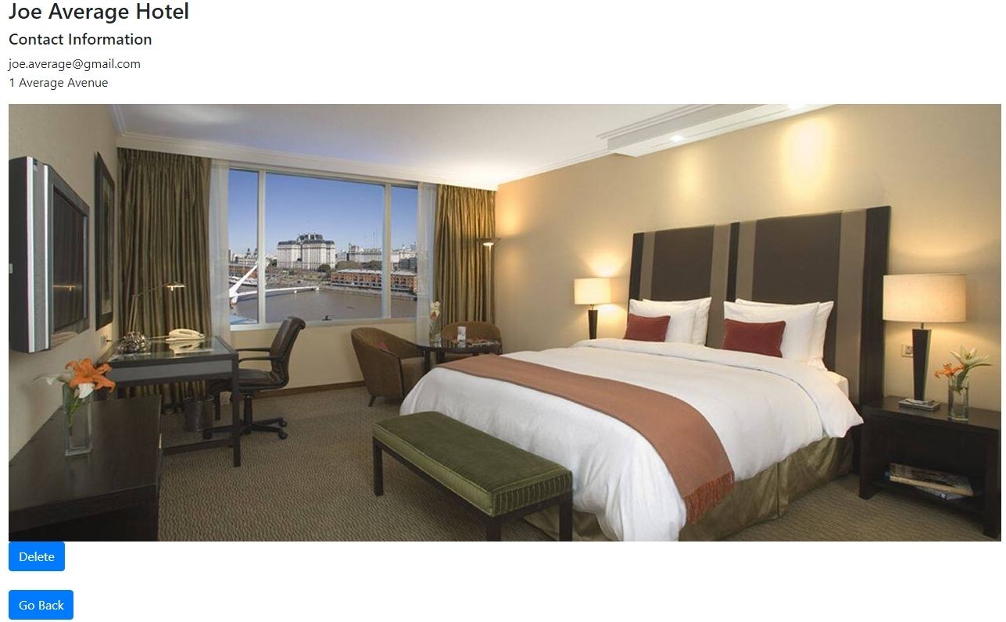

**Note:** The settings and Db files in the /lib/ folder can be edited to accommodate potentially different system needs. Pictures are stored in /lib/pitcture/ folder, pictures for the database only need the file name within /picture/.