Ultimate Cartridge for Atari 8-bit Computers

Website
The Ultimate Cart is a multi-cart for Atari 400/800/XL/XE computers. It is open-source hardware and software. The project website is: https://github.com/robinhedwards/UltimateCart

Basic Usage
The Ultimate Cartridge can be used uncased in an XE system.
Mounting inside a cartridge case is recommended for XL computers since the flaps on the slot may damage the bare PCB.
The SD card slot side should be facing upward (or forwards) in the computer, with the chip side downwards (or backwards).
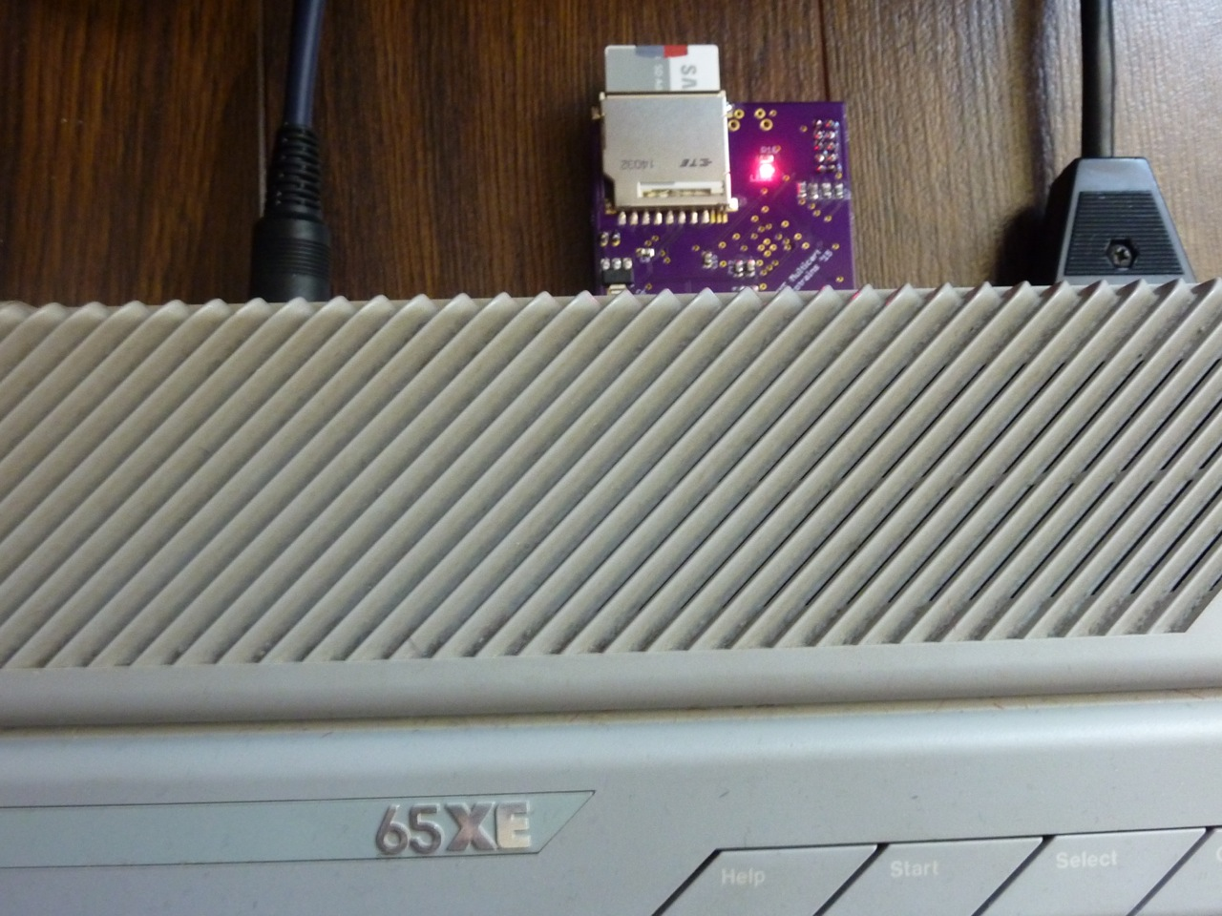
Insert an SD card (either full size, or MicroSD in an adapter) into the slot. The card does not require any special preparation, since the Ultimate cartridge can read FAT (including FAT32) file systems. Long file names are supported.
When the Atari is powered on, a list of any ROM & CAR files and directories on the SD card should be shown on the Atari’s screen. Keyboard commands are shown at the bottom of the screen. A newer version of the firmware also supports XEX files – this may be installed on your cartridge.
It is best to organize your files in directories since the cartridge will load and sort the files in the directory before display. If you have to many files in any one directory, this may cause a noticeable pause before display.
You can disable the cartridge (using the X key) if you want to boot normally (e.g. to disk) and leave the cartridge plugged in (to avoid wear and tear).

SD Cards
Higher speed SD cards are recommended. SDHC (High capacity) cards are supported. On a high-speed card, a 1 megabyte ROM file (e.g. AtariMax) takes about 3 seconds to be loaded into the cartridge when selected. Slower cards may take longer.

Status LED
LED | Meaning
Blinking | The cartridge menu screen is active
On | Selected cartridge is enabled for access (RD4 or RD5 active)
Off | Selected cartridge is disabled (RD4 and RD5 inactive)

Reset Button
Press the reset button (next to the SD card slot) to reset the cartridge firmware. This will generally cause the Atari to crash, and the reset button on the Atari can then be pressed to return to the cartridge menu.

Supported Cartridge Types (CAR files)
Description | CAR Type(s)
Standard Atari 8k | 1
Standard Atari 16k | 2
Atari XEGS 32-1024k | 12-14, 23-25
AtariMax 1mbit (128k) | 41
AtariMax 8mbit (1024k) | 42
Switchable XEGS 32-1024k | 33-38
Megacart 16-1024k | 26-32
Bounty Bob | 18
Williams 32k, 64k | 8, 22
OSS 8k | 44
OSS 16k (034M) | 3
OSS 16k (043M) | 45
OSS 16k (type B) | 15
SIC!Cart (128k, 256k, 512k) | 54-56
SDX 64k | 11
Diamond 64k | 10
Express 64k | 9
SDX 128k | 43
Blizzard 16k | 40

Converting to CAR format
Utilities are available to convert ROM/BIN files into the CAR file format. The ROM2CAR utility available on the project website provides an easy drag and drop interface to do this.
With the most common 8k and 16k Atari ROMs, there is no need to convert these first to CAR format since these cartridge types will simply be assumed from the size of the ROM file (see below).

ROM Files
Plain ROM files are supported, but since these files are raw cartridge dumps, the Ultimate Cart will decide what type of cartridge they come from based on the file size only. The table below shows what types will be used.
ROM File Size | Cartridge Type
8k | Standard Atari 8k
16k | Standard Atari 16k
32k | Atari XEGS 32k
64k | Atari XEGS 64k
128k | Atari XEGS 128k
256k | SIC!Cart
512k | SIC!Cart
1024k | AtariMax 8mbit

XEX Files
The latest version of the firmware adds a new menu, with joystick control. It also supports loading XEX files (in addition to cartridge files).
Note that the XEX loader is copied to location $700 in the Atari’s RAM. This should be compatible with most software in XEX form.

Alternative Menu
If a file named _BOOT.ROM (8k) is present in the root directory of the SD card, the cartridge will attempt to overwrite the in-built boot ROM with this file before the Atari starts accessing the ROM. This allows the menu to be replaced with an alternative version, but successful operation may require a fast SD card. Delete the file to revert to the built-in menu.
Source code for the built-in menu is available on the project website.
Note that setting the hidden or system flag on _BOOT.ROM (using a PC) will prevent this file being displayed on the menu.

Cartridge Cases
The Ultimate Cart PCB is designed to fit in a modified Atari grey (XL-era) cartridge shell. You will need a heavy-duty file and some clippers (e.g. wire clippers). This is only intended to be a rough guide.
First separate the two sides of the shell, trying not to break any of the tabs that hold the two parts of the shell together.
Remove the original PCB and any glue blobs.
From the front (i.e. facing forwards when inserted) part of the shell you will need to remove the plastic centre “post” at its base, since there is no hole in the Ultimate Cart PCB. You will also need to remove the central “clip” at the top of the front shell.
You should then be able to roughly place the Ultimate Cart PCB (chip side up) in the top of the shell (like the PCB you removed). It won’t sit correctly (yet).
At this point it will be clear that you will need to remove 2-3mm height of the side extensions on the top and (partially on the) bottom shell. It should also be clear where slots need to be filed in the front and back of the shell to accommodate the SD card and button.

Upgrading the Firmware
Should new firmware be available, a USB Blaster (or clone) can be used to upgrade your cartridge. A JTAG socket is present on the FPGA side of the board. Connect this to the USB Blaster and power the board. A POF file can then be programmed to the chip using the Altera Quartus Programmer (free download).
To power the board, either supply 5V using the two pin header provided. Alternatively, the board can be powered during the firmware update through the cartridge slot of the Atari.

Board Assembly Information
If you purchased an assembled cartridge from the author, the cartridge has been assembled one of two ways:
Boards purchased before Sept 2015
Assembled using two types of lead-free solder paste. The lower side (with two large chips) uses Sn42Bi58 paste (melting point 130 degrees C). The upper side (with the SD card slot) uses Sn96.5Ag3Cu0.5 paste (melting point 230 degrees), with the exception of the SD card slot itself, which has been soldered with Sn42Bi58. In case of repair, avoid leaded solder since it will lead to brittle and poor joints if mixed with Sn42Bi58.
Boards purchased on or after Sept 2015
Assembled using SN96.5Ag3Cu0.5 paste on both sides (melting point 230 degrees).

